

5000 Series Operator’s Guide

Table of Contents

Welcome to the 5000 Series Professional Duplication Tower 3
Copyright Notice 3
CD-R/RW and DVD-R/RW Recorder Warranty Policy 3
Piracy 3
End User License Agreement 4
About MF DIGITAL 5
What To Expect From Your MF DIGITAL Duplicator 5
About This Manual 5
Getting Started 6
What’s In The Box 6
Packing Materials 6
The Best Place To Put The 5000 6
Safety Precautions 6
Location Of 5000 Series Components 7
Location Of 5000 Series (6 drives) Components 7
Front View 7
Rear View 7
Location Of 5000 Series Recorder Parts And Controls 8
LCD Display Screen And Keypad 8
MF Digital Drives 8
Pioneer DVD±R/±RW 9
System Startup 10
Loading A Disc 11
Removing A Disc 11
General Operation 12
Function Keys 12
Creating A Hard Disk Image 17
Creating A Hard Disk Image 17
Creating A Single Hard Disk Image 17
Creating Multiple Hard Disk Images 19
Enabling Verify After 21
Copying From A Hard Disk Image 22
Multiple Images Disabled 22
Multiple Images Enabled 23
Comparing From A Hard Disk Image 25
Multiple Images Disabled 25
Multiple Images Enabled 26
ATIP Codes (CD-R/RW series only) 28
Reading ATIP Codes 28
Viewing Device Information 29
Creating Audio Compilation Discs 30
Working With CD-ReWritable (CD-RW) Discs 32
CD-RW Supported Formats 32
CD-RW Copying Speed Error! Bookmark not defined.
Utilizing the 5000 Series Client 33
Configuring the 5000 Series 33
Configuring the Client 34
Digital recording with the CD-5906ec Live enabled systems 37
Introduction 37
Features: 37
Specifications: 37
Input / Output 37
Setting up your system 38
Using the 5906 Live 39
Recording 39
Editing your recording and Adding tracks 41
Adding Tracks 41
Editing tracks 42
Disc Spanning 44
Making the disc(s) 45
Method 1 45
Method 2 47
Utilizing the Print Function 50
Setting The Internal Clock 51
Setting The Internal Clock 51
Firmware Updates 52
Appendix A: Supported Formats 54

Welcome to the 5000 Series Professional Duplication Copier Module

Copyright Notice

Copyright ©2003 – 2005 by MFDIGITAL. All rights reserved.

This manual and the accompanying illustrations may not be copied, reproduced, electronically transmitted, or translated into another language, in whole, or in part, without the written consent of MF DIGITAL.
MFDIGITAL, 5000 series, Director, Director PRO Scribe SA, and Scribe PC are trademarks of MFDIGITAL.

Other trademarks referred to are the property of their respective trademark or registered trademark holders.

Recordable Drive Warranty Policy
Individual recorder manufacturers are responsible for the products they provide. As a convenience, MFDIGITAL will honor any service issue related to a defective recorder while under its respective manufacturer’s warranty providing that the recorder has been purchased from MFDIGITAL either directly or indirectly. MFDIGITAL assumes no responsibility for products NOT purchased through MFDIGITAL.

Piracy
The copying of audio, video, or software without the permission of the copyright holder is illegal.
MF DIGITAL. accepts no responsibility for the copyright use or misuse of this equipment. It is the
sole responsibility of the user to ensure that the legal rights of copyright in duplicating are respected.

Corporate Headquarters:

MFDIGITAL
155 Sherwood Avenue
Farmingdale, NY 11735
Tel: (631) 249-9393
Fax: (610) 249-9437
Email: mailto:documentation@mfdigital.com
www: http://www.mfdigital.com

End User License Agreement

- You have acquired a device (“5000 Series CD-R/RW duplicator”) that includes software licensed by MF DIGITAL from Microsoft Licensing Inc. or its affiliates (“MS”). Those installed software products of MS origin, as well as associated media, printed materials, and “online” or electronic documentation (“SOFTWARE”) are protected by international intellectual property laws and treaties. The SOFTWARE is licensed, not sold. All rights reserved.

- IF YOU DO NOT AGREE TO THIS END USER LICENSE AGREEMENT (“EULA”), DO NOT USE THIS DEVICE OR COPY THE SOFTWARE. INSTEAD, PROMPTLY CONTACT MF DIGITAL FOR INSTRUCTIONS ON RETURN OF THE UNUSED DEVICE (S) FOR A REFUND. ANY USE OF THE SOFTWARE, INCLUDING BUT NOT LIMITED TO USE ON THE DEVICE, WILL CONSTITUTE YOUR AGREEMENT TO THIS EULA (OR RATIFICATION OF ANY PREVIOUS CONSENT.)
- GRANT OF SOFTWARE LICENSE. This EULA grants you the following license:
- You may use the SOFTWARE only on the DEVICE.
- NOT FAULT TOLERANT. THE SOFTWARE IS NOT FAULT TOLERANT. MF DIGITAL HAS INDEPENDENTLY DETERMINED HOW TO USE THE SOFTWARE IN THE DEVICE, AND MS HAS RELIED UPON MF DIGITAL TO CONDUCT SUFFICIENT TESTING TO DETERMINE THAT THE SOFTWARE IS SUITABLE FOR SUCH USE.
- NO WARRANTIES FOR THE SOFTWARE. THE SOFTWARE is provided “AS IS” and with all faults. THE ENTIRE RISK AS TO SATISFACTORY QUALITY, PERFORMANCE, ACCURACY, AND EFFORT (INCLUDING LACK OF NEGLIGENCE) IS WITH YOU. ALSO, THERE IS NO WARRANTY AGAINST INTERFERENCE WITH YOUR ENJOYMENT OF THE SOFTWARE OR AGAINST INFRINGEMENT. IF YOU HAVE RECEIVED ANY WARRANTIES REGARDING THE DEVICE OR THE SOFTWARE, THOSE WARRANTIES DO NOT ORIGINATE FROM, AND ARE NOT BINDING ON, MS.
- Note on Java Support. The SOFTWARE may contain support for programs written in Java. Java technology is not fault tolerant and is not designed, manufactured, or intended for use or resale as online control equipment in hazardous environments requiring fail-safe performance, such as in the operation of nuclear facilities, aircraft navigation or communication systems, air traffic control, direct life-support machines, or weapons systems, in which the failure of Java technology could lead directly to death, personal injury, or severe physical or environmental damage. Sun Microsystems. has contractually obligated MS to make this disclaimer.

- No Liability for Certain Damages. EXCEPT AS PROHIBITED BY LAW, MS SHALL HAVE NO LIABILITY FOR ANY INDIRECT, SPECIAL, CONSEQUENTIAL OR INCIDENTAL DAMAGES ARISING FROM OR IN CONNECTION WITH THE USE OR PURPOSE. IN NO EVENT SHALL MS BE LIABLE FOR ANY AMOUNT IN EXCESS OF U.S. TWO-HUNDRED FIFTY DOLLARS (U.S. $250.00).
- Limitations on Reverse Engineering, De-compilation, and Disassembly. You may not reverse engineer, de-compile, or disassemble the SOFTWARE, except and only to the extent that such activity is expressly permitted by applicable law notwithstanding the limitation.
- SOFTWARE TRANSFER ALLOWED BUT WITH RESTRICTIONS. You may permanently transfer rights under this EULA only as part of a permanent sale or transfer of the Device, and only if the recipient agrees to this EULA. If the SOFTWARE is an upgrade, any transfer must also include all prior versions of the SOFTWARE.
- EXPORT RESTRICTIONS. You acknowledge that SOFTWARE is of US-origin. You agree to comply with all applicable international and national laws that apply to the SOFTWARE, including the U.S. Export Administration Regulations, as well as end-user, end-use and country destination restrictions issued by U.S. and other governments. For additional information on exporting the SOFTWARE, see http://www.microsoft.com/exporting/.

About MF DIGITAL
Thank you for purchasing MF DIGITAL’s 5000 Series Copier Module duplicator. MF DIGITAL manufactures a wide variety of CD / DVD duplication equipment, including manual and fully automated CD / DVD duplicators and printers. We hope you will consider us for all of your duplication needs.

What To Expect From Your MF DIGITAL Copier Module Duplicator
Your MF DIGITAL 5000 Series copier module duplicator is professionally designed and manufactured to give you years of trouble free operation. To avoid accidental damage to your new duplicator, please read and understand this manual thoroughly before operating the unit.

About This Manual
This manual is written for both novice and experienced users. Please read through this Operator’s Guide from beginning to end before using the unit. Once having read the manual, follow along chapter by chapter. This will provide the necessary understanding of your new 5000 Series duplicator.

Getting Started
Carefully remove the 5000 Series duplicator from the shipping container. Inspect the contents, and verify them against the packing slip. Report any errors in shipping as soon as possible.

What’s In The Box
Your new 5000 Series duplicator includes:
- 5000 Series duplicator
- Power cord
- Firmware CD
- Manual CD
- LAN cable for network hook-up

Packing Materials
Please retain the original box and packaging in the event that the unit requires future servicing. This will help to reduce the possibility of damage occurring in transit.

The Best Place To Put The 5000
The best operating location for the 5000 Series duplicator is in a climate-controlled area, free of dirt, dust, humidity, excessive heat, and electronic or electromagnetic interference. Room temperature should be between 65 and 75 degrees Fahrenheit, or between 18 and 23 degrees Celsius. Place the 5000 on a solid, steady work surface, and allow sufficient room for all incidental work materials. Provide at least six inches of clearance on all sides of the unit for ventilation.

Safety Precautions
The system is shipped with a three-prong power connector, and must be used with a properly grounded AC receptacle. DO NOT try to defeat the third “ground” prong. All computer peripherals must be properly grounded, and the 5000 is no exception. The use of a power conditioner, such as an Uninterruptible Power Supply (UPS) or a surge protector, is highly recommended. The minimum required size is 500VA.
Repairs or alterations should only be attempted by an authorized, factory-trained technician. MF DIGITAL reserves the right to void the warranty if unauthorized service is performed.

Location Of 5000 Series Components

Location Of 5000 Series (6 drives) Components

Front View
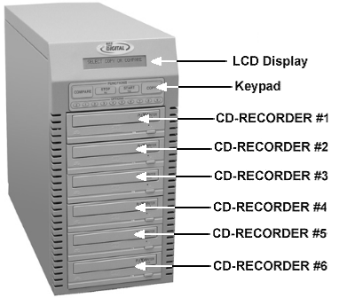

Rear View
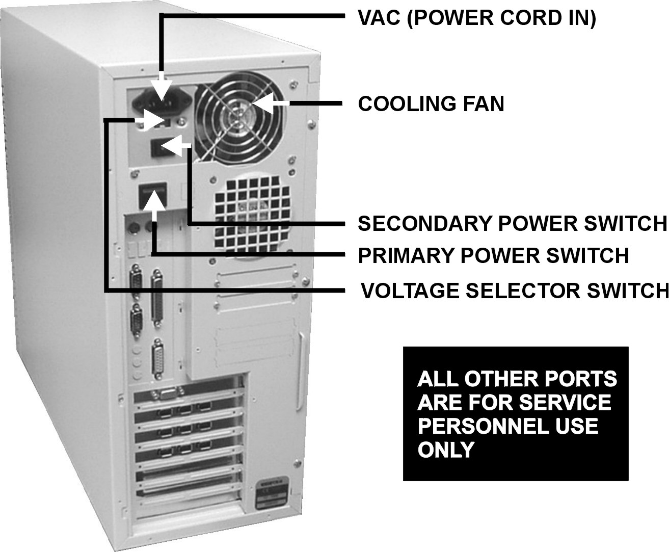

Location Of 5000 Series Recorder Parts And Controls

LCD Display Screen And Keypad
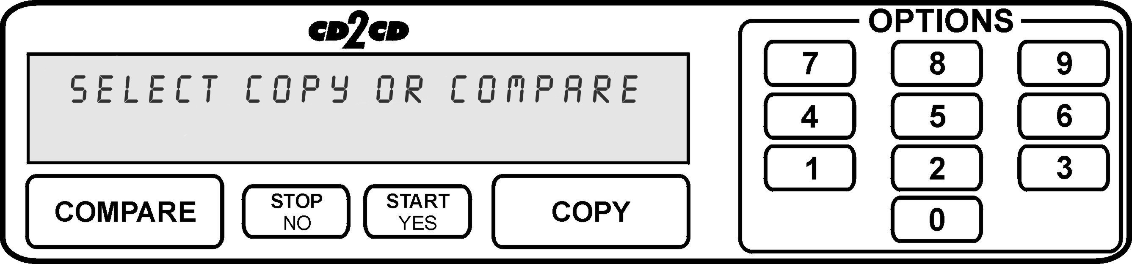

MF Digital 52x ProDRIVE
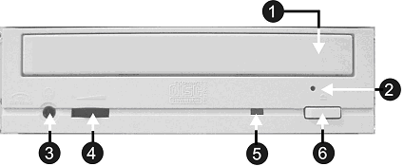

Legend

- Disc tray - Discs are loaded and removed from this tray. Pressing the eject button will open the tray when the power is switched on to the 5000 Series.
- Emergency eject pinhole - In the event that the disc tray will not open by pressing the eject button, insert the tip of a large paper clip into this hole and push.
- Earphone jack
- Volume Control
- Read and write status LED - This indicator lights up when the recorder is reading or writing.
- Eject button - This button is used to open or close the disc tray.

Pioneer DVD±R/±RW

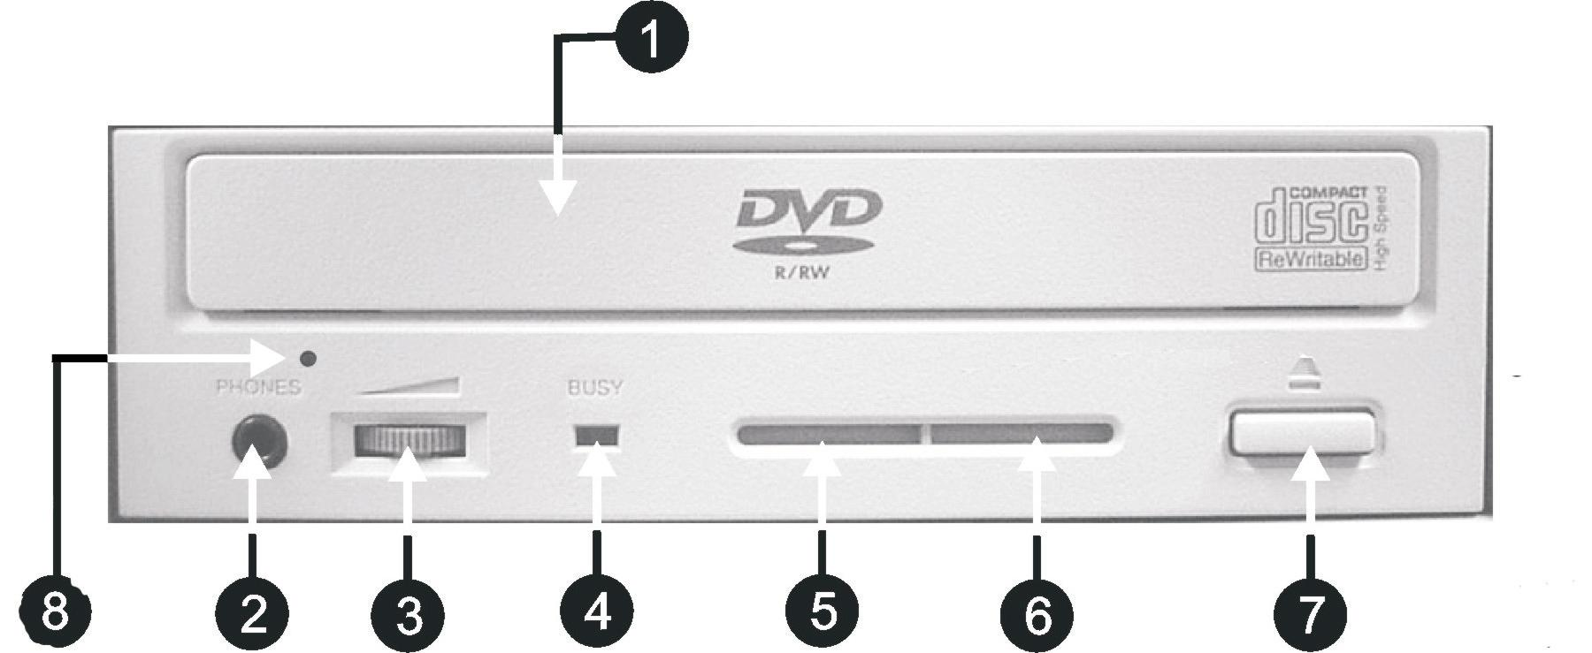

Legend

- Disc Tray - Discs are loaded and removed from this tray. Pressing the eject button will open the tray when the power to the 5000 Series is switched on.
- Headphone Jack – Connect headphones here.
- Volume Control Knob – This controls the volume level of the headphones.
- Disc Indicator – Light indicates presence of disc in drive.
- Ventilation Hole – Do not block.
- Ventilation Hole – Do not block.
- Eject Button – This button is used to manually open the disc tray.
8) Emergency Eject Pinhole – In the event that the disc tray will not open by pressing the eject button, insert the tip of a large paper clip into this hole.

System Startup
Before duplicating can begin it is necessary to review a few details.
- Plug one end of the supplied power cord into the upper receptacle at the rear of the unit.
- Next, verify that the voltage selector switch is set correctly. It is located between the two power receptacles. The 5000 Series supports both 115 VAC and 230 VAC at 50 ~ 60 Hz. Please confirm that the appropriate voltage (115 VAC for North America) has been selected.
 | CAUTION  Always use properly grounded receptacles or severe damage to your system may result. The use of a surge protector or Uninterruptible Power Supply (UPS) is highly recommended.

- Make sure you power on the unit using the primary power switch (located on the rear of the unit) and secondary power switch (located on the power supply).

- Once the proper voltage setting has been confirmed, it is time to turn on the unit. Wait a minute or two while the system starts up. The screen will now read:


After the startup routine is complete, a series of self-diagnostics will be performed. The screen will now read in sequence:


Once complete, the unit will display the main operating screen:



Loading A Disc
- After the 5000 Series’ power has been switched on, press the eject button on the front of the recorder to open its disc tray.
- Load by carefully placing the disc (label side up) into the recessed area of the disc tray, so that the disc lays flat.
- Press the eject button on the front of the recorder to close the disc tray.
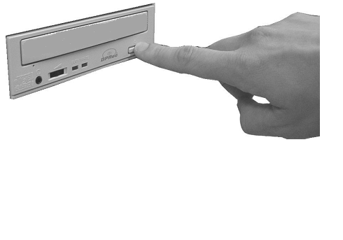

Removing A Disc
- While the 5000 Series’ power is still switched on, press the eject button on the front of the recorder to open the disc tray.
- After the disc tray has completely opened, lift the disc by its edges and carefully remove it.
- Press the eject button on the front of the recorder to close the disc tray.

General Operation
The 5000 Series is extremely versatile and offers many useful and powerful features.

Function Keys
Various uses for the 5000 will be explained throughout this Operator’s Guide. The following section explains the purpose of the function keys.

The numeric keys on the keypad have special functions. When the main operating screen is displayed:



- Press the “0” key on the keypad. The screen will now read:

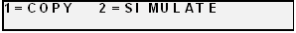

The factory setting for this function is “Copy”. The “Simulate” mode is a diagnostic tool, which is useful for testing the readability of a master disc, without actually writing to blank discs loaded into the recorders. It is also helpful for training purposes, and for experimenting with various system functions.
- Press the “1” key to select “Copy” or the “2” key to select “Simulate”. After pressing either key, you will be returned to the main operating screen.
- Press the “1” key on the keypad. Something similar to the following will be displayed on the screen in sequence:

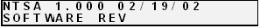
- This is the version information of the firmware currently installed on the 5000.


- This displays the image size on the internal hard disk, time and date.

- This displays the Verify After status of the 5000. The Verify After function will verify a copied disc against the master disc immediately after it has been copied.


- This displays the Multiple Images status of the 5000. Multiple images allows the user to store up to 6 separate master images on the internal Hard Drive.


- This displays the Installed Memory of the 5000.


- This displays the number of good and bad copies that were produced to date on the system

- Press the “2” key on the keypad. You will see several functions scroll across the screen. Select a function by pressing the corresponding number on the keypad. Enable or disable the function by pressing the “Start/Yes” or “Stop/No” key.

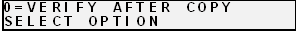
- 0- The factory setting for this function is disabled. When enabled, the Verify After feature automatically compares discs to the master disc or hard disk image after copying is completed. Due to the nature of the various compact disc formats, only CD-ROM Mode 1, CD-ROM Mode 2, CD-ROM XA Mode 2 Form 1, and audio (CD-DA) discs can be compared.


- 1- The factory setting for this function is disabled. When enabled, the Multiple Images feature allows up to six images to be stored on the hard disk drive at one time. This setting will remain in effect until disabled, even after restarting the 5000.

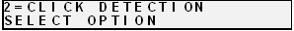
- 2- The factory setting for this function is “enabled”. When “disabled”, the Click Detection feature allows masters with small random errors to be read to the hard drive. Caution should be taken when disabled, as masters that would normally be rejected will be allowed to be read-in. Undesirable results may occur.

- Not used.

- Print function. See page “40”.

- Press the “5” key on the keypad. The screen will now read:


- By using the Audio Track Import feature, audio compilation discs can be created one track at a time from one or more masters.
- Manually place an audio master disc into drive number 1.
- Press the “Start/Yes” key
- Press the number of the track you wish to import and press the “Start/Yes” key. Only one track may be imported at a time. All of the tracks will create one master image on the hard drive.
- Once you have imported all of the tracks, copy the image you just created from the hard drive as you normally would.

- Press the “6” key on the keypad. Something similar to the following will be displayed in sequence:

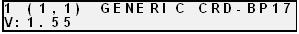
This display is the device information for each of the recorders installed in the 5000. This includes their host number, model name, and firmware version.

- Press the “7” key on the keypad. The screen will now read:


    - Press the “Start/Yes” key to clear the hard drive.
If the “Stop/No” key is pressed you will be prompted to set the “System Time.”



    - Press the “Start/Yes” key to set the system time.
    - If the “Stop/No” key is pressed you will be prompted to “Read ATIP?”


When selected, the ATIP function allows you to determine the manufacturer of the CD-R placed in drive 1 of the 5000. (Not available on DVD)

• If you pressed the “Stop/No” key at you will be prompted to “Set the Drive Order”:


• Press the “Stop/No” key if you do not want to reset the drive order. Press the “Start/Yes” key and you will then see the following screen:


• All of the drives will open at this time:


• Close the drive tray of the drive you would like to be drive number “1”. It can be any one of the drives. You will then see the following screen:


• Close the remaining drives in order from top to bottom.

- If you pressed “Stop/No” to “Set Drive Order”, you will be prompted to “Change Network Settings”. Pressing “Start/Yes” will allow you to set-up the network client feature. Please see Setting Up Network Client section (p. 36) for further details. Pressing “Stop/No” will bring you back to the “Select Copy or Compare” screen.

- Press the “8” key on the keypad. The screen will now read (CD version shown):
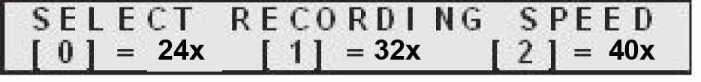
The factory setting for this function is “40x” for CD and “8x” for DVD. When selected, the Select Recording Speed feature allows you to set the copying speed as determined by the capabilities of the recorders installed in the 5000.
• After pressing any of those keys, the screen will now read:





- Press the “9” key on the keypad. Something similar to the following will be displayed in sequence:


This displays the status of the last disc copied or compared in each of the 5000’s recorders. If the last operation performed was successful, the screen will report “OK”. If problems were encountered, an error message will be displayed.

Creating A Hard Disk Image

Creating A Hard Disk Image
The 5000 Series comes equipped with an internal hard disk drive, which can be used to store copies of master discs for later recording or comparing. Each master is saved as a single image file. Up to six images can be stored on the hard disk at one time.

A hard disk image is useful as a convenient way of copying standard master discs. For example, create hard disk images for three or four master discs which are needed on a regular basis, and access them to make copies as required.

Creating A Single Hard Disk Image
Although the 5000 Series’ internal hard disk can store up to six images of master discs, it is sometimes prudent not to use this Multiple Image feature and only allow one image to be created and stored. For example, using a single image simplifies the copying process. This reduces the chance that an operator might make copies of the wrong discs by selecting the incorrect hard disk image.

To create a single hard disk image, the steps are as follows:

- From the main operating screen depicted below:


• Press the COPY key. The screen will now read:

• Press the STOP/NO key. The screen will now read:

If the master does not load, you may have to reset the drive order to distinguish drive 1 (see page 17).
Note:

• Press the START/YES key. The screen will now read in sequence:

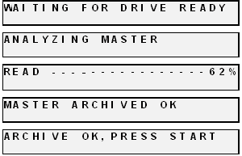

The master disc is now stored as an image on the hard disk. If you are creating an audio image, Pregaps and SubIndexes will be shown.

Note: If discs failed to Archive properly, the recorder tray drawer will stay closed, and the screen will read ”Archive Failed, Press Start”. This points to a problem with the master CD. Try a different master CD.

- Press the “Start/Yes” key, and you will be returned to the main operating screen:

Note: When the Multiple Images feature is disabled, only one image can be saved on the hard disk. If a new image is created, the old one is overwritten.

Creating Multiple Hard Disk Images
The Multiple Images feature allows the 5000 Series’ internal hard disk to store up to six master disc images. The factory setting for this function is “disabled”. To enable multiple images proceed as follows:

- From the main operating screen depicted below:

- Press the “2” key. The screen will now display the following:

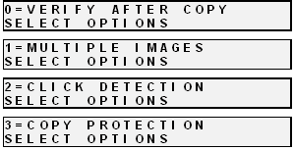
- Press the “1” key to select multiple images. The screen will now read:

• Press the “START/YES” key to enable “Multiple Images”.


• You will then be returned to the main operating screen:

• Press the “COPY” key. The screen will now read:


• Press the “STOP/NO” key. The screen will now read:


• Press the “START/YES” key. The screen will now read:



• Select the number that will designate the location of your master. The screen will then read in sequence:

The master disc is now stored as an image on the hard disk. If you are creating audio images, Pre gaps and Sub Indexes will be shown.

Note: If discs failed to Archive properly, the recorder tray drawer will stay closed, and the screen will read” Archive Failed, Press Start”. Try a different master disc.

Enabling Verify After
The Enabling Verify After option, allows the user to verify the copy against the image on the hard drive. This ensures the user that the copies are exactly like the master image. To enable this option, do the following:

• From the main operating screen depicted below:
• Press the “2” key and the screen will now display in sequence:

• Press the “0” key, and the screen will now read:


• Press the “START/YES” key to enable, or the “STOP/NO” key to disable the “Verify After” option. If you press the “START/YES” key the screen will read:

• You will then be returned to the main operating screen.



Copying From A Hard Disk Image
After a hard disk image has been created, it can be used as the copying master source. If you have not already created a hard disk image, do so now, as described in the previous section.

Multiple Images Disabled
To make copies from a hard disk image that was previously created with the Multiple Images feature “disabled” (i.e. from a single hard disk image), the steps are as follows:

- From the main operating screen depicted below:


- Load as many blank discs as are required into the CD-R/RW recorders.
- Press the “COPY” key on the keypad. The screen will now read:


- Press the “START/YES” key to begin copying from the hard disk image, to the blank discs in the recorders. Depending on the format type of the image, something similar to the following will be displayed on the screen:

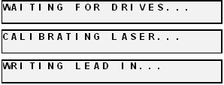
Progress will be displayed on the screen during the operation:

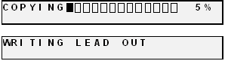

- Upon successful completion, the copied disc(s) will be ejected. The screen will now read:


    - Press the “START/YES” key, and you will be returned to the main operating screen:

Note: If discs failed to COPY properly, the recorder tray drawer will stay closed, and the screen will read” Copy Failed, Press Start”. This copy should not be used.

Multiple Images Enabled
To make copies from hard disk images that were previously created with the Multiple Images feature “enabled”, the steps are as follows:

- From the main operating screen depicted below:

- Load as many blank discs as are required into the recorders. Press the “COPY” key on the keypad. The screen will now read:

- Press the “START/YES” key. The screen will now read:



The 5000 Series defaults to the first image (1). For the purposes of this example, press the “1” key to select this image, followed by the “START/YES” key. The screen will now read:

Progress will be displayed on the screen during the operation:

- Upon successful completion, the copied disc(s) will be ejected. The screen will now read:

    - Press the “START/YES” key, and you will be returned to the main operating screen:

Note: If discs failed to COPY properly, the recorder tray drawer will stay closed, and the screen will read” Copy Failed, Press Start”. This copy should not be used.

Comparing From A Hard Disk Image
For quality control purposes, the 5000 Series is equipped with powerful verification capabilities. Copied discs can be compared against hard disk images. This feature ensures copying integrity.

Note: Due to the nature of the various compact disc formats, only CD-ROM Mode 1, CD-ROM Mode 2, CD-ROM XA Mode 2 Form 1, and most CD/DVD formats can be compared.

Multiple Images Disabled
To compare copied discs to a hard disk image that was previously created with the Multiple Images feature “disabled” (i.e. from a single hard disk image), the steps are as follows:

- From the main operating screen depicted below:

- Load the copied discs to be compared into the recorders.
- Press the “COMPARE” key on the keypad. The screen will now read:


- Press the “START/YES” key. The screen will now read:


Progress will be displayed on the screen during the operation:


Upon successful completion, the compared disc(s) will be ejected. The screen will now read:



- Press the “START/YES” key, and you will be returned to the main operating screen:

Note: If discs failed to Compare properly, the recorder tray drawers stay closed at completion, giving the user a “Compare Failed, Press Start” message. These discs should not be used. To help you determine the nature of the problem, error messages can be displayed by pressing the “9” key on the keypad.

Multiple Images Enabled
To compare copied discs to a hard disk image that was previously created with the Multiple Images feature “enabled”, the steps are as follows:

- From the main operating screen depicted below:

- Load the copied discs to be compared into the recorders.
- Press the “COMPARE” key on the keypad. The screen will now read:

- Press the “START/YES” key. The screen will now read:

- Select the image you would like to compare against by pressing 1, 2, 3, 4, 5, or 6.

Progress will be displayed on the screen during the operation:



Upon successful completion, the compared disc(s) will be ejected. The screen will now read:


- Press the “START/YES” key, and you will be returned to the main operating screen:

Note: If discs failed to Compare properly, the recorder tray drawers stay closed upon completion. These discs should not be used. To help you determine the nature of the problem, error messages can be displayed by pressing the “9” key on the keypad.

ATIP Codes (CD-R/RW series only)
ATIP stands for “Absolute Time In Pre-Groove”. In firmware 1.0XX and higher, the ATIP option allows you to determine the manufacturer of the disc placed in the top drive of the 5000. It will also determine the minutes, seconds, and frames present on the disc. Many generic brand CDs will not be recognized.

Reading ATIP Codes
To read an ATIP Code from a disc, the steps are as follows:
- From the main operating screen depicted below:


- Place the disc that you wish to read the ATIP information from, into the top drive of the 5000.
- Press the “7” key. The screen will now read:


- Press the “STOP/NO” key. The screen will now read:


- Press the “STOP/NO” key. The screen will now read:


- Press the “STOP/NO” key. The screen will now read:

- Press the “START/YES” KEY. The screen will now read something similar to this.



- The screen will now read something similar to the following:

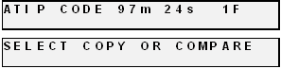

Viewing Device Information
To view the 5000 Series’ DRIVE device information, the steps are as follows:

- From the main operating screen depicted below:

- Press the “6” key. Something similar to the following will be displayed on the screen:

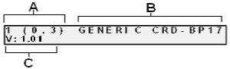

The device information is displayed for each of the drives installed in the 5000 series copier module. The information displayed is the following:

A= Device Number (position of device in system)
B= Drive Model Number
C= Firmware version installed on drive

Creating Audio Compilation Discs
In addition to copying entire CDs, audio compilation discs can be created one track at a time, from one or more master discs containing audio CD-DA, Mixed Mode, or CD-Extra. This is accomplished by using the 5000 Series’ audio track import feature. The audio will be imported to the 1st partition of the hard drive.

To create an audio compilation disc, the steps are as follows:

- From the main operating screen depicted below:

- Load the master disc that contains the audio track(s) you wish to copy into the top recorder. Wait for the LED lights on the front of all the recorders to stop flickering (this may take up to 30 seconds).

Note: Only one audio compilation disc can be created at one time. If several copies are required, first create the original compilation disc, and then copy it in the usual way.

- Press the “5” key. The screen will now read:


- Press the “START/YES” key. The screen will now read:


- Press the number of the track you would like to select. Track number 1 is used as an example.


- If you wish to make changes, press the “STOP/NO” key. If the selection is correct, press the “START/YES” key. The screen will now read:

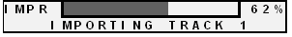
- This screen shows the progress of the importation, the tracks are placed in the “1” partition of the hard drive. Once complete the screen will read:

- If you would like to import more tracks, press the “START/YES” key. If you are finished press the “STOP/NO” key and the screen will now read:

- Press the “COPY” key and place blank CD-Rs into the drives of the 5000 Series. The screen will now read:


Press the “START/YES” key to begin copying. The screen will now read:


- If you wish to copy additional tracks from another master CD, eject the former master disc. You will then load the new master disc. Press the “1” key and proceed as before. If you have finished, press the “9” key to complete the disc. The screen will now read:

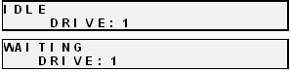
Upon successful completion, the compiled disc will be ejected. Press the “STOP/ NO” key and the screen will read:

Press the “START/YES” key and you will be returned to the main operating screen:


Working With CD-Re-Writable (CD-RW) Discs
In addition to working with DVD+/-R and CD+/-R discs, the 5000 can also copy both to and from DVD and CD RE-Writable (DVD/RW CD/RW) discs.

CD-RW Supported Formats
The 5000 can copy CD-RW discs written in most logical formats (ISO 9660, audio, etc.) but not those created using the Universal Disk Format (UDF). CD-RW discs using UDF are produced by packet writing software (such as Adaptec DirectCD, CeQuadrat PacketCD, Prassi abCD, etc.). Because UDF discs cannot be read by all CD-ROM drives, they are not a good choice for distributing data.

Utilizing the 5000 Series Client
The 5000 series has a client feature which enables a remote user.

Configuring the 5000 Series
- Connect the 5000 Series to your network using the RJ-45 connector on the back of the system.
- Turn on the 5000 Series
- Wait for the 5000 Series to boot up, you will see:


- Press the “7” key, you will see:


• Press the “START/YES” key, you will see:


• You must leave “MF” at the front of the name. You should name it “MF001” for example.


• Press the “START/YES” key, you will see:


• Press the “Stop No” key if the network does not use DHCP or press the “START/YES” key if the network does use DHCP. If you press the ““START/YES” “ key you will be prompted to Restart the system, if you press the “Stop No” key you will see:


• Enter the 4 sets of numbers of the IP address, one set at a time. After each octet press the “START/YES” key. Do not enter an IP address of a machine that is already on the network. When you have entered in the entire IP address, you will see:


• Enter the 4 sets of numbers of the subnet. Pressing “START/YES” after each set. You will then see:


• Press the “START/YES” key and then Restart the system by turning it Off and back On again.

Configuring the Client
- Place the firmware CD into the CD-ROM drive of your PC
- Double click on “Embedded” folder
- Double click on SaClient.exe
- Press “Connect” in the lower right hand corner

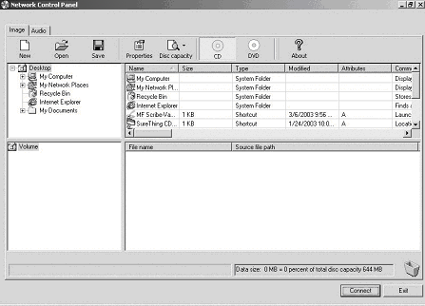

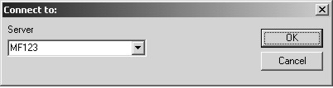

- Enter the name of the 5000 Series on the network.
- Press “OK”
- A new tab will appear at the top of the screen called “MF123”
- Click the “MF123” tab and you will see:
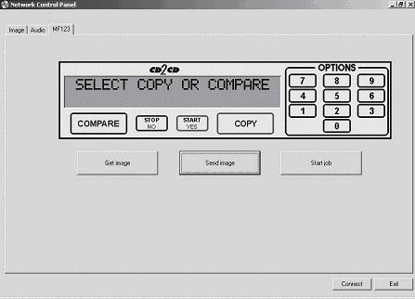

- Click “Get image” to pull an image from the 5000. Give the image a name and location. The image will be saved with a .img file extension.
- Click “Send image” to send an image to the 5000. The image may be an .img, .iso, .udf, or .isc.

- To burn from the client, click “Start job”. Click “Browse” to select an image to burn to the 5000. Select “Copy”, “Verify”, or “Test. Enter a quantity and click “OK”.
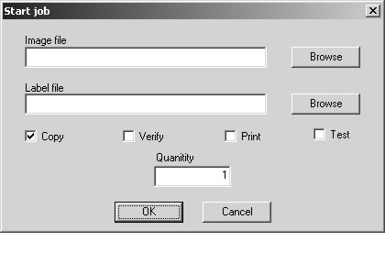

Digital recording with the 5906 Live enabled systems | 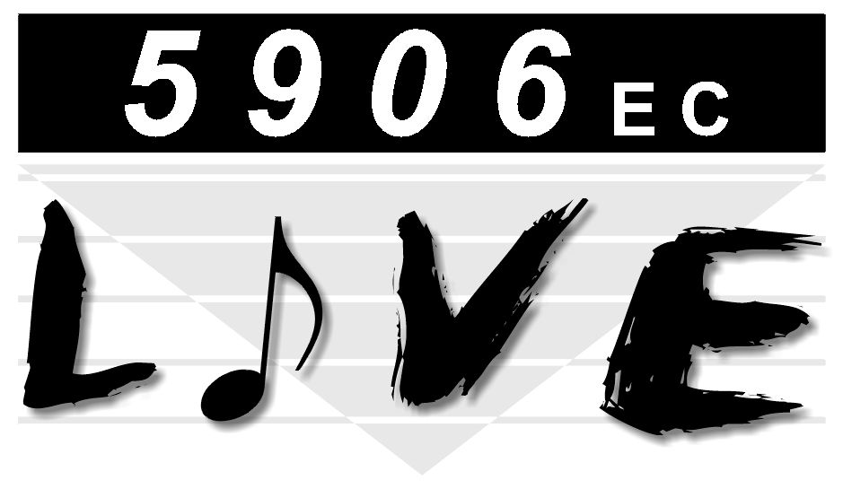

Introduction
The 5906 “Live” is a special edition of the 5906 which allows for audio recording directly to the system’s HD. This proves to be an ideal solution for live event recording, enabling the user to go from recorded event to making multiple CDs with in only a few minutes of the event.

Features:
- 2 x 2 analog I/O
- 24-bit/96kHz fidelity
- S/PDIF digital I/O with 2-channel PCM
- 1 x 1 MIDI I/O
- Analog I/O with gold-plated RCA jacks
- Non destructive Start ID editing.

Specifications:
Frequency response: | 22Hz-22kHz, -0.4, -0.4dB
Dynamic range: | 104dB (A-weighted) (D/A)
 | 100.4dB (A-weighted) (A/D)
THD: | < 0.002%

Input / Output | 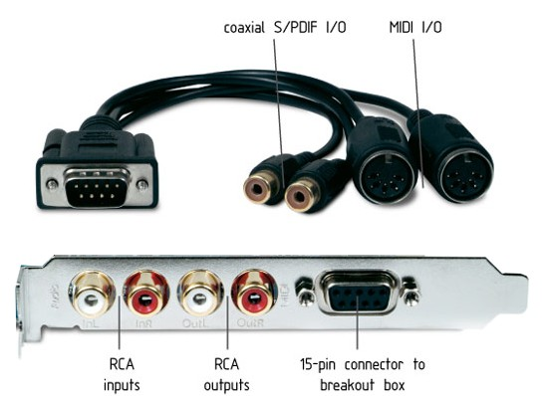

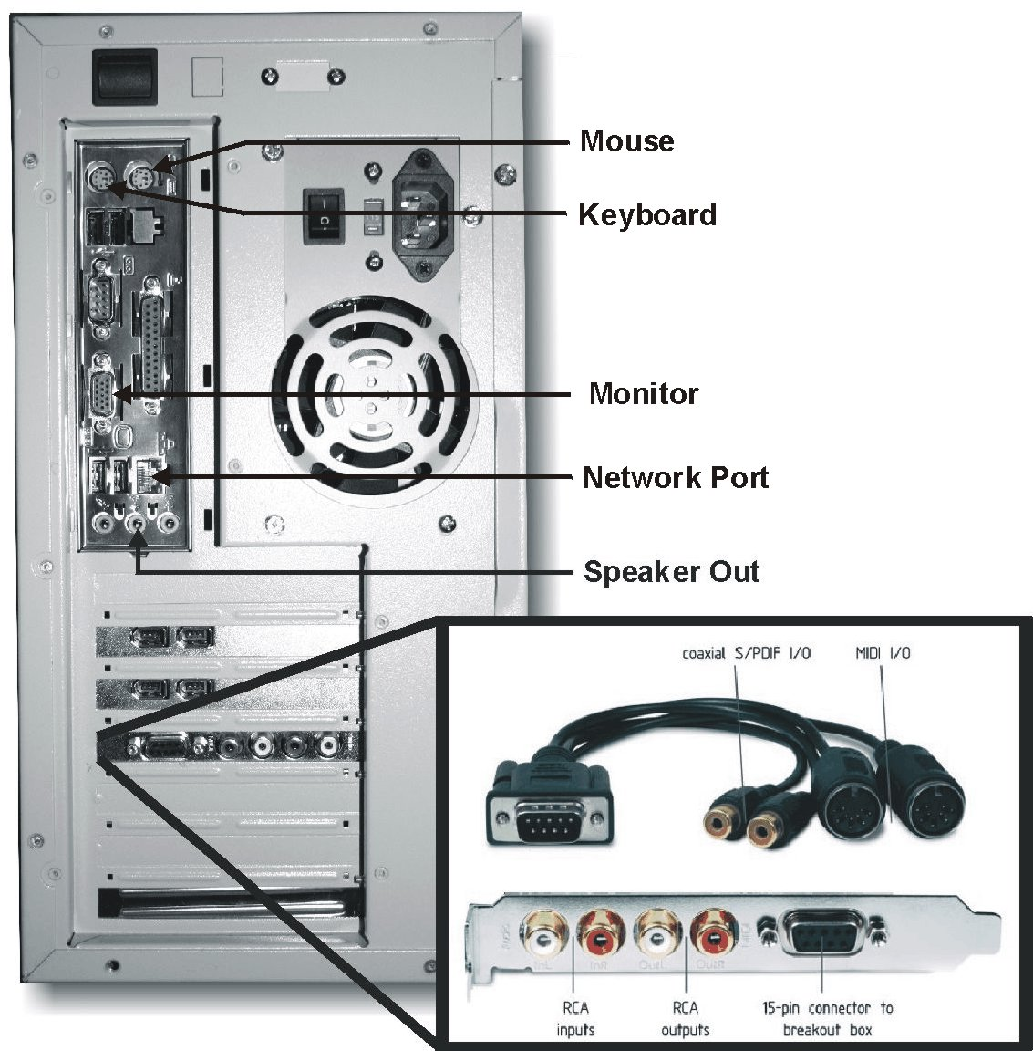

Setting up your system
You should have already set up you system as outlined in the beginning of this manual. The 5906 Live differs from the standard edition 5906 in that is uses a monitor, keyboard, and mouse to enhance the user interface making operation simpler and easier than what the normal backlit LCD display would provide.

 | CAUTION  Your5906 uses Microsoft Windows XP Embedded Operating System. While this may appear to be a conventional PC, XP Embedded is specially designed for embedded applications. Do not install any non MF Digital supported software. Any damage as a result of this will not be covered under warranty.

Using the 5906 Live

Recording
- Connect the desired input to either the S/PDIF Digital IN, the analog IN, or Midi In. Note that the S/PDIF and Midi inputs are made via the included breakout cable and each connector is labeled INPUT or OUTPUT.
- Using your mouse, click on the AUDIO TAB and the following screen should be displayed:
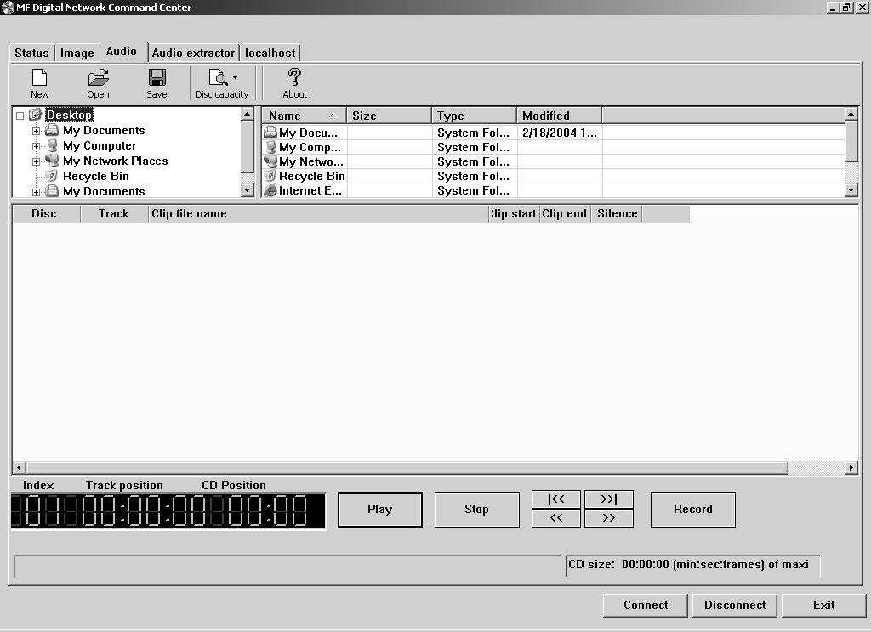

- Click on RECORD to bring up the RECORDER dialog
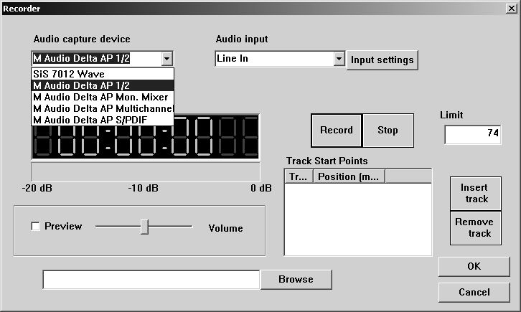

Using your mouse, select the desired input from the Audio Capture Device pull-down.
- Click on browse to select location and a filename to save the recording to. Keep in mind that CD-DA quality recording consumes about 10 MB/min
- Click on the RECORD button to start recording. During recording, the following screen is displayed:
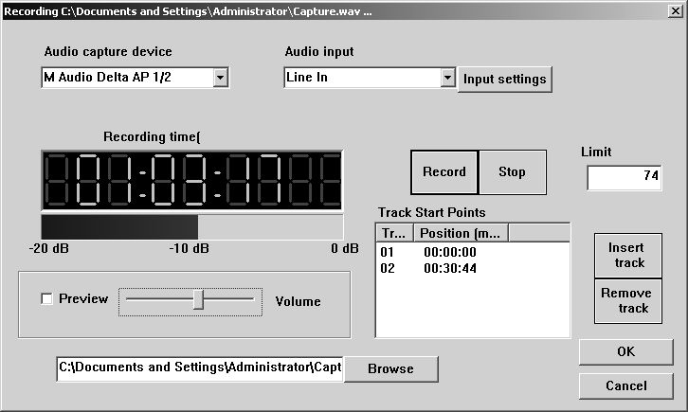

Browse: Selects the desired folder and filename. You will be prompted to over-write existing files.
Preview: Check this box to preview the audio as it is being recorded. Attach speakers to the green jack on the back on the 5906. The output may be adjusted using the slider.
Stop: allows you to end recording.
Limit: Allows you to set a maximum record time. Entering 74 here will stop recording from the select input in 74 minutes.
Insert Track: Inserts a START ID at the point the button is clicked. A START ID serves as a track point in your live recording. These may also be added and removed manually once recording has been completed. START Ids have no effect on the audio being recorded but merely serves as the “track” points.
Remove Track: Removes the selected START ID. All Audio CDs must have an INDEX 1 so START ID 1 cannot be removed.
OK: Closes the dialog box.
- Click “STOP” to end recording and then “OK” to close the dialog.

Editing your recording and Adding tracks
The AUDIO TAB is where you create your CD projects. WAV files and MP3 files may be dragged and dropped into your project and represent a single track. WAV files must be 44.1 kHz, 16-Bit, and stereo. The CD-DA standard does not allow for mono CDs. A mono CD is simply one where the left and right channels are the same.

Adding Tracks
By default, each WAV, or MP3 file represents a single track. Certainly there are times, especially in live recording, where a single large WAV file, which might represent 60 minutes or more, may slit into multiple tracks, edited for in point, out point, and start IDs. We’ll touch on this in just a minute. First let’s add a track or two. Here’s how:

- From the AUDIO TAB, use the top two panes of the window to navigate your PC to find the desired WAV file. Left click to select a file then drag the WAV file into the project to the bottom pane of the screen. You can press CTRL or SHIFT when clicking on files to select multiple files or a range of files.

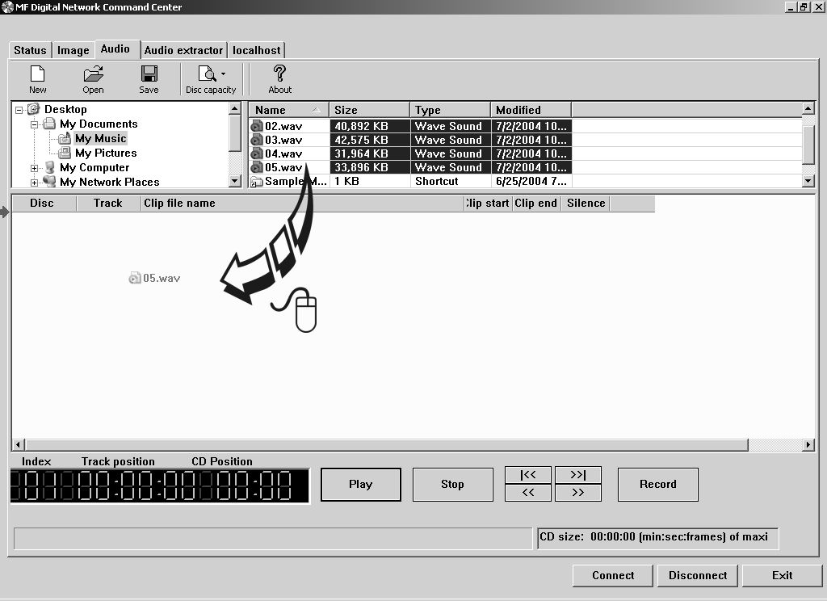

You may rearrange the order of tracks simply by dragging them to their desired position on the play list.

Editing tracks
Tracks (WAV and MP3 Files) may be edited for In Point, Out Point, Track Silence, Track Pre-gap length, ISRC Code, sub-indexes, setting the copy prohibit flag (this is not copy protection), and the ability to split a track into multiple tracks. This is extremely handy on long recordings where several tracks are desired. Note this is non destructive and does not effect the source file in anyway but merely sets the a START ID, or track mark, at the location inserted.
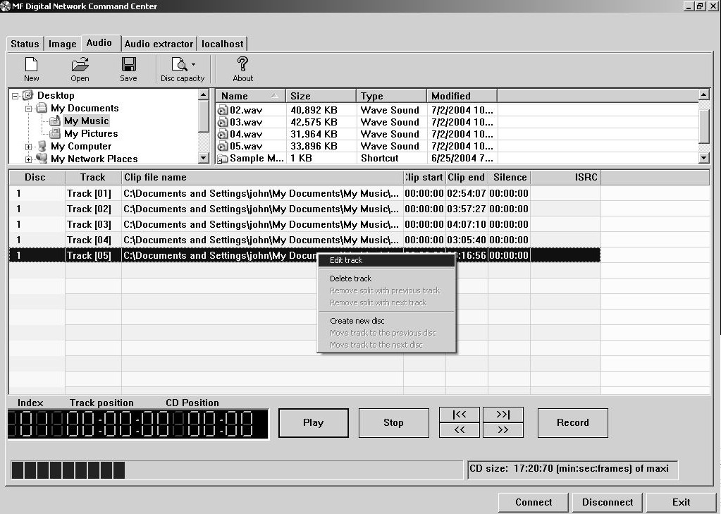
- To edit a track, right click on the desired track and select EDIT. A screen similar to the following will be displayed:

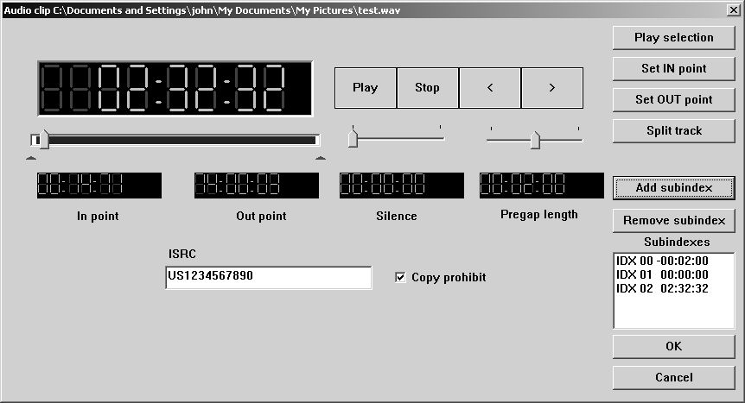

The operations available are as follows:

Set In Point: In Point is the point where you wish to begin the track. Adjust using the slider above IN POINT digital display. Use the up and down arrow keys for fine adjustments, or click on the green LCD digital IN POINT time display for direct entry. You will see the following:

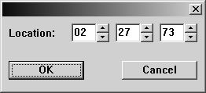

Once you are satisfied, click on the SET IN POINT button
Set Out Point: Out Point sets the end of the track. If you are making a disc from a single WAV file, you may want to use SPLIT TRACK (See below) to set all track START IDs and use SET OUT POINT only to trim the end of the last track if desired. Adjust using the slider above OUT POINT digital display. Use the up and down arrow keys for fine adjustments, or click on the green LCD digital OUT POINT time display for direct entry as above. Once you are satisfied, click on the SET IN POINT button
Silence: Allows you to set the amount of silence between tracks. Set using the slider and arrow keys as you did with the IN and OUT points, or click on the green LCD digital SILENCE time display for direct entry.
Pregap Length: Set the “countdown” time between tracks. Set using the slider and arrow keys as you did with the IN and OUT points or click on the green LCD digital PREGAP LENGTH time display for direct entry.
ISRC Code: Allows you to enter an ISRC code for the track. ISRC, or International Standard Recording Code, is the international identification system for sound recordings. For more information, please visit http://www.ifpi.org/isrc/ or http://www.riaa.com/issues/audio/isrc_faq.asp.
Copy Prohibit: This allows you set the copy prohibit bit. This is not copy protection but merely serves to indicate that digital copying is not allowed and that this is copyrighted material. Most recorders ignore this bit, except those that are SCMS capable. Checking this 'flag' on any CD tracks identifies these tracks as the first copies, so you won't be able to record them digitally from the CD onto an SCMS-equipped digital recorder.
Sub-indexes: or indexes provide additional starting points within a single audio track. Indexes are stored in the Q sub-channel and are most often found on classical music and sound effects CDs. Please note that many CD players cannot make use of sub-indexes. To add a sub-index, adjust the slider above IN POINT digital display to the desired insertion point. Use the up and down arrow key for fine adjustments. Once you are satisfied, click on the ADD SUBINDEX button.
Split Track: Perhaps the most used button on this screen. This allows you to divide the current track into multiple tracks. This is common on live recordings where you desire to track points in the recording. For example, let say you just recorded a speaker for over 60 minutes. A CD with a single track may not be desirable. To split a track, adjust using the slider above IN POINT digital display to the desired point you would like the new START ID to appear. Use the up and down arrow keys for fine adjustments, or click on the large main green LCD digital time display in the top left corner for direct entry. You will see the following:

Once you are satisfied, click on the SPLIT TRACK button.

A handy trick to delete undesired content is to create a track out of the content you do not wish to include then delete the track. The source .WAV will remain unaffected but the resulting CD will not contain the content removed.

Disc Spanning
There are times when your recording will not fit on a single disc. The 5906 Live gives you the ability to choose the point at which you wish span to the next disc. To do so, here’s how:
- Right click on the track you desire to be the first track on the next disc. You may repeat this for each subsequent disc desired.

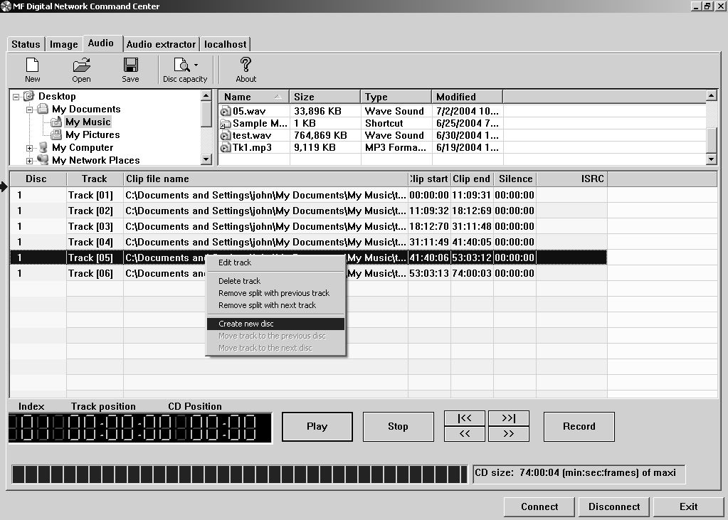

- Select “Create New Disc”. You will notice the disc number in the left most column increment along with all tracks below. If a third disc is desired, left click on the track you wish to be the first track of the next disc, right click and select “Create New Disc” once again.
- Once you are happy with the disc set, click on SAVE and you will be prompted to save one .ISC file for each disc created. .ISC files, or image scripts, are images from which you can create discs. These files are relatively small as they contain simply the location of IDs and disc splits. You will need the source WAV for future use.
- To undo a span, simply click on the track you wish to move back to the previous disc, right click on it, and select “Move track to the previous disc…” by left clicking on it.

Making the disc(s)
Making discs is easy. If you have already read through the section on the network client, you are likely ready to go. If you have not, you may wish to do so now. Jobs can be started from either the STATUS tab or the LOCALHOST tab. STATUS TAB is best iof you wish to start the job on multiple MF Digital CD copiers. Optionally you may use the network client remotely.

Method 1
Starting a job from LOCALHOST:
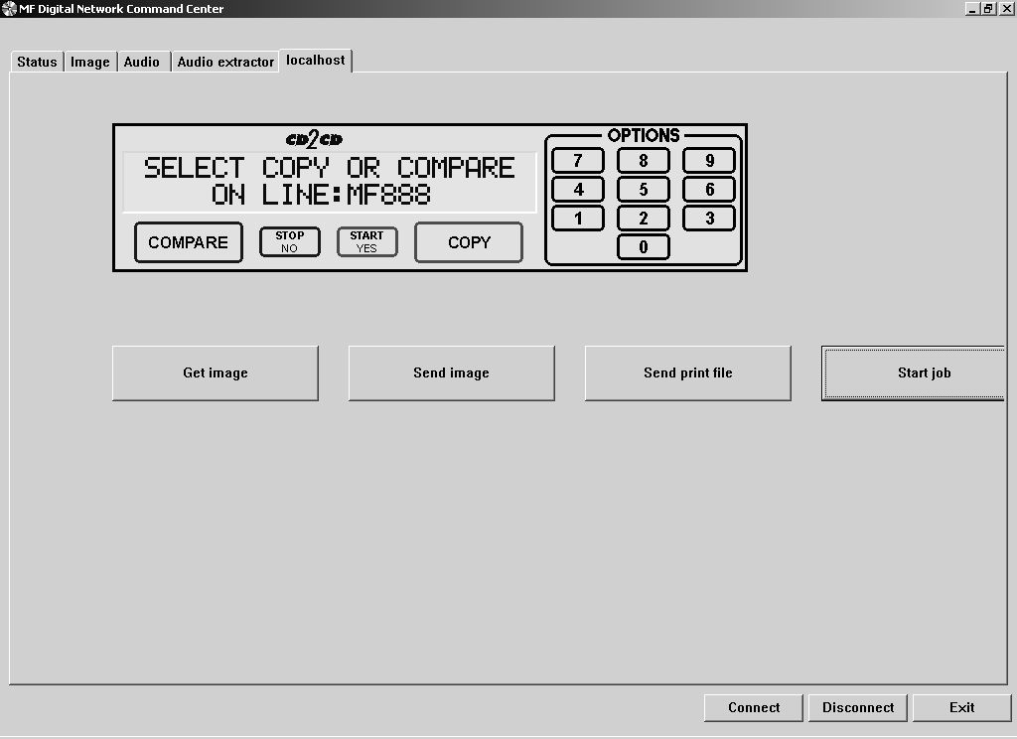
- Click on the START JOB button
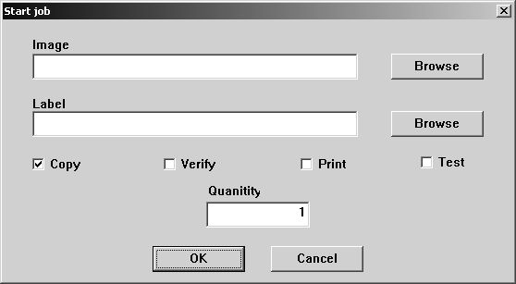
- Click on the BROWSE button and select an image file to use (.ISC, .ISO, or .IMG). Likely this will be the .ISC file made in the previous step.
- Leave LABEL blank as the CD-5906EC does not support in-line direct to disc printing so you need not enter anything here. Consider the MF Digital 3000 Series for automating duplication and printing if desired.
- Select the desired job options:

 | COPY: | If you would like to write the disc, check this option. Typically this will always be checked
 | VERIFY: | If you would like to verify the disc, select this option. This will perform a bit-for-bit verify of the disc. Selecting COPY and TEST at the same time will perform a VERIFY on the disc once written
 | PRINT: | Not applicable here, but on systems supporting direct-to-disc in-line print, this option could be selected to enable printing
 | TEST: | Select this option, to perform a SIMULATED write of the disc. The disc will not actually be written. This is great for learning how to use your system, or for troubleshooting purposes. Selecting TEST and VERIFY at the same time will result in ALL discs being rejected as they contain no data.
- Enter the desired quantity of discs and then click on OK and your job will start: If it does not, be sure you have 1 GB of free space on the hard disc

Method 2
Starting a job from the STATUS tab:
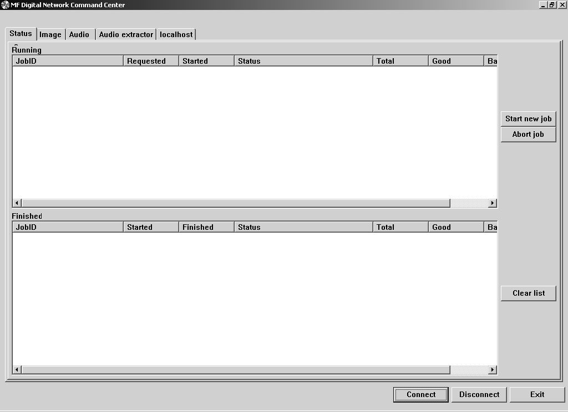
- Click on the START NEWJOB button
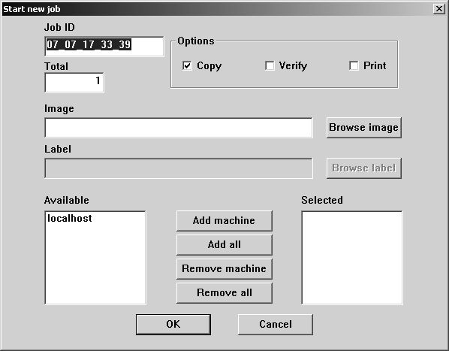
- Use the default JOB ID or enter your own. This is a handy way to identify your job making it easy to recognize what job is running.
- In the box under TOTAL, enter the desired quantity of discs
- Click on the BROWSE IMAGE button and select an image file to use (.ISC, .ISO, or .IMG). Likely this will be the .ISC file made in the previous step.
- Leave LABEL blank as the 5906 does not support in-line direct to disc printing so you need not enter anything here. Consider the MF Digital 3000 Series for automating duplication and printing if desired.
- Select the desired job options:
 | COPY: | If you would like to write the disc, check this option. Typically this will always be checked
 | VERIFY: | If you would like to verify the disc, select this option. This will perform a bit-for-bit verify of the disc. Selecting COPY and TEST at the same time will perform a VERIFY on the disc once written
 | PRINT: | Not applicable here, but on systems supporting direct-to-disc in-line print, this option could be selected to enable printing
- Next choose which systems you wish to allocate to the job. If not networked, or if this is the only MF Digital stand-alone system on your network, only LOCALHOST will appear. If you have other unit but they do not appear, go to the LOCALHOST TAB, click on connect to add other stand-alones. Once connected, you may start up jobs on multiple systems simultaneously. To add systems, simply left click on the desired system to use and then click on the ADD MACHINE. Optionally you may add all available systems by clicking on ADD ALL. The REMOVE buttons can be used to unallocated that system from the job you are about to launch.
- Once you have filled in the appropriate fields and you are happy with your selections, click on the OK button and your job will start: If it does not, be sure you have 1 GB of free space on the hard disc

Utilizing the Print Function

THIS PRINTER AND FEATURED HAS BEEN DISCONTINUED

The 5000 Series may also be connected to a Spectrum2 printer. Please follow the instructions below to do so:

- Connect the 5000 Series to a Spectrum2 printer using a DB-9 cable and a printer cable.
- Load a .prn into the #1 drive of the 5000 Series. This .prn must be named 1.prn.
- Press the “4” key. This will send the 1.prn to the printer.
- After pressing the “4” key, you may simply press the “Print” key on the Spectrum2 to print 1.prn multiple times.

Setting The Internal Clock
The Scribe EC Standalone’s internal clock is set at the factory for Eastern Standard Time (observing daylight savings when applicable).

To set the internal clock, the steps are as follows:

- Press the “7” key on the keypad. The screen will now read:

Press the “Stop/No” and you will be prompted to set the “System Time.”


• Press the “Start/Yes” key if you would like to set the system time. The screen will then read:


• Press the “Start/Yes” key after each entry.





• You will then be returned to the main operating screen:



Firmware Updates

From time to time the 5906 internal “firmware” may need updating to add new features or improve existing functions. Firmware is easily updated by loading a “Firmware Update CD” into the system. The latest version of firmware will be available for downloading to your computer from the MF DIGITAL web site: www.MFDIGITAL.com
Once a firmware image file is downloaded, a “Firmware Update CD” can then be written using a computer, a CD-R/RW recorder, and most popular premastering programs (such as: Adaptec Easy CD Creator and Toast, CeQuadrat WinOnCD, Ahead Nero, NTI CD-Maker, and others). Refer to your premastering software documentation for details on how to record a disc from an image file.

After having created a “Firmware Update CD”, perform the following steps to update the 5906 Copier Module firmware:

- With the system turned ON, load the “Firmware Update CD” into the top CD-R/RW or DVD±R/±RW recorder.
- Turn off the power to the Scribe EC Standalone.
- Turn on the power to the Scribe EC Standalone.
- The system will startup:


- You will see the “Initializing System” screen:


• You will see the upgrade firmware screen:

- Select “Yes” to upgrade the firmware.
- Upon completion, the system will automatically reboot and the following screen will appear:
- Remove the CD at this time.
- It is possible that the firmware on the CD-R/RW drives may be updated during this process. If so, you will notice all the drive lights come on and the screen will read “Firmware Upgrade”. DO NOT TURN SYSTEM OFF. Turning system off during the process will damage the drives.

• You will then be returned to the main operating screen:


Appendix A: Supported Formats

Originally designed for audio use, the Compact Disc (CD) evolved quickly and now employs a wide variety of formats for audio, data, and multimedia applications. The following is a list of the most popular formats currently supported by the 5000 Series. Periodic firmware updates will be made available to deal with new formats as they appear. To obtain the latest version of firmware, contact your MF DIGITAL reseller or download the update from the MF DIGITAL web site: www.MFDIGITAL.com

Many CD formats are international or industry standards, but variations on them may emerge from time to time. Should you encounter a disc (which does not employ a copy protection scheme) that you cannot copy on your 5000 Series, MF DIGITAL will do its best to promptly add support for this format. Dealing with custom formats, however, may be subject to a development charge.

Keeping track of how the various formats relate to each other can be confusing. For example, the 5000 Series can copy all CD-ROM Mode 1 discs - this includes ISO 9660, HFS, Hybrid, Rock Ridge and many other types of file systems. As a result, the 5000 Series will most likely copy CD formats not listed in the table below. If you require further assistance, please contact MF DIGITAL’s technical support department at (631) 249 9393 ext. 217 or email: support@MFDIGITAL.com

5000 Series Supported Formats CD-R/RW
ISO 9660 | CD-ROM Mode 1 & Mode 2
CD-DA (Compact Disc-Digital Audio) | CD-ROM XA Mode 2 Form 1 & Form 2
Hybrid (ISO 9660/HFS) | Single session
Hybrid (ISO 9660/HFS/Rock Ridge) | Multisession
Mixed Mode | Disc-at-Once and Track-at-Once
CD-I Form 1 & Form 2** | Rock Ridge
Native O/S’s (NT, DOS, OS/2, UFS, HFS (Mac O/S), SUN, AS/400, AIX, etc.) | CD-Extra
Video CD | Romeo
Photo CD | Joliet
Picture CD | Bootable CD

5000 Series Supported Formats
DVD single layer
DVD-R (In case of write, 650nm disc only)
DVD-RW
DVD+R
DVD+RW
CD-ROM Mode 1
CD-ROM XA Mode 2 (form 1, form 2)
Photo CD (single and multi session)
CD-DA
CD-Extra (CD PLUS)
CD-R
CD-RW

*High-Speed CD-RW is not supported to write

