

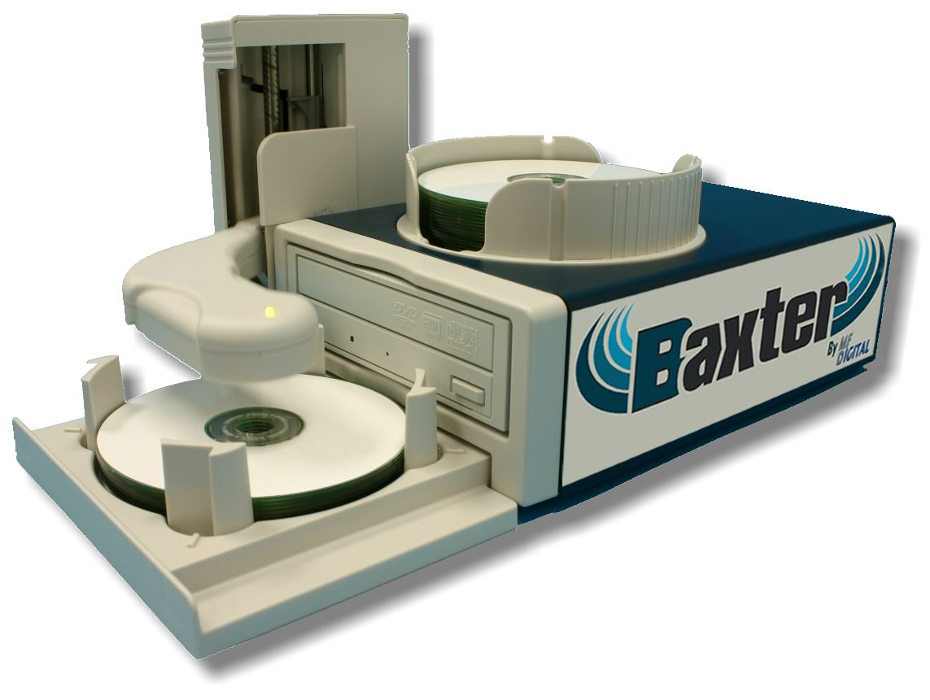

Operator’s Guide
Rev.: 112205.1

Copyright Notice
Copyright ©2005 by MF Digital. All rights reserved.

This manual and the accompanying illustrations may not be copied, reproduced, electronically transmitted, or translated into another language, in whole, or in part, without the written consent of MF Digital
MF Digital, SCRIBE-PC, SCRIBE-SA, Baxter, Director, and 5906-Live are trademarks of MF Digital

Other trademarks referred to are the property of their respective trademark or registered trademark holders.

Warranty
MF Digital warrants to the original purchaser that the equipment that you have purchased is free from defects in materials and workmanship, for a period of time as follows:

Duplicator Electronics & Mechanical Parts 1 year
Recorders (warranty by drive manufacturer) 1 year

This warranty is applicable when the warranty registration has been completed and returned to MF Digital within a reasonable period of time following the purchase and the warranty is NOT transferable. This warranty does not apply to malfunctions caused by misuse, negligence, accident, or alteration, nor is MF Digital responsible for consequential damages related to the use of this equipment. This warranty is made in lieu of any other warranty expressed or implied.

Recorder Warranty Policy
Individual recorders manufacturers are responsible for the products they produce. As a convenience, MF Digital will honor any service issue related to a defective recorder while under its respective manufacturer’s warranty providing that the recorder has been purchased from MF Digital either directly or indirectly. MF Digital has no responsibility for products NOT purchased through MF Digital

Piracy
The copying of audio, video, or software without the permission of the copyright holder is illegal. MF Digital accepts no responsibility for the copyright use or misuse of this equipment. It is the sole responsibility of the user to ensure that the legal rights of copyright in duplicating and printing are respected.


121 Carolyn Blvd.
Farmingdale, NY 11735
Tel.: (001) 631 249 9393
Fax.: (001) 631 249 9273
Email: info@mfdigita.com
http://www.mfdigital.com

Table of Contents

About MF Digital 4
What To Expect From Your MF Digital Duplication System 4
About This Manual 4
Getting Started 5
What’s In The Box 5
What you will also need: 5
Minimum PC requirements: 5
Packing Materials 6
The Best Place To Put The Baxter 6
Safety Precautions 6
Removing Packing Restraints 7
Setup 7
Installing media adapters 7
Installing input bin 7
Front View 8
Rear View 8
Making the connection 9
Starting Up / Driver Install 9
Installing the Baxter Software 11
Quick Start, Making Copies 15
Starting Baxter’s Scribe Application 15
The Scribe Application 18
Starting Baxter’s Scribe Application 18
Scribe Application Layout 20
Reviewing and changing the settings 20
Settings Editor 21
Application Temp Folder 22
CD / DVD Images Default Folder 22
CD Labels Default Folder 22
Saved Jobs Default Folder 22
Location of the JOB.LOG 22
Data image editor 23
Creating a data disc image 23
Image Toolbar 24
Selecting Disc Capacity 25
Adding Files and Folders 25
Creating, renaming, and removing Folders 25
Static and Dynamic Content 26
Saving The Current Disc Image File 27
Editing Image properties 27
To create a physical disc image file: 29
Loading An Existing Script File 29
Audio Image Editor 31
Audio Image Editor Toolbar 32
Adding Tracks 33
Removing Tracks 33
Changing A UPC Code 34
Changing ISRC Codes And Copy Prohibit Flags 34
Inserting, Editing And Removing Silence 36
Inserting, Editing And Removing Subindexes 37
Saving The Current Audio Disc Image 38
To create a physical audio disc image file (.IMG): 38
Loading An Existing Script File 39
Job Manager Tab 40
The Production Process 41
Creating a job 41
Archive only – reading in a master disc 43
Copy and / or Verify 45
Relay mode job 47
Network Client Software 49
Client PC minimum requirements: 49
Installing the client software 49
Using the client software 50
Appendix A: Premium Utilities 51
Riptastic for MF Digital 51
Back-up Platinum for MF Digital 52
Installing add-on applications 52
Becoming an add-on developer. 52
Appendix B: Troubleshooting 53

About MF Digital
Thank you for purchasing MF Digital’s Baxter autoloading duplication system. MF Digital manufactures a wide variety of software and audio duplication and production equipment, including manual and fully automatic CD and DVD duplicators and printers. We hope you will consider us for all of your production needs.

What To Expect From Your MF Digital Duplication System
Your MF Digital’s Baxter duplication system is professionally designed and manufactured to give you years of trouble free operation. To avoid accidental damage to your new duplication system, please read and understand this manual thoroughly before operating the unit.

About This Manual

This manual is written for both novice and experienced users. Please read through this Operator’s Guide from beginning to end before using the unit. Once having read the manual, follow along chapter by chapter. This will provide the necessary understanding of your new Baxter duplication system.

Getting Started
Carefully remove the Baxter duplication system from the shipping container. Inspect the contents and verify them against the packing slip. Report any errors in shipping as soon as possible.

What’s In The Box
The package includes:
- Baxter duplication system
- Power transformer
- Input tray
- Power cord
- USB 2 interface cable
- Baxter Software / Manual CDs

What you will also need:
- Compatible host PC
- High quality CD or DVD media

Minimum PC requirements:
Host PCs should meet or exceed these minimum requirements:

- CPU: Pentium 4, Celeron > 1.5Ghz, AMD Athlon, Sempron, or better processor
- 512 MB of RAM
- Windows XP or Windows 2000
- Duplication: 10GB of free NTFS formatted hard disk space. MP3 Ripping or back-up: 30GB
- USB 2.0 PC interface

Note: CD ripping speed is directly related to the speed of the PC the Baxter is attached to. The faster the better…

Packing Materials
Please retain the original box and packaging in the event that the unit requires future servicing. This will help to reduce the possibility of damage occurring in transit. In the event that the system is shipped back to MF Digital without the original box and packaging, customers will be charged for new box and packaging.

The Best Place To Put The Baxter
The best operating location for the Baxter duplication system is in a climate controlled area, free of dirt, dust, humidity, excessive heat, and electronic or electromagnetic interference. Room temperature should be between 65 and 75 degrees Fahrenheit, or between 18 and 23 degrees Celsius. Place the Baxter on a solid, steady work surface and allow sufficient room for all incidental work materials. Provide at least three inches of clearance on all sides of the unit for ventilation.

Safety Precautions
The system is shipped with a three-prong power connector and must be used with a properly grounded AC receptacle. DO NOT try to defeat the third “ground” prong. All computer peripherals must be properly grounded and the Baxter is no exception. The use of a power conditioner such as an Uninterruptible Power Supply (UPS), or a surge protector is always a good idea.

Repairs or alterations should only be attempted by authorized factory trained technicians. MF Digital reserves the right to void the warranty if unauthorized service is performed.

Removing Packing Restraints
Be sure to remove all packing restraints before operation or power-on. Save the foam block, as you will need to return it to its place when transporting the unit in the future.

Setup
Before turning on your unit, please follow these steps:

Installing media adapters
The input media adapters allow you to set the input bin to accept standard 120mm discs, 80mm mini discs, or BizCDs.

Step 1: Install the four pillars on the Input bin
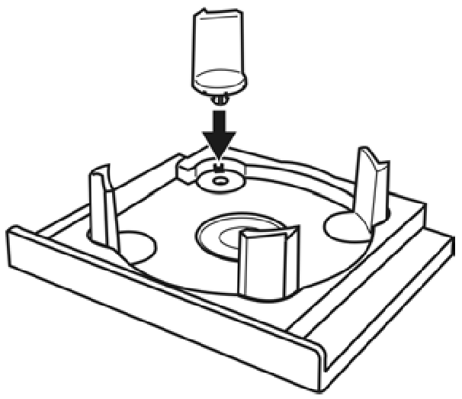

Note: The bottoms of the Pillars have 2 different size posts, large and small. Place the pillars with similar posts diagonally across from each other into the corresponding holes.

Installing input bin

The input and output bins serve as the containers to store the blank and recorded discs. The input bin attaches to the front of the unit and the output is affixed to the top of the Baxter. Input / output capacity is 25 discs. Rejects are discarded to the back left side of the unit.

Step 2: Attach the Input bin to Baxter
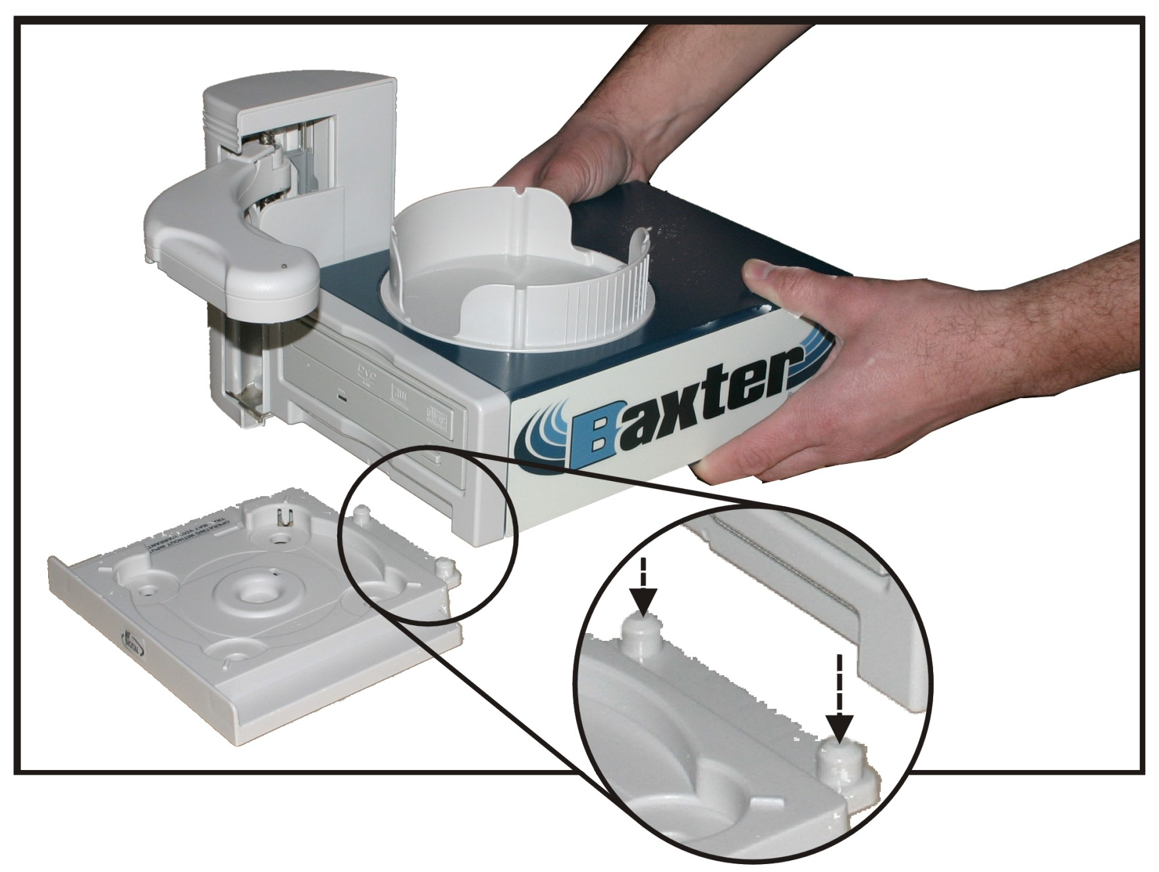
- Locate the input bin and place it on the work surface.
- Lower the Baxter onto the input bin such that the pins mate with the matching recesses on the bottom of the unit. Be sure nothing is under the input bin and the unit and bin are sitting flat and level.

Step 3: Rotate the four pillars as shown below and set to desired media type.

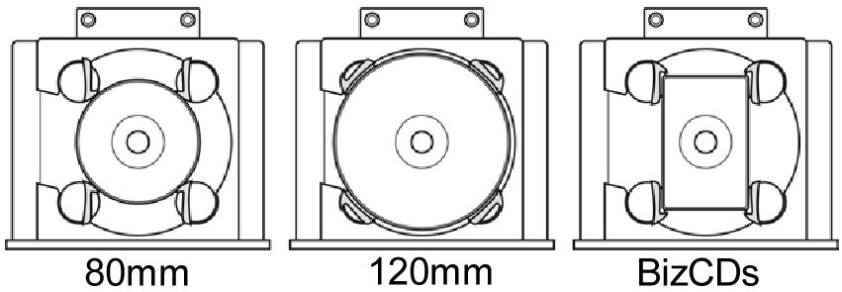

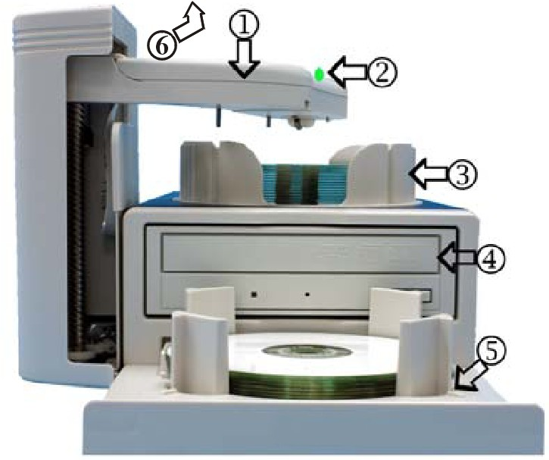
Front View

- Robotic Arm
- Status indicator: Green=Ready, Yellow=Burning, Red=Error
- Output Bin
- CD/DVD Burner
- Input Bin
- Rejects: Baxter discards rejects over the top of (3) Output Bin.

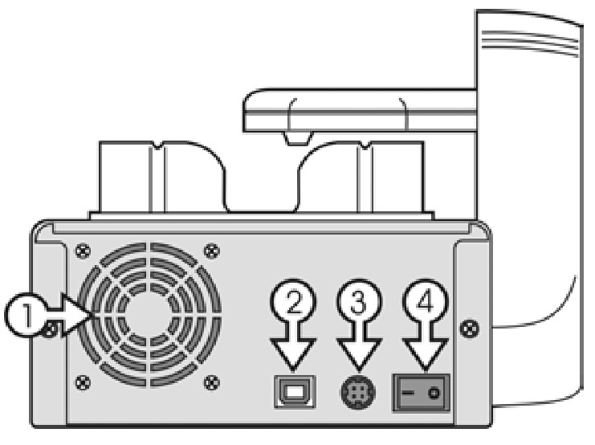
Rear View

- Fan
- USB 2.0 Connector
- DC IN – Power Input
- Power Switch

Making the connection
The Baxter requires a host PC to control it. Your PC should meet the requirements detailed earlier. Installation is simple, and only a single USB 2 connection need be made between your PC and the Baxter.
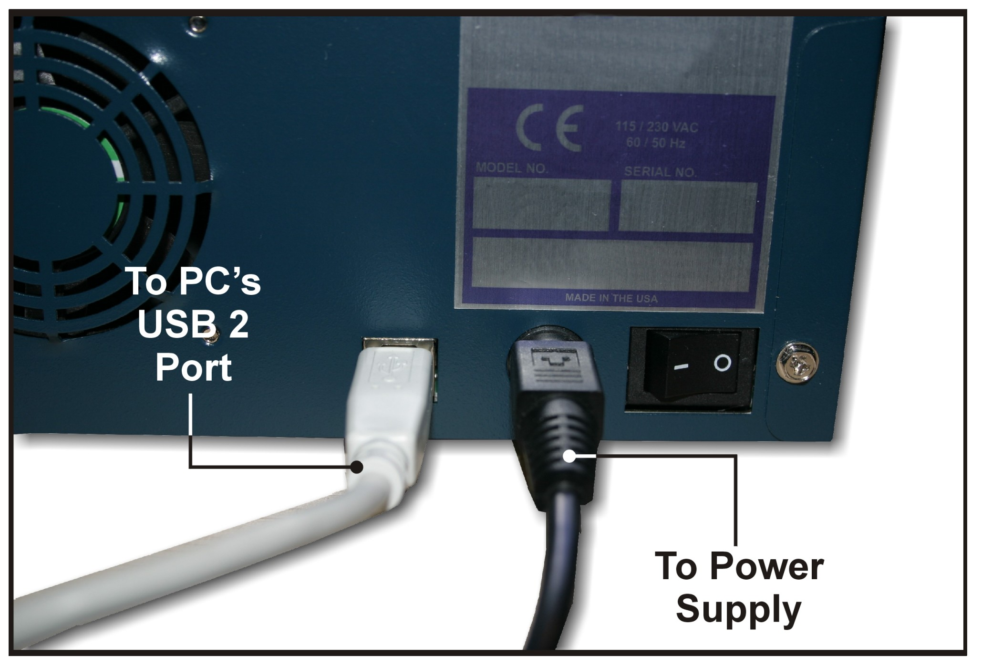
- Make sure the Baxter power switch is set to the off position (0=Off, 1=ON).
- Connect one end of the USB Cable to the USB port on the back of the unit. Connect the other to the USB 2.0 port on the back of your PC.
- Connect Power cable to the power supply. Then connect the power cord from the power supply to the wall outlet.

CAUTION
Always use properly grounded receptacles, or severe damage to your system may result. The use of a surge protector or Uninterruptible Power Supply (UPS) is highly recommended.

Starting Up / Driver Install

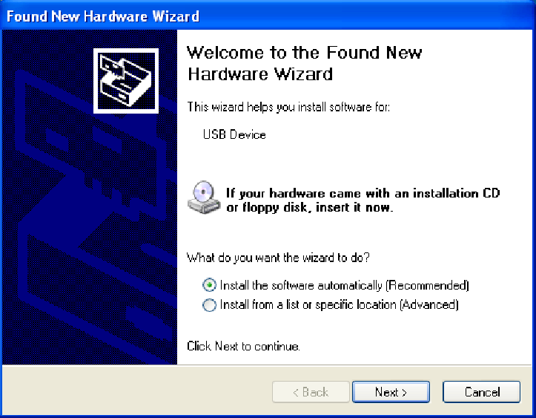  (Fig. 1)  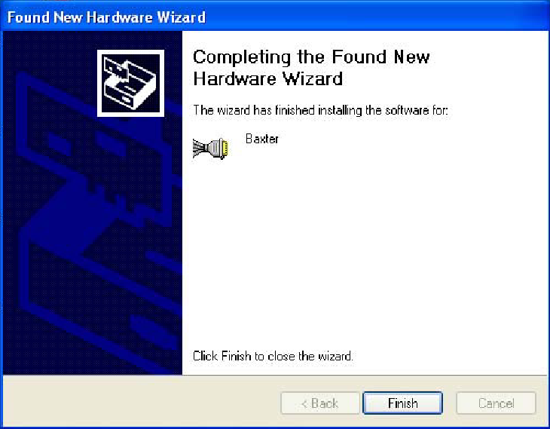  (Fig. 2) | - Insert the installation disc into your computer disc drive.  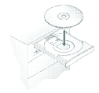  - Once you have connected the USB 2.0 cable and the power, turn the unit on by pressing rocker the to “1” or “ON”. Your PC should now prompt that it has “found new hardware”: Click “install software automatically” button (See Fig. 1).  - The driver will be installed automatically. If the wizard does not find it automatically, you will be asked to point to the install file on the Baxter Installation CD. Select the file “x:\Baxter usb driver \MFD_Baxter.inf” where “x” is the drive letter of the disc drive in which you have put the Install CD.  - After the driver installation is complete, you will be prompted to finish the installation. (See Fig. 1)  - Click on FINISH

Installing the Baxter Software
Baxter’s main application is the Scribe PC duplication software. In addition to being the software used for copying and creating discs from files, it also serves as the launch pad for the included premium utilities; Riptastic, and Backup Platinum. See appendix A for a description of these application and their installation.

If you are upgrading or reinstalling the software, it is recommended you remove the old version first.

Note: Always install the Scribe PC software prior to the premium utilities.

To install the Baxter software:

- Insert the Baxter software CD into one of the drives on the host PC
- Click on Start/Run.

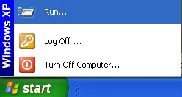

- In the “Open” text box, type “D:\Scribe_EC_setup.exe” (D=Disc Drive) where “D” represents the letter of the drive you have placed the disc in.

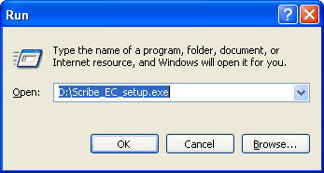

- Then, click on OK and the installer screen will appear:

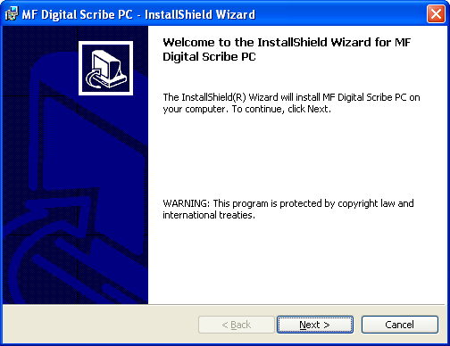

- Click NEXT to continue

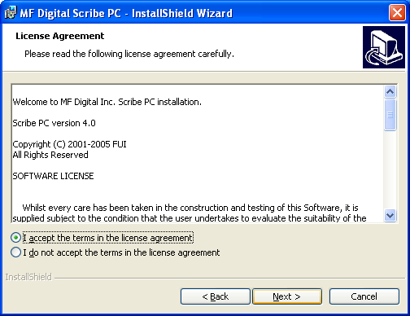

- If you accept the terms of the license agreement, select “I accept…” then click NEXT to continue.

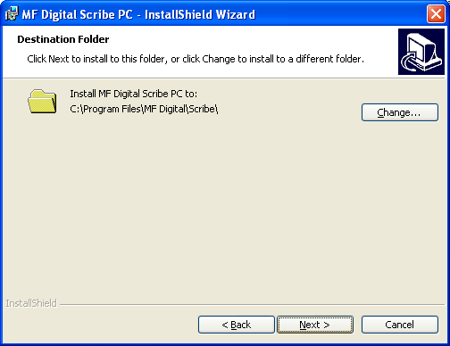

- Click NEXT to continue, or CHANGE to install to a location other than the default.

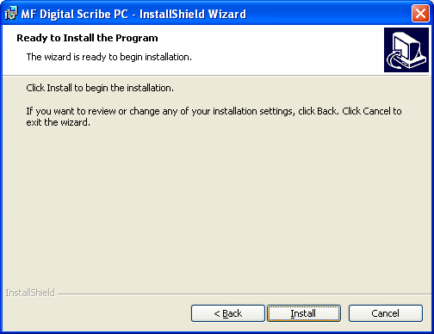

- Click INSTALL to continue.

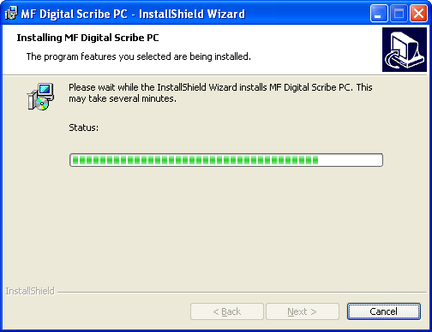

- Please wait while the Baxter software is copied to your hard drive.

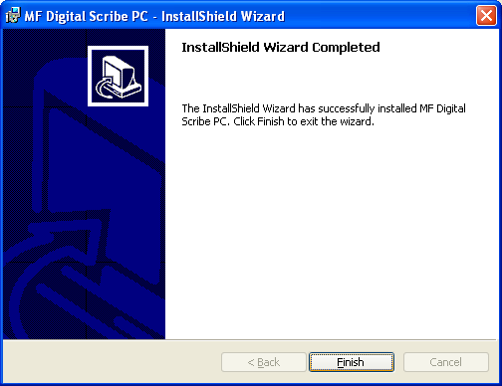

- Installation is complete. Click FINISH.

Quick Start, Making Copies

Starting Baxter’s Scribe Application
To start Baxter’s Scribe application the steps are as follows:

- From the desktop of the computer, click the MF Digital Scribe PC Icon
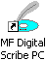
- The Scribe application screen will now be displayed:

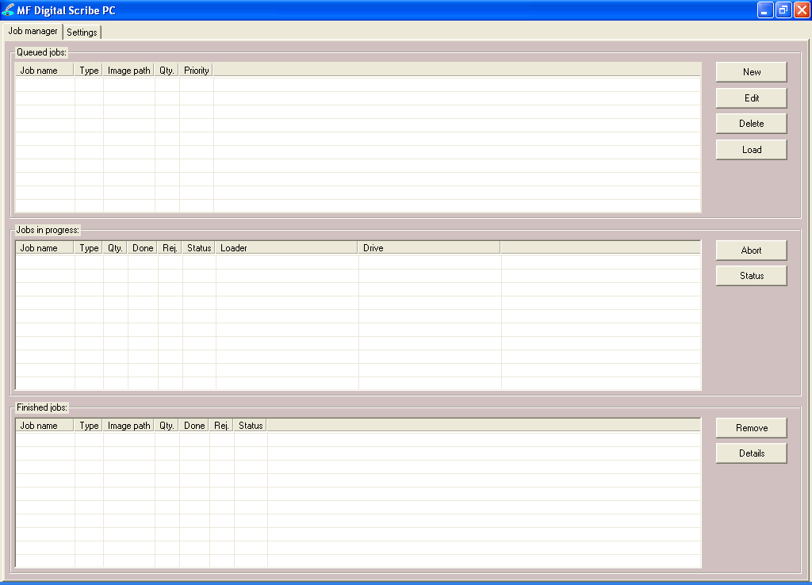
- Place some blank CDs or DVDs into the input bin followed by the master CD or DVD you wish to copy. If the master is a DVD you must use DVD blanks. If the master is a CD, you must use CD-R/RW blanks. Baxter’s Scribe software will not convert between types.
- Click the NEW button to start a new job. The following dialog box to the right will be displayed: | 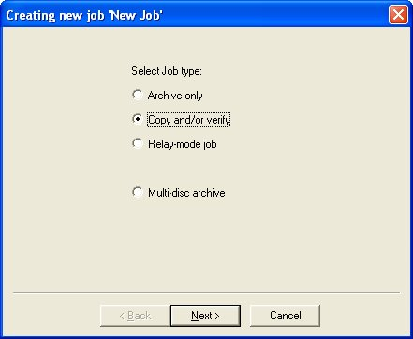
- Select “Copy and/or verify” and then click NEXT. You will now be prompted:

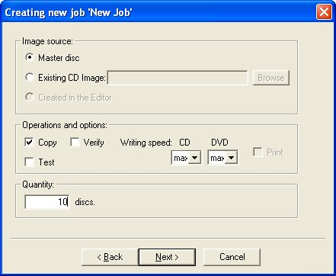

Enter the desired number of copies in the “Quantity” box. When you satisfied with your selections, click NEXT.

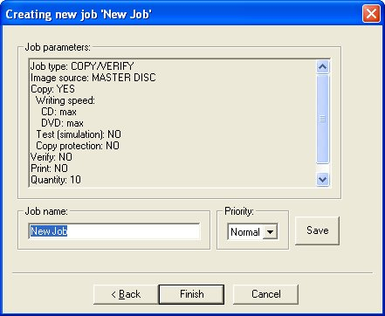

- Use the default “Job Name” or enter your own such as a work order number. Click FINISH when you are ready.

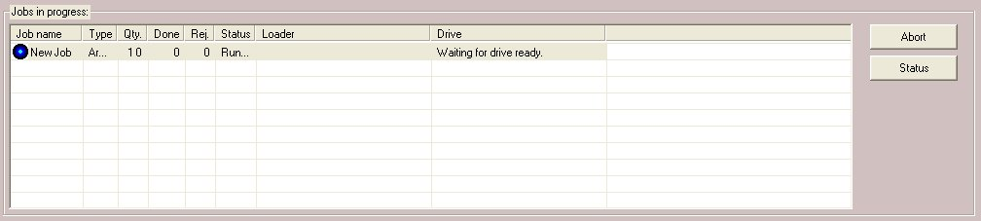

The “Jobs in Progress” section of the Job Manager TAB will now show the status of the job you just started. The Scribe will now load the master disc into the drive. Once read-in successfully, Baxter will accept the master disc to the output bin and then load the first blank disc to begin duplication.

The Scribe Application
The Baxter is a state-of-the-art CD / DVD duplicating system. It is designed to create, duplicate and verify most standard disc formats. This startup section will guide you through starting and configuring Baxter’s Scribe software.

Starting Baxter’s Scribe Application
To start the Scribe application the steps are as follows:

- From the desktop of the computer, click the MF Digital Scribe Icon
- The Scribe application screen will now be displayed:

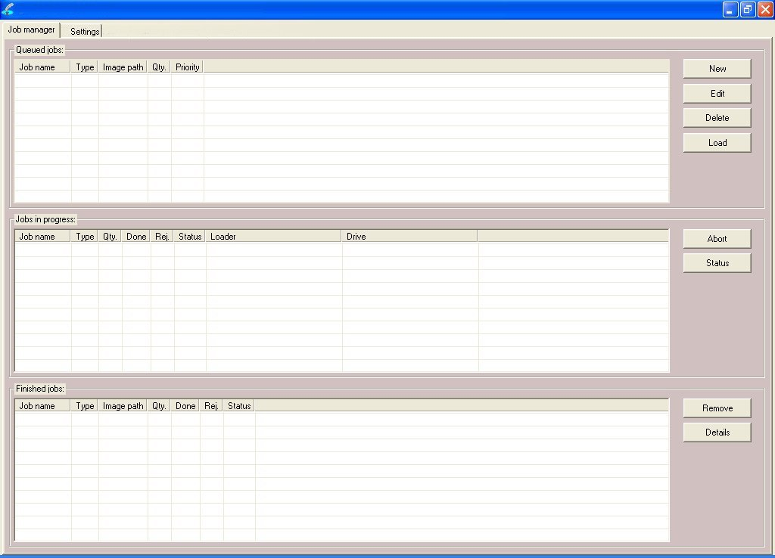

When first started, you are in “standard”. “Standard” mode is best suited for those who do duplication only and are not pre-mastering from files.
Baxter’s Scribe software can pre-master audio CDs from WAV, or MP3, data DVDs and CDs from local files and network files, as well as DVD Video discs from previously authored VIDEO_TS folders. If you wish to pre-master any of these types of discs, you will need to enable Scribe’s “Advanced Authoring Tools”. To do so:

- Click on the “Settings” TAB now:

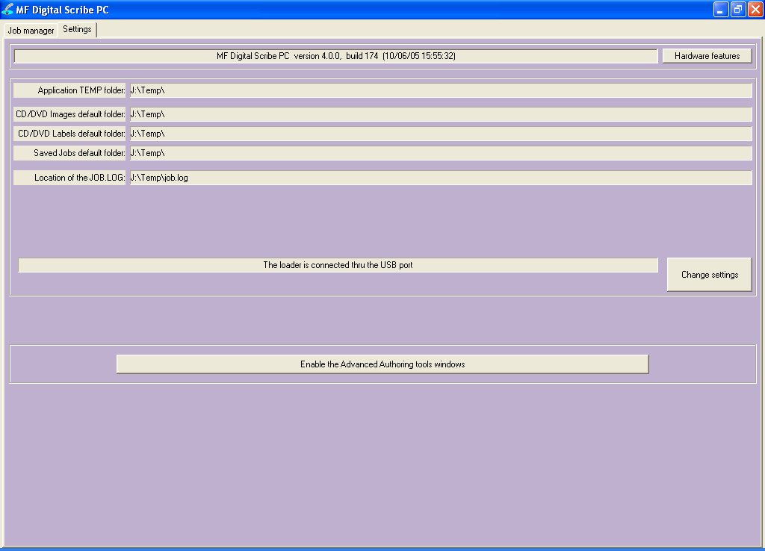

- Click on and three new TABs will be revealed:

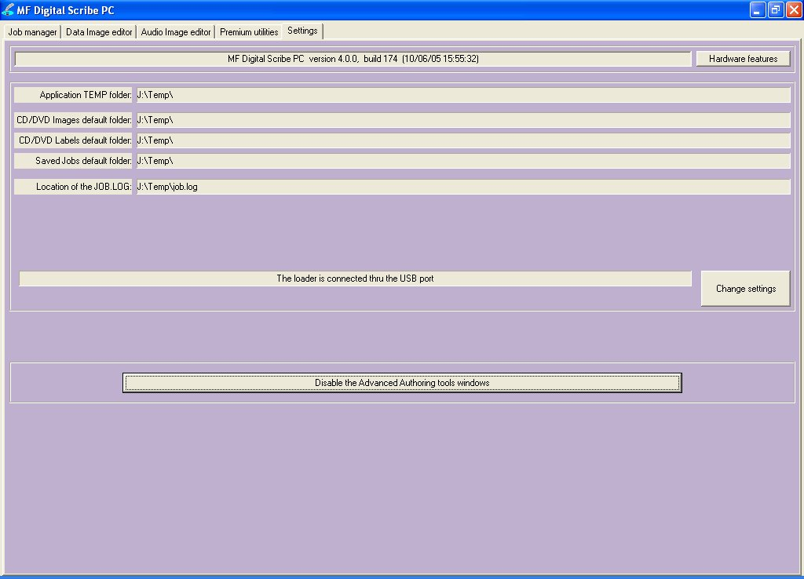

- You may toggle between these modes, simply by enabling and disabling the Advanced Authoring Tools.

Scribe Application Layout
The Scribe application is organized into either two or five cards, depending on if Advance Authoring Tools enabled. These cards, referred to as TABs, are accessible by clicking on the desired TAB on the top of the screen. Tabs include Job Manager, Data Image Editor, Audio Image Editor, Settings, and Premium Utilities). By completing the information on these cards, you control the actions of the Scribe to create, duplicate and verify various discs.

Tabs:
Job Manager | This is where jobs are started. The status of all jobs pending, in progress, and completed are displayed here.
Data Image Editor* | On this TAB you can pre-master a data CD or DVD as well as a DVD Video disc from a pre-existing VIDEO_TS folder.
Audio Image Editor* | This TAB allows you to pre-master an audio CD from WAV or MP3 files.
Settings | Defines settings and default file locations.
Premium Utilities* | Scribe add-in plug-ins can be found here. They include batch audio CD ripping to Mp3/WMA, and hard disk back-up software.
*Accessible only when Advanced Authoring Tools are enabled on the “Settings” TAB.

Reviewing and changing the settings
Before we get started, it is best to visit the “Settings” TAB to ensure your system is setup correctly. The “Settings” TAB allows you to do this.

• Click the Settings tab

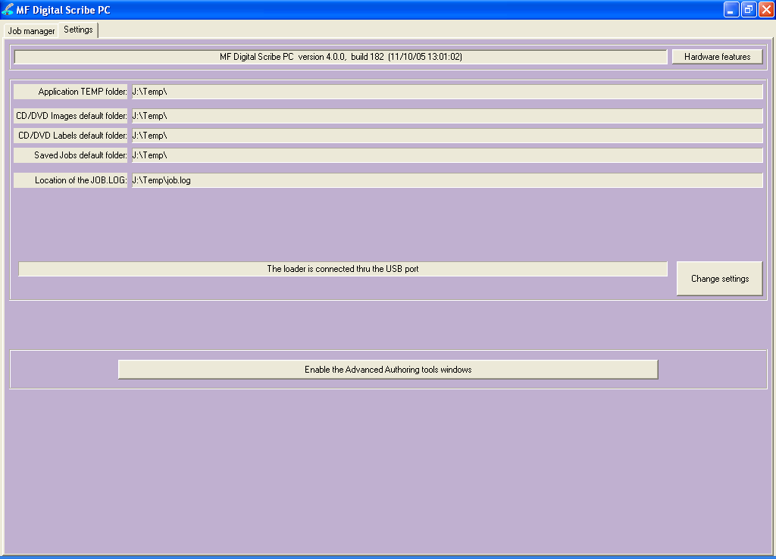

The Settings tab is divided into four areas: Version Information, Default folders, Communication Port, and the toggle button to enable and disable advanced authoring tools. The field closest to the top of the tab is the software’s version information. This lets you know what version of you are currently running. The settings below the version information may be customized. The following section illustrates this procedure.

Settings Editor
• From the Settings tab, click the Change Settings button and the following screen will be displayed.

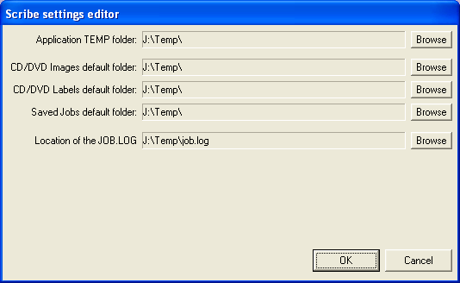

Application Temp Folder
• To choose an application temp folder, click the Browse button to the right of the Application TEMP folder field. This folder is a temporary location for your disc images to reside before and during duplication. After job completion, the image is removed.

Note: You should have 10GB of free space on your hard drive specifically for this folder. The folder should always reside on a drive formatted NTFS and NEVER FAT32 or FAT16.

CD / DVD Images Default Folder
• To choose a default folder for your CD and DVD images, click the Browse button to the right. When creating a new job, this will be the default folder that the Scribe software opens to browse for an image file path.

CD Labels Default Folder
• The Scribe software is used by other MF Digital products which can also print in-line. This does not apply to the Baxter, as it is a “duplication only” model.

Saved Jobs Default Folder
• Think of a job as a work order. It saves the quantity, the image and image file so that past jobs my be quickly recalled and resubmitted. To choose a default folder for your jobs, click the Browse button to the right of the Saved Jobs default folder field. A job is simply When creating a new job, this will be the default folder that the Scribe software opens to browse for a label file path.

Location of the JOB.LOG
• The job log is simply a text file that serves as record of the jobs you have performed on the unit. To choose a default folder for where the JOB.LOG text file is stored, click the Browse button to the right of the Location of the JOB.LOG field. Use Word, WordPad, or Notepad to view the file.

Data image editor

The first step in constructing a CD or DVD is to create an image file. Image files may be made by reading in a physical master, or by pre-mastering the disc in the Data or Audio Imager Editors. The Scribe software creates industry standard data (Mode 1 ISO 9660 level 2 with Joliet extensions) and audio (Red Book) CDs from scratch as well as duplicates of existing discs authored in most formats.

Creating a data disc image
To create a data disc image:

- Click the Data Image Editor tab. The screen will now read:

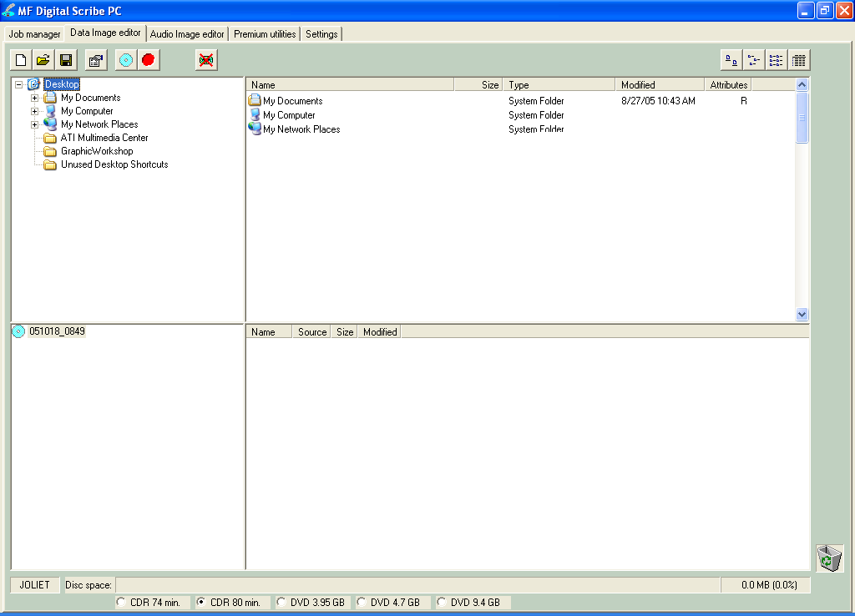

The Data Image Editor tab is divided into four panes. The top left pane lists all of the names and icons of the resources (drives, files and folders) available to the computer. The top right pane displays the contents of any item you click on in the top left pane along with its icon. The bottom left pane lists all the names and icons of files and folders on the disc that is being created. The bottom right pane displays the contents of any item you click on in the bottom left pane, along with its icon.

Image Toolbar
Horizontally along the top of the screen is an area which contains ten buttons, from left to right the buttons are: New CD layout, Load CD layout [*.ISC], Save CD layout [*.ISC], CD Image properties, Create CD image [*.ISO], Record CD, Enable inserting entire contents of folder [*.*], Large Icons, Small Icons, List, and Details.

Image Toolbar:
New CD layout | Starts a new CD or DVD Project. Any current layout is abandoned.
Load CD layout | Loads an existing CD or DVD disc image script file (*.ISC).
Save CD layout | Saves CD or DVD layout to a disc image script file (*.ISC). ISC files are virtual images containing only a list of the contents to be written to the disc. As such, these files are very small but are not self contained like the .ISO, .UDF, and .IMG real image files.
CD Image properties | Allows you change some of the disc properties such as volume label, publisher, data preparer, as well as the desired file system.
Create CD image [*.ISO] | Creates a real disc image file (.ISO for CD or .UDF for DVD). Real image files are self contained and the original source files are not needed once made. These files are large, about the size of the CD or DVD.
Record CD | Click here to burn a disc of this content right away. It is a good idea to save your image file first. Jobs may also be launched at any time from any image file from the STATUS TAB’s “NEW” job button.
Enable inserting entire contents of folder | Specifies the folder as having static or dynamic content. A Dynamic folder’s content can change without having to edit the .ISC file. Static content must exist when the image file is used or the job will fail.
Views | Allows you change view displayed in the top right pane to small or large icons, list, or detail view.

Selecting Disc Capacity
Along the bottom of the lower panes is a series of radio button options that are used to select the capacity of the disc you are creating

• Click the radio button corresponding to the capacity of the discs loaded into the Baxter.

Adding Files and Folders
• Click the desired file or folder in the top left or right pane (source) and hold down the mouse button.
• Drag the file or folder over the disc icon in the lower left pane (fig. 1) and release the mouse button.

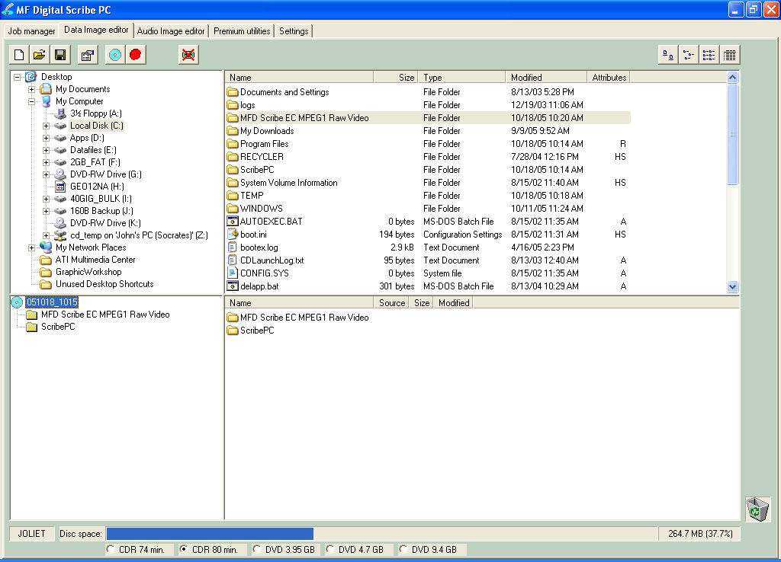  (fig. 1) | 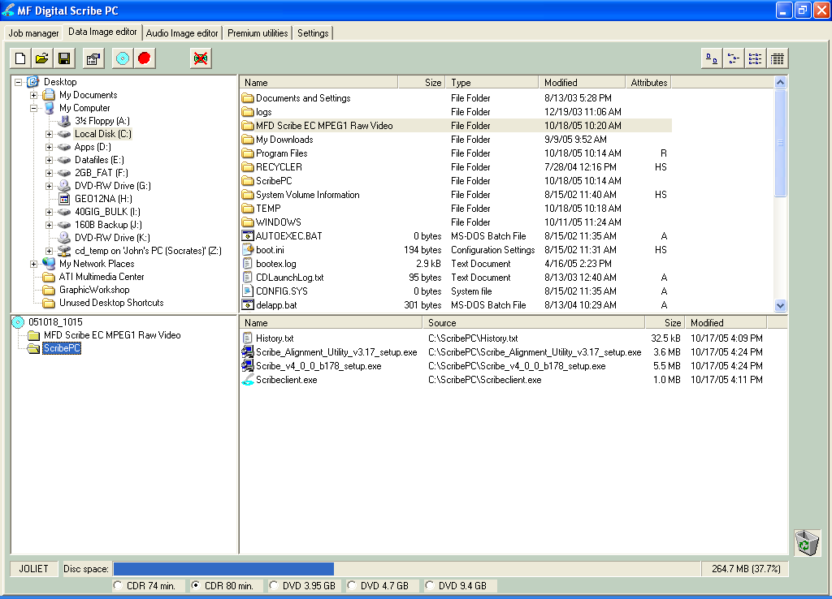  (fig. 2)

• The files in the lower right pane represent the contents of the disc being created (fig. 2).

Creating, renaming, and removing Folders
- In the bottom left pane, first click at the point you wish to insert a folder, or on the folder to be renamed or removed, then Right-Click on it and select the desired operation.

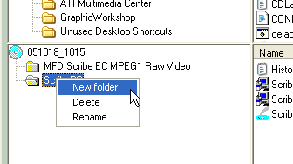

You can also delete content by:
- Click the desired file or folder in the bottom left or right pane and drag the item to the recycle bin in the lower right hand corner. This does not delete the actual file, but rather exclude it from the CD or DVD layout.

Static and Dynamic Content
Scribe software allows discs to be created from both static and dynamic content. A finished CD or DVD created from static content will contain the exact files and folders that are specified when the disc image is created. A finished disc created from dynamic content will contain the files and folders that exist in specified locations at the time the job is submitted for recording (rather than when the disc image is created).

For example, specifying dynamic content when creating a CD or DVD layout would allow a job to be run every week that records the contents of a specific folder onto a disc without having to create a new disc image every time. In this case the contents of the folder (not the folder itself) can change.

To specify a file or folder on a disc image as containing dynamic content:

- Click in the *.* check box so that the red “X” disappears.

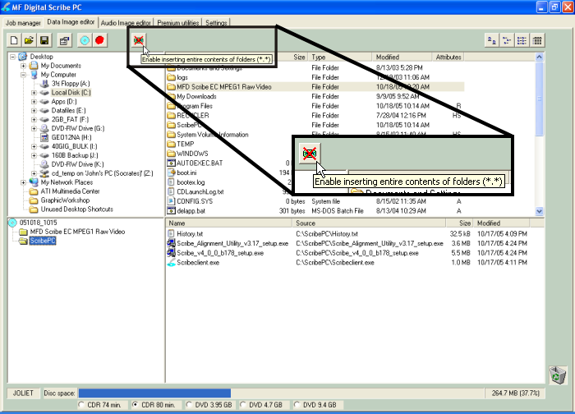

Disabled Enabled

Note:
Please be sure not to exceed the capacity of the disc being used.

Saving The Current Disc Image File
Once a data disc image has been created, it must be saved before it can be used by the Scribe software as a data source for recording. Disc images can either be saved as script files (with an “ISC” extension) or physical image files (with an “.ISO” extension for CD or a .UDF for DVD).

A script file (ISC) contains pointers to the source data files and is used as a guide at the time of recording the disc. Since a script file does not include the source data it is best used when producing unique or projects with dynamic content and when the source data will always be available to the Scribe software.

A physical image file (ISO for CD, UDF for DVD) is an exact replica of the final disc and contains all of the source data. It is therefore best used when producing static projects that are recorded on a regular basis and when source data will not always be available to the Scribe software. Please note that depending upon the amount of data to be recorded, a physical image file can occupy as much as 700 MB (CD) or 4.7 to 9 GB (DVD) of hard disk space.

Before saving your image, you may wish to view the properties

Editing Image properties

- Click the CD Image Properties button on the toolbar. The screen will now read:

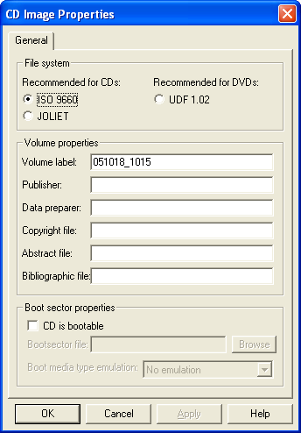

The CD IMAGE PROPERTIES dialog box contains a series of radio buttons as well as a number of information boxes.

- Click the radio button corresponding to the logical file system to be used on the disc (ISO 9660, Joliet, or UDF 1.02 for DVD).
- Optionally complete the volume properties information boxes:

Volume Properties
Volume Label | Optionally enter the name you want to call the CD / DVD.
Publisher | Optionally enter the name of the publisher.
Data Preparer | Optionally enter the name of the person who prepared the disc.
Copyright File | Optionally enter the file name that provides copyright information about the disc.
Abstract File | Optionally enter the file name that describes the contents of the disc.
Bibliographic File | Optionally enter the file name that provides bibliographic information about the disc.

- Click the OK button.
• Click the Save CD layout button on the toolbar. The screen will now read:

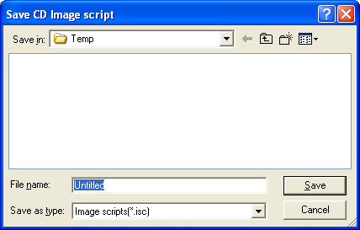

- Select the volume and directory where you want to save the script file.
- Enter the name for the script file and click the Save button.

To create a physical disc image file:
- Click the Create CD Image button on the toolbar. The screen will now read:

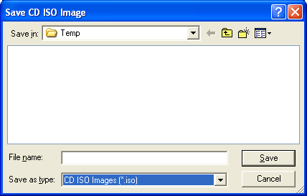  Disc Image File | Or… | 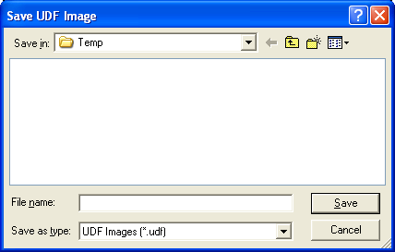  DVD Image File

- Select the volume and directory where you want to save the physical image file.
• Enter the name for the physical image file and click the Save button.

Loading An Existing Script File
Once a data disc image script file has been saved it can be modified at a later date.

To load an existing script file:
- Click the Load CD layout [*.ISC] button on the toolbar. The screen will now read:

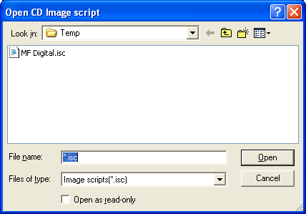

• Select the desired file and click the Open button.

Audio Image Editor
The Scribe software creates industry standard audio (Red Book) CDs from scratch that can be played on any home, car or portable compact disc audio player or computer CD or DVD-ROM drive. Audio tracks are created using any combination of 44.1 kHz, 16 bit stereo WAV or MP3 files.

To create an audio disc image:

- Click the Audio Image Editor tab. The screen will now read:

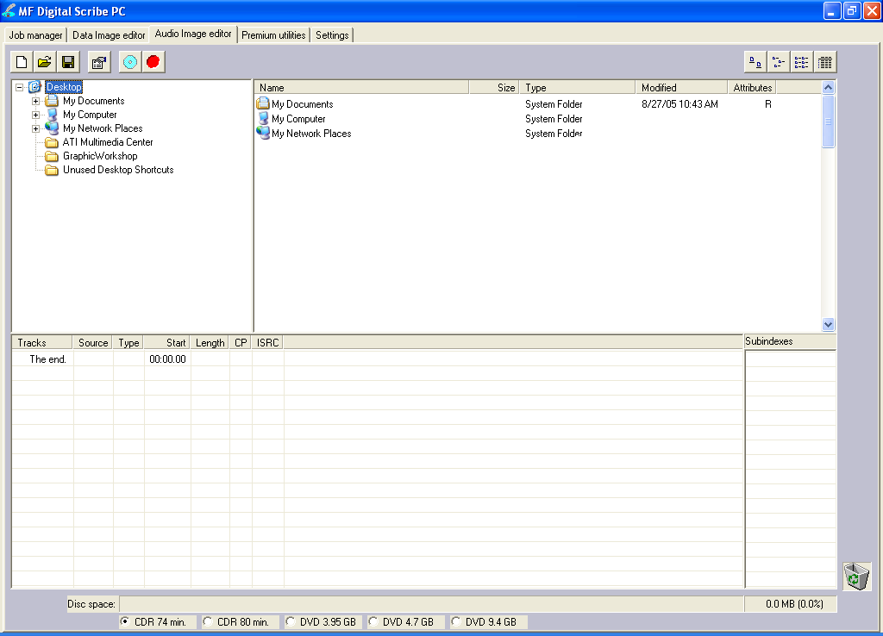

The Audio Image Editor tab is divided into four panes. The top left pane lists all the names and icons of the disk drives available to the Scribe software, as well as files and folders on the currently selected disk drive (source). The top right pane displays the contents of any item you click on in the top left pane along with its icon. The bottom left pane lists the names of audio files on the CD which is being created (disc image) as well as their type (WAV or MP3), start position and length, copy prohibit status and ISRC code. The bottom right pane displays the sub-indexes of any file you click on in the bottom left pane.

Audio Image Editor Toolbar
Horizontally along the top of the screen is an area which contains ten buttons, from left to right the buttons are: New CD layout, Load CD layout [*.ISC], Save CD layout [*.ISC], CD Image properties, Create CD image [*.IMG], Record CD, Large Icons, Small Icons, List, Details.

Image Toolbar:
New CD layout | Starts a new Audio CD project. Any current layout is abandoned.
Load CD layout | Loads an existing Audio CD image script file (*.ISC).
Save CD layout | Saves the current Audio CD layout to an image script file (*.ISC).
CD Image properties | Unlike with data discs, the properties button audio discs allows you to optionally change only the disc’s UPC code.
Create CD image | Creates a real CD image file (.IMG). Real image files are self contained and the original source files are not needed once made. These files are large, about the size of the finished disc.
Record CD | Click here to burn a CD of this content right away. It is a good idea to save your image file first. Jobs may also be launched at any time from any image file from the STATUS TAB’s “NEW” job button.
Views | Allows you change view displayed in the top right pane to small or large icons, list, or detail view.

Adding Tracks
• As depicted below, drag one or more WAV / MP3 files onto the text "The end" as it appears in the top left corner of the bottom pane. Multiple files may be selected by pressing and holding down the SHIFT or CTRL key while clicking on the tracks. SHIFT allows you to select a range of contiguous tracks, while CTRL allows you to selectively pick multiple tracks. As additional tracks are added, drag and drop them in at the desired insertion point.

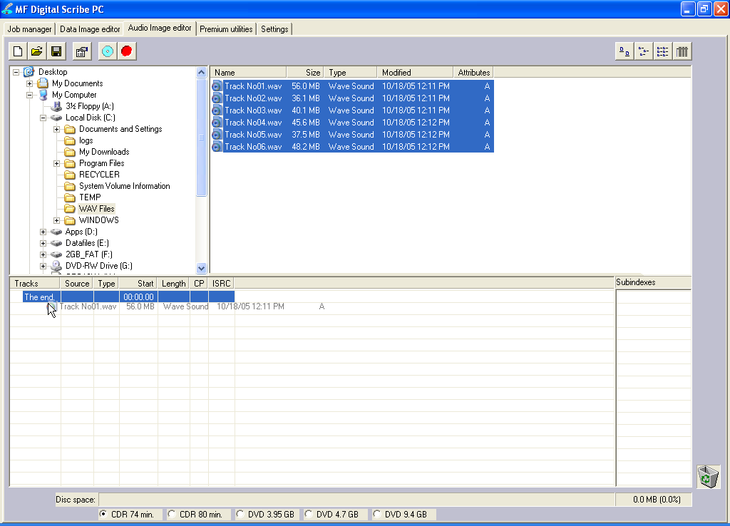

Removing Tracks
- Click the desired audio track in the bottom left pane and hold down the mouse button.
- Drag the audio track over the trashcan in the bottom right of the Audio tab and release the mouse button, or right click on the track and click delete.
- Click the Yes button.

Changing A UPC Code
The UNIFORM PRODUCT CODE (UPC) is an optional 13-digit descriptor that can be written into an audio CD.

To change the UPC code:

- Click the CD Image Properties button on the Image toolbar. The screen will now read:

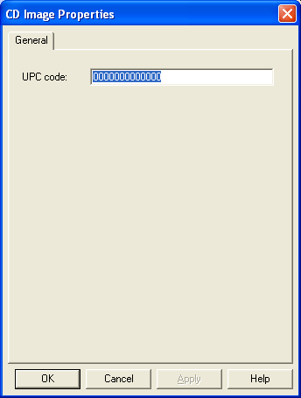

- Enter the numeric code and click the OK button.

Changing ISRC Codes And Copy Prohibit Flags
The INTERNATIONAL STANDARD RECORDING CODE (ISRC) is an optional 12-character descriptor that identifies a specific track on an audio CD. Each track can have its own unique ISRC consisting of 2 alphanumeric characters (country), 3 alphanumeric characters (owner), 2 digits (year of recording) and 5 digits (serial number). For more information on ISRC codes, you can visit:

http://www.riaa.com/issues/audio/isrc_faq.asp

The Copy Prohibit flag is a setting in each track on an audio CD, indicating whether or not that track can be copied by a digital recorder.

To change an ISRC code:

- Right click the desired audio track in the lower left pane, and select Edit. The screen will now read:
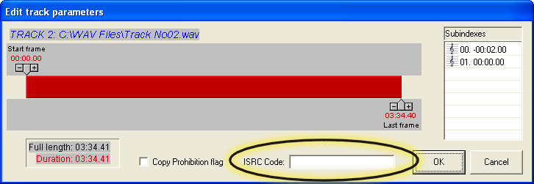

- Enter the code in the ISRC line and click the OK button. Valid codes start with two-letter country code, followed by ten digits.

To change a Copy Prohibit flag:

- Right click the desired audio track in the lower left pane, and select Edit The screen will now read:

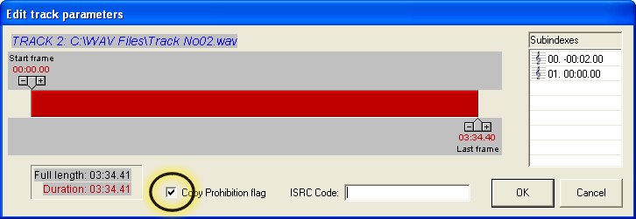

- To enable Copy Prohibit bit select the Copy Prohibit box so that it is checked, or uncheck the box to disable Copy Prohibit bit.

Inserting, Editing And Removing Silence
When assembling an audio CD disc image the Scribe software does not insert silences (gaps) between tracks.

To insert silence between tracks:

- Right click on an audio track.
- Select “Insert silence.”

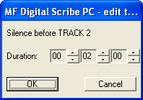

To edit the amount of silence between tracks:

- Right click the silence indicator you wish to edit in the lower left pane, and select Edit.
- Click the up and down indicators to increase or decrease the duration of the silence (minutes, seconds, frames).
- Click the OK button.

To remove silence between tracks:

- Click the silence indicator you wish to remove in the lower left pane and hold down the mouse button.
- Drag the silence indicator over the trashcan in the bottom right of the Audio tab and release the mouse button.
- Click the Yes button.
or
- Right click the silence indicator, and select Delete.

Inserting, Editing And Removing Subindexes
Subindexes are markers used by CD audio players to locate specific points inside an audio track. Subindex 0 indicates the start of any silence before the beginning of a track and subindex 1 indicates the beginning of a track’s audio material. Other subindexes can also be assigned to allow some audio players to locate specified material within a track itself.

To insert subindexes in a track:

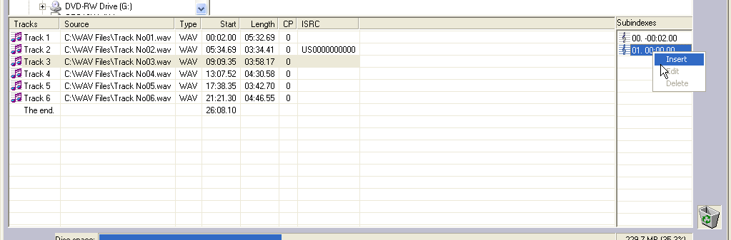
- Click on the desired track to highlight it, then right click subindex 01 in the subindex column and then click the Insert button. The screen will now read:

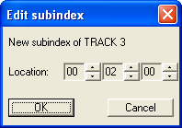

- Click the up and down indicators to specify the location of the subindex (minutes, seconds, frames).
- Click the OK button.

To edit subindexes:

- Right click the subindex you wish to edit in the lower right.
- Click the edit button.
- Click the up and down indicators to specify the new location of the subindex (minutes, seconds, frames).
- Click the OK button.

To remove subindexes:

- Right click the subindex you wish to remove in the lower right pane.
- Select Delete
or
- Drag the subindex over the trashcan in the bottom right of the Audio tab and release the mouse button.
- Click the Yes button.

Saving The Current Audio Disc Image
Once an audio disc image has been created it must be saved before it can be used by the Scribe software as an audio source for recording. Disc images are saved as script files (with an “ISC” extension).Image Scripts may be easily edited later while physical images cannot and must be regenerated..

To save an audio disc image script file:

- Click the Save button on the toolbar. The screen will now read:

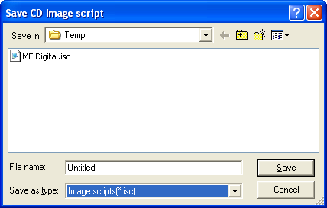

- Select the volume and directory where you want to save the script file.
- Enter the name for the audio disc script file and click the Save button.

To create a physical audio disc image file (.IMG):
- Click the Create CD Image button on the toolbar. The screen will now read:

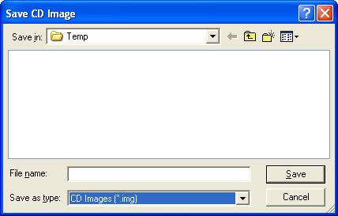
- Select the volume and directory where you want to save the physical image file.
• Enter the name for the physical image file and click the Save button.

Loading An Existing Script File
Once a data disc image script file has been saved it can be modified at a later date.

To load an existing script file:
- Click the Load CD layout [*.ISC] button on the toolbar. The screen will now read:

- Select the desired file and click the Open button.

Job Manager Tab
A job is any production run whether it be reading-in a master (archive), or copying an existing disc. In addition to showing you the status of jobs, the job manager is where you will go start new jobs.

• Click the Job Manager tab.

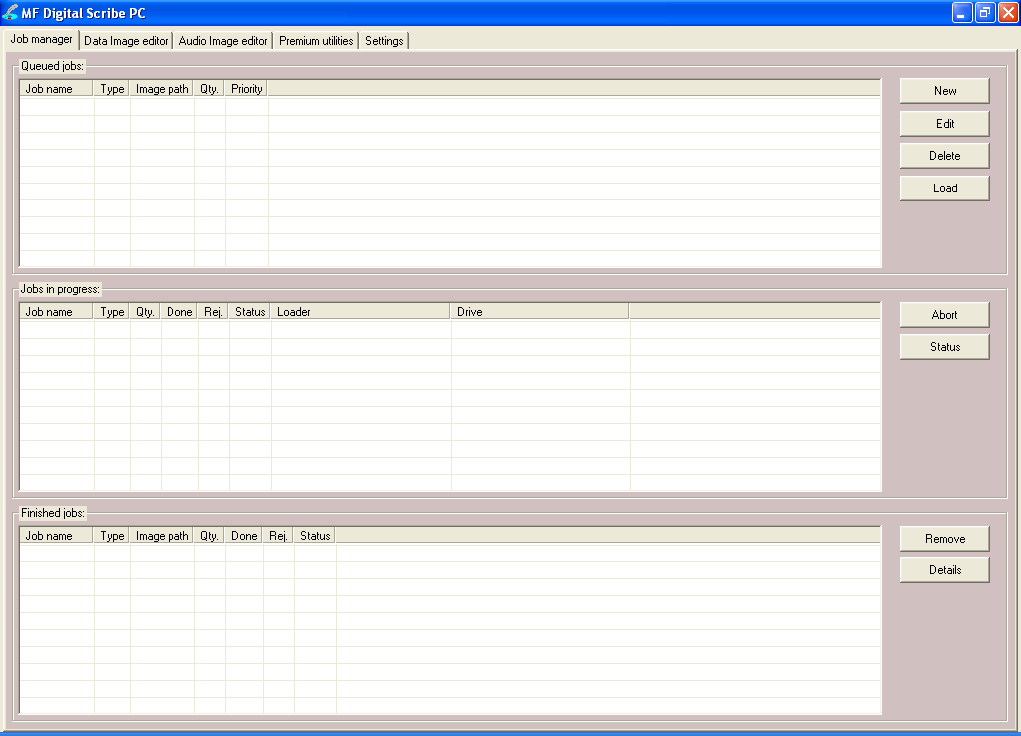

The screen will now show the Job manager tab where the progress of jobs submitted for production can be easily monitored. The Status tab is divided into three panes. The top pane is the JOB QUEUE window which lists all of the jobs waiting to be processed by displaying their assigned Job name, type of job, image path, total number of requested discs, their assigned priority, as well as the names of their associated disc image and label files.

The middle pane is the ACTIVE JOBS window that lists all the jobs currently in process by Baxter. Information displayed for each job includes its assigned Job name, type of job, total number of requested discs, the number of successful discs produced, the number of failed discs produced, the immediate status of the job (copying images, loading discs, copying discs, unloading discs, etc.) and the progress.

The lower pane is the finished jobs window that lists all the jobs completed by Baxter. Information displayed for each job includes its assigned Job name, type of job, image path, the total number of requested discs, the number of successful discs produced, the number of failed discs produced, and the status.

The Production Process
During production, the blank discs will be loaded one at a time from the input bin into the recorder. Upon successful completion the discs will be unloaded onto the output. This process will continue until the job is complete and the Baxter will then advance to the next job in the queue according to its priority.

However, if the input bin, sometimes referred to as a hopper, empties before the job is complete the screen will read:

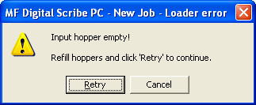

To continue running the job, place additional blank discs onto the input bin and click the Retry button. To stop the job, click the Cancel button and the remainder of the job will be aborted. The Baxter will then advance to the next job in the queue according to its priority.

Note: Any rejected discs have failed to record properly and should not be used.

Creating a job
In order to produce copies you must create a job. Think of a job as your work-order. It tells the Baxter what to do, and how many to do.

• Click the New button to the right of the Queued jobs area.
Clicking on New in the Queued jobs area of the Job Manager tab brings up the Creating new job ‘New Job’ wizard. The Creating new job ‘New Job’ wizard includes a series of four check boxes: Archive only, Copy and/or Verify, Relay-mode job, and Multi-disc archive. Also included in the wizard is the image path fields, quantity, priority, speed, and media type. The first step in creating a job is to set the general options so as to define which operations the Baxter will perform when the job is submitted for production.

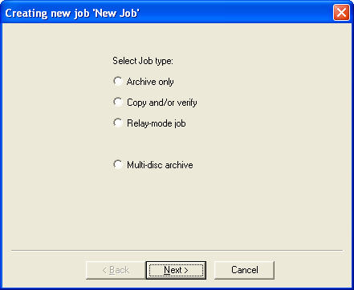

- Check the option box to enable the production option needed for your job and click “Next”:

Operations and Options:
Copy | When checked the discs in the submitted job will be recorded using the disc image file selected in the IMAGE field.
Verify | When checked the discs in the submitted job will automatically be compared against the source files after recording is completed.
Test | When checked the discs in the submitted job will not be recorded.
Archive  (Read-in) | When checked, an existing disc is saved to the hard drive as a physical image file for later recording.
Relay Mode | When checked an image of the top most disc (master disc) is created on the hard drive and used to make copies.
Multi-disc archive  (Batch read-in) | This is the same as ARCHIVE, but allows you to batch read in several discs in succession
Speed | The recording speed pull-down allows you to set the recording speed as determined by the capabilities of the recorder installed in the Baxter.

Archive only – reading in a master disc
An Archive job allows you to read-in an existing master to create a disc image file. DVDs will be saved as .UDF files and discs to .IMG files. These files may be used later when starting a COPY job. If you will not need to copy this master again, you can read & copy in one step by starting a COPY job, and selecting MASTER CD as described in the next section.

- Select the “Archive only” button as seen in (fig. 1).  - Click browse and select the “Image file path” for the file that you would like to archive. This lets the Scribe software know where to place your file and what name to give your file.  - The file path that you choose will show in the window as seen in (fig. 3). Click “Next”.  - The “Job parameters” will then be displayed. Give your job a name and select a priority.  - Click “Finish” and the Scribe software will run the job. | 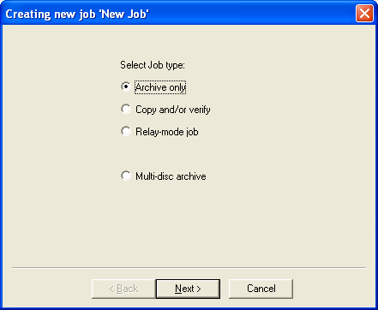  (fig. 1)  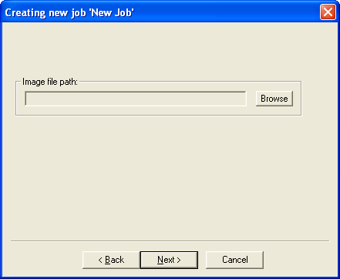  (fig. 2)  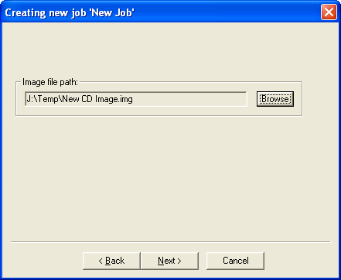  (fig. 3)  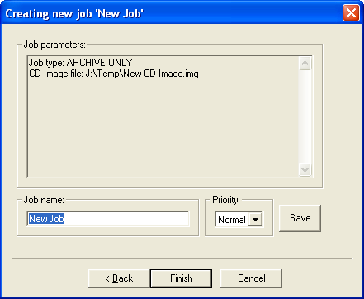  (fig. 4)

Copy and / or Verify
This allows you to start copying or verifying from an image file, or a new master disc.

- On the Job Manager TAB click new and select the “Copy and/or Verify” button as seen in (fig. 1).  - Click “Next”.  - Select the Image source for your job. This can be an ISC, IMG, or UDF or a master disc that you place on top of the blank discs. The Scribe software will archive (read-in) the contents of the master and copy the contents to as many discs as are indicated in the quantity box. If the Scribe software detects another master during the copy process, the Scribe software will reject the additional master. You may also select browse and choose an existing disc image.  - You will then want to choose the Operations and Options for your job: Copy, Test, Writing speed, and Verify, You will then enter the quantity of discs toward the bottom of the screen.  - If you choose “Existing CD Image” the file will show in the window, as seen in (fig. 3).  - Click “Next”.  - The Job parameters will then be displayed. Give your job a name and select a priority.  - Click Finish and the Scribe software will run the job. | 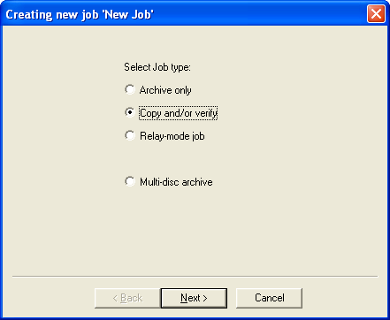  (fig. 1)  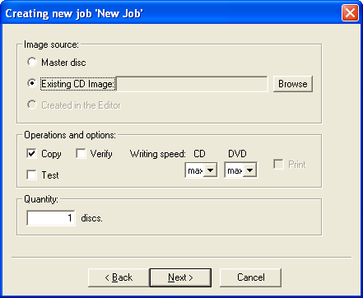  (fig. 2)  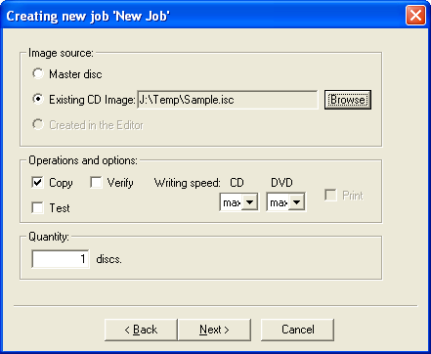  (fig. 3)  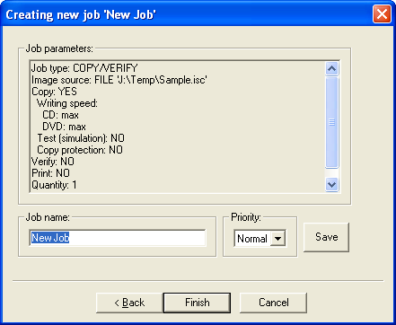  (fig. 4)

Relay mode job
Relay mode allows you to make multiple copies of multiple masters. Simply load the unit with the desired number of blank discs, then the master such that the master sits on top of the blanks. Then load in more blanks followed by the next master and so on. The end result will be copies of each master placed in to the input bin(s).

- Select the Relay-mode job button as seen in (fig. 1).  - Click Next.  - Select the Operations and options for the relay mode job.  - Click Next.  - If needed, you can move files up and down in the list until the order of PRN files matches the order in which your masters were loaded (fig.4).  - The Job parameters will then be displayed. Give your job a name and select a priority.  - Click Finish and the Scribe software will run the job.  - The Job parameters will then be displayed. Give your job a name and select a priority.  - Click Finish and the Scribe software will run the job. | 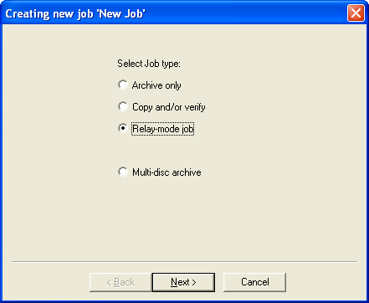  (fig. 1)  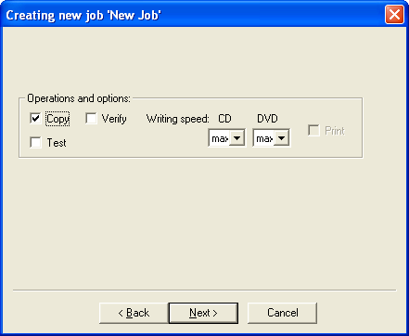 (fig. 2)  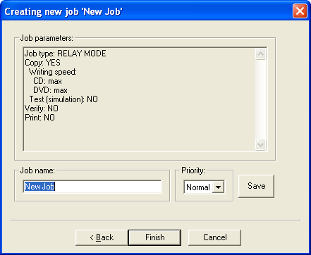  (fig. 3)

Network Client Software
The Baxter comes the Scribe Network client. This allows you to connect the Baxter as you would any Microsoft Windows XP PC on your network. In doing so, you can share the Baxter with other users on your network allowing them to submit jobs remotely.

Client PC minimum requirements:
Client PCs should meet or exceed these minimum requirements:

- Pentium 4 or better processor
- 512 MB of RAM
- Windows XP or Windows 2000
- 10GB of free NTFS formatted hard disk space and meat the same.
- If you use firewall software, be sure not to block the port(s) used by the Baxter client software (virtual port 12345)
- 100 Base-T network supporting Microsoft TCP/IP protocol.

Installing the client software
The Scribe network client, a file named ScribeClient.exe, was copied to your hard drive during installation. The client software is a single .EXE file and simply needs to be copied to the desired location You can do either by copying the file to a server, a share on the PC you wish to give client privileges too, or use the Baxter and write the file to disc.

Here we will show you how to install and run from the desktop of the Windows 2000 / XP client PC.

- On your Baxter, right click on Start and select Explore.  - Use Windows Explorer to browse your Baxter’s hard drive. If you have the default factory installation, locate the "C:\Program Files\MF Digital\Scribe\” folder.  - Right click on Scribeclient.exe and select COPY. | 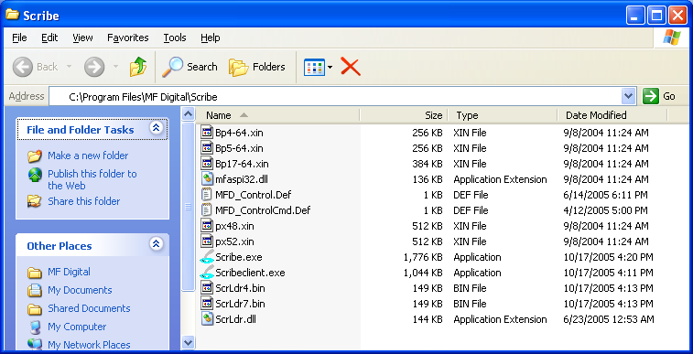
- Again using Windows Explorer. browse to the location where you would like to place the client software, right click and select PASTE. I suggest copying to your remote’s PC’s desktop, or to a network a share from which you can copy ScribeCLient.exe file to each client PC’s desktop.

Using the client software
The Scribe network client, is virtually identical to the Baxter software itself. It allows you to remotely do almost most everything you can on the Baxter copier itself. This does NOT include the premium utilities as detailed in Appendix C which must be run locally on the Baxter’s host PC.

Before running the Scribeclient.exe client application, be sure the Baxter copier is powered on and available on the network. The client software will NOT work unless the Baxter is running as it functions as job server.

- If you copied the client software to your desktop, click on the Scribeclient.exe icon:    - You will be prompted for a User Id (fig.)  - Enter a unique name in the User ID. User IDs are for the sole purpose of distinguishing one user from another when shared amongst multiple users. It does not serve the purpose of granting or not granting access to the device.  - Click on Connect. Select Hosts will be displayed (fig. 2)  - Left click on the appropriate Baxter. This list displays computers by their network name. Then click OK.  - The familiar Baxter application will open up. Its use is the same as the Baxter, so please refer to previous pages on how to use the software. | 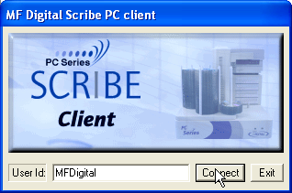  (fig 1.)  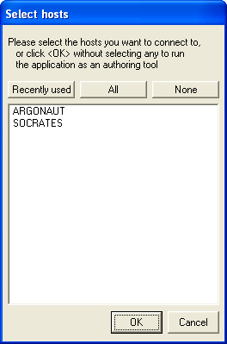  (Fig.2)

Appendix A: Premium Utilities
The “Premium utilities” tab is the launch pad for MF Digital’s Baxter add-on applications. These applications serve unique purposes and automate many everyday tasks.

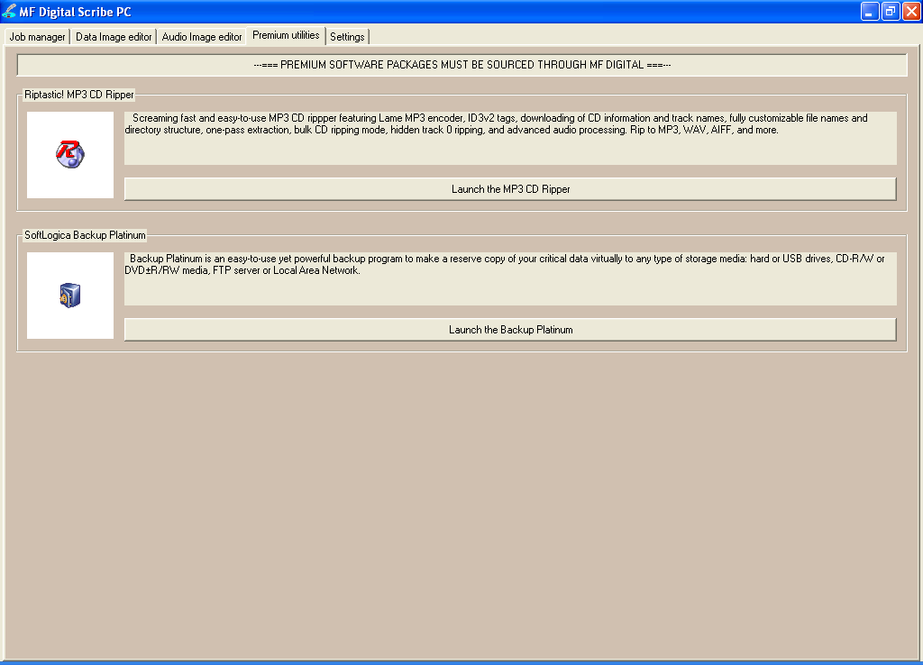

Add-ons include:
- Riptastic for MF Digital CD Ripper
- Platinum Backup for MF Digital

Riptastic for MF Digital
Load the Baxter with your audio CDs and quickly and easily rip your entire collection of CDs with this screaming fast and easy-to-use MP3 and WMA CD ripper.

- Batch Rip CDs to MP3, WMA, WMA lossless, WAV, or AIFF.
- Supports a wide variety constant bit rates as well variable bit rates.
- Automatically get CD title, artist, and track names from the Internet.
- Store CD title, artist, track names, and more in ID3 Tags.
- Fine-tune ripping with advanced Audio Processing features such as Normalization, Amplification and Attenuation, Silence Trimming, Digital Resampling, and Channel Merging.
- Precisely control your preference of file names and directory naming based on ID3 tags.

Back-up Platinum for MF Digital
An easy-to-use program designed for an automatic backup of your data to CD or DVD.

- Full and incremental backup/restore
- Auto Disc spanning. When one disc is full, Baxter will simply load the next.
- Integrated compression & encryption
- A powerful scheduler makes it easy to define the backup plan and run backup and recovery tasks automatically from hourly to monthly basis.
- E-mail notification about operation results

Installing add-on applications
Please refer to the Baxter Installation manual. Documentation for the use of the application accompanies the software itself. Simply run the SETUP for the desire application(s). Any number of add-on applications may be installed at one time.

Becoming an add-on developer.
If you or your company produce software which can benefit from automation and would be a desirable product for the typical user, please email us at info@mfdigital.com and a representative will be in touch with you shortly.

Appendix B: Troubleshooting

The Scribe PC program did not recognze Baxter. | - Check the power cable on the back of the Baxter.  - Make sure the power switch on Baxter is turned ON.  - Check the USB cable connection between Baxter loader and the host.  - Maker sure the driver is installed.
Scribe PC program did not recognize the drive. | - Press the eject button on the drive to check for power to the drives.  - Check the power cable connection on the back of the drive bay.  - Check if the Windows operating system recognized the drives by going to My Computer or Device Manager. Windows operating system must initialize the drives prior to executing the Scribe PC program. Do not put the Scribe PC shortcut in your start-up as the software may try to initialize Baxter prior to the drive being recognized.
Baxter failed to pick-up discs. | - Fan Discs. New discs can stick together. Baxter will have difficulty picking discs that are stuck together. Fan the discs out before loading them into the input bin. If the discs continue to stick, they may be of an inferior quality. Try another brand.  - Use Discs not prone to stickiness  Be sure media adapters are installed and set to the correct media size; 120mm, 80mm, or BizCD (See Page 8)

