

Developer’s Guide

Copyright © 2003, 2004, 2005, 2006, 2007, 2008, 2009, 2010, 2011 by
MF Digital. All rights reserved.

Information is provided by MF Digital on an “AS IS” basis without any other warranties or conditions, expressed or implied, including but not limited to warranties of merchantable quality, satisfactory quality, merchantability or fitness for a particular purpose, or those arising by law, statute, usage of trade, course of dealing or otherwise. You assume the entire risk as to the results of the information received. We shall have no liability to you or any other person or entity for any indirect, incidental, special, or consequential damages whatsoever, including, but not limited to, loss of revenue, or profit, lost or damaged data or other commercial or economic loss, even if we have been advised of the possibility of such damages, or they are foreseeable. We are also not responsible for claims by a third party.
This manual and the accompanying illustrations may not be copied, reproduced, or translated into another language, in whole, or in part, without the written consent of MF Digital.
Microsoft is a registered trademark of Microsoft Corporation
Other trademarks referred to are the property of their respective trademark or registered trademark holders.

About MF Digital 4
Introduction 5
Network Integration 7
Shared Network Resource 7
Client Support 7
Capacity & Throughput 8
Integrity of Copies & Quality Assurance 9
Integrated printing 10
EasiAPI 10
The Job File 11
The Image Script File 13
Data ISC 13
Audio ISC 14
The Label File 15
Complete.bat 18
Registry Entries 19

About MF Digital
MF Digital is recognized as the world’s premiere manufacturer of CD/DVD duplication and publishing systems. MF Digital’s product line spans from manual CD-R and DVD-R duplicators, to advanced, automated authoring systems ready for easy integration into almost any network topology. This complete product line, coupled with support for all formats, an unparalleled feature set, and strict adherence to compact disc standards has secured success and accolades for MF Digital both domestically and internationally.
Director is the culmination of over a decade of experience in manufacturing duplication and production equipment. From our roots as the engineers who developed the best selling diskette duplicator, then later the architects of the first automated CD duplicator, MF Digital has become the leader in CD/DVD duplication equipment. The recipe for our success is simple. We build highly functional, practical, cost effective solutions of the highest quality. | 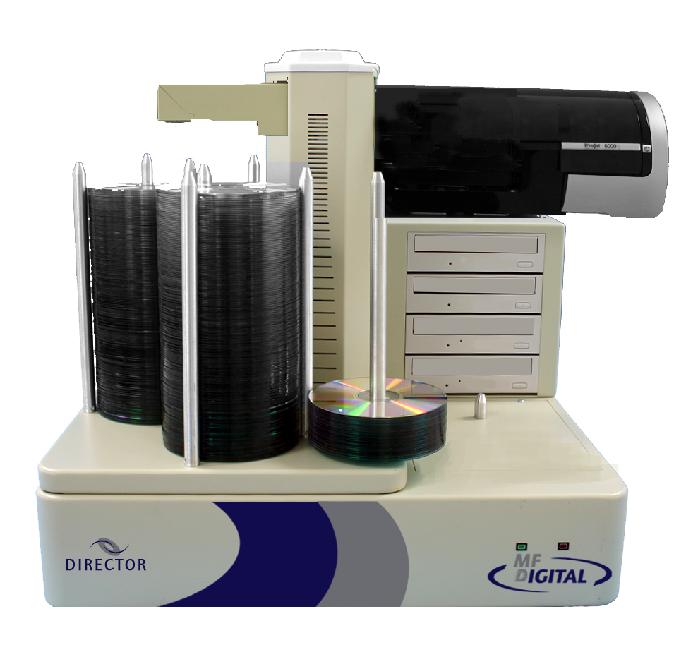

Introduction
In the years since MF Digital designed it’s first CD duplicator, the need for a new breed of CD/DVD duplicator has come to the fore. One that can serve as an enterprise wide network enabled CD / DVD disc-on-demand system. An automated system capable of not only CD / DVD duplication but also creating unique discs, providing mastering, and in-line printing direct to disc for easy identification. It was with this in mind that MF Digital designed the Director.
MF Digital brings fully automated “Disc-on-Demand” to your network with Director. The Director is the most advanced network based CD / DVD production system available. Here’s why:

- Up to four CD-R or DVD-R drives with up to 600 disc input / output capacity.
- Definable user profiles allow for fully controllable access.
- Full production, error, and usage logging
- Free client software can submit jobs to the Director from down the hall or from across the Internet. Unlimited clients!
- Intelligent job queuing, prioritizing, and polling
- MF Digital's EasiAPI, an easily accessible API for integrating into other software applications allows full control of the Director by simply editing three ASCII text files
- Powerful asynchronous recording technology allows up to 4 independent jobs to be processed simultaneously with in-line “direct-to-disc” printing on the surface of the CD or DVD

Director is the proven combination of MF Digital's award winning software and unmatched autoloader technology. Director is analogous to a network print server. While a network print server functions as a shared resource allowing multiple users access to printing, the Director allows users across a local or wide area network the ability create discs on demand. The following Director attributes assure performance and reliability:
- Network Integration Through the use of Windows™ 2000 Professional operating system, the Director can readily attach to virtually any network. Director is enterprise ready!
- Shared Network Resource Multiple users can utilize the Director at one time, supported by an unlimited job queue.
- Client Support Client software allows remote access from down the hall to across the internet. Great access for the occasional CD or to start a complete job. MF Digital includes a Windows based client capable of submitting full production jobs from any PC.
- Capacity & Throughput Each Director is equipped with up to four CD-R/RW or DVD-R/+R/-RW/+RW Recorders capable of simultaneously processing four different jobs, fed by up to a 600 disc input/output. This means you spend less time monitoring the status of media usage and more time doing other important work. A true lights-out performer!
- Integrity of Copies & Quality Assurance Separate Input, Accept, and Reject bins. Full bit-for-bit verification assures nothing less than 100% accurate copies. MF Digital's exclusive process allows for the comparison of audio CD-Rs - Only MF Digital can claim to have true audio comparison!
- Integrated Printing Each duplicated disc can be printed in-line with user definable artwork. Inkjet and thermal printer offerings assure that you get the results you want!
- EasiAPI While the Director comes fully functional with a robust software set, MF Digital’s EasiAPI makes it simple to allow your application to control the Director. Ideal to automate any system requiring output to disc.

Network Integration
Using Windows XP™ the Director can seamlessly integrate into almost any network topology. Shipping with a 10/100 NIC card Director can communicate with Macintosh, UNIX, Banyan Vines, all Windows PC's and more TCP/IP based protocols. NWLink allows Director to access Novell environments. Add a Fiber Channel card to attach to your SAN for faster processing of source files into images. This can increase performance dramatically, particularly if you are using a DVD Director.

Shared Network Resource
While the Director can run on its own without being attached to a network, it really begins to excel as a shareable network resource. Multiple users can access the director from either a local or wide area network. Jobs, which consist of a user defined selection of files available from any accessible network resource, and user CD artwork, to be printed on the disc for easy identification, can be launched remotely or locally. Up to eight jobs can be processed at the same time. Job queuing allows unlimited jobs to be launched and then automatically processed once an active job is completed.

Client Support
Included with the Director Series, whether Professional or Office Publisher, is an unlimited-seat Windows client. The Windows Client allows you to launch jobs from any PC on our network, whether data, DVD Video from Title Sets, or Audio CDs. You can pre-master data discs from files, DVD Video from Title sets, or audio form WAV or MP3 files. Below you see the track editor for the Windows Client.
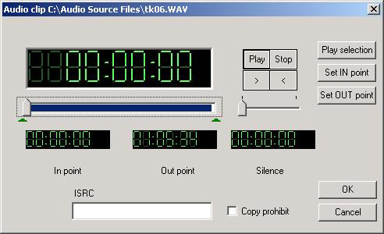
Included are several audio editing tools allowing for the quick editing of CD-DA discs, addition of sub-indexes, ISRC coding as well as altering the length of silence between tracks. Director and its clients can copy virtually any disc and is able to author CD-DA, Data CD-ROM Mode 1 and on DVD models, UDF 1.02 as well as authoring Video DVD from a Title-Set! Below you find the Windows Client main screen. Notice that the screen is divided into 4 panes. The upper panes show the drive and folders you wish to copy from on the left and on the upper right are the files within those folders. The lower panes are where you drag and drop files that you wish to put to CD-R or DVD-R with the left showing the folder structure and on the lower right the files and folders contained in the folders on the left pane.
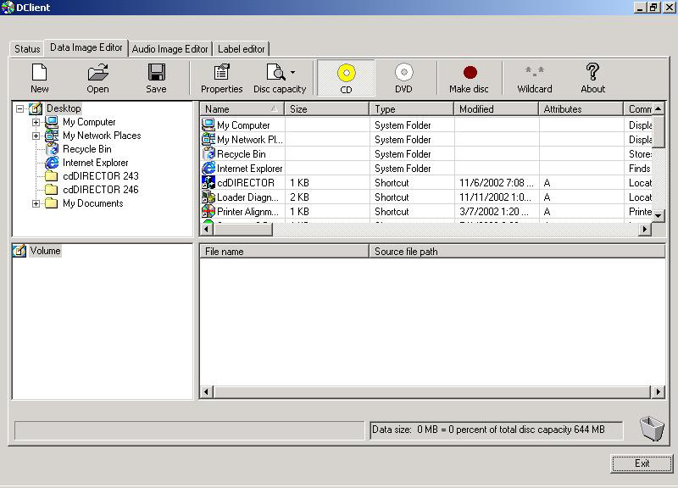

Capacity & Throughput
Any number of Directors can exist on a Network limited only by TCP/IP. Each one, equipped with up to four CD-R/RW or DVD-R/+R/-RW/+RW. Units equipped with a DVD Recorder can write both CDs and DVDs. A 600 disc input / output can keep the Director running for hours fully unattended. Full, preemptive multitasking allows the Director to produce up to four different jobs submitted by up to four different users at the same time. While these jobs are being processed, the Director’s job queue ensures the next jobs are ready to be processed as soon as a resource is available.

Integrity of Copies & Quality Assurance
MF Digital has built its success in duplication by making copy integrity our highest priority. MF Digital's drives all produce high quality, professional-caliber discs. Married with quality media, the Director can reach its peak performance. You are assured of finished discs that are of the highest production values. More so perhaps in media than in many things you get what you pay for. Inexpensive media, while tempting to get, oftentimes will cause more grief than not. MF Digital always recommends the highest quality CD-R/RW and DVD-R/+R/-RW/+RW for use with any product we manufacture. Doing so ensures that the stage is set for success!
- Separate input, accept, and reject bins Unlike other solutions whereby accepted and rejected discs are placed in the same bin, separate accept, and reject bins make identifying successfully recorded discs easy, while at the same time minimizing operator error.
- Disc verification With each job a full bit-for-bit verification process may be performed assuring the integrity of each and every disc. MF Digital is the only manufacturer that can copy and compare an audio CD-R. The verification process can take as long as writing the disc does and is very media dependent. If you are using low quality media you are much more likely to experience verification problems.
- Localization of Data The CD-Recording process can be an unforgiving one. Slow network resources can cause buffer under-runs resulting in slower than optimal production. MF Digital guarantees success by retrieving the selected data and assembling a localized CD image file. This image file contains all the selected files for a given job and stores them locally on the Director during the writing process. Slow devices like ZIP drives or floppies and even dial-up resources will not cause buffer under-runs. MF Digital's ProDRIVE and Pioneer's A03 and A04 both use BurnPROOF technology so even if the source cannot sustain the necessary rates your CD-Rs or DVD-Rs will still be burned and of the highest quality.
With advances made to network storage, particularly with Fiber Channel based SANs, you can also set the Director to write directly from a known good source. A known good source is any storage medium that can sustain the necessary transfer rate for duplicating a CD or DVD without a buffer underrun state occurring. Director can be easily integrated into a SAN, which is great for high speed transfer rates across the wire. A Director with a Fiber Channel card installed can typically "Trust" a SAN resource, which allows you to burn from CD-R or DVD-R images not physically stored on the Director’s host PC. This can be a huge time saver and increases your throughput quite dramatically. A real plus for any of our DVD customers!

Integrated printing

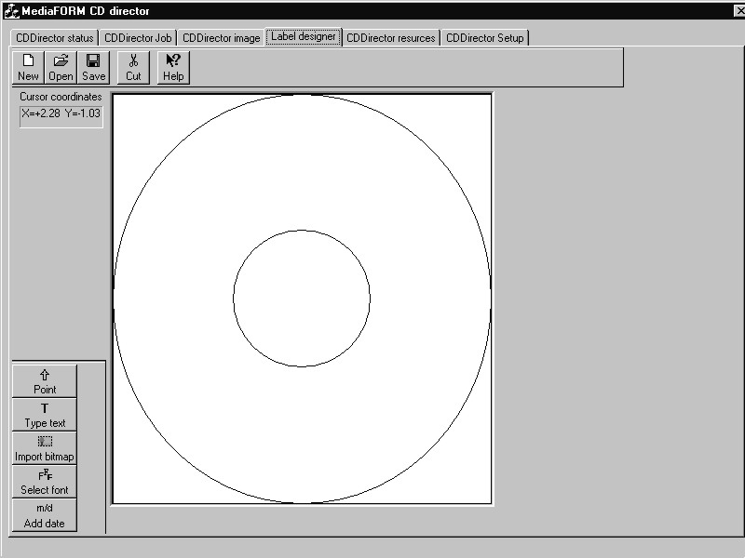 | The Director comes with a CD label designer that allows the user to easily create a design. Any installed Windows font can be used to create text elements. Graphic images, like corporate logos, can also be applied. When a job is defined the user can select the artwork to be applied immediately after a successful write, all in-line to the duplication process without operator handling or intervention.

EasiAPI
An API, or Application Program Interface, is a set of routines, protocols, and tools for building software applications. A good API makes it easier to develop a program by providing all the building blocks necessary to operate the machine. MF Digital’s EasiAPI allows a developer to write an application that can take full control of the Director without the need of knowing the intricacies of writing CD-Rs and DVD-Rs.
What makes the MF Digital Director different is that in order to produce discs on the Director the only thing the developer must do is create or edit three simple ASCII text files similar in appearance to Windows’ INI files. These three files are the Job file (*.JOB), the Image Script file (*.ISC), and Label file (*.LBL). To start a job, the developer must simply rename the .JOB file extension to .REQ and then copy it to this folder: //DIRECTOR/DIRECTOR/REQUESTS folder. This is a special folder within Director. This folder is constantly polled for entries. When a new job, or request, is found, that job is placed in the queue. If any drives are free, the job will immediately begin.
When creating these files for use with your own front end application it is best to create your original templates using the Director's GUI. These saved files can then be used as the basis for creating your own ISC , JOB and LBL files. Also, when you upgrade your Director software it is best to create another set of files with the GUI and compare the file against your original templates. In this way you can be sure that there were no additions or subtractions from available options or changes in syntax.

The Job File
The Job File (*.JOB) serves to define what the Director is to do. It includes what operation(s) to perform, the quantity to produce, the Image Script file to use, the Label file to use, a description and user information.
[Options]
JobID=010199-001
Comments=ABC Corp. Statement 01/01/99 to 01/31/99
UserID=j_smith
Quantity=2
CopyOption=1
CompareOption=1
Simulate=0
ArchiveOption=0
PrintOption=1
[Image]
ExistingImage=Z:\billing\ABC001\010199.isc
[Label]
LabelFile=Z:\billing\ABC001\010199.img
JobID: JobID is a mandatory field and is simply a label you assign that helps you to identify the job. A master number or work order number are good to use.
Comments: The comments is an optional field and serves to describe the job. A description of the master is typically entered here. Only alphanumeric characters are used here.
UserID: A mandatory field and is used to enter the Director user name (not the Windows user name) of the person submitting the job. After a job completes an entry is made to the log file, which is a Fox Pro Database. The job history can then be sorted by Username allowing the system manager to reconcile Director usage.
Quantity: The Quantity field is a mandatory field and is used to indicate the desired number of successful copies of the CD project listed under the [Image] label. Discs that fail during the duplication process are not counted toward the quantity you enter. For instance, if you submit a JOB with a quantity of 50 and 1 fails during the recording process the Director will use 51 total pieces of media to complete your request. See TotalDoneCounter under Registry Entries to alter the way Director processes your desired quantity.
CopyOption: The CopyOption is a Boolean value, in other words it can be set to true or false whereby “0” equals false, and “1” equals true. When set to true, the disc will be copied. If set to false, no copying to the disc will occur for the current job.
CompareOption: CompareOption, like the CopyOption, is a Boolean value, and can be set to true or false where “0” equals false, and “1” equals true. When set to true, the disc will be compared bit-by-bit to the image after being written. If set to false, the compare operation will not be performed. Be aware that by selecting Compare, you will nearly double the amount of time that the CD / DVD will be processed in the drive.
Simulate: The Simulate option, is a Boolean value, and can be set to true or false where “0” equals false, and “1” equals true. When set to true, or “1”, the disc will be written in simulation mode only and no actual writing will be performed. This is useful for testing purposes. If set to false, and the CopyOption is set to “1” then the disc will be written to.
ArchiveOption: The ArchiveOption is a Boolean value, and can be set to true or false where “0” equals false, and “1” equals true. When set to true, or “1”, the Director will attempt to read in the disc on the top of the input spindle and create an image file of the disc. This Image file is a single file stand-alone representation of the master disc. Once read in, the master will no longer be needed as the image file contains the complete data of the source CD. The Quantity option must be set to “0”. Unless you are trying to read-in, or archive a disc, this option should be set to “0” for off.
PrintOption: The PrintOption is a Boolean value, and can be set to true or false where “0” equals false, and “1” equals true When set to “1”, or true, the disc will be printed after the being written using the label artwork defined under [Label] line item in the .JOB file. If set to “0” or false, no printing will be performed even if a label file is listed under [Label].
[Image]: This section simply indicates which CD image file you wish to use. A few different types are supported but all have the same result. They serve as a representation of the DATA to be written to the disc. The image file can be a Director Image Script (*.ISC), a Director CD image file (*.IMG), or an ISO image file produced with a third party software package such as Gear, Toast, or Easy CD Creator to name but a few. Keep in mind that the file listed here must be relative to the Director. For example if your application builds the image file on your “C” drive then the Director must also refer to your drive as “C”. It is best to map a drive whereby both your PC and the Director reference the same shared drive as say “Z”. Another way around this is to copy the file to the Director or use UNC file naming.
LabelFile =: This section simply indicates which CD label artwork file is to be used when the PrintOption=1. The artwork file can be either a .PRN file or a Director Label file (*.LBL). .LBL files can be created using Label Designer software integral to the Director application. The advantage to this file type is it’s easy controllability from a calling application. For example, if you desired to print the same artwork to each disc but increment a serial number each disc, or wished to customize each disc with the customer’s name, then the LBL file is for you. More on this in a bit. .PRN files are created by simply using the printer’s driver set to “Print to File” under the printer’s properties. “Printing to file” captures what would normally be sent direct to the printer, to a file. This file can then be used to print CDs. The advantage of this file type is if you prefer to generate your artwork with graphic design software such as Quark Express or CorelDRAW. Keep in mind that you can still use these packages in conjunction with .LBL files but you must export to a Windows bitmap file format (*.BMP) and then paste in the graphic as an element of the label file (*.LBL).

The Image Script File
The Image Script file (*.ISC) serves as the source file for the data to be burned to the disc. The ISC can be thought of as a virtual image file. Virtual in that it does not contain the data itself, but rather a list of the files to be included on the CD ultimately produced. Where the Label (*.LBL) defines the appearance of the disc in terms of what is printed on the disc, the Image Script file (*.ISC) defines the look of the disc in terms of its data and how it will appear to a computer using the disc. While the Director uses two other type of image files, ISO and IMG (a MF Digital format used for duplication only), the ISC file is the best suited for use with the API. An exception to this would be if the DATA from “disc to disc” did not change but the printed label on each disc did. In terms of imaging here is what the Director can do for you:
- Mode One or Data CDs are authored in either Joliet for extended file names and ISO 9960 which utilizes the 8 dot 3 naming convention
- CD-DA from audio source files, either WAV or MP3. Both file types must be 16bit, stereo at 44.1KHz for proper audio streaming
- DVD can be authored in UDF 1.0 which is analogous to CD-R’s Mode One
- DVD Video can be authored with just one or two folders. Valid Audio_TS (optional) and Video_TS (mandatory) folders created from third-party software packages can be dragged and dropped in Data Image Editor and the resulting DVD will play on most commercial and PC DVD players
In the following pages you will find a sample data Image Script file and an audio Image Script File. While somewhat self-explanatory, let’s review some of the entries now

Data ISC
VolumeName = This represents the name or title to be applied to the CD. In our example we have called the disc Product Info
AddFile = Referring to our sample file, the AddFile entry on line 6 instructs the Director to include a file called MSRPRICE.PDF which currently resides in the C:/ANY NETWORK RESOURCE/PRESS KIT_2002/ folder and write it to the disc such that it will be located in the root or “/” folder. Before the AddFile command can be used, the CDs target folder must be created with the CreateFolder entry. The root directory is an exception as all discs will contain at this folder. The AddFile = command is a means of creating your disc statically. This means that when a JOB is submitted using this command the Director will attempt to collect and duplicate your files statically. A static entry means that a specific file structure is expected by the ISC. If a file is missing that was specified by the ISC, the job will not be able to proceed as it does not match the expected structure of the source files.

Note: UNC file naming is supported. The above example could have easily been //DIRECTOR/PRESS KIT_2002/

[Image]
TemplateImage =

VolumeName = Product Info

AddFile = C:/Any Network Resource/Press Kit_2002/MSRPrice.pdf -> /MSRPrice.pdf
AddFolder = C:/Any Network Resource/Press Kit_2002/Acrobat -> /Acrobat
CreateFolder = /Brochure
CreateFolder = /Brochure/Color PDF
AddFile = C:/Any Network Resource/Press Kit_2002/Brochure/Color PDF/SmartDRV.pdf -> /Brochure/Color PDF/SmartDRV.pdf
AddFile = C:/Any Network Resource/Press Kit_2002/Brochure/Color PDF/EZDatAud.pdf -> /Brochure/Color PDF/EZDatAud.pdf
AddFile = C:/Any Network Resource/Press Kit_2002/Brochure/Color PDF/cdDIRECT.pdf -> /Brochure/Color PDF/cdDIRECT.pdf
AddFile = C:/Any Network Resource/Press Kit_2002/Brochure/Color PDF/CD-5916.pdf -> /Brochure/Color PDF/CD-5916.pdf
AddFile = C:/Any Network Resource/Press Kit_2002/Brochure/Color PDF/CD-5900.pdf -> /Brochure/Color PDF/CD-5900.pdf
AddFile = C:/Any Network Resource/Press Kit_2002/Brochure/Color PDF/CD-5400L.pdf -> /Brochure/Color PDF/CD-5400L.pdf
AddFile = C:/Any Network Resource/Press Kit_2002/Brochure/Color PDF/CD-3706P.pdf -> /Brochure/Color PDF/CD-3706P.pdf
CreateFolder = /Brochure/B&W PDF

; created 11/01/02 09:40:02
AddFolder = Again, let’s refer to our sample file, the AddFolder entry on line 7 instructs the Director to include a folder currently residing ON C:/ANY NETWORK RESOURCE/PRESS KIT_2002/ACROBAT so that it appears as the /Acrobat folder on the CD to be produced. Adding folders in this way negates the need to use the AddFile command. AddFolder = is a Dynamic method of adding folders and files to your disc. This means that the Director does not look for any specific file structure when it collects the files to build your disc’s image; instead it copies all of the contents of the target folder to your finished disc. Be aware that the folder being copied dynamically can easily exceed the capacity of your media, so your disc should be made before the folder reaches too large a size.

Audio ISC
[Qsheet] Mandatory image file header necessary for the Director to process the audio source files to CD-DA, or a Red Book compliant CD-R. Resulting CD’s will be playable in most modern CD or DVD players.  BeginTrack Mandatory descriptor. Delineates the start of a track. There are a maximum of 99 tracks allowed to adhere to the audio Red Book standard.  SourcePath = The directory path to the audio source file relative to the Director. Names can be in UNC file naming format as well.  StartFrame = Describes in frames where in the source file the output track will begin. One frame = 1/75 of a second in an audio CD.  FramesCount = Describes total length in frames of output track. For the first track, shown in the example below, the frame count is 9,213 which is 122 seconds or just over 2 minutes.  ISRC = International Standard Recording Code. The ISRC code is contained in the subcode of each track or recording. The ISRC code consists of letters and numbers, 12 Characters in length. The code is made up of characters representing the country, registrant, year and designation code. | [Qsheet]  UPC = 0000000000000  BeginTrack  SourcePath = C:\Temp\MP3 Files\tk01.mp3  StartFrame = 133  FramesCount = 9213  ISRC = US-223445566  CopyProhibit = 1  SubIndex = 1275  EndTrack  BeginSilence  FramesCount = 150  EndSilence  BeginTrack  SourcePath = C:\Temp\MP3 Files\tk02.mp3  ISRC = US3344556677  CopyProhibit = 1  SubIndex = 1350  EndTrack  BeginSilence  FramesCount = 150  EndSilence  BeginTrack  SourcePath = C:\Temp\MP3 Files\tk03.mp3  ISRC = US4455667788  CopyProhibit = 1  SubIndex = 1425  EndTrack  BeginTrack  SourcePath = C:\Temp\WAV files\tk01.WAV  SubIndex = 1500  EndTrack  ; created Friday, November 01, 2002 05:14:01
CopyProhibit = A boolean value, whereas “0” equals off and “1” equals on. When enabled the Copy Prohibit flag is thrown signifying the creator’s intent not to allow their content to be duplicated. This is in no way an obstacle to being copied but serves more as a warning not to copy the material.
SubIndex = Creates a searchable point within a track. Used for play only for professional players like those found in radio stations that support this feature. This is used mostly for audio CD’s with unbroken content like a concert CD and subindexes are also used for sound effects CD’s.
EndTrack Mandatory descriptor. Demarks the end of the Audio track. One EndTrack must be present for each BeginTrack.
BeginSilence Allows for the adding or expansion of the Silence between tracks. There must be an EndSilence for every BeginSilence.
EndSilence Always bookended with BeginSilence, EndSilence deliniates the end of the modified silence between tracks.
UPC = Universal Product Code. A 13-digit descriptor that can be written to an audio CD.

The Label File
When creating these files it is best to create templates using the Director's GUI, saving and then submitting a job. This saved file can then be used as the basis for creating your own JOB files. Also, when you upgrade your Director software it is best to create another JOB file with the GUI and compare the file against your original template. In this way you can be sure that there were no additions or subtractions from available options or changes in syntax.
Note: It is very important to keep your template files up to date as we have seen issues arise when someone uses a particularly old JOB, LBL or ISC file with newer Director software. Jobs may not submit properly, or at all if the files are too different from the one the Director is expecting.

The Label (*.LBL) defines the appearance of the disc in terms of what is printed physically on the disc. If the disc(s) to be produced are not to be printed, then there is no need to create or manipulate a label. There are three basic commands for adding print elements to a CD, they are the AddBitmap, AddUnicodeText and AddText commands. The CD itself can be thought of as an X - Y coordinate system whereby the center of the disc is the origin at 0,0, the extreme right would be 225, 0, the extreme left -225, 0, the bottom most position 0, -225, and the top most at 0,225.

[Label] Mandatory file header. This Must appear as the first line of the label file. It serves no other purpose than to identify the file type. Below is an example of a label file.
[Label]
AddText=RectTop#-131,RectLeft#-82,FontHeight#156,Weight#700,Italic#1,Content#Marketing Disc
AddBitmap=RectTop#150,RectLeft#-120,RectBottom#120,RectRight#120,GraphicsFile#C:\Director\Clipart\logo3.bmp
AddUnicodeText = Identifies the 4 digit hexidecimal equivalent for the output of a True type Barcode element.
AddBitmap = Identifies the insertion of Bitmap (BMP) graphic file. Any number of bitmap images may be included. Each bitmap must have a separate line entry beginning with the AddBitmap command.
Content# The string of text to be printed
AddText = Identifies the insertion of a text element. Any number of text elements may be added.
The AddText, AddUnicodeText and AddBitmap commands contain properties that can further define their appearance. The Bitmap and text properties are as follows:
RectTop# Y-axis location of the top left corner where bitmap is printed (1/100 inch resolution)
RectLeft# X-axis location of the top left corner where bitmap is printed (1/100 inch resolution)
FontHeight# Size of font expressed in points (1/720 inch resolution)
CharSet# Selecting one of the following numbers specifies the character set of the font. The default is “0”

0 ANSI character set
1 Default character set symbol character set
77 Mac character set
134 GB2312 character set Chinese Big5
161 Greek character set
162 Turkish character set
163 Vietnamese character set
177 Hebrew character set Arabic character set Baltic character set
204 Russian character set
222 Thai character set
238 Eastern European character set
204 Russian character set
Underline# A Boolean value when set to “0” text will be normal, if set to “1” text will be underlined
Escapement# The angle between the font's baseline and escapement vectors, in units of ¹/₁₀ degrees. The default is zero.
FaceName# Defaults to Arial, this value defines the font being used to create your text.
Italic# A Boolean value, when set to “0” text will be normal, if set to “1” text will be italicized
Orientation# The angle between the font's baseline and the device's x-axis, in units of ¹/₁₀ degrees
OutPrecision# Using one of the following flags specifies the desired precision (closeness of the match) between the logical font ideally described by the structure and the actual logical font. This value is used by the font mapper to produce the logical font.
- Specifies the default font mapper behavior.
1 This value is not used by the font mapper, but it is returned when raster fonts are enumerated.
5 Instructs the font mapper to choose a Device font when the system contains multiple fonts with the same name.
6 Instructs the font mapper to choose a raster font when the system ontains multiple fonts with the same name.
- This value instructs the font mapper to choose from TrueType and other outline-based fonts.

StrikeOut# Defaulted to zero. If set to “1” the text ill have a strike-out through it

Weight# Defaulting to 400, you can use the following numbers to adjust the boldness or weight of the font:
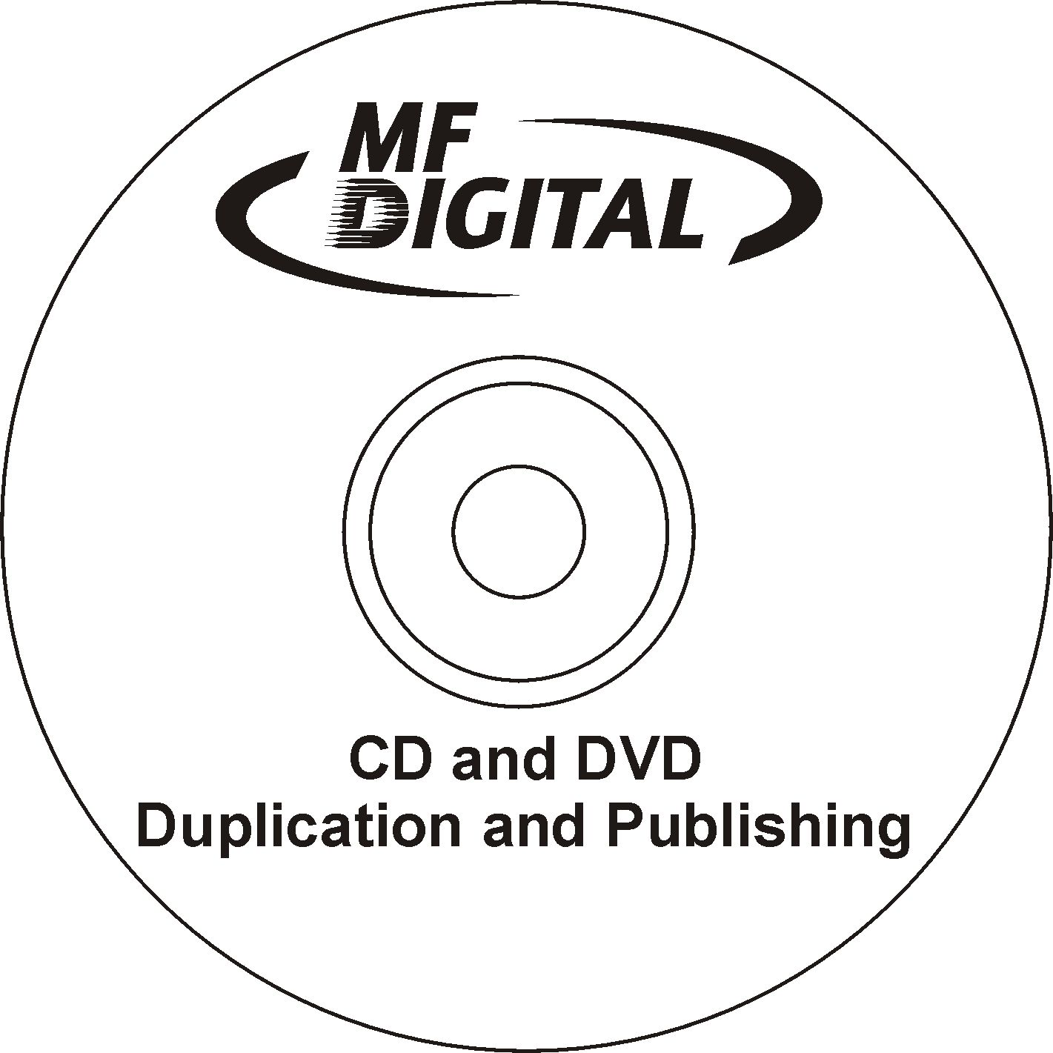

0 Default weight
100 Thin weight
200 Extra-light weight
300 Light weight
400 Normal weight.( Default value)
500 Medium weight
600 Semi-bold weight
700 Bold weight
800 Extra-bold weight
900 Heavy weight

StrikeOut# Defaulted to zero. If set to “1” the text will have a strike-out through it

Complete.bat
Director can be configured to run a batch file at the end of a job. By simply placing your batch file named complete.bat in the /Director folder the Director application will execute it at the end of any given job passing the JOBID and job status as command line arguments. The uses are myriad, the batch files could be made to send notification via email or Windows messenger service, run a virus scan, or delete the contents of a folder. Below is just one example of a batch file that can be processed by Director. It will detail the status of jobs that are completed; noting the job ID, date and time stamp as well as success/failure reporting.

@echo off
echo JobID=%1 JobStatus=%2 (0=OK, 1=Abort/fail) >> c:\Director\complete.log
@time /t >> c:\Director\complete.log
@date /t >> c:\Director\complete.log
echo ----------------------------- >> c:\Director\complete.log

The output of this file would be a text file called complete.log which captures the outcome of the last 7 jobs. It will look similar to this:

-----------------------------
JobID=12347 JobStatus=1 (0=Ok, 1=Abort/fail)
10:44a
Thu 05/10/2001
-----------------------------
JobID=12348 JobStatus=1 (0=Ok, 1=Abort/fail)
10:44a
Thu 05/10/2001
-----------------------------
JobID=12349 JobStatus=1 (0=Ok, 1=Abort/fail
10:46a
Thu 05/10/2001
-----------------------------
JobID=12350 JobStatus=0 (0=Ok, 1=Abort/fail)
10:47a
Thu 05/10/2001
-----------------------------
JobID=12351 JobStatus=0 (0=Ok, 1=Abort/fail)
10:49a
Thu 05/10/2001
-----------------------------
JobID=12353 JobStatus=1 (0=Ok, 1=Abort/fail)
11:16a
Thu 05/10/2001
-----------------------------
JobID=156 JobStatus=1 (0=Ok, 1=Abort/fail)
12:41p
Thu 05/10/2001
-----------------------------

Registry Entries
MF Digital allows an unprecedented amount of control of not only the process of moving your data to disc but of the way Director software looks and operates. Many options are available to change through the Windows registry. This was done as a measure of security; so as not to have just anyone capable of making changes to your Director. Windows registry can be accessed by clicking on the Start button and going to Run. You must have Administrative rights on the Director, otherwise you cannot access Windows registry. When the Run menu appears type “regedit” into the appropriate field. Looking at the diagram on the next page you see the path to the optional keys already expanded HKEY_LOCAL_MACHINE/SOFTWARE/CDDIRECTOR/OPTIONS If these keys do not appear in your Director's registry contact MF Digital technical support about upgrading your Director's software. As always, software upgrades are free. In some situations a hardware upgrade may be necessary to utilize these features.

Note: Altering anything in Windows registry can have a negative impact on your Director including causing it to no longer boot. Please use the utmost caution and back up your registry before making any registry edits. If you are uncertain about making changes in registry, please contact MF Digital technical support who can assist you

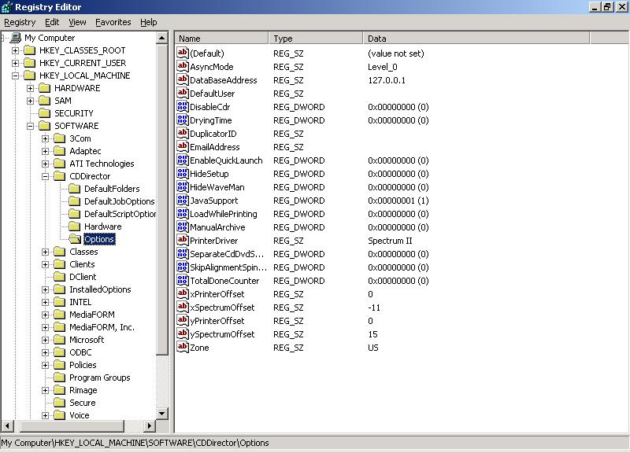
Several of the registry keys you see above are also located, as check boxes, in the Setup tab of the Director software. These include:

- AsyncMode Changes the level of synchronous operation of not only the drives but of job and priority when submitting a job. Please see the user’s manual for a more detailed explanation of Director's ability to tailor the way it handles jobs and drive assignments to your specifications.
- DryingTime The number in seconds of additional time for the disc to sit in the extended printer tray after the CD is done printing. This is for inkjet printers only and is typically used only when there is full, heavy coverage printing of the disc.
- PrinterDriver Selects the printer that is installed on your Director. There are two available printers: CD Color Printer IV which is the Primera Signature IV Inkjet printer, the other is Spectrum II .
- EmailAddress Address of operator who wishes to receive notification of error states, such as “Input Empty” or a situation when user intervention is required to correct a condition at the Director’s location. A POP3 mail account must be setup for the Director to use this feature.
- DatabaseAddress The IP address of the database in which user records, and job logs are stored. The database must be stored on the Director. The 127.0.0.1 loop back is the default address and works in most circumstances. Otherwise set to the system actual IP address.

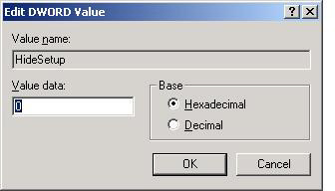 | Editing Windows registry is a simple process. When you explore to the key you wish to edit just double click on the key representing the option you wish to enable or disable. Many of the key’s Value Data fields are simple Boolean values where “0” = off or disabled and “1” will turn on or enable that particular feature.
Changes do not take effect until the Director application is restarted. Simply changing the figure in the Value data field will alter Director’s appearance and/or functionality. Looking at these two diagrams, you will see that the HideSetup key was changed from disabled (above) to enabled (right). The next time the Director application is started, the Setup tab will no longer be displayed. | 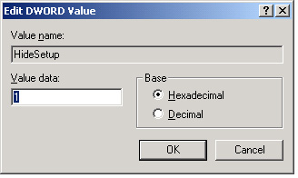

- DefaultUser This option, when enabled, automatically inserts a user name and password into the appropriate field in the Job Tab. Just enter into the Value data the user name you wish to have. This enables you to start a job without entering your Director user name and password
- HideWaveman Changing the Value data to “1” will enable this feature so that the Waveman audio editor tab will no longer appear. By default this feature is disabled, allowing the Waveman tab to be displayed
- JavaSupport Enabled or set to “1” by default, this allows for the disabling of the Java based client included with the Director software. Set it to “0” to and you will no longer have access to the Director via the Java client> This IS only for older NT based Director. Java client is no longer supported.
- LoadWhilePrinting This enables Director to load discs into the drives while the printer is functioning. Normally a serial process (copy, then print) enabling this will cause these processes to happen asynchronously. “0” disables this feature and “1” will enable it.
- ManualArchive Normally disabled this feature makes it possible to read in a master from the Director’s PC CD-ROM drive rather than automatically loading the master into the top drive of the robotic base unit
- SeparateCdDvdSpindle On units equipped with optional dual spindle support, this enables the abaility to dedicate one bin for CDs and one for DVDs. In this way JOBS of either type may be submitted without concern for which media is loaded.
- SkipAlignmentSpindle This feature is ONLY for legacy “MediaFORM” banded products and should NEVER be checked on the MF Digital Director EC Series. During the process of printing on older pneumatic based robotics, discs are usually moved from the write drives to the alignment spindle to assure a perfect placement on to the printer. Perfect drive alignment is needed for this to work!
- TotalDoneCounter Typically when you enter a desired quantity of discs to produce Director will continue to process your media until it completes your request of good, finished discs. Let’s say you have 100 pieces of media on the input spindle and you entered a quantity 50 for a duplication job, but 1 of them fails during the burn. Normally, Director will have used 51 pieces of media to complete the above job. When TotalDoneCounter (“1”) is enabled the Director will stop at your requested quantity, regardless of outcome. So, in the above scenario you would have 45 good discs, 5 bad and the Director will stop. The Director will not continue once the total media usage exceeds the quantity you entered.

