

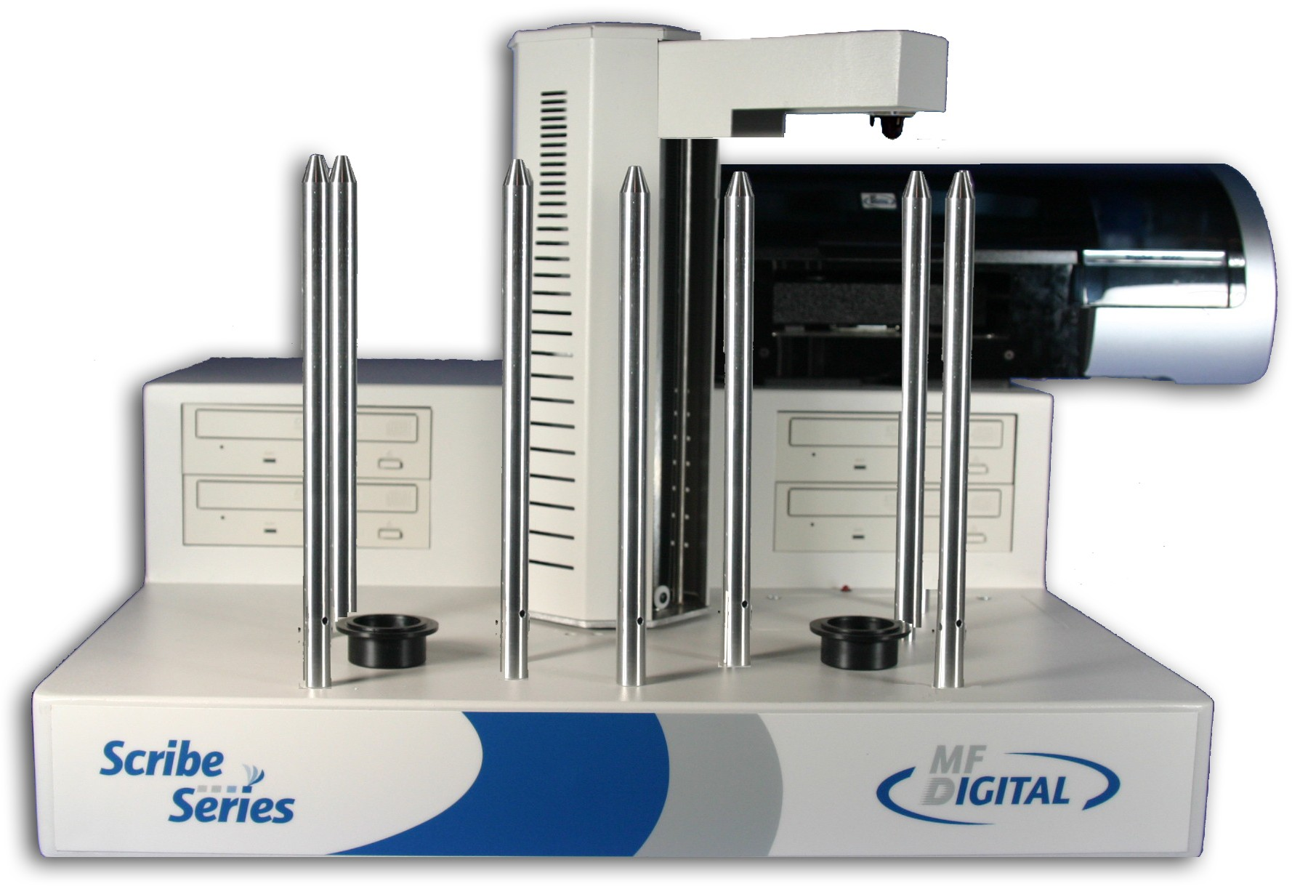

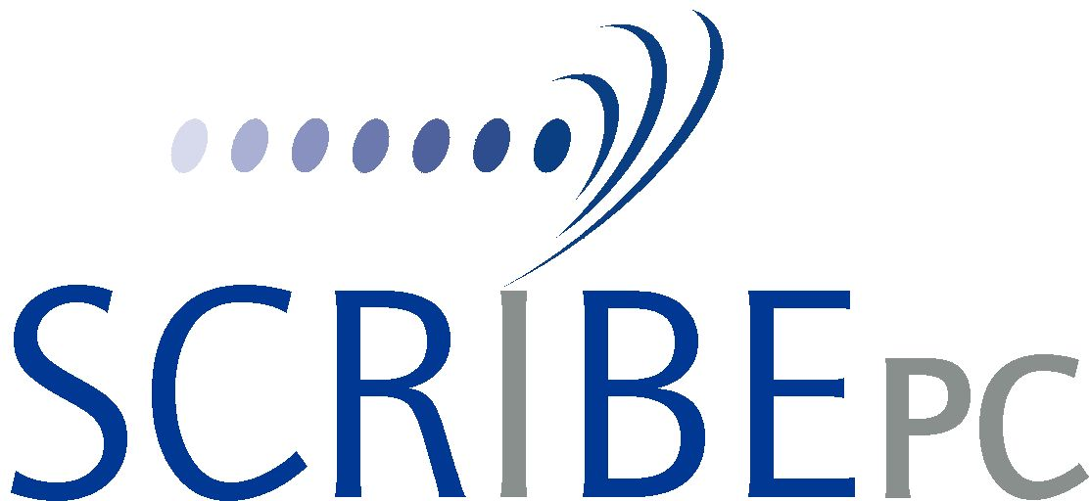

Series Operator’s Guide
Rev.: 112206.1

Copyright Notice
Copyright ©2003-2006 by MF DIGITAL. All rights reserved.

This manual and the accompanying illustrations may not be copied, reproduced, electronically transmitted, or translated into another language, in whole, or in part, without the written consent of MF DIGITAL
MF DIGITAL, SCRIBE-PC, SCRIBE-SA, Baxter, Director, and 5906-Live are trademarks of MF DIGITAL

Other trademarks referred to are the property of their respective trademark or registered trademark holders.

Warranty
MF DIGITAL warrants to the original purchaser that the equipment that you have purchased is free from defects in materials and workmanship, for a period of time as follows:

Duplicator Electronics & Mechanical Parts 1 year
Recorders (warranty by drive manufacturer) 1 year
Prism Plus Thermal Printer 6 Months
PicoJet Inkjet CD/DVD Printer 1 year limited warranty

This warranty is applicable when the warranty registration has been completed and returned to MF DIGITAL within a reasonable period of time following the purchase and the warranty is NOT transferable. This warranty does not apply to malfunctions caused by misuse, negligence, accident, or alteration, nor is MF DIGITAL responsible for consequential damages related to the use of this equipment. This warranty is made in lieu of any other warranty expressed or implied.

Recorder Warranty Policy
Individual recorders manufacturers are responsible for the products they produce. As a convenience, MF DIGITAL will honor any service issue related to a defective recorder or printer while under its respective manufacturer’s warranty providing that the recorder has been purchased from MF DIGITAL either directly or indirectly. MF DIGITAL has no responsibility for products NOT purchased through MF DIGITAL

Piracy
The copying of audio, video, or software without the permission of the copyright holder is illegal. MF DIGITAL accepts no responsibility for the copyright use or misuse of this equipment. It is the sole responsibility of the user to ensure that the legal rights of copyright in duplicating and printing are respected.


121 Carolyn Blvd.
Farmingdale, NY 11735
Tel.: (001) 631 249 9393
Fax.: (001) 631 249 9273
Email: info@mfdigita.com
http://www.mfdigital.com/

Table of Contents

About MF DIGITAL 5
What To Expect From Your MF DIGITAL CD Duplication System 5
About This Manual 5
Features of the Scribe PC 5
Installing The ScribePC 6
What’s In The Box 6
What you will also need: 6
Options 6
Packing Materials 7
The Best Place To Put The ScribePC 7
Safety Precautions 7
Removing Packing Restraints 8
Input And Output Spindles 8
Making the connection 8
Starting Up 9
Installing the ScribePC Software 10
Quick Start, Making Copies 14
Starting the ScribePC Application 14
A note about “Ignore Low Ink Level” 16
The ScribePC Application 17
Starting the ScribePC Application 17
Selecting STANDARD or ADVANCED mode 17
ScribePC Application Layout 19
Reviewing and changing the settings 19
Settings Editor 20
Application Temp Folder 21
CD / DVD Images Default Folder 21
CD Labels Default Folder 21
Printer Driver 21
Spindle Select 21
Shake Disc 22
Data image editor 23
Creating a data disc image 23
Image Toolbar 24
Selecting CD Capacity 25
Adding Files and Folders 25
Creating, renaming, and removing Folders 25
Static and Dynamic Content 26
Saving The Current Disc Image File 27
Editing Image properties 27
To create a physical disc image file: 29
Loading An Existing Script File 29
Audio Image Editor 31
Audio Image Editor Toolbar 32
Adding Tracks 33
Removing Tracks 33
Changing A UPC Code 34
Changing ISRC Codes And Copy Prohibit Flags 34
Inserting, Editing And Removing Silence 36
Inserting, Editing And Removing Subindexes 37
Saving The Current Audio Disc Image 38
To create a physical audio disc image file (.IMG): 38
Loading An Existing Script File 39
Job Manager Tab 40
The Production Process 41
Creating a job 41
Archive only – reading in a master disc 44
Copy and / or Verify 46
Relay mode job 48
Print only job 50
Multi-disc Archive – reading in several masters at a time 51
Data Import – Ripping data CDs or DVDs 53
Log Files 55
JOB.LOG 55
JOB.LOG.CSV 55
Network Client Software 56
Client PC minimum requirements: 56
Installing the client software 56
Using the client software 57
Appendix A: Creating .PRN Files (Prism Plus) 59
Printer Driver setup 59
Making a .PRN label file 59
Appendix B: Creating .PRN Files (PicoJet) 61
Printer Driver setup 61
Making a .PRN label file 62
Appendix C: Creating & Using Adobe Acrobat PDF Files 65
Appendix D 67
How to setup SureThing CD Labeler to Merge with a CSV document. 67
Creating your data merge file (CSV) 68
Using Headers in your CSV Document 72
Scribe Client and STD Files with Merge 74
Appendix E: Premium Utilities 75
Riptastic for MF Digital 75
Back-up Platinum for MF Digital 76
Ordering Premium Utilities 76
Installing add-on applications 76
Becoming an add-on developer. 76
Appendix F: ScribePC Alignment Utility 77

About MF DIGITAL
Thank you for purchasing MF Digital’s ScribePC autoloading duplication and printing system. MF DIGITAL manufactures a wide variety of software and audio duplication and production equipment, including manual and fully automatic CD and DVD duplicators and printers. We hope you will consider us for all of your production needs.

What To Expect From Your MF DIGITAL CD Duplication System
Your MF DIGITAL ScribePC duplication system is professionally designed and manufactured to give you years of trouble free operation. To avoid accidental damage to your new duplication system, please read and understand this manual thoroughly before operating the unit.

About This Manual
This manual is written for both novice and experienced users. Please read through this Operator’s Guide from beginning to end before using the unit. Once having read the manual, follow along chapter by chapter. This will provide the necessary understanding of your new ScribePC duplication system.

Features of the Scribe PC
The Scribe PC Series of copiers is the most advanced series of copiers available today. Features Include:
- Networkable: Ethernet onboard, comes complete with unlimited seat Windows Network Client.  - Heavy-duty robotics, as well as the fastest robotics, makes for the ideal copier for those mission critical applications.  - Copies virtually any CD or DVD.  - PC Built-in: No need to buy an additional PC, or the need to open up your existing PC to install cards and tackle compatibility issues.  - Unlimited queue: Queue up as many jobs as you like; copy, copy & print, print only, or even data-import jobs.  - Pre-master from files or batch read: Read in one master or many at a time to image files. Use these image files for later copying.  - Spindle select: load with both CDs and DVDs and the unit will pick the appropriate disc. | - Data-import: In addition to image file creation, you can copy the contents of multiple Windows readable CDs or DVDs as files and folders to a user defined local or network location.  - Flexible printing: Support for both thermal, and ink jet printing. No need to make hardware dedicated PRNs like competitive copiers. Use Adobe PDF, SureThing STD, or PRN files for your print source.  - Print unique content: Use merge field in your SureThing (included) STD file to print serial numbers, unique text like customers names on each disc.  - Relay mode: Make multiple copies of multiple masters including print.

Installing The ScribePC
Carefully remove the ScribePC duplication system from the shipping container. Inspect the contents and verify them against the packing slip. Report any errors in shipping as soon as possible. The ScribePC is available as a copy only system, or both a copy and print system.

What’s In The Box
Your ScribePC CD / DVD duplication system has a PC onboard, so there is no need to buy or dedicate a PC to operate it. The package includes:
- ScribePC duplication system
- Power cord
- ScribePC Software / Manual CD

What you will also need:
- PC compatible VGA Monitor (if LCD, use an analog one)
- PC Mouse (P/S2 Style recommended)
- PC Keyboard (P/S2 Style recommended)

Options
- Disc label printers: Supported models include the MF Digital PicoJet thermal inkjet printer, and the Prism Plus Thermal Printer.
- MP3 / WMA audio CD batch ripping software
- Hard disk back-up software
- 80mm and BizCDs autoloader and printer adapters.

Packing Materials
Please retain the original box and packaging in the event that the unit requires future servicing. This will help to reduce the possibility of damage occurring in transit. In the event that the system is shipped back to MF DIGITAL without the original box and packaging, customers will be charged for new box and packaging.

The Best Place To Put The ScribePC
The best operating location for the ScribePC duplication system is in a climate controlled area, free of dirt, dust, humidity, excessive heat, and electronic or electromagnetic interference. Room temperature should be between 65 and 75 degrees Fahrenheit, or between 18 and 23 degrees Celsius. Place the ScribePC on a solid, steady work surface and allow sufficient room for all incidental work materials. Provide at least six inches of clearance on all sides of the unit for ventilation.
Like all automated copiers, the Scribe uses photo sensors that can be adversely affected by direct light sources. Avoid placing the system in direct sunlight, under halogen or mercury vapor lights, or other close and very bright light sources. If your Scribe is behaving erratically, and it is in close proximity to bright light, or focused lighting such as spot lights, try moving it to an area with more subdued lighting. If the unit operates normally, then you may need to remove or adjust the light source, or relocate the Scribe to a different spot.

Safety Precautions
The system is shipped with a three-prong power connector and must be used with a properly grounded AC receptacle. DO NOT try to defeat the third “ground” prong. All computer peripherals must be properly grounded and the ScribePC is no exception. The use of a power conditioner such as an Uninterruptible Power Supply (UPS), or a surge protector is highly recommended. The minimum required size is 400VA.

Repairs or alterations should only be attempted by authorized factory trained technicians. MF DIGITAL reserves the right to void the warranty if unauthorized service is performed.

Removing Packing Restraints
The ScribePC ships with a picker arm restraint to reduce the possibility of damage in transit. This restraint must be removed before operation or power-on. Remove the foam block above the transfer arm. Save the foam block, as you will need to return it to its place when transporting the unit in the future.

Input And Output Spindles
The input areas and output spindle serve as the containers to store the blank and recorded discs. Spindle capacity ranges from 250 discs to 600 discs depending on model and setup.

Making the connection
The ScribePC requires a Monitor, Keyboard, and mouse to use it properly. While these items are not included, they are readily available and standard PC components.

- Make sure the ScribePC power switch is set to the off position.
- Please connect you monitor, keyboard, and mouse now, then connect the AC power cord in to the receptacle at the rear of the unit, and the other end into the wall or UPS power outlet.

 | CAUTION  Always use properly grounded receptacles, or severe damage to your system may result. The use of a surge protector or Uninterruptible Power Supply (UPS) is highly recommended.

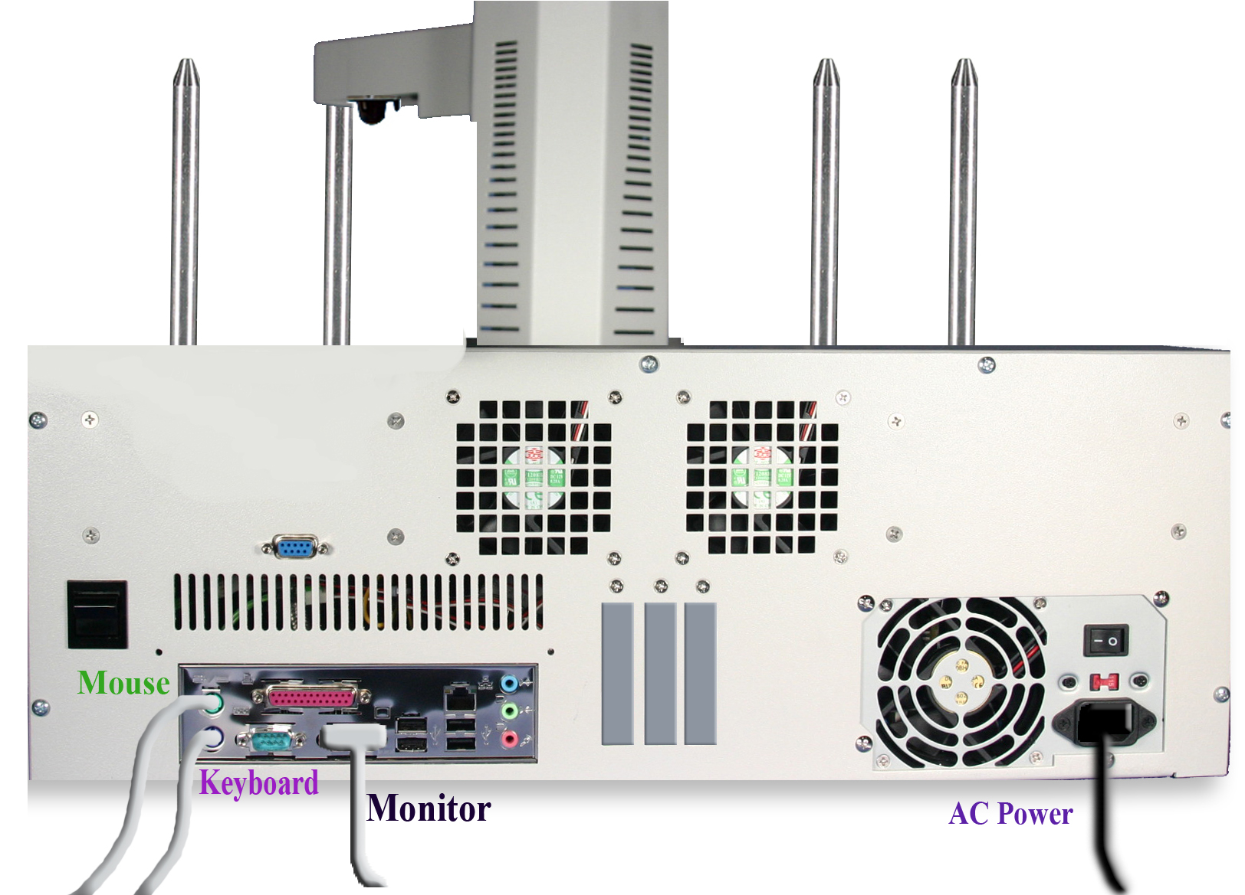

Starting Up
- If equipped, switch on the power to the printer – With PicoJet let print cartridges park.
- Switch the Scribe PC power switch to on position.

 | Note: The ScribePC uses Microsoft’s Windows XP operating system. To get the most out of the ScribePC it is recommended that users supplement this manual with an operating system guide.

Installing the ScribePC Software

 YOU LIKELY CAN SKIP THIS STEP

Your ScribePC 910x came pre-loaded with the Scribe software already installed. If for any reason you wish to re-install, it is recommended you remove the old version first.

To install the ScribePC software:

- Insert the ScribePC software CD into one of the drives on the ScribePC drive tower.
- Click on Start/Run.

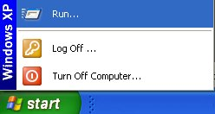

- In the “Open” text box, type “D:\Scribe_EC_setup.exe” (D=Disc Drive) where “D” represents the letter of the drive you have placed the disc in.

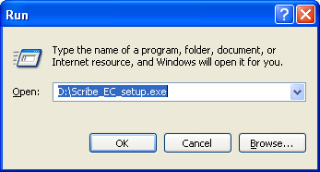

- Then, click on OK and the installer screen will appear:

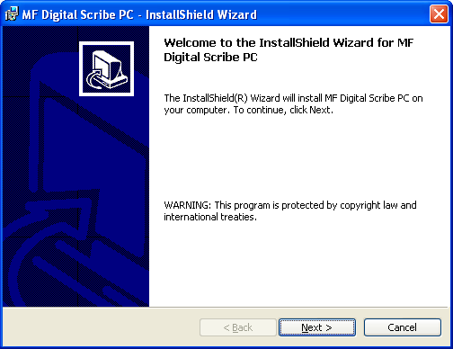

- Click NEXT to continue

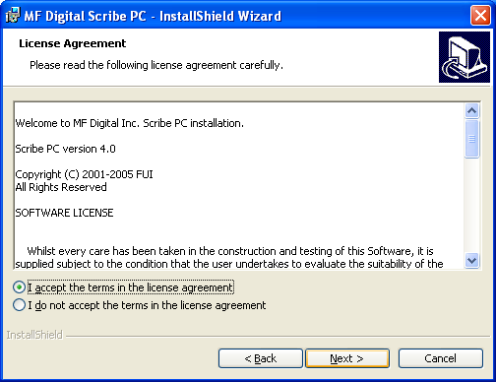

- If you accept the terms of the license agreement, select “I accept…” then click NEXT to continue.

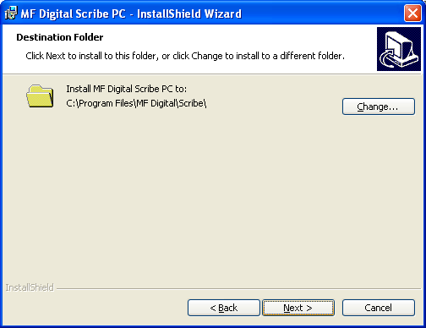

- Click NEXT to continue, or CHANGE to install to a location other than the default.

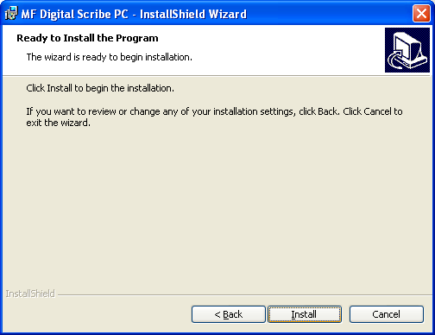

- Click INSTALL to continue.

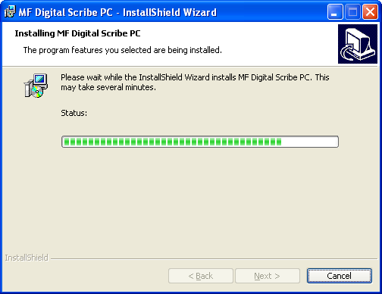

- Please wait while the ScribePC software is copied to your hard drive.

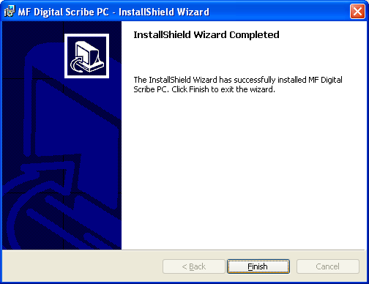

- Installation is complete. Click FINISH.

Quick Start, Making Copies

Starting the ScribePC Application
To start the ScribePC application the steps are as follows:

- From the desktop of the computer, click the MF Digital Scribe PC Icon
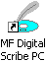
- The ScribePC application screen will now be displayed:

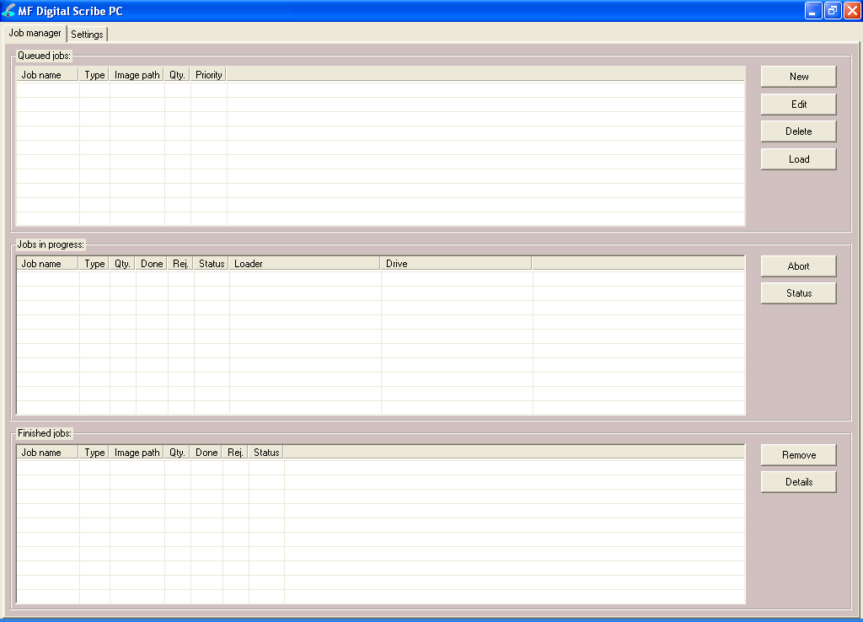
- Place some blank CDs or DVDs into the input hopper followed by the master CD or DVD you wish to copy. If the master is a DVD you must use DVD blanks. If the master is a CD, you must use CD blanks. The ScribePC will not convert between types.
- Click the NEW button to start a new job. The following dialog box to the right will be displayed: | 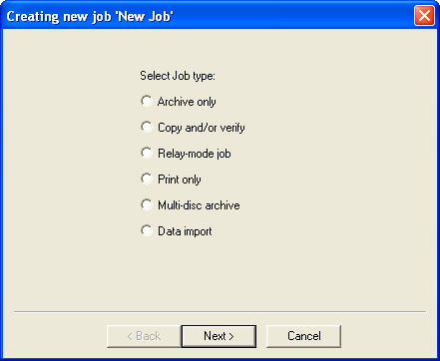
- Select “Copy and/or verify” and then click NEXT. You will now be prompted:

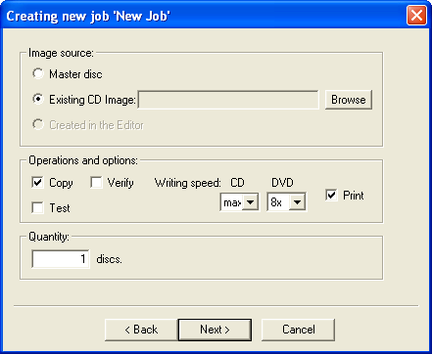

Enter the desired number of copies in the “Quantity” box. If you system is equipped with a printer, you may also check “Print”. If you do so, be sure you have prepared a PRN file as detailed in the section entitled “Creating .PRN Files”. Optionally, you may use a SureThing .STD file (See appendix on SureThing Files and merge fields), or an Adobe Acrobat PDF files. Adobe PDF files should be made as described in “Creating & Using Adobe Acrobat PDF Files”. Also, be sure your printer is attached as described in the manual that accompanied your printer, and is selected on the Settings TAB. When you satisfied with your selections, click NEXT.

- If you selected PRINT, the following dialog will appear:

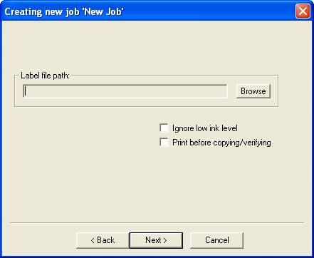
Click on browse and locate the PRN, STD, or PDF file to be used. Enter the desire number of copies and optionally select “Print before copying / verifying” (for use when using BizCDs and BizCD adapter) and / or “Ignore low ink level”.

A note about “Ignore Low Ink Level”
Competitive systems continue to attempt to print even when cartridges have run out, resulting in ruined discs. PicoJet equipped Scribe PC systems will stop at 4% remaining ensuring you will not waste discs. Optionally you can choose to ignore this safeguard to glean the last few discs out of a cartridge.

When you re satisfied with your choices, click on “Next” to continue:

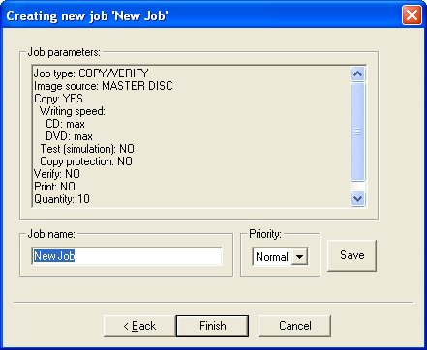

- Use the default “Job Name” or enter your own such as a work order number. Click FINISH when you are ready.

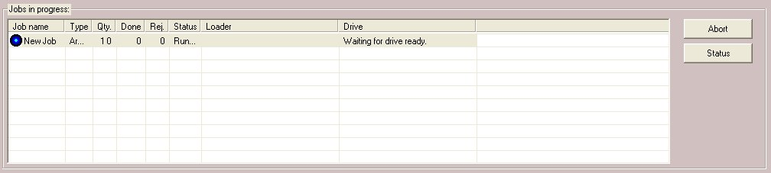

The “Jobs in Progress” section of the Job Manager TAB will now show the status of the job you just started. The Scribe will now load the master disc into the drive. Once read-in successfully, it will accept the master disc to the output hopper and then load the first blank disc to begin duplication.

The ScribePC Application

The ScribePC is a state-of-the-art CD / DVD duplicating system. It is designed to create, duplicate and verify most standard disc formats. This startup section will guide you through starting and configuring the ScribePC application.

Starting the ScribePC Application
To start the ScribePC application the steps are as follows:

- From the desktop of the computer, click the MF Digital Scribe PC Icon
- The ScribePC application screen will now be displayed:

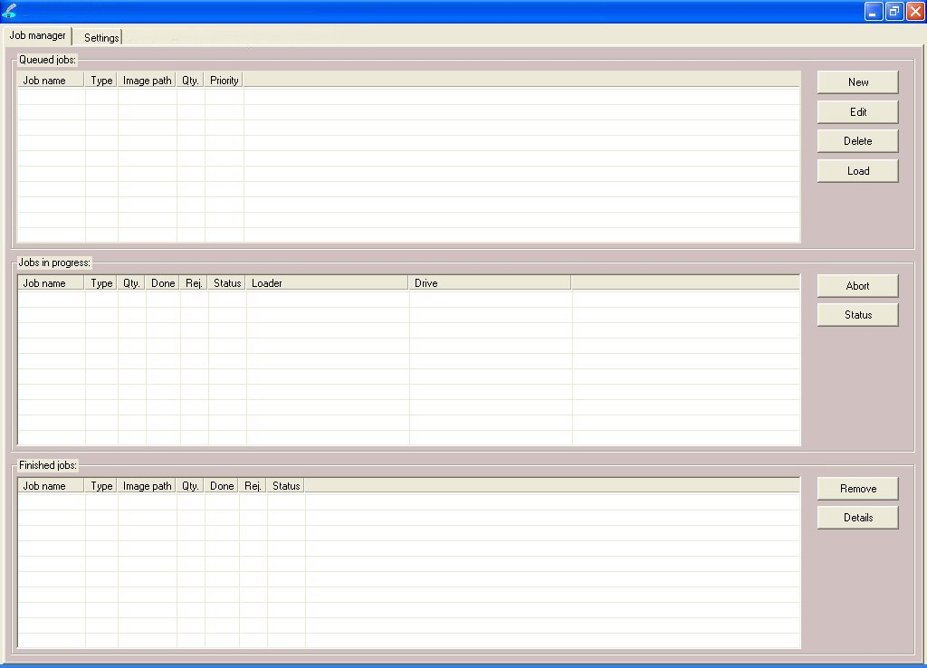

Selecting STANDARD or ADVANCED mode
When first started, you are in “standard”. “Standard” mode is best suited for those who do duplication only and are not pre-mastering from files.
The ScribePC can pre-master audio CDs from WAV, or MP3, data DVDs and CDs from local files and network files, as well as DVD Video discs from previously authored VIDEO_TS folders. If you wish to pre-master any of these types of discs, you will need to Scribe PC’s “Advanced Authoring Tools”. To do so:

- Click on the “Settings” TAB now:

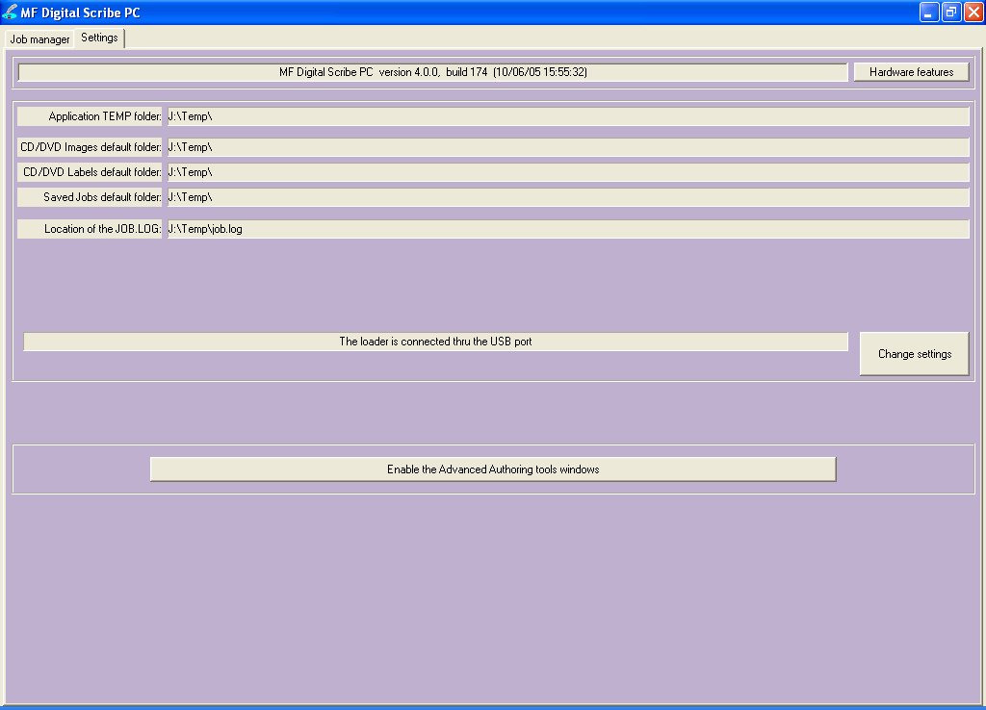

- Click on and three new TABs will be revealed:

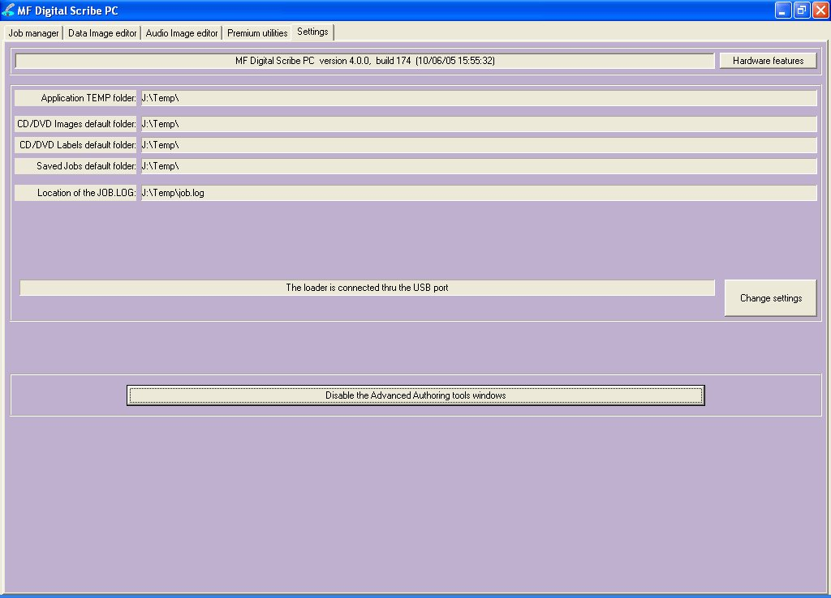

- You may toggle between these modes, simply by enabling and disabling the Advanced Authoring Tools.

ScribePC Application Layout
The ScribePC application is organized into either two or five cards, depending on if Advance Authoring Tools enabled. These cards, referred to as TABs, are accessible by clicking on the desired TAB on the top of the screen. Tabs include Job Manager, Data Image Editor, Audio Image Editor, Settings, and Premium Utilities. By completing the information on these cards, you control the actions of the ScribePC to create, duplicate and verify CDs as well as print disc labels.

Tabs:
Job Manager | This is where jobs are started. The status of all jobs pending, in progress, and completed are displayed here.
Data Image Editor* | On this TAB you can pre-master a data CD or DVD as well as a DVD Video disc from a pre-existing VIDEO_TS folder.
Audio Image Editor* | This TAB allows you to pre-master an audio CD from WAV or MP3 files.
Settings | Defines settings and default file locations.
Premium Utilities* | Scribe add-in plug-ins can be found here. They include batch audio CD ripping to MP3, WMA, FLAC, AIF, or WAV, and hard disk back-up software.
*Accessible only when Advanced Authoring Tools are enabled on the “Settings” TAB.

Reviewing and changing the settings
Before we get started, it is best to visit the “Settings” TAB to ensure your system is setup correctly. If you purchased your unit and printer at the same time, then you should already be set-up correctly as we pre-configure units at the factory. If the printer was bought later, or separately for some reason, then you will need to select the installed printer. The “Settings” TAB allows you to do this.

• Click the Settings tab

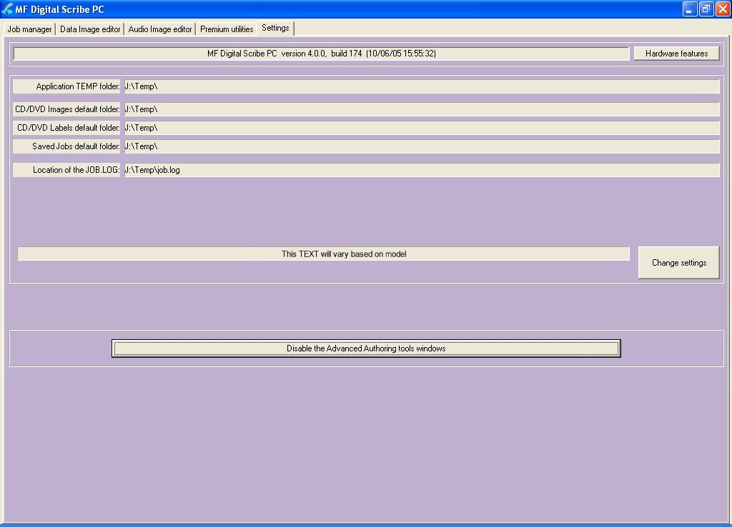

The Settings tab is divided into four areas: Version Information, Default folders, Printer, and Communication Ports. The field closest to the top of the tab is the Scribe PC’s version information. This lets you know what version of ScribePC you are currently running. The settings below the version information may be customized. The following section illustrates this procedure.

Settings Editor
• From the Settings tab, click the Change Settings button and the following screen will be displayed.

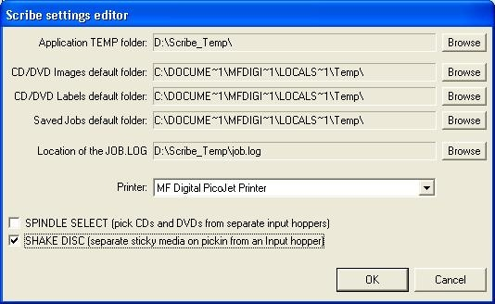

Application Temp Folder

• To choose an application temp folder, click the Browse button to the right of the Application TEMP folder field. This folder is a temporary location for your CD image to reside before and during duplication. After job completion, the image is removed.

Note: You should have 10GB of free space on your hard drive specifically for this folder. The folder should always reside on a drive formatted NTFS and never FAT32 or FAT16.

CD / DVD Images Default Folder

• To choose a default folder for your CD and DVD images, click the Browse button to the right. When creating a new job, this will be the default folder that the ScribePC opens to browse for an image file path.

CD Labels Default Folder

• To choose a default folder for your CD labels, click the Browse button to the right of the CD labels default folder field. When creating a new job, this will be the default folder that the ScribePC opens to browse for a label file path.

Printer Driver

The PRINTER DRIVER pull-down is used to indicate to the ScribePC the type of printer that is installed.

- Click the PRINTER DRIVER pull down and select the type of printer being used.

Spindle Select

When enabled, SPINDLE SELECT allows you to assign one input spindle for DVD-R and one for CD-R. This is useful when submitting multiple jobs or when the ScribePC is being shared amongst network users. When a job requiring CD blanks is started, the ScribePC will know from which spindle to draw blank CD-R media. Likewise, when a job requiring DVD blanks is submitted, the ScribePC will know to which spindle contains DVD-R/+R media. Be sure to fill input spindles only half full, as the first input cannot double as both an input and output spindle an output spindle

- Check the box to enable “Spindle Select” mode.

Note: Capacity is halved in this mode. Fill input spindles only half full. Since the first input spindle cannot double for output as it would when “Spindle Select” mode is disabled. The output will overflow if you fail to do so.

Shake Disc

When enabled, SHAKE DISC will perform a slight shaking motion with each pick of disc from an input hopper. If the discs are somewhat sticky, this can help in separating them. Only enable this in the event you have sticky media.

- Check the box to enable “SHAKE DISC”

Note: When loading blank CDs or DVDs, it is a good idea to fan out the discs. If discs are excessively sticky, it is best to source a different brand or part number. Media made with proper lacquer curing times will minimize this effect.

Data image editor

The first step in constructing a CD or DVD is to create an image file. Image files may be made by reading in a physical master, or by pre-mastering the disc in the Data or Audio Imager Editors. The ScribePC creates industry standard data (Mode 1 ISO 9660 level 2 with Joliet extensions) and audio (Red Book) CDs from scratch as well as duplicates of existing CDs authored in most formats.

Creating a data disc image
To create a data disc image:

- Click the Data Image Editor tab. The screen will now read:

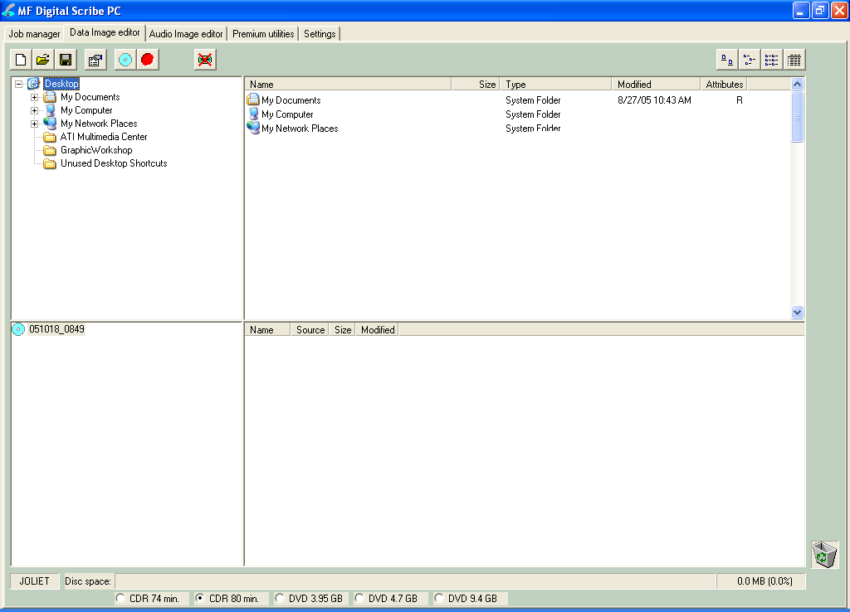

The Data Image Editor tab is divided into four panes. The top left pane lists all of the names and icons of the resources (drives, files and folders) available to the computer. The top right pane displays the contents of any item you click on in the top left pane along with its icon. The bottom left pane lists all the names and icons of files and folders on the disc that is being created. The bottom right pane displays the contents of any item you click on in the bottom left pane, along with its icon.

Image Toolbar
Horizontally along the top of the screen is an area which contains ten buttons, from left to right the buttons are: New CD layout, Load CD layout [*.ISC], Save CD layout [*.ISC], CD Image properties, Create CD image [*.ISO], Record CD, Enable inserting entire contents of folder [*.*], Large Icons, Small Icons, List, and Details.

Image Toolbar:
New CD layout | Starts a new CD or DVD Project. Any current layout is abandoned.
Load CD layout | Loads an existing CD or DVD disc image script file (*.ISC).
Save CD layout | Saves CD or DVD layout to a disc image script file (*.ISC). ISC files are virtual images containing only a list of the contents to be written to the disc. As such, these files are very small but are not self contained like the .ISO, .UDF, and .IMG real image files.
CD Image properties | Allows you change some of the disc properties such as volume label, publisher, data preparer, as well as the desired file system.
Create CD image [*.ISO] | Creates a real disc image file (.ISO for CD or .UDF for DVD). Real image files are self contained and the original source files are not needed once made. These files are large, about the size of the CD or DVD.
Record CD | Click here to burn a disc of this content right away. It is a good idea to save your image file first. Jobs may also be launched at any time from any image file from the STATUS TAB’s “NEW” job button.
Enable inserting entire contents of folder | Specifies the folder as having static or dynamic content. A Dynamic folder’s content can change without having to edit the .ISC file. Static content must exist when the image file is used or the job will fail.
Views | Allows you change view displayed in the top right pane to small or large icons, list, or detail view.

Selecting CD Capacity
Along the bottom of the lower panes is a series of radio button options that are used to select the capacity of the disc you are creating

• Click the radio button corresponding to the capacity of the discs loaded into the ScribePC.

Adding Files and Folders
• Click the desired file or folder in the top left or right pane (source) and hold down the mouse button.
• Drag the file or folder over the CD icon in the lower left pane (fig. 1) and release the mouse button.

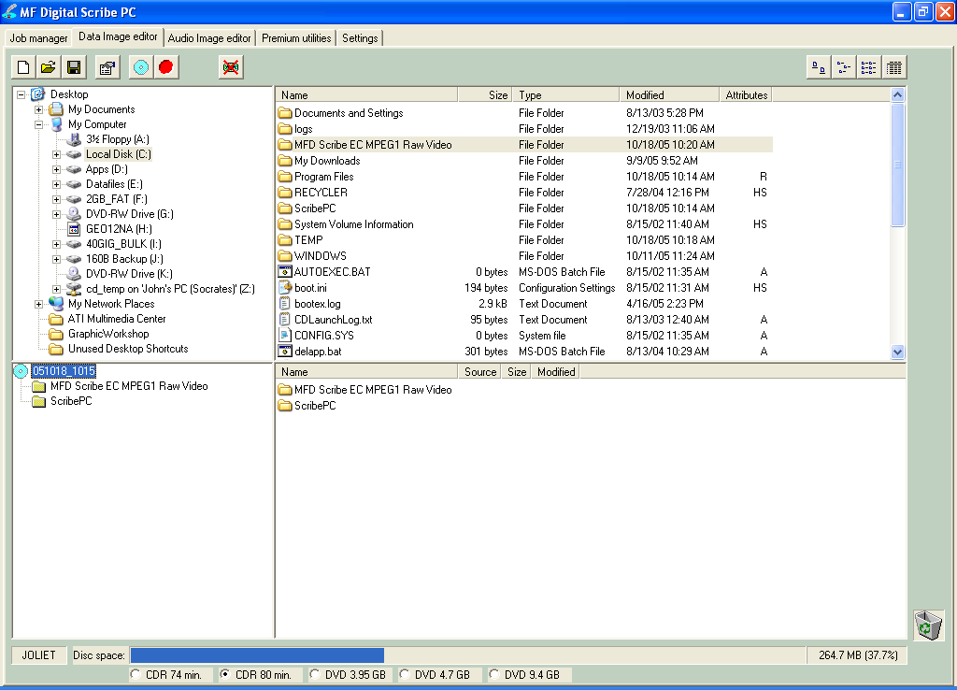  (fig. 1) | 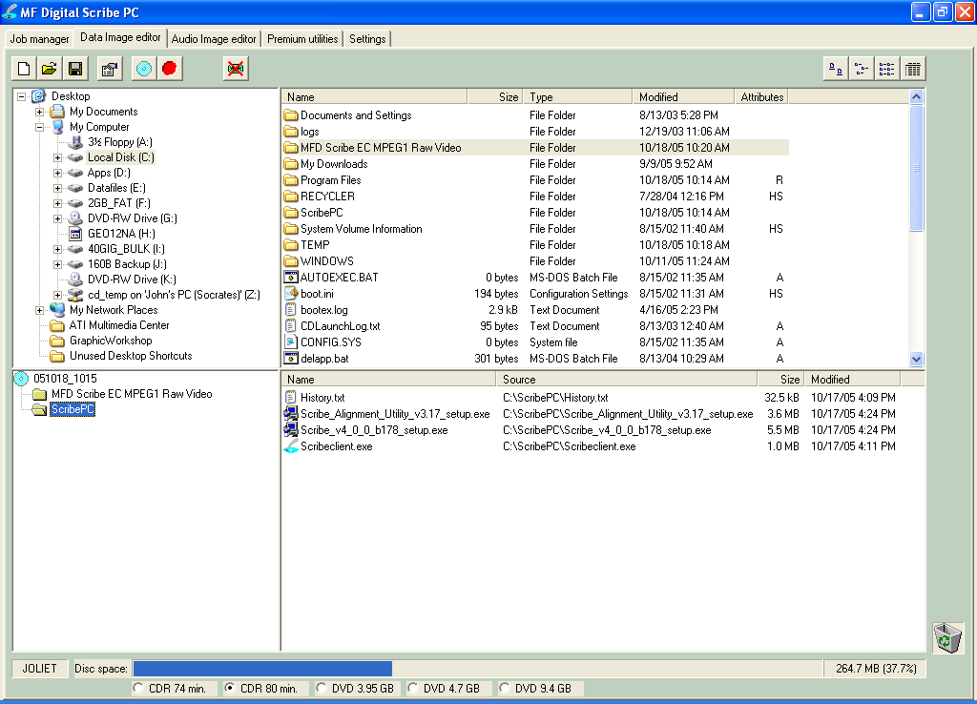  (fig. 2)

• The files in the lower right pane represent the contents of the CD being created (fig. 2).

Creating, renaming, and removing Folders
- In the bottom left pane, first click at the point you wish to insert a folder, or on the folder to be renamed or removed, then Right-Click on it and select the desired operation.

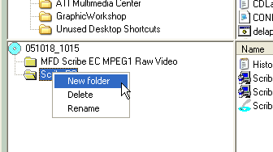

You can also delete content by:
- Click the desired file or folder in the bottom left or right pane and drag the item to the recycle bin in the lower right hand corner. This does not delete the actual file, but rather exclude it from the CD or DVD layout.

Static and Dynamic Content
The ScribePC allows discs to be created from both static and dynamic content. A finished CD or DVD created from static content will contain the exact files and folders that are specified when the disc image is created. A finished CD created from dynamic content will contain the files and folders that exist in specified locations at the time the job is submitted for recording (rather than when the disc image is created).

For example, specifying dynamic content when creating a CD or DVD layout would allow a job to be run every week that records the contents of a specific folder onto a CD without having to create a new disc image every time. In this case the contents of the folder (not the folder itself) can change.

To specify a file or folder on a disc image as containing dynamic content:

- Click in the *.* check box so that the red “X” disappears.

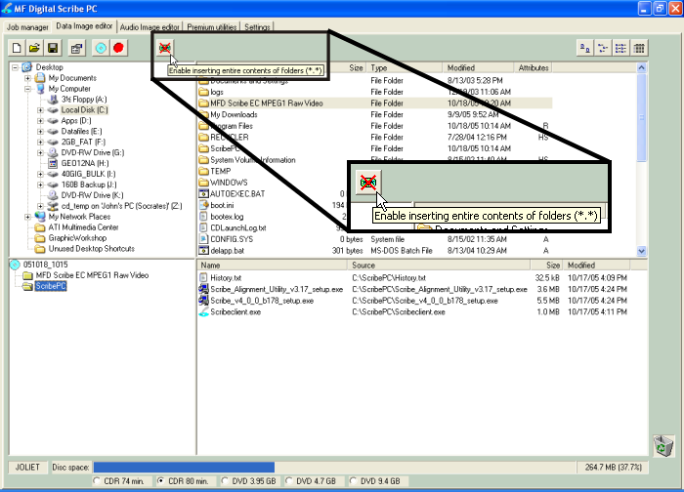

Disabled Enabled

Note:
Please be sure not to exceed the capacity of the disc being used.

Saving The Current Disc Image File
Once a data disc image has been created, it must be saved before it can be used by the Scribe PC as a data source for recording. Disc images can either be saved as script files (with an “ISC” extension) or physical image files (with an “.ISO” extension for CD or a .UDF for DVD).

A script file (ISC) contains pointers to the source data files and is used as a guide at the time of recording the disc. Since a script file does not include the source data it is best used when producing unique or projects with dynamic content and when the source data will always be available to the ScribePC.

A physical image file (ISO for CD, UDF for DVD) is an exact replica of the final disc and contains all of the source data. It is therefore best used when producing static projects that are recorded on a regular basis and when source data will not always be available to the ScribePC. Please note that depending upon the amount of data to be recorded, a physical image file can occupy as much as 700 MB (CD) or 4.7 GB (DVD) of hard disk space.

Before saving your image, you may wish to view the properties

Editing Image properties

- Click the CD Image Properties button on the toolbar. The screen will now read:

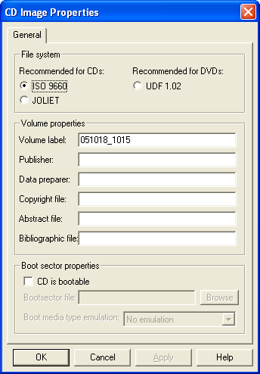

The CD IMAGE PROPERTIES dialog box contains a series of radio buttons as well as a number of information boxes.

- Click the radio button corresponding to the logical file system to be used on the CD (ISO 9660, Joliet, or UDF 1.02 for DVD).
- Optionally complete the volume properties information boxes:

Volume Properties
Volume Label | Optionally enter the name you want to call the CD / DVD.
Publisher | Optionally enter the name of the publisher.
Data Preparer | Optionally enter the name of the person who prepared the disc.
Copyright File | Optionally enter the file name that provides copyright information about the CD.
Abstract File | Optionally enter the file name that describes the contents of the CD.
Bibliographic File | Optionally enter the file name that provides bibliographic information about the CD.

- Click the OK button.
• Click the Save CD layout button on the toolbar. The screen will now read:

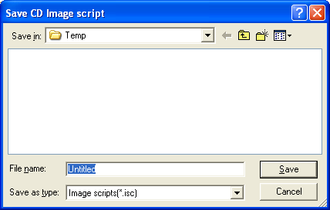

- Select the volume and directory where you want to save the script file.
- Enter the name for the script file and click the Save button.

To create a physical disc image file:
- Click the Create CD Image button on the toolbar. The screen will now read:

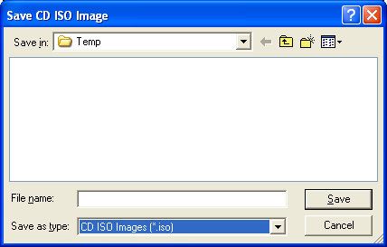  CD Image File | Or… | 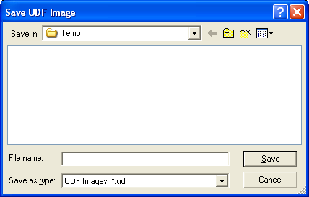  DVD Image File

- Select the volume and directory where you want to save the physical image file.
• Enter the name for the physical image file and click the Save button.

Loading An Existing Script File
Once a data disc image script file has been saved it can be modified at a later date.

To load an existing script file:
- Click the Load CD layout [*.ISC] button on the toolbar. The screen will now read:

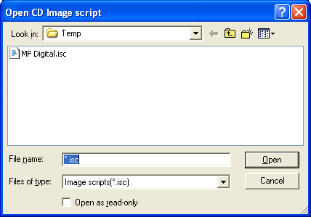

• Select the desired file and click the Open button.

Audio Image Editor
The ScribePC creates industry standard audio (Red Book) CDs from scratch that can be played on any home, car or portable compact disc audio player or computer CD or DVD-ROM drive. Audio tracks are created using any combination of 44.1 kHz, 16 bit stereo WAV or MP3 files.

To create an audio disc image:

- Click the Audio Image Editor tab. The screen will now read:

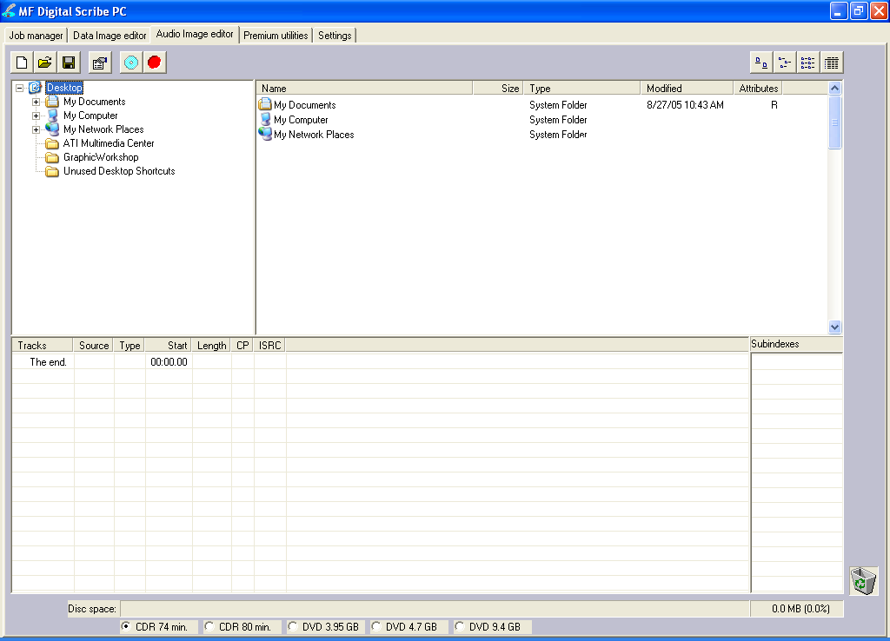

The Audio Image Editor tab is divided into four panes. The top left pane lists all the names and icons of the disk drives available to the ScribePC, as well as files and folders on the currently selected disk drive (source). The top right pane displays the contents of any item you click on in the top left pane along with its icon. The bottom left pane lists the names of audio files on the CD which is being created (disc image) as well as their type (WAV or MP3), start position and length, copy prohibit status and ISRC code. The bottom right pane displays the sub-indexes of any file you click on in the bottom left pane.

Audio Image Editor Toolbar
Horizontally along the top of the screen is an area which contains ten buttons, from left to right the buttons are: New CD layout, Load CD layout [*.ISC], Save CD layout [*.ISC], CD Image properties, Create CD image [*.IMG], Record CD, Large Icons, Small Icons, List, Details.

Image Toolbar:
New CD layout | Starts a new Audio CD project. Any current layout is abandoned.
Load CD layout | Loads an existing Audio CD disc image script file (*.ISC).
Save CD layout | Saves the current Audio CD layout to a disc image script file (*.ISC).
CD Image properties | Unlike with data discs, the properties button audio discs allows you to optionally change only the disc’s UPC code.
Create CD image | Creates a real disc image file (.IMG. Real image files are self contained and the original source files are not needed once made. These files are large, about the size of the finished CD.
Record CD | Click here to burn a disc of this content right away. It is a good idea to save your image file first. Jobs may also be launched at any time from any image file from the STATUS TAB’s “NEW” job button.
Views | Allows you change view displayed in the top right pane to small or large icons, list, or detail view.

Adding Tracks
• As depicted below, drag one or more WAV / MP3 files onto the text "The end" as it appears in the top left corner of the bottom pane. Multiple files may be selected by pressing and holding down the SHIFT or CTRL key while clicking on the tracks. SHIFT allows you to select a range of contiguous tracks, while CTRL allows you to selectively pick multiple tracks. As additional tracks are added, drag and drop them in at the desired insertion point.

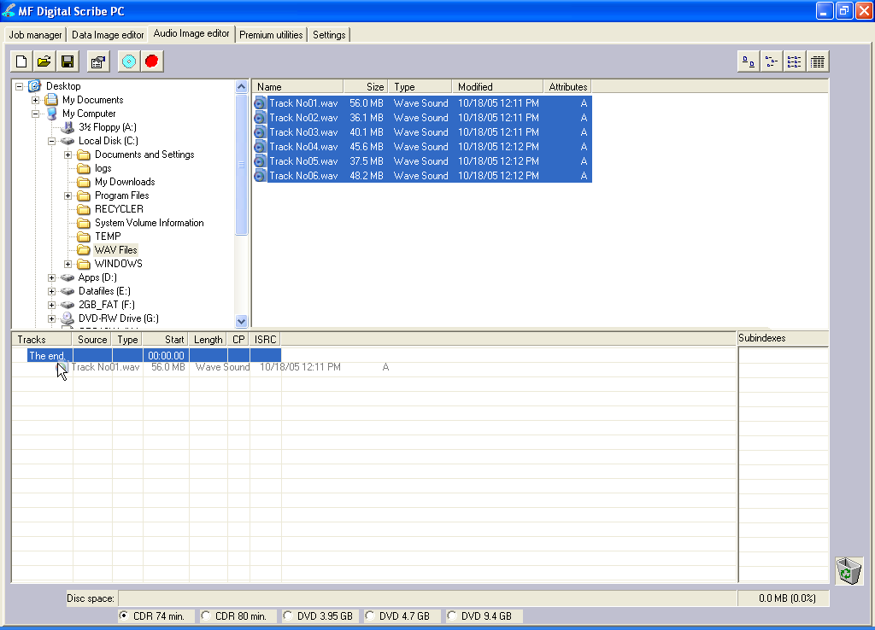

Removing Tracks
- Click the desired audio track in the bottom left pane and hold down the mouse button.
- Drag the audio track over the trashcan in the bottom right of the Audio tab and release the mouse button, or right click on the track and click delete.
- Click the Yes button.

Changing A UPC Code
The UNIFORM PRODUCT CODE (UPC) is an optional 13-digit descriptor that can be written into an audio CD.

To change the UPC code:

- Click the CD Image Properties button on the Image toolbar. The screen will now read:

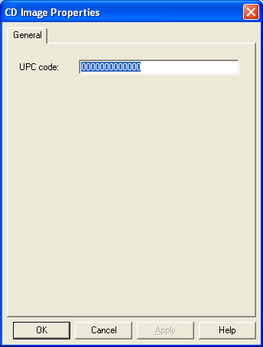

- Enter the numeric code and click the OK button.

Changing ISRC Codes And Copy Prohibit Flags
The INTERNATIONAL STANDARD RECORDING CODE (ISRC) is an optional 12-character descriptor that identifies a specific track on an audio CD. Each track can have its own unique ISRC consisting of 2 alphanumeric characters (country), 3 alphanumeric characters (owner), 2 digits (year of recording) and 5 digits (serial number). For more information on ISRC codes, you can visit:

http://www.riaa.com/issues/audio/isrc_faq.asp

The Copy Prohibit flag is a setting in each track on an audio CD, indicating whether or not that track can be copied by a digital recorder.

To change an ISRC code:

- Right click the desired audio track in the lower left pane, and select Edit. The screen will now read:
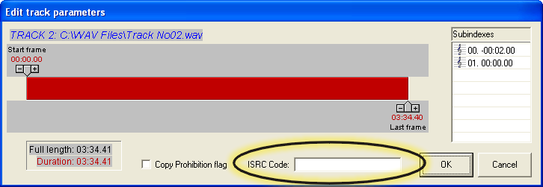

- Enter the code in the ISRC line and click the OK button. Valid codes start with two-letter country code, followed by ten digits.

To change a Copy Prohibit flag:

- Right click the desired audio track in the lower left pane, and select Edit The screen will now read:

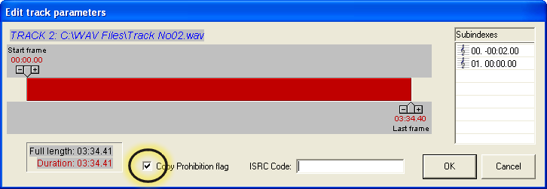

- To enable Copy Prohibit bit select the Copy Prohibit box so that it is checked, or uncheck the box to disable Copy Prohibit bit.

Inserting, Editing And Removing Silence
When assembling an audio CD disc image the ScribePC application does not insert silences (gaps) between tracks.

To insert silence between tracks:

- Right click on an audio track.
- Select “Insert silence.”

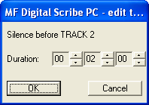

To edit the amount of silence between tracks:

- Right click the silence indicator you wish to edit in the lower left pane, and select Edit.
- Click the up and down indicators to increase or decrease the duration of the silence (minutes, seconds, frames).
- Click the OK button.

To remove silence between tracks:

- Click the silence indicator you wish to remove in the lower left pane and hold down the mouse button.
- Drag the silence indicator over the trashcan in the bottom right of the Audio tab and release the mouse button.
- Click the Yes button.
or
- Right click the silence indicator, and select Delete.

Inserting, Editing And Removing Subindexes
Subindexes are markers used by CD audio players to locate specific points inside an audio track. Subindex 0 indicates the start of any silence before the beginning of a track and subindex 1 indicates the beginning of a track’s audio material. Other subindexes can also be assigned to allow some audio players to locate specified material within a track itself.

To insert subindexes in a track:

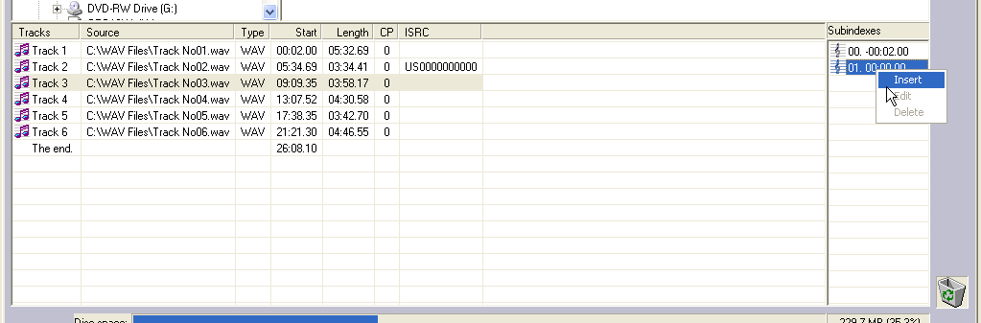
- Click on the desired track to highlight it, then right click subindex 01 in the subindex column and then click the Insert button. The screen will now read:

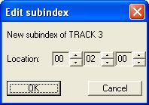

- Click the up and down indicators to specify the location of the subindex (minutes, seconds, frames).
- Click the OK button.

To edit subindexes:

- Right click the subindex you wish to edit in the lower right.
- Click the edit button.
- Click the up and down indicators to specify the new location of the subindex (minutes, seconds, frames).
- Click the OK button.

To remove subindexes:

- Right click the subindex you wish to remove in the lower right pane.
- Select Delete
or
- Drag the subindex over the trashcan in the bottom right of the Audio tab and release the mouse button.
- Click the Yes button.

Saving The Current Audio Disc Image
Once an audio disc image has been created it must be saved before it can be used by the Scribe PC as an audio source for recording. Disc images are saved as script files (with an “ISC” extension).Image Scripts may be easily edited later while physical images cannot and must be regenerated..

To save an audio disc image script file:

- Click the Save button on the toolbar. The screen will now read:

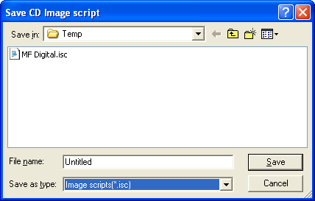

- Select the volume and directory where you want to save the script file.
- Enter the name for the audio disc script file and click the Save button.

To create a physical audio disc image file (.IMG):
- Click the Create CD Image button on the toolbar. The screen will now read:

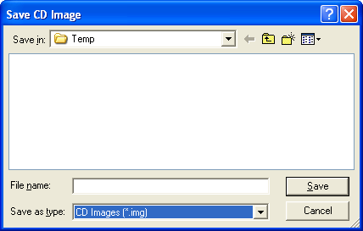
- Select the volume and directory where you want to save the physical image file.
• Enter the name for the physical image file and click the Save button.

Loading An Existing Script File
Once a data disc image script file has been saved it can be modified at a later date.

To load an existing script file:
- Click the Load CD layout [*.ISC] button on the toolbar. The screen will now read:

- Select the desired file and click the Open button.

Job Manager Tab
A job is any production run whether it be reading-in a master (archive), copying an existing disc, copying and printing, or printing only. In addition to showing you the status of jobs, the job manager is where you will go start new jobs.

• Click the Job Manager tab.

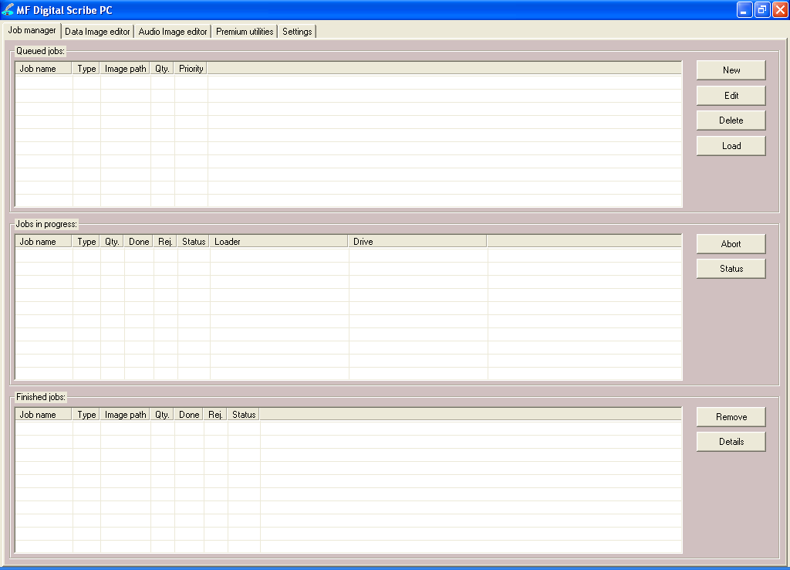

The screen will now show the Job manager tab where the progress of jobs submitted for production can be easily monitored. The Status tab is divided into three panes. The top pane is the JOB QUEUE window which lists all of the jobs waiting to be processed by displaying their assigned Job name, type of job, image path, total number of requested CDs, their assigned priority, as well as the names of their associated disc image and label files.

The middle pane is the ACTIVE JOBS window that lists all the jobs currently being recorded or printed by the SCRIBE PC. Information displayed for each job includes its assigned Job name, type of job, total number of requested CDs, the number of successful CDs produced, the number of failed CDs produced, the immediate status of the job (copying images, loading discs, copying discs, unloading discs, etc.) and the progress.

The lower pane is the finished jobs window that lists all the jobs completed by the SCRIBE PC. Information displayed for each job includes its assigned Job name, type of job, image path, the total number of requested CDs, the number of successful CDs produced, the number of failed CDs produced, and the status.

The Production Process
During production the blank discs will be loaded one at a time from the input spindle into the recorders and/or printer. Upon successful completion the discs will be unloaded onto the output spindle if the “print” general option is not selected. If selected, the discs will go to the printer before being placed on the output spindle. This process will continue until the job is complete and the SCRIBE PC will then advance to produce the next job in the queue according to its priority.

However, if the input spindle empties before the job is complete, the screen will read:

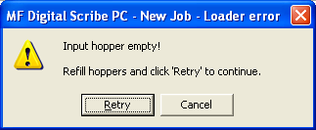

To continue producing the job, place additional blank discs onto the input spindle and click the Yes button. To stop the job click the No button and the remainder of the job will be aborted. The SCRIBE PC will then advance to produce the next job in the queue according to its priority.

Note: Any discs dropped in the reject area have failed to record properly and should not be used. Be sure to remove rejected discs periodically during operation.

Creating a job
In order to produce copies you must create a job. Think of a job as your work-order. It tells the Scribe PC what to do, and how many to do.

• Click the New button to the right of the Queued jobs area ON THE Job Manager tab. This brings up the Creating new job ‘New Job’ wizard.

The Creating new job ‘New Job’ wizard offers six options.

Type of Jobs:
Archive only  (Read-in) | This option allows you to read in the top most disc in the input bin. The disc is saved to the hard drive as an image file. This file can serve as a master for future copy and/or verify jobs.
Copy | This option allows you to start a copy, or copy & print job from an existing image or from a new master disc.
Verify | This option allows you to start a verify / compare job from an existing image or from a master disc. This option is good for checking previously made copy to ensure they are the same as the master.
Relay Mode | This option allows you to make copies, as well as print the copies, of multiple master discs. Rather than launching several jobs from various image files, with “relay Mode” you can simply load up the input bin(s) with several blanks (same type as master), then a master disc (CD or DVD). Repeat this for each master you wish to copy in this batch mode. Each time a disc with data is encountered, it will be read-in and copying will then continue until the next disc with data is reached.
Print only | This option allows you to start a print only job. You must have already made a print image file as detailed in the appendixes of this manual. File types include; PRN files - made for the attached printer, Adobe PDF files, or SureThing STD files.
Multi-disc archive  (batch read-in) | Similar to Archive, this option allows you to batch read several masters.
Data import | Unlike ARCHIVE, or reading-in a master to an image file, Data-import allows you to copy the contents of the CD or DVD as files and folders to a user defined local or network location. You can even set up multiple batches with one batch writing to one location, and the other writing to their own user defined paths

Archive only – reading in a master disc
An Archive job allows you to read-in an existing master to create a disc image file. DVDs will be saved as .UDF files and CDs to .IMG files. These files may be used later when starting a COPY job. If you will not need to copy this master again, you can read & copy in one step by starting a COPY job, and selecting MASTER DISC as described in the next section.

- Select the “Archive only” button as seen in (fig. 1).  - Click browse and select the “Image file path” for the file that you would like to archive. This lets the SCRIBE PC know where to place your file and what name to give your file.  - The file path that you choose will show in the window as seen in (fig. 3). Click “Next”.  - The “Job parameters” will then be displayed. Give your job a name and select a priority.  - Click “Finish” and the SCRIBE PC will run the job. | 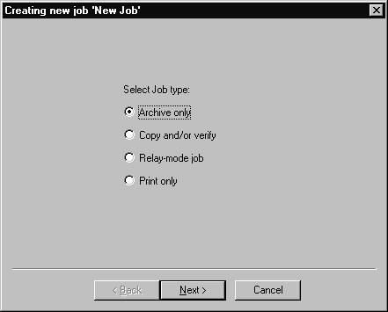  (fig. 1)  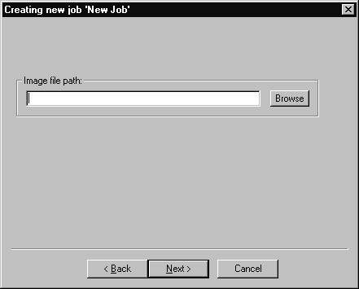  (fig. 2)  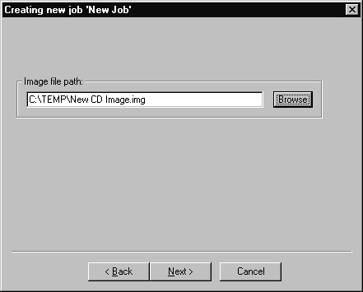  (fig. 3)  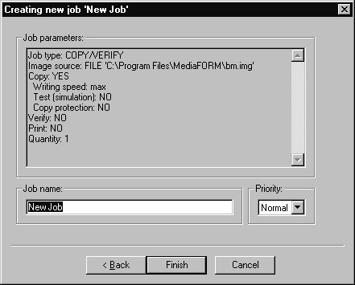  (fig. 4)

Copy and / or Verify
This allows you to start copying or verifying from an image file, or a new master disc.

- Select the “Copy and/or Verify” button as seen in (fig. 1).  - Click “Next”.  - Select the Image source for your job. This can be an ISC, IMG, UDF or a master disc that you place on top of the blank discs. The SCRIBE PC will archive (read-in) the contents of the master and copy the contents to as many discs as are indicated in the quantity box. If the SCRIBE PC detects another master during the copy process, the SCRIBE PC will reject the additional master. You may also select browse and choose an existing disc image.  - You will then want to choose the Operations and Options for your job: Copy, Test, Writing speed, Verify, and Print.  Operations and Options:  - You will then enter the quantity of discs toward the bottom of the screen, then click the ‘Next’ button.  - If you choose ‘Print’, you will b prompted to select a label file (fig. 3). Click on browse and locate the PRN, STD, or PDF file to be used (Seethe appendices of this manual for tips on making these files). Enter the desire number of copies and optionally select “Print before copying / verifying” (for use when using BizCDs and BizCD adapter) and / or “Ignore low ink level”.  - When you are satisfied with your selections, click the ‘Next’ button. The job confirmation dialog will be displayed (fig 3).  - Click on the ‘Finish’ button to launch your job. | 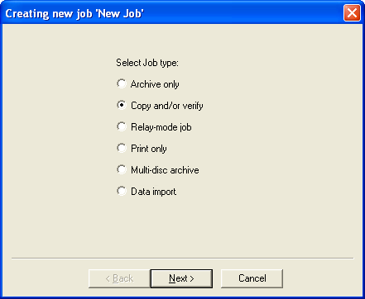  (fig. 1)  (fig. 2)  (fig. 3)  (fig. 4)
  Copy | When checked, the discs in the submitted job will be recorded using the disc image file selected in the IMAGE field.
  Verify | When checked, the discs in the submitted job will automatically be compared against the source files after recording is completed.
  Print | When checked, the discs will be printed with the disc label selected in the LABEL FILE field.
  Test | When checked the CDs in the submitted job will not be recorded.
  Speed | The recording speed pull-down allows you to set the recording speed as determined by the capabilities of the recorders installed in the ScribePC.
  Print first | When checked, ScribePC will print the disc before copying. This is require when printing to BizCDs.
  A note about “Ignore Low Ink Level”
  Competitive systems continue to attempt to print even when cartridges have run out, resulting in ruined discs. PicoJet equipped Scribe PC systems will stop at 4% remaining ensuring you will not waste discs. Optionally you can choose to ignore this safeguard to glean the last few discs out of a cartridge.

Relay mode job
Relay mode allows you to make multiple copies of multiple masters. Simply load the unit with the desired number of blank discs, then the master such that the master sits on top of the blanks. Then load in more blanks followed by the next master and so on. The end result will be copies of each master placed in to the input bin(s).

- Select the Relay-mode job button as seen in (fig. 1).  - Click Next.  - Select the Operations and options for the relay mode job.  - Click Next.  - If you checked the “Print” option on the previous screen, you will be presented with “List of Label files” screen (fig. 3). Here you will create a list of printer label files (PRN) Click add to select the desired file.  Add as many PRN files as masters loaded and in the same order (fig. 4).  If needed, you can move files up and down in the list until the order of PRN files matches the order in which your masters were loaded (fig.4).  - The Job parameters will then be displayed. Give your job a name and select a priority.  - Click Finish and the SCRIBE PC will run the job.  - The Job parameters will then be displayed. Give your job a name and select a priority.  - Click Finish and the SCRIBE PC will run the job. | 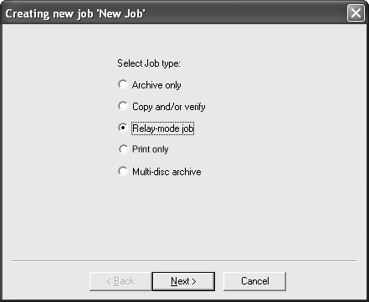  (fig. 1)  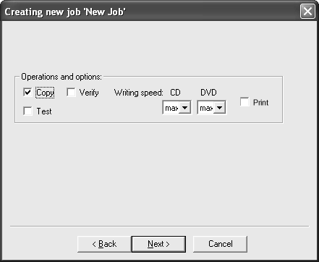(fig. 2)  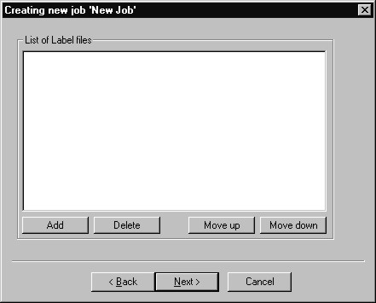  (fig. 3)  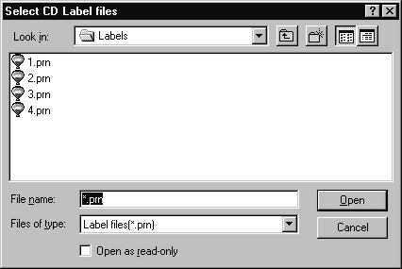  (fig. 4)  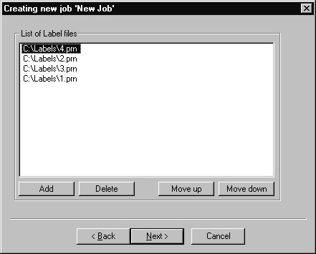  (fig. 4)

Print only job
Print only job allows you print discs without first duplicating them.

- On the Job Manager TAB, click the New button to the right of the Queued jobs area to start a new job. Select the Print only button as seen in (fig. 1).  - Click Next  .  - Click Browse and locate the label file that you would like to use, either a .PRN, an Adobe Acrobat .PDF, or SureThing .STD file. See the appendices of this manual for tips on working with these files.  - Enter a quantity of discs for the job. Optionally you may choose to ignore low ink level  - When you are satisfied with your selections, click the ‘Next’ button. The job confirmation dialog will be displayed (fig 3).  - Click on the ‘Finish’ button to launch your job. | 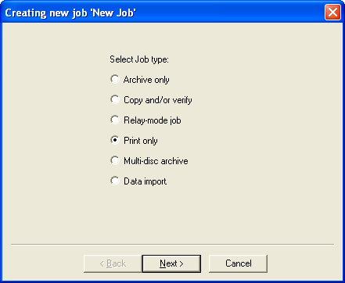  (fig. 1)  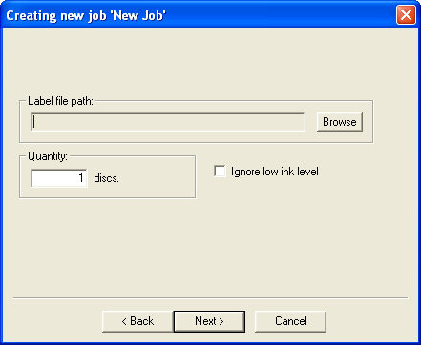  (fig. 2)  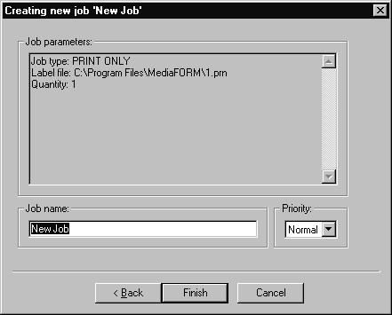  (fig 3)
  A note about “Ignore Low Ink Level”
  Competitive systems continue to attempt to print even when cartridges have run out, resulting in ruined discs. PicoJet equipped Scribe PC systems will stop at 4% remaining ensuring you will not waste discs. Optionally you can choose to ignore this safeguard to glean the last few discs out of a cartridge.

Multi-disc Archive – reading in several masters at a time
Similar to an archive job, used to read-in an existing master disc to create an image file, multi-disc archive lets you read in several masters in batch. DVDs will be saved as .UDF files and CDs to .IMG files. These files may be used later when starting a COPY job.

- On the Job Manager TAB, click the New button to the right of the Queued jobs area to start a new job. Select the Multi-disc archive button as seen in (fig. 1).  - Click Next.  - Click on the up and down arrows to set the desired number of discs to be read-in. In the example to the right (fig 2), we have set the number to ‘5’. By default, the files will be named sequentially, and stored to the default image folder.  To change the desired filename(s), right-click the master you wish to edit, and select Rename (fig 3). Similarly, you can choose ‘Move up’ and ‘Move down’ to change the order of masters.  select the desired destination folder, if other than the default, then enter the desire filename and click the ‘Save’ button when you are happy with your entry. Be sure to always leave the .IMG filename extension (fig 4).  - Click NEXT, and the confirmation screen depicted in fig. 5 will be displayed. Load the masters into the input bin. The top-most disc will be assigned the first image filename on the list, so be sure you the discs loaded in the correct order.  - Click the ‘Finish' to launch the batch read-in job. | 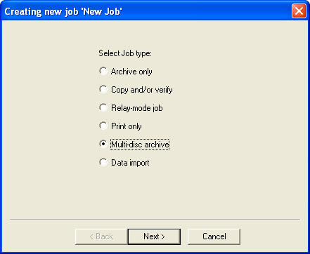  (fig. 1)  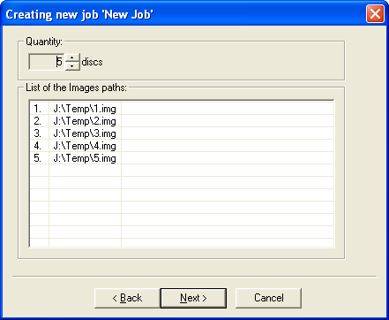  (fig. 2)  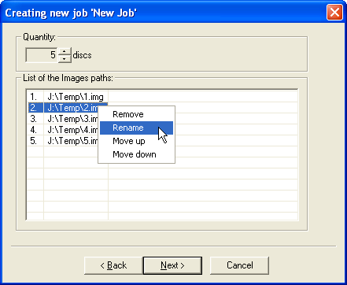  (fig. 3)  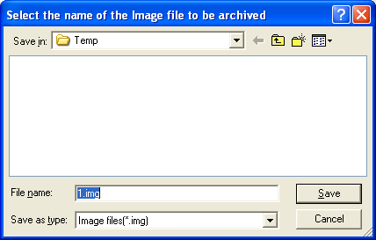  (fig. 4)  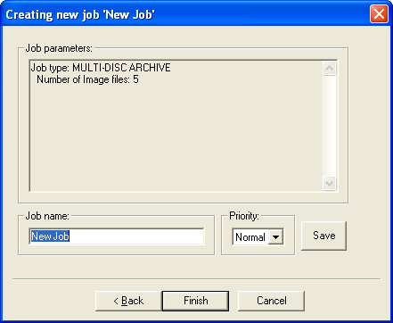  (fig. 5)

Data Import – Ripping data CDs or DVDs
While the Archive, or multi-disc Archive job options allow you read in a CD or DVD to create a single file image of that disc, a ‘Data import’ job allows you to copy the director structure of a CD or DVD to local or network storage location. You can even set up multiple batches with one batch writing to one location, and the other writing to their own user defined paths. This makes for the perfect tool to automate the ripping of Windows readable data CDs or DVDs. Simply stack up your data CDs or DVDs in the input hopper and Scribe will copy the contents one by one into user definable locations. This is a great way to migrate data from disc and old jukebox devices to newer high capacity storage platforms such as high-density optical disc, storage area networks, or other network attached storage devices.

- On the Job Manager TAB, click the New button to the right of the Queued jobs area to start a new job. Select the Data import button as seen in (fig. 1).  - Click Next.  - Click on the up and down arrows to set the desired number of discs to be ripped. In the example to the right (fig 2), we have set the number to 25. Click on the ‘Browse’ button if you wish to select a destination folder other than the default image folder for this batch. Choose the desired sub-folder naming option, either based on the CD or DVD’s volume name or customized names.  Option 1 – Based on Volume Name  Each disc in the batch will copied a folder name based on the volume name of the CD or DVD to the main destination folder. Click on the ‘Next’ button if you wish to use this method, or…  Option 2 – Customized  ‘Customized’ allows you to choose the sub-folder name of each disc in the batch to rip. This sub folder will be created within the main destination folder. By default, the first disc will be copied to a sub-folder called Disc1, the second to Disc2, and so on (fig 3).  If you wish to modify this, double click on the entry you wish to change (fig 4). Select the desired destination folder, if other than the default, then enter the desired sub-folder name in the file name text box then click save. You will be returned to the folder list dialog (fig 3).  - Click NEXT, and the confirmation screen depicted in fig. 5 will be displayed.  - Click the ‘Finish' to launch the data import job. | 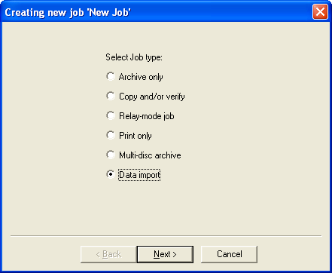  (fig. 1)  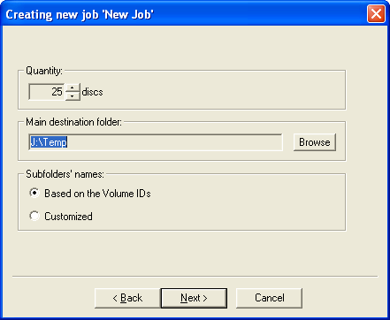  (fig. 2)  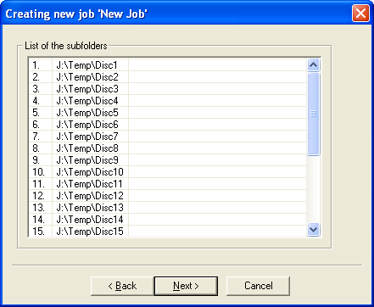  (fig. 3)  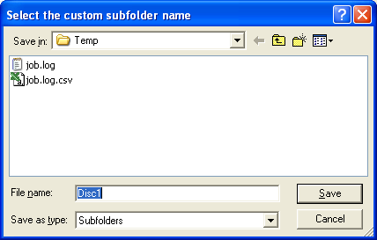  (fig. 4)  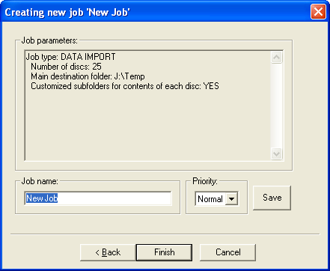  (fig. 5)

Log Files
The Scribe PC maintains two log files; JOB.LOG and JOB.LOG.CSV. These files are written to the folder defined on the settings TAB.

JOB.LOG
This is a simple text file that can be viewed using Notepad, Wordpad, Word or any text other word processor. It is formatted so that it is easily readable by the user.

Job name: New Job
Start time: 11/16/06 19:17:38
Completion time: 11/16/06 19:20:24
Status: Aborted by user (Input hopper empty).
Job type: Data import
Main destination folder: J:\Temp
Customized subfolders for contents of each disc: YES
Quantity: 25
Done: 1
Rejected: 0
============================================================

Job name: New Job
Start time: 11/16/06 19:21:13
Completion time: 11/16/06 19:22:39
Status: Finished without errors
Job type: Data import
Main destination folder: J:\Temp
Customized subfolders for contents of each disc: NO
Quantity: 1
Done: 1
Rejected: 0
============================================================

JOB.LOG.CSV
This is also simple text file, and it contains the same data as the JOB.LOG file, but it is in CSV, or Comma Separated Values format. CSV files re best opened with Excel, or imported into a database or spreadsheet.

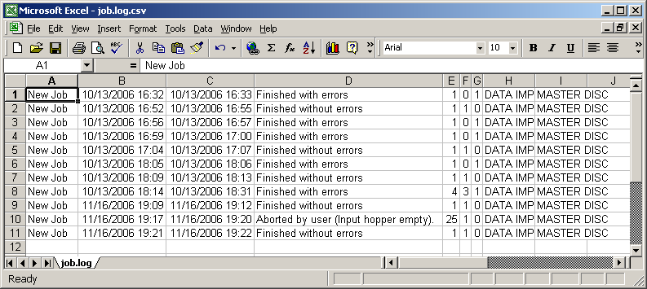

Network Client Software
The Scribe PC comes with 100-base-T Ethernet. Gigabit Ethernet is also available at a slight premium. This allows you to connect the Scribe PC as you would any Microsoft Windows XP PC on your network. In doing so, you can share the Scribe PC with other users on your network allowing them to submit jobs remotely.

Client PC minimum requirements:
Client PCs should meet or exceed these minimum requirements:

- Pentium 4 or better processor
- 512 MB of RAM
- Windows XP or Windows 2000
- 10GB of free NTFS formatted hard disk space.
- If you use firewall software, be sure not to block the port(s) used by the ScribePC client software (virtual port 12345)
- 100 Base-T network supporting Microsoft TCP/IP protocol.

Installing the client software
The Scribe network client, a file named ScribeClient.exe, was copied to your hard drive during installation. The client software is a single .EXE file and simply needs to be copied to the desired location You can do either by copying the file to a server, a share on the PC you wish to give client privileges too, or use the Scribe PC and write the file to disc.

Here we will show you how to install and run from the desktop of the Windows 2000 / XP client PC.

- On your ScribePC, right click on Start and select Explore.  - Use Windows Explorer to browse your Scribe PC’s hard drive. If you have the default factory installation, locate the "C:\Program Files\MF Digital\Scribe\” folder.  - Right click on Scribeclient.exe and select COPY. | 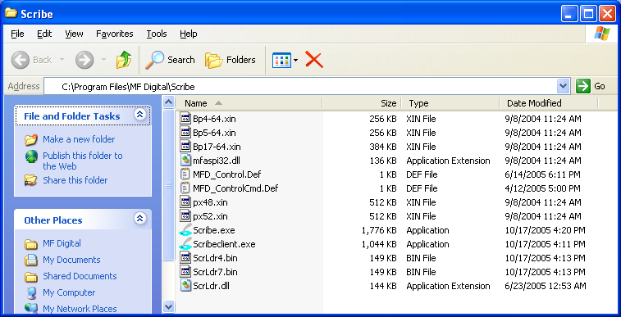
- Again using Windows Explorer. browse to the location where you would like to place the client software, right click and select PASTE. I suggest copying to your remote’s PC’s desktop, or to a network a share from which you can copy ScribeCLient.exe file to each client PC’s desktop.

Using the client software
The Scribe network client, is virtually identical to the Scribe PC software itself. It allows you to remotely do almost most everything you can on the Scribe PC copier itself. This does NOT include the premium utilities as detailed in Appendix C.

Before running the Scribeclient.exe client application, be sure the ScribePC copier is powered on and available on the network. The client software will NOT work unless the ScribePC is running as it functions as job server. Normally you can launch the client as is. In some cases, like large corporate domains where network scanning time can be slow, it may be best to use the command line switches below. These can mitigate the time it takes the client to poll the network looking for hosts.

Optional command line switches for ScribeClient.exe:
/uid username | Specifies the username which has to be at least 6 chars long and contain only small or capital letters (a-z, A-Z), digits (0-9), and underscore sign (_).
/sid servername1,2… | Specifies the Scribe server name(s), separated by commas or spaces.

- If you copied the client software to your desktop, click on the Scribeclient.exe icon:    - You will be prompted for a User Id (fig.)  - Enter a unique name in the User ID. User IDs are for the sole purpose of distinguishing one user from another when shared amongst multiple users. It does not serve the purpose of granting or not granting access to the device.  - Click on Connect. Select Hosts will be displayed (fig. 2)  - Left click on the appropriate ScribePC. This list displays computers by their network name. Then click OK.  - The familiar Scribe PC application will open up. Its use is the same as the Scribe PC, so please refer to previous pages on how to use the software. | 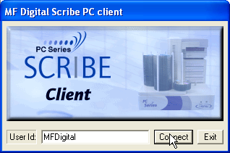  (fig 1.)  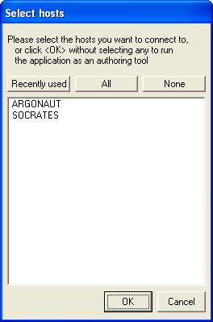  (Fig.2)

Appendix A: Creating .PRN Files (Prism Plus)
Printer Driver setup  Before you create your first print label, you must first set a couple of printer defaults. Once you have done this, you need not repeat this step again unless you reinstall the printer driver.  - Double-click MY COMPUTER on the desktop, then click on CONROL PANEL. From the control panel, click on PRINTERS AND FAXES. Right-click on RIMAGE PERFECT IMAGE PRINTER PF and select properties. Click on the ADVANCED TAB, and set the PRINT DIRECTLY TO PRINTER option as seen in Fig A.  - Your printer shipped with a monochrome back ribbon. You need to tell the printer that this ribbon is installed. As depicted in Fig B., click on the DEVICE SETTINGS tab, and click on the INSTALLED RIBBON pull down and select “Monocolor”.  - Click OK  Making a .PRN label file  Next, we will create a “.prn” file by printing the document to a file instead of routing it directly to a printer. You will be prompted to specify the filename and location. This puts the document in a format that the ScribePC can use for printing. Follow the instructions below to create a .prn.  - Use the CD Designer that was included with your Prism Plus software to create label. When a label file is saved in CD Designer it is given a .BTW extension. This format is not usable by the ScribePC program. You will however want to save your label as a .BTW for future editing (Fig. C).  - To create a “.prn” you must use the Print feature after you have created your label. Click on File-Print. In the NAME text box, be sure the RIMAGE PERFECT and Select the Print to file option (Fig D.).  - Click on Print and give your file a name (Fig. E.). It is a good idea to Click on BROWSE and choose the labels folder defined on the settings TAB of the Scribe PC software.  - Click on PRINT when you are satisfied and the PRN file will be created. This file may now be used in the ScribePC software. | 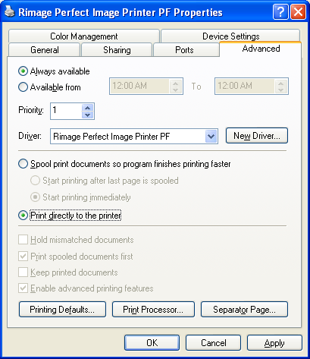  (Fig A.)  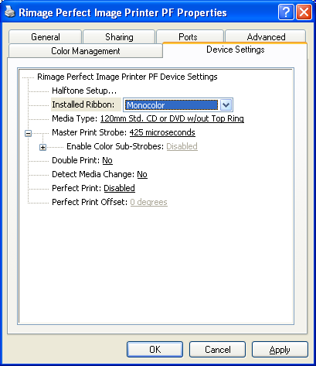  (Fig B.)  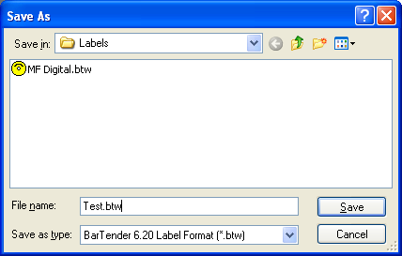  (Fig C)  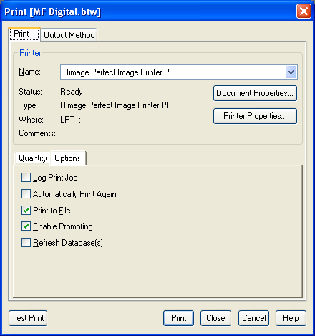  (Fig D)  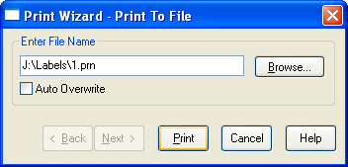  (Fig E.)

Note:. A .prn file cannot be edited. It contains information to create the image, and the settings of the particular printer. If any of the settings of the printer are changed, a new .prn file must be generated.

Appendix B: Creating .PRN Files (PicoJet)
If you have not already read the manual that accompanied your PicoJet printer, now would b a good time. Here is a recap on h0w to make “.PRN” files for use with your PicoJet CD / DVD printer and Scribe{C copier.

Printer Driver setup
Before you create your first print label, you must first set a couple of printer defaults. Once you have done this, you need not repeat this step again unless you reinstall the printer driver. If you purchased your printer and copier at the same time, this was pre-configured at the factory
- Double-click MY COMPUTER on the desktop, then click on CONROL PANEL. From the control panel, click on PRINTERS AND FAXES. Right-click on PICOJET 6000 and select properties. Click on the ADVANCED TAB, and set the PRINT DIRECTLY TO PRINTER option.

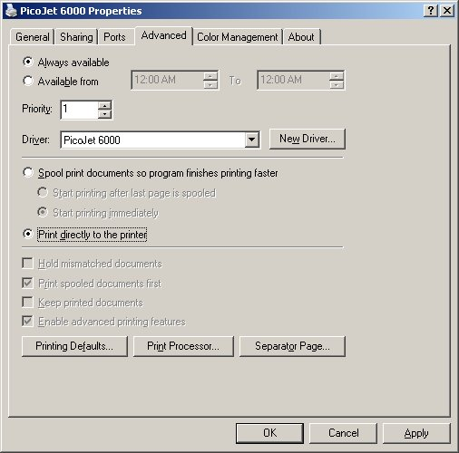

- Click on “OK”. Start the SureThing software and complete the initialization screens if prompted. If you have not familiarized yourself with the software yet, it would be a good time to go through the “start-up” tutorials. If prompted:

Making a .PRN label file

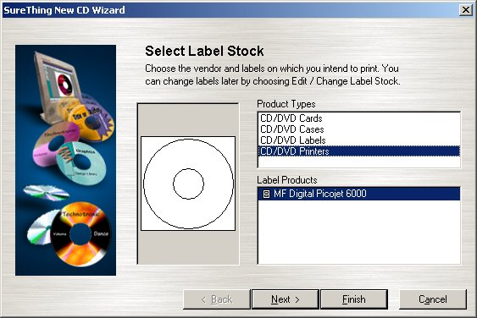

- Select the MF Digital PicoJet 600 and click “Finish”.
- Design your CD / DVD label.

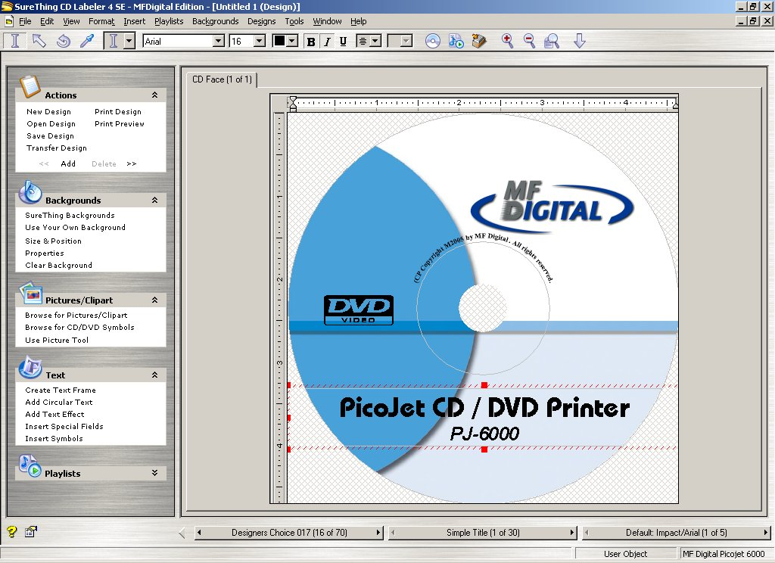

- If you plan to edit this file later, it is best to save it now. Click on FILE-SAVE | 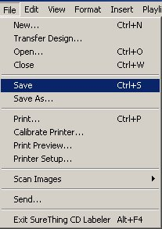

Enter a filename to save your label to a SureThing “.STD” file. This file cannot be used as the print file for your MF Digital Copier but can be useful if later editing is needed. To create the compatible file, a PRN file, click on FILE-PRINT:

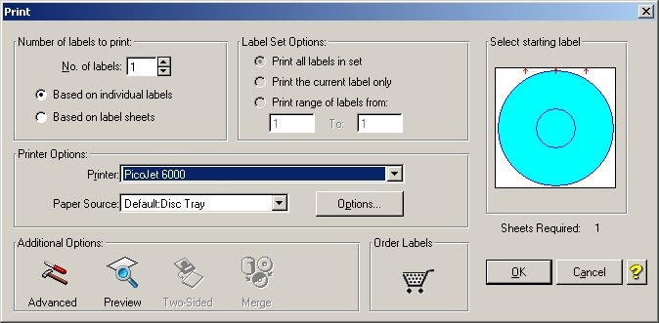

- Be sure to leave “No. of Labels” set to 1. Under “Additional Options” at the bottom of this dialog box, click on “Advanced” and check off “Print to File”.

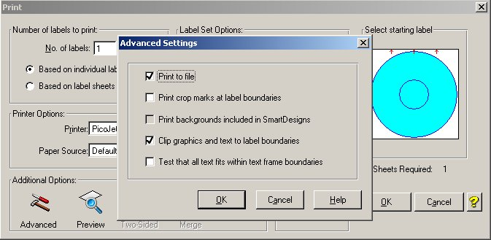

- Click on OK and then you will be returned to the “print” main dialog box. Click “OK” again and the “Print-to-File” dialog box will open:

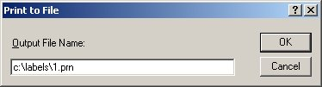

- Type in the path and desired filename, but be sure to retain the .PRN file extension. In the example above, we will be creating 1.PRN in the “labels” folder. Folder will not automatically be created. Folders in the path MUST already exist. It is a good idea choose the labels folder defined on the settings TAB of the Scribe PC software.
- You have usefully created a PRN file!

Note:. A .prn file cannot be edited. It contains information to create the image, and the settings of the particular printer. If any of the settings of the printer are changed, a new .prn file must be generated.

Appendix C: Creating & Using Adobe Acrobat PDF Files
It may be more convenient for you to use Adobe Acrobat .PDF files rather than .PRN files. This can be the case when you prefer to use an application such as Adobe Photoshop, which we will use in our example below.

MF Digital Duplication systems allow you to create your disc labels using the popular Adobe Acrobat File .PDF file format for printing. To make this process simple, MF Digital has created PDF templates for you to design your artwork on. These templates are located on our tech support page at:  http://www.mfdigital.com/techsupport.html  To use these templates, please follow the instructions below. In this example, we will use Adobe Photoshop but the process is similar for other graphics applications.  - Open Adobe Photoshop. From the File Menu, choose “Open”. Browse to find the PDF template that you downloaded and choose that file, click the open button. You will be alerted with an IMPORT PDF dialog window as seen in Fig. A  - Click the OK button.  - The template will open in Adobe Photoshop. If you select the IMAGE menu, then choose Image Size, the image size dialog will appear, verify the Document Size, Height & Width reads the correct size for the template you are working with. For this example, the document size should read 119.94mm x 119.94mm as depicted in Fig. B  - When laying out text in Photoshop, Photoshop automatically creates a new layer, one for each piece of text you add. Should you need to insert a graphic, from the Layer Menu, choose LAYER->NEW LAYER. Photoshop will insert a new layer for you. You can then add the graphic onto this layer.(Yellow Square) as per Fig. C.  (Note: For our purposes, this is NOT a tutorial on the use of Photoshop. You should already be familiar with its use.)  - After you lay out your design, the template layer needs to be “turned off”. This is done by using the layers palette (red square, Fig. D). You will notice that to the left of each layer is an eye. Clicking the eye will turn that layer off. Notice the template now disappears. Fig. E  - You will now need to convert your design into a PDF file, to do this, make sure you have Adobe Acrobat installed (Full version not simply the Reader). From the File Menu, choose Print. Under the Printer section of the Print Dialog, change the Printer name to the PDF Printer (acrobat versions vary in names). Fig. F Click the OK button.  - You will be prompted to give a name to the PDF file. Enter the desired filename - Fig. G   CAUTION  When submitting the PDF file to print, please make sure the target printer is not the default printer. (If printing to PicoJet – PicoJet cannot be the default printer) If needed, add a dummy printer to printers and faxes directory.  Note: When submitting PDF files for printing via the network client. The drivers for the printer attached to the Scribe PC, must also be loaded on the PC running the client software. | 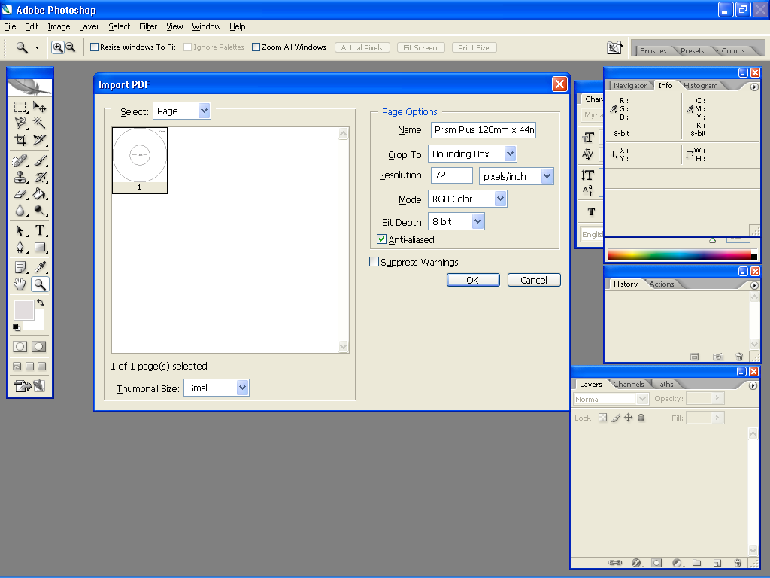  Fig. A  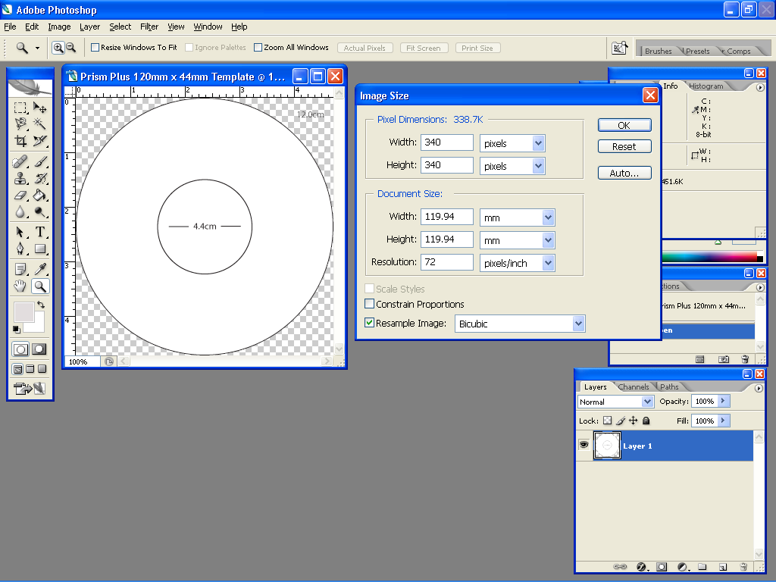  Fig. B  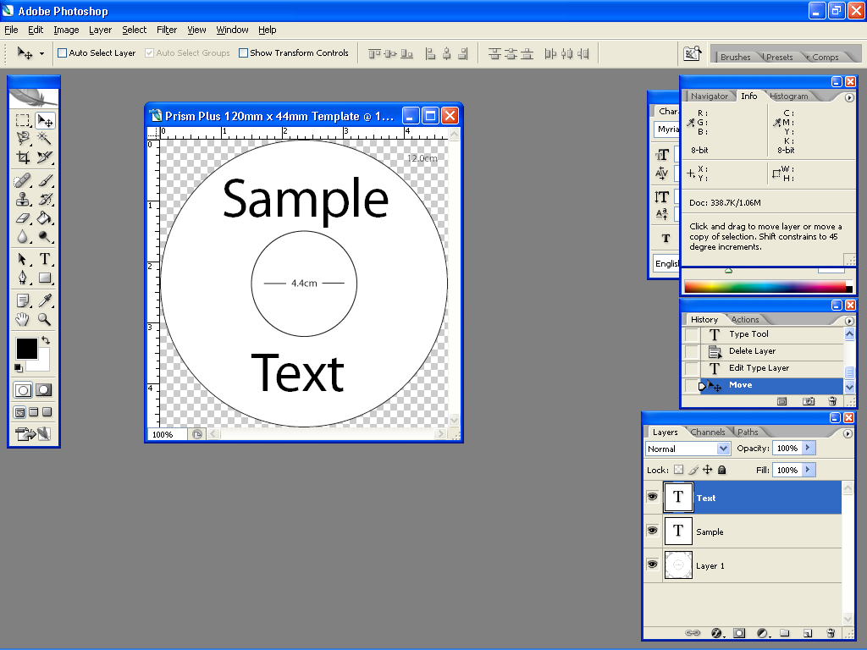  Fig. C  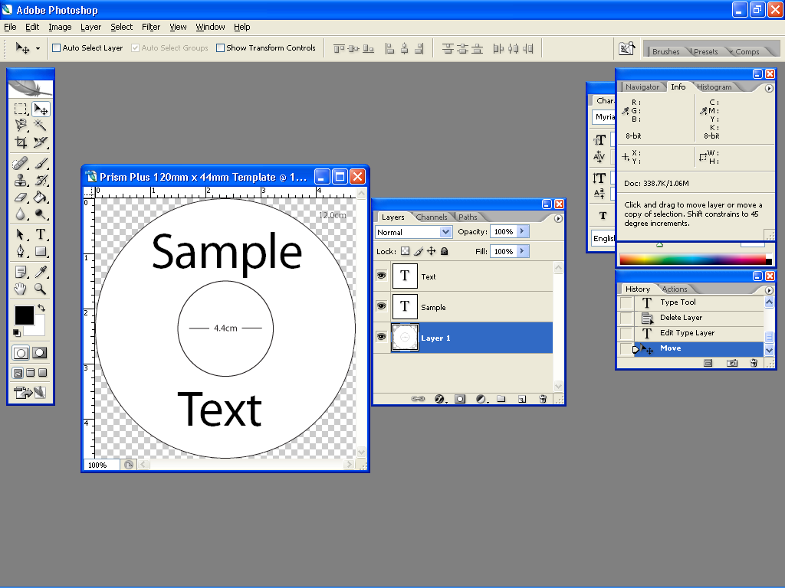  Fig. D  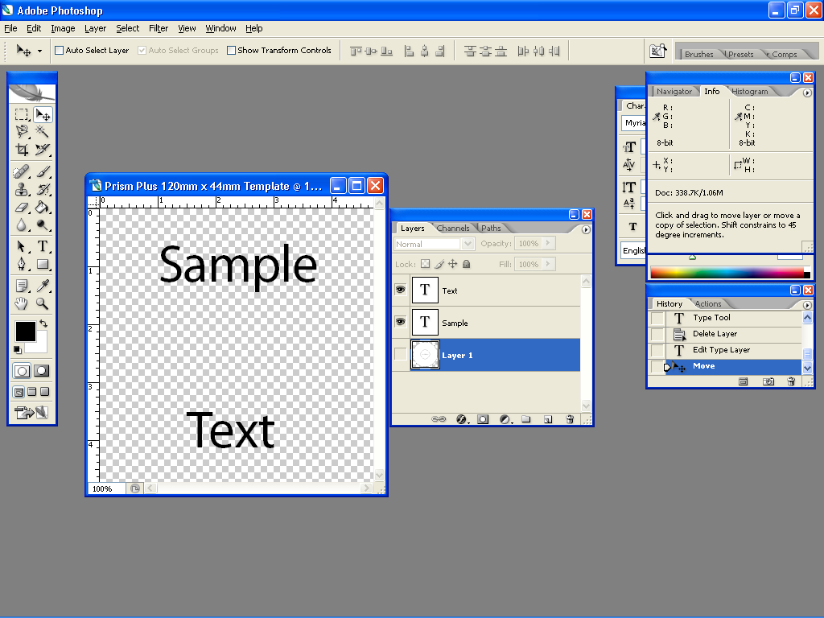  Fig. E  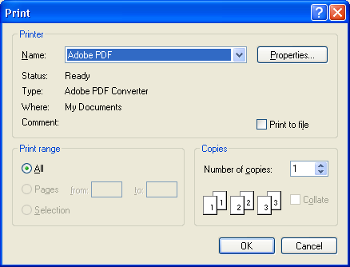  Fig. F  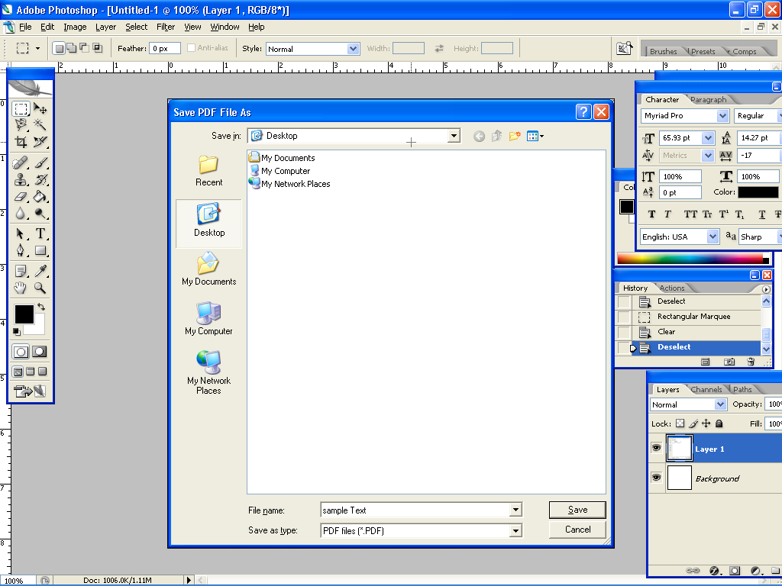  Fig. G

Appendix D

How to setup SureThing CD Labeler to Merge with a CSV document.

Your Scribe PC Series software now allows you to print using the SureThing Document file, STD for short. Using this file type gives you the flexibility to print unique information on your discs. To take advantage of this feature. Please follow the steps below.

Step 1:  Launch the SureThing CD Labeler and choose the correct template for your Printer. For this example we will set this up using the Prism Plus Printer. | 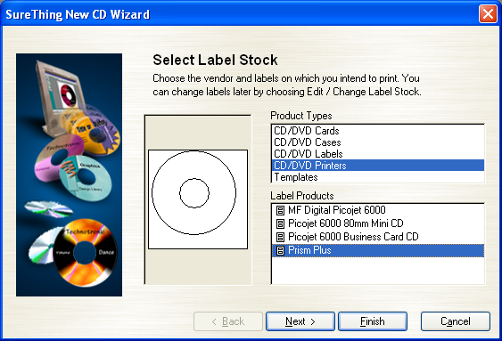
Step #2:  If you have any text or images that will remain static for your label, this would be the best time to add those in.  In the example on the right, we’ve added a logo and a line of text. | 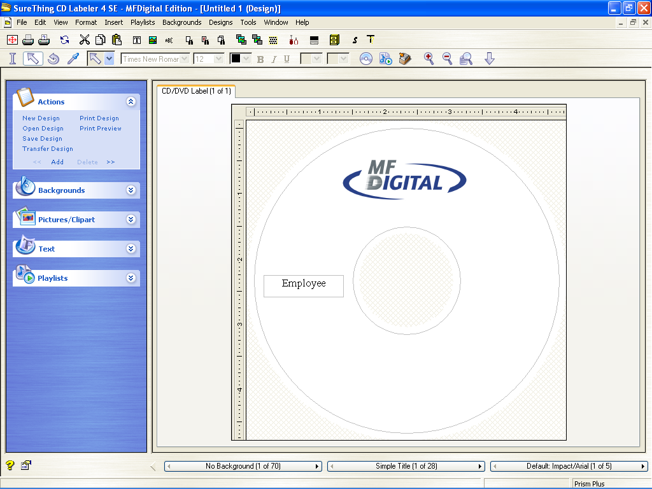

Note:

Up to now, you could print this label and it would remain constant for each disc you planned to print. But we want to print some information that is unique for each disc. To do this, a merge field must be added and we have to tell SureThing where to get this data from so it can print it.

Creating your data merge file (CSV)

A very simple CSV can be created in Notepad, an application that is apart of the Windows Operating System. You can also use Microsoft Excel and simply export to a CSV format. A CSV format is information that is separated by commas, hence the name, Comma Separated Value.

Using Notepad:  In this example, we have created a simple list of names.  This example demonstrates a single field. Each name represents a record.  There are 4 records in this example. | 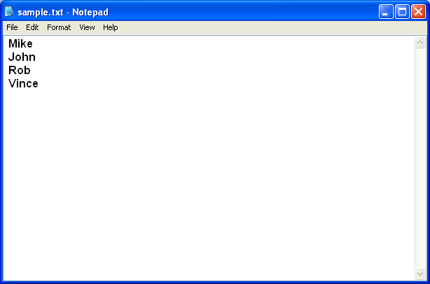
Using Excel:  This example shows how to create a CSV using Microsoft Excel. The screenshot has been blown up to make viewing easier.  As shown, each name is put on a separate line. Each line represents a record. This example has 1 field with 4 records. | 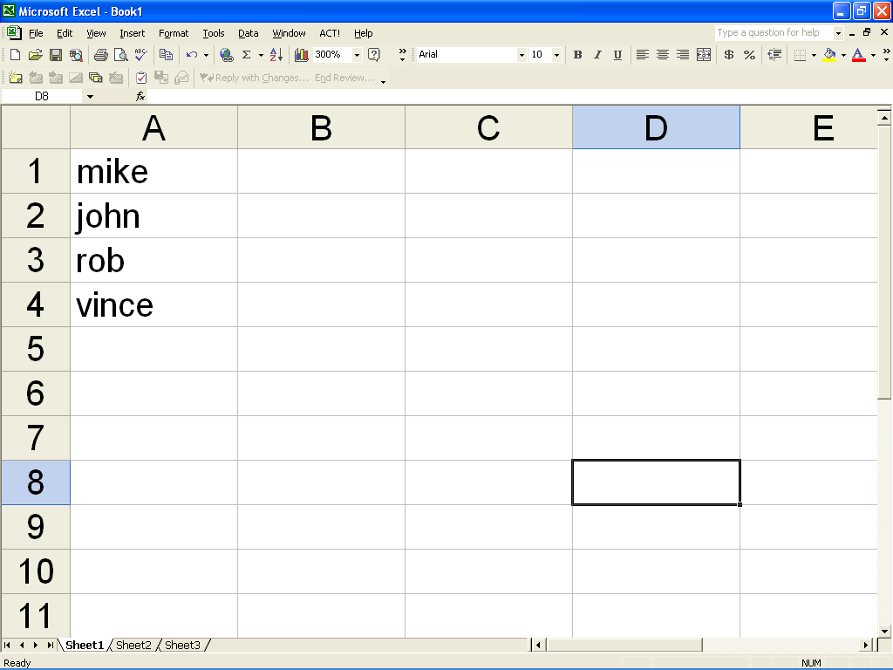
To export the Excel spreadsheet as a CSV, do the following.  - Click the File Menu.  - Choose Save As  - Change the Save As Type drop down menu to CSV.  - Name your CSV file  - Select a location, and choose Save | 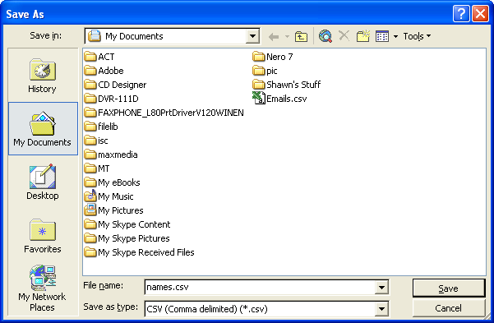
Step 3:  Now that we have our CSV file all set, lets Merge it with our STD File.  In SureThing, click the Insert Menu, and choose Insert Merge Field.  The Insert Field Dialog appears. | 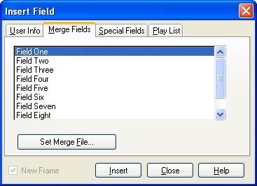
Step 4:  Now click the Set Merge File button. Now the Set Merge File Dialog appears.  Locate your CSV File and select it.  Once selected, click the Set button on the right. | 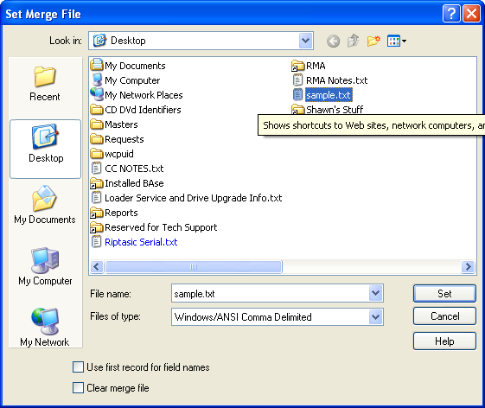
You’ll notice the window in the center of Insert Field Dialog has now changed.  It now contains the name of Field 1. This is the Field that we are going to use. Select it and Press the Insert button.  The field will be inserted behind this dialog. If there are no more fields that you wish to insert it will be necessary to press the Close button. | 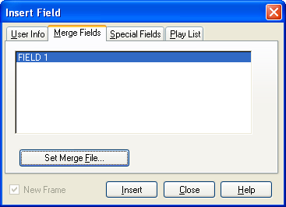
SureThing has now inserted the Field, giving it the name of that field’s placeholder, Field 1.  In the example to the right, we have moved the Field to the print on the right side of the disc. | 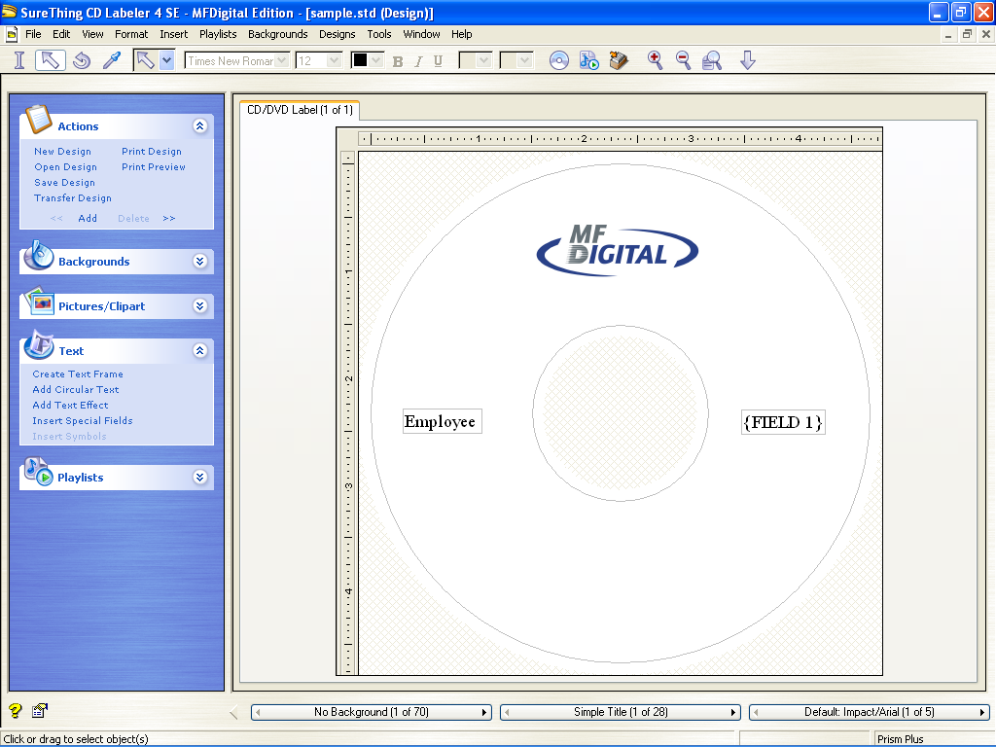
Step 5:  From the File Menu, choose Save, choose a location, give the STD a filename, and click Save. | 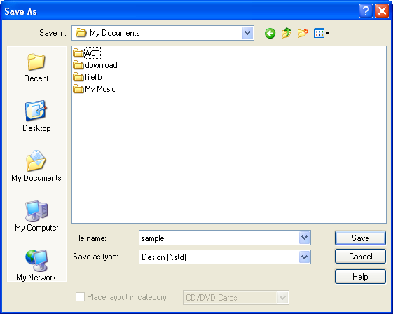

Using Headers in your CSV Document
If you would like your CSV Document to contain headers., this option is supported and can be easily be implemented. Headers are the names of each of the fields. Each header or field name must be separated by a comma. When using Headers, you can tell SureThing that the first record contains field names and SureThing will utilize those field names in the Insert Field Dialog, Field names are not printed.

Shown in the example to the right, the first line contains a field name, entitle Names. | 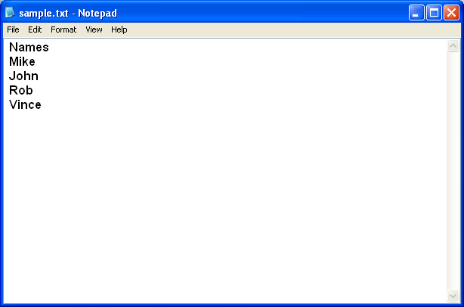
In this example, please note the option, “use first record for field names” is checked which is indicated by the red box.  Selecting this option tells SureThing that your CSV contains Headers and the first record contains field names. | 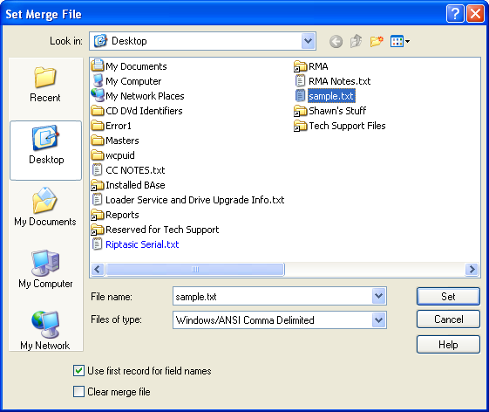
In this example, when you insert a field, you can see the field name “Names” has appeared in the Insert Field Dialog Box rather then the generic Field 1 name.  At this point you can click the Insert Button and the field will be inserted into your design. | 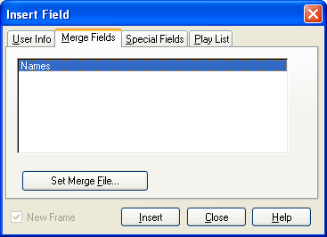
As you can see the field has been inserted but with the name of the field, “Names”.  Now you can save the document. | 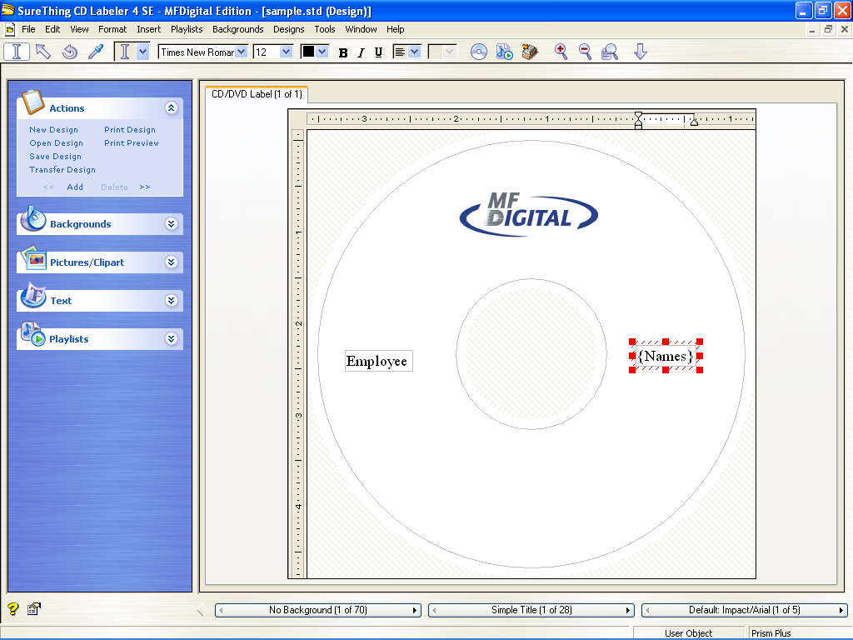

Scribe Client and STD Files with Merge

Although Scribe Client supports the printing of STD files, it DOES NOT support STD files with merge. If you wish to print STD Files with Merge you can take advantage of the UNC Method. The Universal Naming Convention (UNC) is a way to identify a shared file in a computer without having to specify (or know) the storage device it is on. In Windows operating systems, Novell NetWare, and possibly other operating systems, the UNC can be used instead of the local naming system (such as the DOS naming system in Windows).

In Windows operating systems, the UNC name format is:

\\servername\sharename\path\filename

NOTE: If you are using this method, make sure your STD and CSV are not linked. If so, you must clear the link which can be done in SureThing on the Set Merge File Dialog. Click the check box labeled Clear Merge File and then click Set. The “link” will now by broken.

To implement this method utilizing UNC, following the steps below.

- On the Local Scribe Machine, create a shared folder, for example, name the folder MERGE
- Now copy your STD and CSV File to the Shared Folder.
- Perform the steps as outline above to merge the CSV with your STD file.
- DO NOT copy these files back to your local machine, leave them in the Shared Folder you created.
- Submit the STD File to your Scribe via Scribe Client. You will see the information being printed uniquely on your discs.

Appendix E: Premium Utilities
The “Premium utilities” tab is the launch pad for MF Digital’s Scribe PC add-on applications. These applications serve unique purposes and automate many everyday tasks. While they do not come with your unit, they may be purchased at any time.

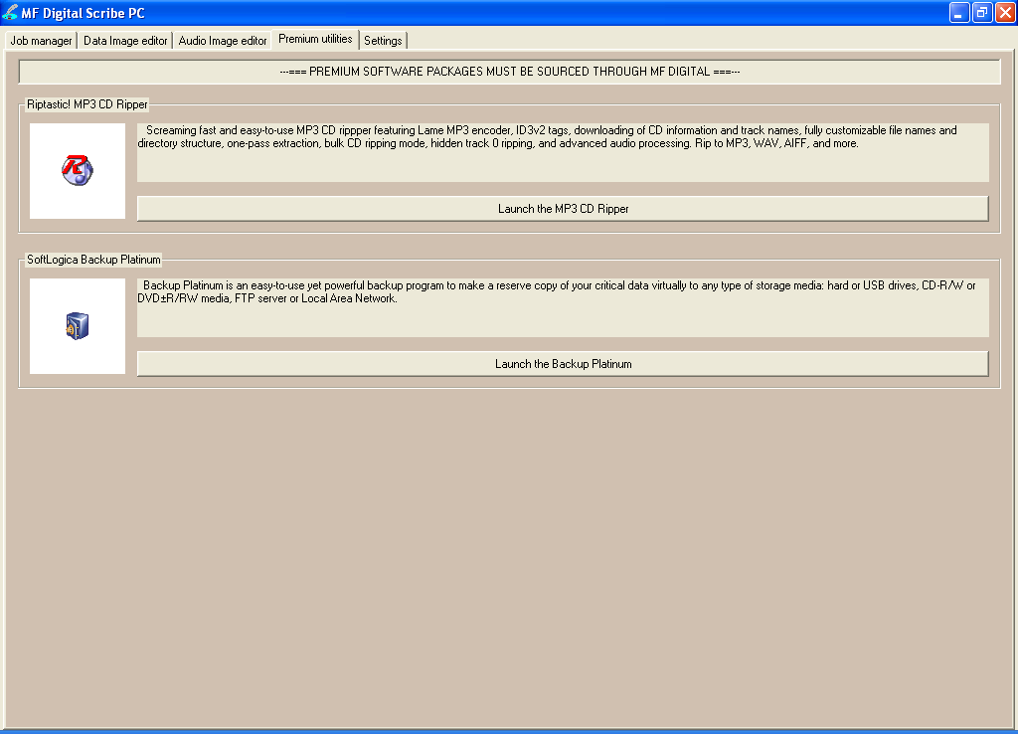

Add-ons include:
- Riptastic for MF Digital CD Ripper
- Platinum Backup for MF Digital

Riptastic for MF Digital
Load the Scribe PC with your audio CDs and quickly and easily rip your entire collection of CDs with this screaming fast and easy-to-use MP3 and WMA CD ripper.

- Batch Rip CDs to MP3, WMA, WMA lossless, WAV, or AIFF.
- Supports a wide variety constant bit rates as well variable bit rates.
- Automatically get CD title, artist, and track names from the Internet.
- Store CD title, artist, track names, and more in ID3 Tags.
- Fine-tune ripping with advanced Audio Processing features such as Normalization, Amplification and Attenuation, Silence Trimming, Digital Resampling, and Channel Merging.
- Precisely control your preference of file names and directory naming based on ID3 tags.

Back-up Platinum for MF Digital
An easy-to-use program designed for an automatic backup of your data to CD or DVD.

- Full and incremental backup/restore
- Auto Disc spanning. When one disc is full, Baxter will simply load the next.
- Integrated compression & encryption
- A powerful scheduler makes it easy to define the backup plan and run backup and recovery tasks automatically from hourly to monthly basis.
- E-mail notification about operation results

Ordering Premium Utilities
Adding premium utilities is easy! Call your reseller or MF Digital today! When ordering, please refer to this table:

Add-on | Part No.
Riptastic for MF Digital | SWM-RIPTASTICM57C
Backup Platinum for MF Digital | SWM-HANDYBACKUP
*** To order add-on software, contact your reseller or MF Digital at (001) 631-249-9393 x205

Installing add-on applications
Documentation for the use of the application accompanies the software itself. Simply run the SETUP for the desire application(s). Any number of add-on applications may be installed at one time.

Becoming an add-on developer.
If you or your company produce software which can benefit from automation and would be a desirable product for the typical user, please email us at info@mfdigital.com and a representative will be in touch with you shortly.

Appendix F: ScribePC Alignment Utility
If Needed (Pre-Aligned at Factory)

- Insert the ScribePC CD into the CD-ROM drive of your PC.  - Click on setup.exe of the alignment utility (fig. 1).  - Click OK (fig. 1).  - Click the button indicated in (fig. 2).  - Enter a name for the group where the Alignment Utility will be located. Click Continue (fig. 3). When you want to open the Utility, click Start / Programs / ”group name” this is a shortcut.  - Click OK (fig. 5).  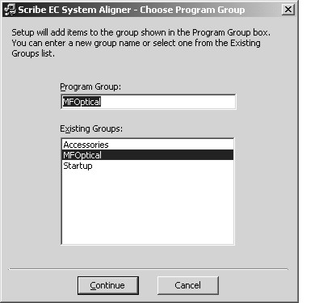  (fig. 3) | 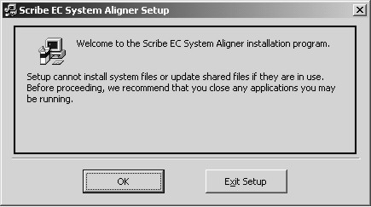  (fig. 1)  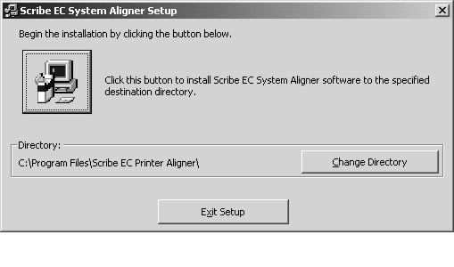  (fig. 2)  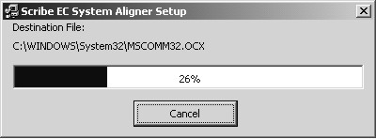  (fig. 4)  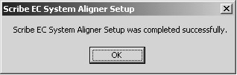  (fig. 4)

