


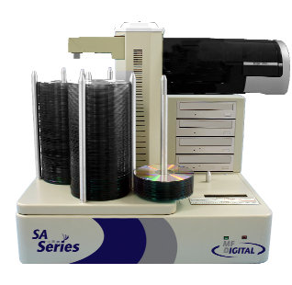 | 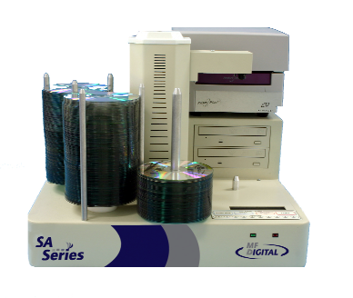 | 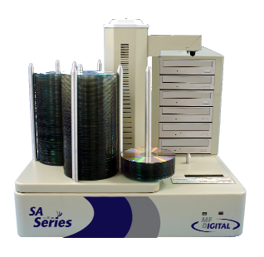

Scribe SA Standalone Series Operator’s Guide
(With SA Client Application)

Table of Contents
Welcome to the Scribe SA Standalone System 4
Copyright Notice 4
Recorder Warranty Policy 4
Piracy 4
End User License Agreement 5
About MF DIGITAL 6
What To Expect From Your MF DIGITAL CD / DVD Duplicator 6
About This Manual 6
Getting Started 7
What’s In The Box 7
Packing Materials 7
The Best Place To Put The Scribe SA Standalone 7
Safety Precautions 8
Location Of CD-R/RW and DVD ±R/±RW Recorder Parts And Controls 9
LCD Display Screen And Keypad 9
MF Digital Drive 9
Removing Packing Restraints 10
Input Bin and Output Spindle 10
System Startup 10
General Operation 13
Function Keys 13
The COPY and COMPARE Buttons 23
Aligning the Drives – If Needed (Pre-aligned at Factory) 27
Selecting the Printer 29
Aligning the Printer – If Needed (Pre-aligned at Factory) 29
Creating A Hard Disk Image 32
Creating A Single Hard Disk Image 32
Creating Multiple Hard Disk Images 35
Copying From A Hard Disk Image 39
Multiple Images Disabled 39
Multiple Images Enabled 40
Comparing From A Hard Disk Image 44
Multiple Images Disabled 44
Multiple Images Enabled 46
Enabling Verify After Copy 48
Erasing CD-RW/DVD-RW Discs 50
Creating .prn Files (Prism Plus Printer) 51
Creating .prn Files (Inkjet Printer) 52
Utilizing .PDF Files for Printing (Command Module Client Only) 523
Utilizing the Printer Option 55
Copy and Print 55
Print Only 56
Viewing Device Information 60
Setting The Internal Clock 61
Firmware Updates 63
Quick Setup Guide for the Scribe SA Standalone Series Client Application 65
Utilizing the Scribe SA Standalone Series Client 66
Configuring the Scribe SA Standalone Series 66
Installing the SA Client Application 68
Utilizing the SA Client Application 69

Welcome to the Scribe SA Standalone System

Copyright Notice

Copyright ©2003,2004,2005 by MF DIGITAL. All rights reserved.

This manual and the accompanying illustrations may not be copied, reproduced, electronically transmitted, or translated into another language, in whole, or in part, without the written consent of MF DIGITAL.
MF DIGITAL, 5000 series, Director EC, Scribe EC, Scribe EC Standalone, are trademarks of MF DIGITAL.

Other trademarks referred to are the property of their respective trademark or registered trademark holders.

Recorder Warranty Policy
Individual CD-R/RW recorder manufacturers are responsible for the products they provide. As a convenience, MF DIGITAL will honor any service issue related to a defective recorder while under its respective manufacturer’s warranty providing that the recorder has been purchased from MF DIGITAL either directly or indirectly. MF DIGITAL assumes no responsibility for products NOT purchased through MF DIGITAL.

Piracy
The copying of audio, video, or software without the permission of the copyright holder is illegal.
MF DIGITAL. accepts no responsibility for the copyright use or misuse of this equipment. It is the sole responsibility of the user to ensure that the legal rights of copyright in duplicating are respected.

Corporate Headquarters:

MF DIGITAL
121 Carolyn Blvd.
Farmingdale, NY 11735
Tel: 001 631 249 9393
Fax: 001 631 249 9273
Email: mailto:documentation@mfdigital.com
http://www.MFDIGITAL.com

End User License Agreement

- You have acquired a device (“Scribe SA Standalone Series CD-R/RW duplicator”) that includes software licensed by MF DIGITAL from Microsoft Licensing Inc. or its affiliates (“MS”). Those installed software products of MS origin, as well as associated media, printed materials, and “online” or electronic documentation (“SOFTWARE”) are protected by international intellectual property laws and treaties. The SOFTWARE is licensed, not sold. All rights reserved.

- IF YOU DO NOT AGREE TO THIS END USER LICENSE AGREEMENT (“EULA”), DO NOT USE THIS DEVICE OR COPY THE SOFTWARE. INSTEAD, PROMPTLY CONTACT MF DIGITAL FOR INSTRUCTIONS ON RETURN OF THE UNUSED DEVICE (S) FOR A REFUND. ANY USE OF THE SOFTWARE, INCLUDING BUT NOT LIMITED TO USE ON THE DEVICE, WILL CONSTITUTE YOUR AGREEMENT TO THIS EULA (OR RATIFICATION OF ANY PREVIOUS CONSENT.)
- GRANT OF SOFTWARE LICENSE. This EULA grants you the following license:
- You may use the SOFTWARE only on the DEVICE.
- NOT FAULT TOLERANT. THE SOFTWARE IS NOT FAULT TOLERANT. MF DIGITAL HAS INDEPENDENTLY DETERMINED HOW TO USE THE SOFTWARE IN THE DEVICE, AND MS HAS RELIED UPON MF DIGITAL TO CONDUCT SUFFICIENT TESTING TO DETERMINE THAT THE SOFTWARE IS SUITABLE FOR SUCH USE.
- NO WARRANTIES FOR THE SOFTWARE. THE SOFTWARE is provided “AS IS” and with all faults. THE ENTIRE RISK AS TO SATISFACTORY QUALITY, PERFORMANCE, ACCURACY, AND EFFORT (INCLUDING LACK OF NEGLIGENCE) IS WITH YOU. ALSO, THERE IS NO WARRANTY AGAINST INTERFERENCE WITH YOUR ENJOYMENT OF THE SOFTWARE OR AGAINST INFRINGEMENT. IF YOU HAVE RECEIVED ANY WARRANTIES REGARDING THE DEVICE OR THE SOFTWARE, THOSE WARRANTIES DO NOT ORIGINATE FROM, AND ARE NOT BINDING ON, MS.
- Note on Java Support. The SOFTWARE may contain support for programs written in Java. Java technology is not fault tolerant and is not designed, manufactured, or intended for use or resale as online control equipment in hazardous environments requiring fail-safe performance, such as in the operation of nuclear facilities, aircraft navigation or communication systems, air traffic control, direct life-support machines, or weapons systems, in which the failure of Java technology could lead directly to death, personal injury, or severe physical or environmental damage. Sun Microsystems. has contractually obligated MS to make this disclaimer.

- No Liability for Certain Damages. EXCEPT AS PROHIBITED BY LAW, MS SHALL HAVE NO LIABILITY FOR ANY INDIRECT, SPECIAL, CONSEQUENTIAL OR INCIDENTAL DAMAGES ARISING FROM OR IN CONNECTION WITH THE USE OR PURPOSE. IN NO EVENT SHALL MS BE LIABLE FOR ANY AMOUNT IN EXCESS OF U.S. TWO-HUNDRED FIFTY DOLLARS (U.S. $250.00).
- Limitations on Reverse Engineering, De-compilation, and Disassembly. You may not reverse engineer, de-compile, or disassemble the SOFTWARE, except and only to the extent that such activity is expressly permitted by applicable law notwithstanding the limitation.
- SOFTWARE TRANSFER ALLOWED BUT WITH RESTRICTIONS. You may permanently transfer rights under this EULA only as part of a permanent sale or transfer of the Device, and only if the recipient agrees to this EULA. If the SOFTWARE is an upgrade, any transfer must also include all prior versions of the SOFTWARE.
- EXPORT RESTRICTIONS. You acknowledge that SOFTWARE is of US-origin. You agree to comply with all applicable international and national laws that apply to the SOFTWARE, including the U.S. Export Administration Regulations, as well as end-user, end-use and country destination restrictions issued by U.S. and other governments. For additional information on exporting the SOFTWARE, see http://www.microsoft.com/exporting/.

About MF DIGITAL
Thank you for purchasing MF DIGITAL’s Scribe SA Standalone auto-loading CD / DVD duplicator. MF DIGITAL manufactures a wide variety of CD / DVD duplication equipment, including manual and fully automated CD and DVD duplicators and printers. We hope you will consider us for all of your duplication needs.

What To Expect From Your MF DIGITAL CD / DVD Duplicator
Your MF DIGITAL Scribe SA Standalone duplicator is professionally designed and manufactured to give you years of trouble free operation. To avoid accidental damage to your new duplicator, please read and understand this manual thoroughly before operating the unit.

About This Manual
This manual is written for both novice and experienced users. Please read through this Operator’s Guide from beginning to end before using the unit. Once having read the manual, follow along chapter by chapter. This will provide the necessary understanding of your new Scribe SA Standalone duplicator.

Getting Started
Carefully remove the Scribe SA Standalone duplicator from the shipping container. Inspect the contents, and verify them against the packing slip. Report any errors in shipping as soon as possible.

What’s In The Box
Your new Scribe SA Standalone duplicator includes:
- Scribe SA Standalone duplicator
- Power cord
- Firmware CD
- Manuals CD
- Operator’s Guide (on CD)
- Quick Connect Guide

Packing Materials
Please retain the original box and packaging in the event that the unit requires future servicing. This will help to reduce the possibility of damage occurring in transit. Should you lose or misplace your carton, a new one will need to be purchased from MF Digital.

The Best Place To Put The Scribe SA Standalone
The best operating location for the Scribe SA Standalone duplicator is in a climate-controlled area, free of dirt, dust, humidity, excessive heat, direct sunlight, and electronic or electromagnetic interference. Room temperature should be between 65 and 75 degrees Fahrenheit, or between 18 and 23 degrees Celsius. Place the Scribe SA Standalone on a solid, steady work surface, and allow sufficient room for all incidental work materials. Provide at least six inches of clearance on all sides of the unit for ventilation.

Safety Precautions
The system is shipped with a three-prong power connector, and must be used with a properly grounded AC receptacle. DO NOT try to defeat the third “ground” prong. All computer peripherals must be properly grounded, and the Scribe SA Standalone is no exception. The use of a power conditioner, such as an Uninterruptible Power Supply (UPS) or a surge protector, is highly recommended. The minimum required size is 500VA.

Repairs or alterations should only be attempted by authorized, factory-trained technicians. MF DIGITAL reserves the right to void the warranty if unauthorized service is performed.

Location Of CD-R/RW and DVD ±R/±RW Recorder Parts And Controls

LCD Display Screen And Keypad

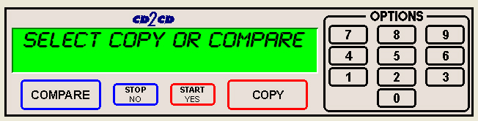

Note: For the purposes of this manual. The above screen shot will be used for demonstration purposes only. Your LCD and keypad will differ slightly but all the functions explained in this manual are identical

MF Digital Drive

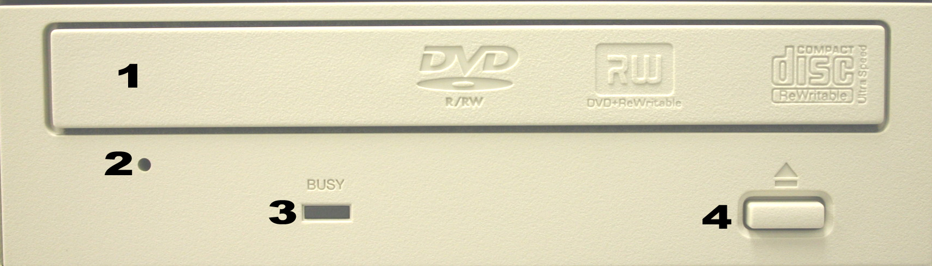

Legend

- Disc tray - Discs are loaded and removed from this tray. Pressing the eject button will open the tray when the power is switched on to the Scribe EC Standalone.
- Emergency eject pinhole - In the event that the disc tray will not open by pressing the eject button, insert the tip of a large paper clip into this hole and push.
- Read and write status LEDs - These indicators light up when the recorder is reading or writing.
- Eject button - This button is used to open or close the disc tray.

Removing Packing Restraints
The Scribe SA Standalone ships with a picker arm restraint to reduce the possibility of damage in transit. This restraint must be removed before operation or power-on. Gently remove the zip tie and foam from around the transfer arm. Save the foam tube, as you will need to return it to its place when transporting the unit in the future.

Input Bin and Output Spindle
The input bins and the output spindle serve as the containers to store from 250 discs up to 600 discs depending on printer option. The input bins become output bins once the output spindle is full.

System Startup

(fig. 2)

(fig. 4)
Before duplicating can begin it is necessary to review a few details.
- Verify that the voltage selector switch is set correctly. It is located between the two power receptacles. The Scribe SA Standalone supports both 115 VAC and 230 VAC at 50 ~ 60 Hz. Please confirm that the appropriate voltage (115 VAC for North America) has been selected.
- Next, plug one end of the supplied power cord into the receptacle at the rear of the unit.
 | CAUTION  Always use properly grounded receptacles or severe damage to your system may result. The use of a surge protector or Uninterruptible Power Supply (UPS) is highly recommended.

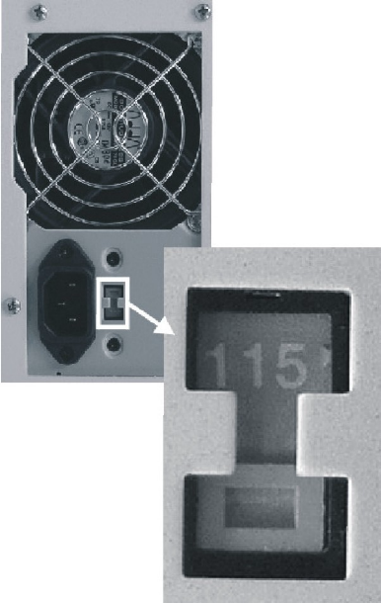
- Make sure you power on the unit using the primary power switch located on the back of the Scribe SA Standalone. You must also power on the drive bay. That switch is located at the front of the drive bay itself.
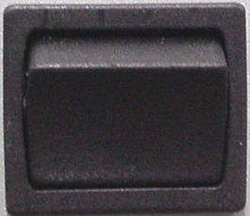

- Once the proper voltage setting has been confirmed, it is time to turn on the unit. Wait a minute or two while the system starts up. The screen will now read:

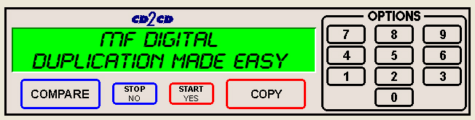

After the startup routine is complete, a series of self-diagnostics will be performed. The screen will now read in sequence:

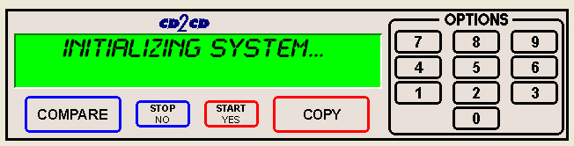

Once complete, the unit will display the main operating screen:

General Operation
The Scribe SA Standalone is extremely versatile and offers many useful and powerful features.

Function Keys
Various uses for the Scribe SA Standalone will be explained throughout this Operator’s Guide. The following section explains the purpose of the function keys.

The numeric keys on the keypad have special functions. When the main operating screen is displayed:


- Press the “0” key on the keypad. The screen will now read:

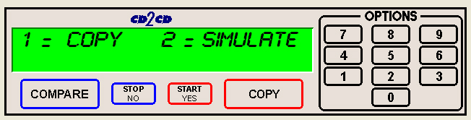

The factory setting for this function is “Copy”. The “Simulate” mode is a diagnostic tool, which is useful for testing the readability of a master disc, without actually writing to blank discs loaded into the recorders. It is also helpful for training purposes, and for experimenting with various system functions.
- Press the “1” key to select “Copy” or the “2” key to select “Simulate”. After pressing either key, you will be returned to the main operating screen.


- Press the “1” key on the keypad. Something similar to the following will be displayed on the screen in sequence:
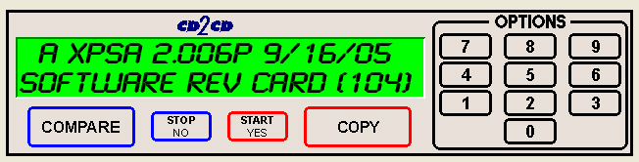

- As indicated by the red square, this is the version information of the firmware currently installed on the Scribe SA Standalone.

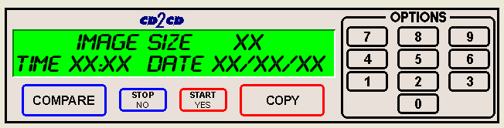

- This displays the image size on the internal hard disk, time and date.

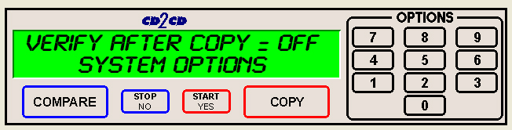

- This displays the Verify After status of the Scribe SA Standalone. The Verify After function will verify a copied disc against the master disc immediately after it has been copied.

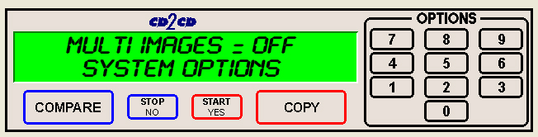
- This displays the Multiple Images status of the Scribe SA Standalone. Multiple images allows the user to store up to 6 separate master images on the internal Hard Drive.

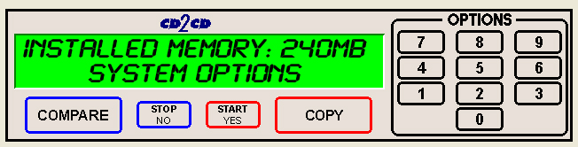
- This displays the Installed Memory of the Scribe SA Standalone.
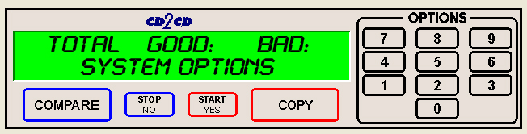

- This displays the number of good and bad copies that were produced to date on the system



- Press the “2” key on the keypad. You will see several functions scroll across the screen. Select a function by pressing the corresponding number on the keypad. Enable or disable the function by pressing the “Start/Yes” or “Stop/No” key.

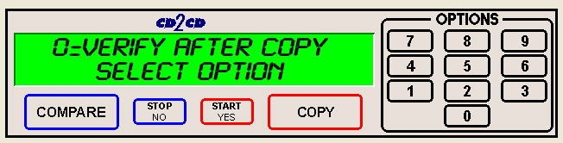
- 0- The factory setting for this function is disabled. When enabled, the Verify After feature automatically compares discs to the master disc or hard disk image after copying is completed. Due to the nature of the various compact disc formats, only CD-ROM Mode 1, CD-ROM Mode 2, CD-ROM XA Mode 2 Form 1, and audio (CD-DA) discs can be compared.

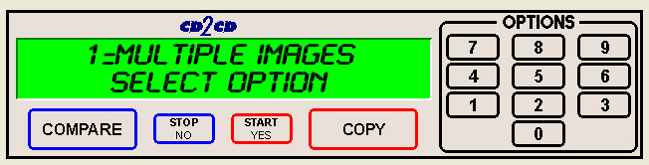
- 1- The factory setting for this function is disabled. When enabled, the Multiple Images feature allows up to six images to be stored on the hard disk drive at one time. This setting will remain in effect until disabled, even after restarting the Scribe SA Standalone.

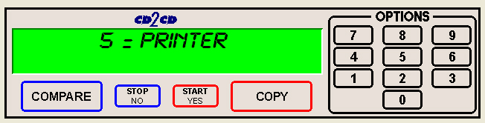
- 5- Pressing the “5” key will give you the option to choose a printer or disable the printer option. See the Utilizing the Printer Option section of this manual for more information.

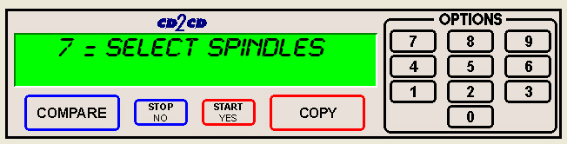
- 7-Pressing the “7” key will give you the option to seperate the bins for DVDs and CDs. This is called Spindle Selection. When this selection is enabled, the bins are separated as follows. Input Bin #1 is for for CDs, Input Bin #2 is for DVDs. Input #3 (if no printer is used) is disabled. The Output Spindle will be used for both CDs and DVDs.


- Not used.

- Pressing the “4” key on the keypad will first display the option for importing PRN files.
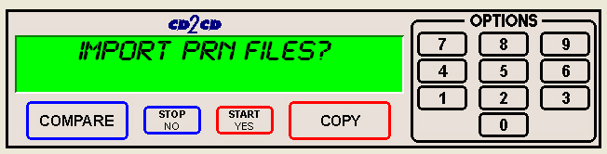
- Pressing “Stop/No” Button will now display

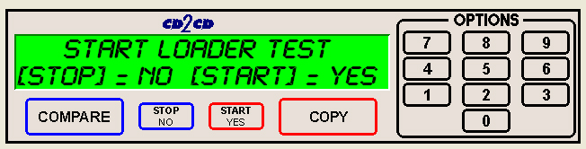

- When selected, the Loader Test Mode function allows you to manually control the robotic functions of the system, this features aids you in troubleshooting the robotic functions. The commands are explained below.

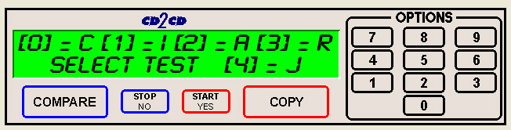
- “C”- calibrates the picking arm
- “I”- loads a disc into the open drive from the input spindle
- “A”- unloads the disc and places it on the accept spindle.
- “R”- key puts the disc in the rejection area in front of the drive tower.
- “J” – retrieves a disc from the input hopper and hovers above an open drive tray.
- Press the “Stop/No” key to exit

- If you pressed the “Stop/No” key for Loader Tester you will be prompted to align the printer.
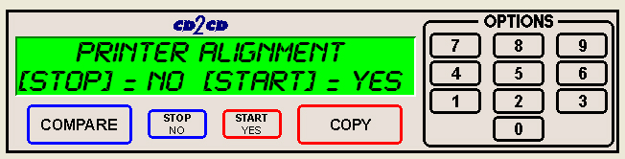
- Please see the Aligning the Printer section of this manual for further instructions.


- Press the “5” key on the keypad. The screen will now read:

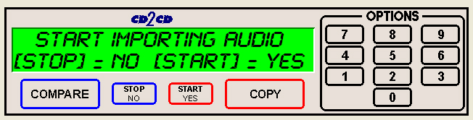
- By using the Audio Track Import feature, audio compilation discs can be created one track at a time from one or more masters.
- Manually place an audio master disc into drive number 1.
- Press the “Start/Yes” key
- Press the number of the track you wish to import and press the “Start/Yes” key. Only one track may be imported at a time. All of the tracks will create one master image on the hard drive.
- Once you have imported all of the tracks, copy the image you just created from the hard drive as you normally would.

- Press the “6” key on the keypad. Something similar to the following will be displayed in sequence:
- 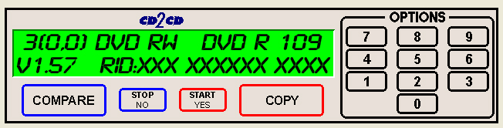
This display is the device information for each of the recorders installed in the Scribe SA Standalone. This includes their host number, model name, and firmware version.


- Press the “7” key on the keypad. The screen will now read:

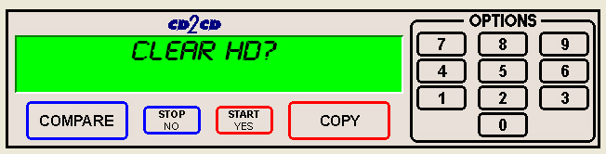
    - Press the “Start/Yes” key to clear the hard drive.
If the “Stop/No” key is pressed you will be prompted to set the “System Time.”

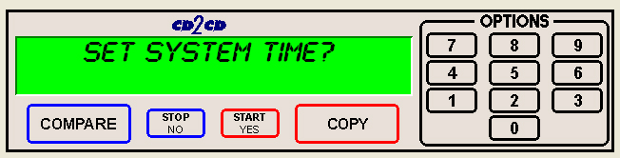

    - Press the “Start/Yes” key to set the system time.

If the “Stop/No” key is pressed you will be prompted to “Read ATIP.”

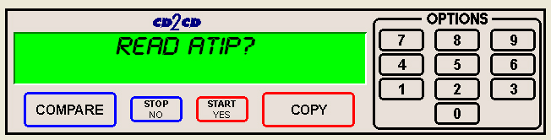
When selected, the ATIP function allows you to determine the manufacturer of the CD-R placed in drive 1 of the Scribe SA Standalone. (Not available on DVD)

• If you pressed the “Stop/No” key at you will be prompted to “Set the Drive Order”:
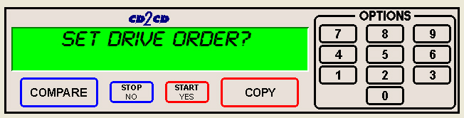

• Press the “Stop/No” key if you do not want to reset the drive order. Press the “Start/Yes” key and you will then see the following screen:
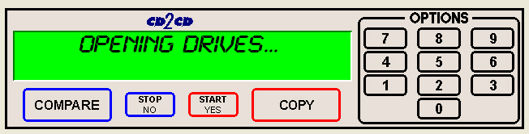

• All of the drives will open at this time:

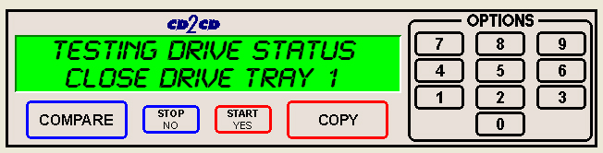
• Close the drive tray of the drive you would like to be drive number “1”. It can be any one of the drives. You will then see the following screen:
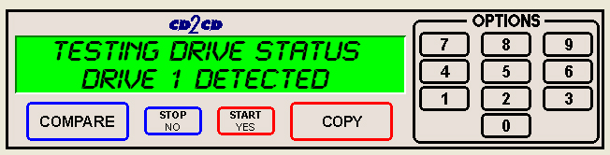

• Close the remaining drives in the order that you would like them to read and the Scribe SA Standalone will reboot.
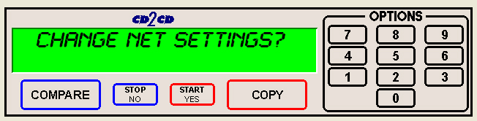
- If you pressed “Stop/No” to “Set Drive Order”, you will be prompted to “Change Network Settings”. Pressing “Start/Yes” will allow you to set-up the network client feature. Please see Utilizing the SA Client Application section (p. 65) for further details. Pressing “Stop/No” will bring you back to the “Select Copy or Compare” screen.


- Press the “8” key on the keypad. The screen will now read:
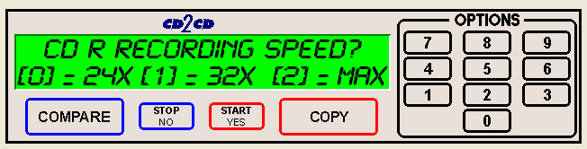

The factory setting for this function is “MAX” for CD and DVD. When selected, the Select Recording Speed feature allows you to set the copying speed as determined by the capabilities of the recorders installed in the Scribe SA Standalone. Drive manufacturer approved media is also an important factor. You will be prompted to select the CD-R Recording Speed first, then DVD-R Speed. The “Stop/No” button will not function for this option.

• CDR Speed = Press the “0” key, the “1” key or “2” key depending on your choice. After your selection the screen will now read:
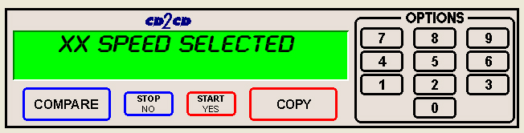

• DVD Speed = Press the “0” key, the “1” key or “2” key depending on your choice. After your selection the screen will now read:
:
• You will then be returned to the main operating screen that reads, “Select Copy or Compare”

Note: There is no option to skip past the CD-R recording speed, if you are merely selecting this option to slow down the recording speed for DVD-R Recording, you will need to first select the CD-R recording speed to advance to next screen to do so.


- Press the “9” key on the keypad. Something similar to the following will be displayed in sequence:
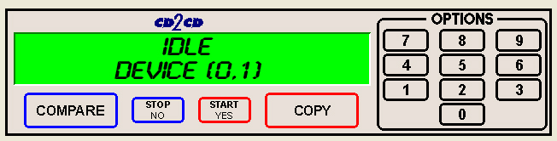

This displays the status of the last disc copied or compared in each of the Scribe SA Standalone’s recorders. If the last operation performed was successful, the screen will report “OK”. If problems were encountered, an error message will be displayed.

The COPY and COMPARE Buttons
The Scribe SA Standalone has two main buttons which you will commonly use when starting jobs. Understanding the options below will aid you in the correct method how to use your system effectively.
When you push the COPY button, the first option displayed is FROM HD?
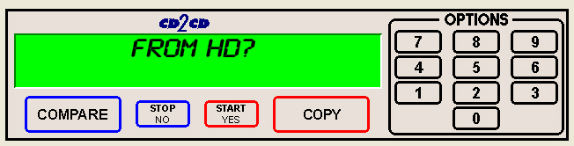
The FROM HD? option lets you copy from a master that has been already archived to the Scribe SA Standalone internal Hard Drive. See the section, Creating a Hard Disk Image later in Manual.

If you push the “Start/No” button, the screen will now read.
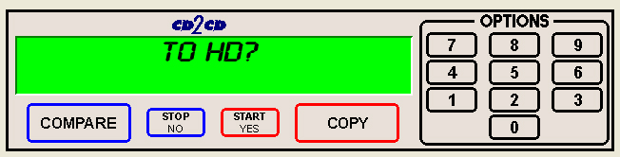
The TO HD? option lets you archive a master disc (CD or DVD) to the Scribe SA Standalone Internal Hard Drive. When the archive is complete, the screen will read, “Archive Ok, Press Start” and return you to the main operating screen, “Select Copy or Compare”

If you push the “Start/No” button, the screen will now read.
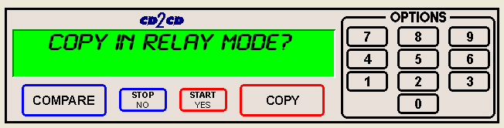
The Copy in Relay Mode? gives you the option to copy multiple masters in sequence, hence the name, Relay mode. The correct pecking order is as follows, [master 1] [blanks] [master 2] [blanks] and so forth. You can also print your labels in relay mode. To do this, a PRN CD has to be created and place on the first stack of masters and blanks. Example, [PRN disc] [master 1] [blanks] [master 2] [blanks]. The PRN files must be labeled accordingly, 1.PRN, 2.PRN and so on.

If you push the “Start/No” button, the screen will now read.
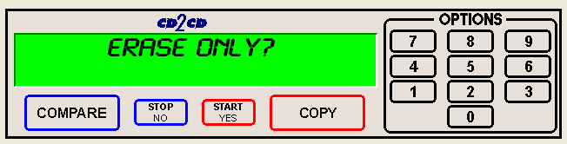
The ERASE ONLY option let you erase your CD-RW or DVD-RW discs using the loader. This is useful if you utilize rewritable discs often and have many to erase.

If you push the “Start/No” button, the screen will now read.
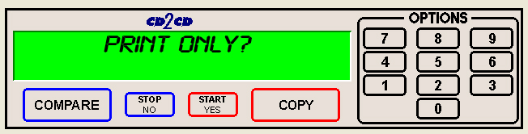
The PRINT ONLY option instructs the Scribe SA Standalone to only do print jobs only. You will be given the option to either import a new PRN file or use an existing one. If you choose to import a new one, burn your PRN file to a CD and then place it on the input hopper. The Loader will come to retrieve the disc and load your PRN to the internal Hard Disk Drive.

If you push the “Start/No” button, the screen will now read.

You will now be returned to the Main operating screen, “Select Copy or Compare”. To use any of these features, push the “Start/Yes” button. These features are outlined later in this manual.

If you decide you want to compare all your duplicates to the master on the hard drive, the Scribe SA Standalone will has this feature. Simply reload all the duplicates back into the input hoppers and push the COMPARE button, enter the quantity, and the Loader will begin to load all the duplicates back into the drive for comparison. Any discs that do not compare will be left in the reject area.

When you push the COMPARE button, the first option displayed is COMPARE AGAINST HD?
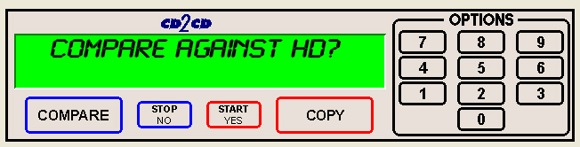
Pushing the “Start/Yes” key will prompt you to enter a quantity to compare.
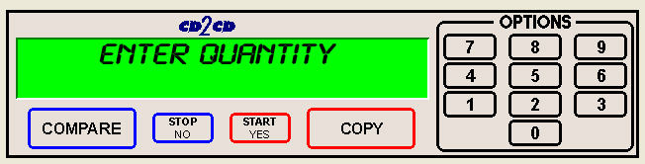

The screen with look something like this when the comparison has begun:
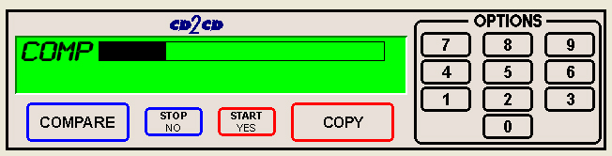

When the comparison is done, the screen will display:

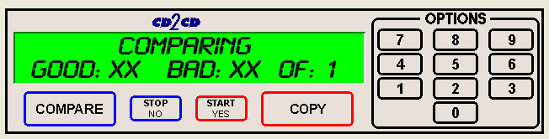

Aligning the Drives – If Needed (Pre-aligned at Factory)

Please follow the instructions below to align the drives on the Scribe SA Standalone.

- From the main operating screen depicted below:

- Press the “4” key. You will then be prompted to Import PRN files first.
- Push the “Stop/No” Key. Now you will be prompted to “Start Loader Test Mode?”. Press the “Start/Yes” key to enter “Loader Test Mode”

- The following screen will appear. Place a CD in the 1st input area.

- To test the alignment of the drive tower, first press the number with corresponds to the “C” command for calibrate. Then press “I” for input. This will pick up a CD from the input area and place the CD in the drive. Inspect the placement of the CD, make adjustments if necessary.
- After inserting a CD, press “A” for accept, and the arm will pick the CD out of the drive and place on the output spindle.
- Repeat process as necessary until you are satisfied with the alignment of the drive bay.

Note: Another command you can use is the “J” command. This command will retrieve a disc from the input hopper and hover above an open drive tray. You can then position the drives while the CD is above the tray. Once aligned, simply push the “C” for calibrate, the loader will drop the CD and return to the home position.

Selecting the Printer

- First, the appropriate printer must be selected. To select the appropriate printer, do the following:
At the “Select Copy or Compare, press the “2” key

From the scrolling options screen, press the “5” to select the printer
Select the appropriate printer that you have installed on the system.

Choose the number that corresponds with the printer that you have installed. After choosing the printer, the system will reboot. The printers are listed below.

Disabled – No Printer | 0 |  | Sig Pro | 4
PicoJet | 1 |  | Opti (OptiEC) | 5
Sig IV | 2 |  | EC Pro | 6
Prism | 3 |  | Spectrum | 7

Aligning the Printer – If Needed (Pre-aligned at Factory)

- After the system reboots, the main operating screen will be depicted below:

- Press the “4” key. You will be prompted to “Import PRN files”. Press “Stop/No” to advance to the next option.
- Next you will be prompted to “Start Loader Test”. Press the “Stop/No” button to advance to the Printer Alignment option.
- You will then be prompted to enter the “Printer Alignment” feature, as depicted below:

- Press the “Start/Yes” key to enter the “Printer Alignment” feature.

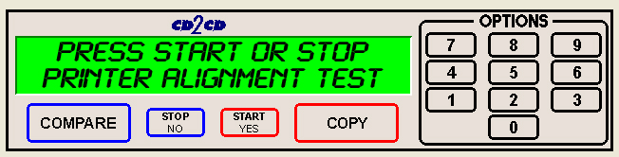
- Place a CD in the input area and press the “Start/Yes” key.

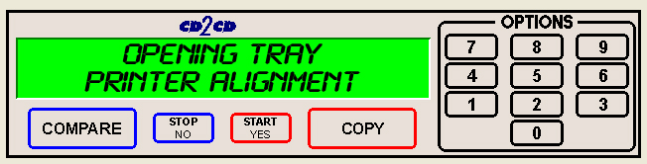

- At this point the automated arm will pick a disc up from the input area and place the CD so that it stops just above the printer tray. Check the alignment of the printer and adjust the printer accordingly. After the disc has been placed you will see the following screen:

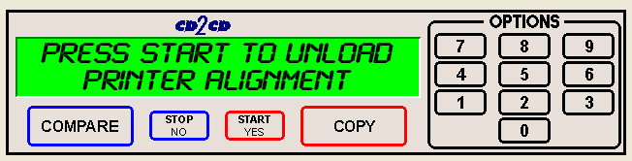
- Press the “Start/Yes” key. The disc will be unloaded from the printer tray and put onto the output spindle. You will be returned to the start of the test, repeat the process if further alignment is required.

Note: When performing this test, the printer tray will eject automatically. You do not need to eject the printer tray. When the test is completed, the tray will close.

Creating A Hard Disk Image
The Scribe SA Standalone comes equipped with an internal hard disk drive, which can be used to store copies of master discs for later recording or comparing. Each master is saved as a single image file. Up to six images can be stored on the hard disk at one time. The image file is store uniquely on the internal hard disk drive as an .IMG file.

A hard disk image is useful as a convenient way of copying standard master discs. For example, create hard disk images for three or four master discs which are needed on a regular basis, and access them to make copies as required.

Creating A Single Hard Disk Image
Although the Scribe SA Standalone’s internal hard disk can store up to six images of master discs, it is sometimes prudent not to use this Multiple Image feature and only allow one image to be created and stored. For example, using a single image simplifies the copying process. This reduces the chance that an operator might make copies of the wrong master by selecting the incorrect hard disk image.

To create a single hard disk image (multiple images disabled), the steps are as follows:

- From the main operating screen depicted below:

• Press the “COPY” key. The screen will now read:
• Press the “Stop/No” key. The screen will now read:
Press the “Start/Yes” key. The screen will now read in sequence:
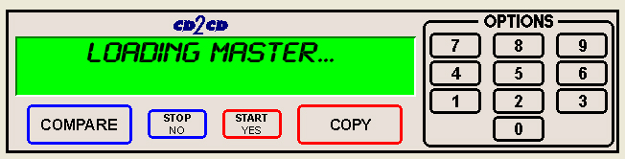
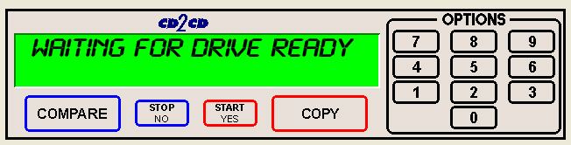
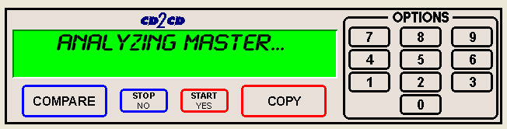

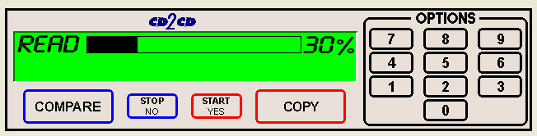

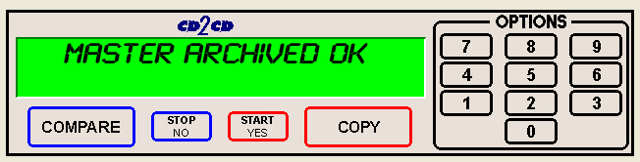
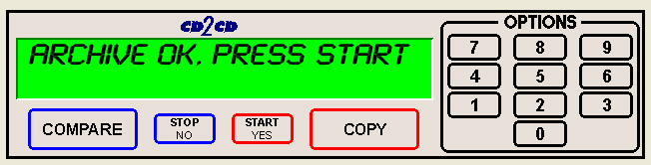

The master disc is now stored as an image on the hard disk

Note: If the master failed to copy to the hard drive properly, the master disc will be placed in the reject area in front of the drives. These discs should not be used.

- Press the “Start/Yes” key, and you will be returned to the main operating screen:

Note: When the Multiple Images feature is disabled, only one image can be saved on the hard disk. If a new image is created, the old image is overwritten.

Creating Multiple Hard Disk Images
The Multiple Images feature allows the Scribe SA Standalone’s internal hard disk to store up to six master disc images. The factory setting for this function is “disabled”. To enable it, and create multiple image files, proceed as follows:

- From the main operating screen depicted below:

- Press the “2” key. The screen will display a scrolling menu of options.

- Press the “1” key to select Multiple Images. The screen will now read:
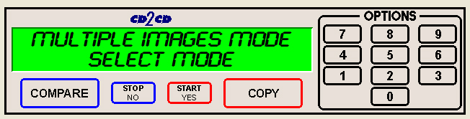

• Press the “Start/Yes” key to enable Multiple Images.

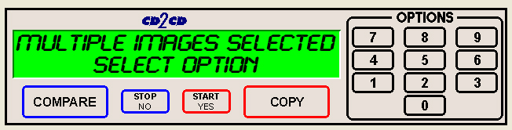
• You will then be returned to the main operating screen:

• Press the “COPY” key. The screen will now read:
• Press the “Stop/No” key. The screen will now read:

• Press the “START/YES” key. The screen will now read:

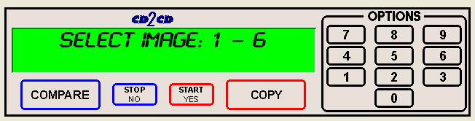

• Select the number that will designate the location of your master. The screen will then read in sequence:

Note: When using the multiple images option, it is a good idea to write an “inventory” of what the images are and what number corresponds to it. So when you need to recall that image, your written log will assist you.

Copying From A Hard Disk Image
Warning: If you have not already created a hard disk image, do so now, as described in the previous section.

After a hard disk image has been created, it can be used as the copying master source.

Multiple Images Disabled
To make copies from a hard disk image that was previously created with the Multiple Images feature “disabled” (i.e. from a single hard disk image), the steps are as follows:
- From the main operating screen depicted below:

- Load as many blank discs as are required into the CD / DVD recorders.
- Press the “COPY” key on the keypad. The screen will now read:

- Press the “Start/Yes” key to begin copying from the hard disk image, to the blank discs in the recorders. Depending on the format type of the image, something similar to the following will be displayed on the screen:

- Enter the quantity of discs you wish to copy:

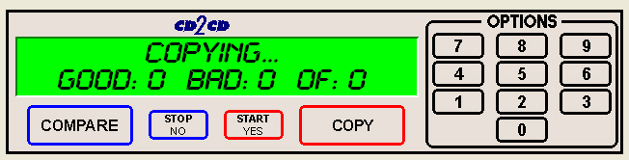
Progress will be displayed on the screen during the operation:

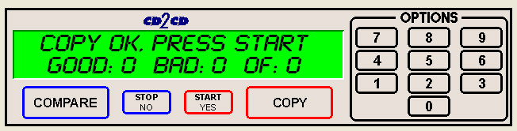
- Press the “Start/Yes” key, and you will be returned to the main operating screen:

Note: If the master failed to copy to the hard drive properly, the master disc will be placed in the reject area in front of the drives. These discs should not be used.

Multiple Images Enabled
To make copies from hard disk images that were previously created with the Multiple Images feature “enabled”, the steps are as follows:

- From the main operating screen depicted below:

- Load as many blank discs as are required into the recorders. Press the “COPY” key on the keypad. The screen will now read:

- Press the “Start/Yes” key. The screen will now read:

The Scribe SA Standalone defaults to the first image (1). For the purposes of this example, press the “1” key to select this image, followed by the “Start/Yes” key. The screen will now read:

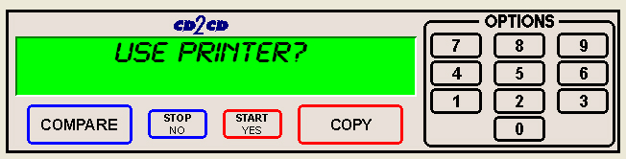
If you installed a printer, Scribe SA will ask if you if you want to use your printer. Pushing the “Start/Yes” button will prompt the Scribe SA Standalone to ask use the Existing PRN file (if preloaded) if no PRN file was preloaded, you will need to have your PRN disc as the first disc in the first input been. Scribe SA Standalone will load your PRN disc.

If you push the “Stop/No” button, the following screen will be displayed.

Progress will be displayed on the screen during the operation:

- Press the “Start/Yes” key, and you will be returned to the main operating screen:

Note: If the master failed to copy to the hard drive properly, the master disc will be placed in the reject area in front of the drives. This disc should not be used.

Tip: Having your “inventory” list ( 1 to 6 ) of images comes in handy for this procedure.

Comparing From A Hard Disk Image
For quality control purposes, the Scribe SA Standalone is equipped with powerful verification capabilities. Copied discs can also be compared against hard disk images. This feature ensures copying integrity.

Note: Due to the nature of the various formats, only CD-ROM Mode 1, CD-ROM Mode 2, CD-ROM XA Mode 2 Form 1, and most DVD formats can be compared (including CD Audio).

Multiple Images Disabled
To compare copied discs to a hard disk image that was previously created with the Multiple Images feature “disabled” (i.e. from a single hard disk image), the steps are as follows:

- From the main operating screen depicted below:

- Load the copied discs to be compared into the CD / DVD recorders.
- Press the “COMPARE” key on the keypad. The screen will now read:

- Press the “Start/Yes” key. The screen will now read:

Progress will be displayed on the screen during the operation:

Upon successful completion, the compared disc(s) will be ejected. The screen will now read:

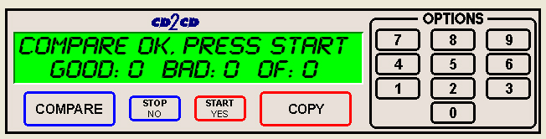
- Press the “Start/Yes” key, and you will be returned to the main operating screen:

Note: If the master failed to copy to the hard drive properly, the master disc will be placed in the reject area in front of the drives. These discs should not be used.

Multiple Images Enabled
To compare copied discs to a hard disk image that was previously created with the Multiple Images feature “enabled”, the steps are as follows:

Tip; If you have compiled a list of your stored images, have them handy as you perform this function.

- From the main operating screen depicted below:

- Load the copied discs to be compared into the CD / DVD recorders.
- Press the “COMPARE” key on the keypad. The screen will now read:

- Press the “Start/Yes” key. The screen will now read:

- Select the image you would like to compare against by pressing 1, 2, 3, 4, 5 or 6.

Progress will be displayed on the screen during the operation:

Upon successful completion, the compared disc(s) will be ejected. The screen will now read:

- Press the “Start/Yes” key, and you will be returned to the main operating screen:

Note: If the master failed to copy to the hard drive properly, the master disc will be placed in the reject area in front of the drives. This disc should not be used.

Enabling Verify After Copy
• From the main operating screen depicted below:
• Press the “2” key and the screen will now display in sequence:

• Press the “0” key, and the screen will now read:

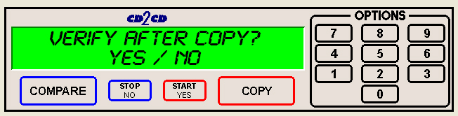
• Press the “Start/Yes” key to enable, or the “Stop/No” key to disable the Verify After option. If you press the “Start/Yes” key the screen will read:

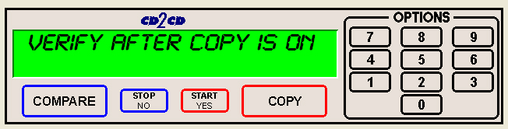
• You will then be returned to the main operating screen which now shows the following:

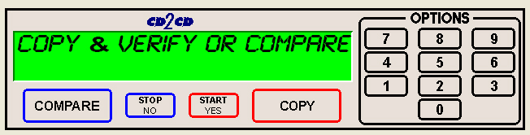

Erasing CD-RW/DVD-RW Discs
- From the main operating screen depicted below:

- Press the “COPY” key on the keypad. You will then press the “Stop/No” key until you reach the following screen:

- Load the CD-RW or DVD-RW discs you would like to erase into the input bin and wait for the green light on the front of the drive to stop blinking.
- Press the “Start/Yes” key on the keypad.
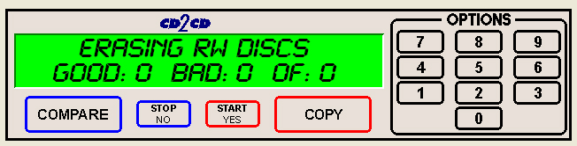

- The Scribe SA Standalone will then erase the CD-RW/DVD-RW disc.

Creating .prn Files (Prism Plus Printer)

(fig. B)

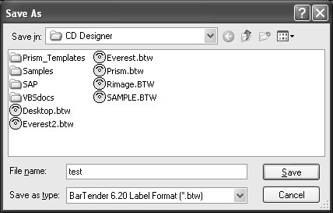
- Create a .prn by printing the document to a file instead of directly to a printer. You will be prompted to specify the filename and location. This puts the document in a format that the Scribe SA Standalone uses for printing. Follow the instructions below to create a .prn.

- When a label file is saved in Rimage CD Designer it is given a .BTW extension. This format is not usable by the Scribe SA Standalone. You will however want to save your label as a .BTW for future editing (fig. A).
- To create a .prn you must use the Print feature after you have created your label.
- Make sure that the Perfect Image Printer PF printer is selected in the name box.
- Select the Print to file option, under the options tab (fig. B) and click PRINT.
- Give your file a name (fig. C).
- Select the Labels folder that you will use as your default, and print file to this folder (fig. C).
- After creating PRN file, give your PRN file the name 1.prn and burn this file to a CD. A second idea is to use the Command Module Application (SA Client and transmit your PRN file across your network, see Utilizing the Scribe SA Standalone Client Application.
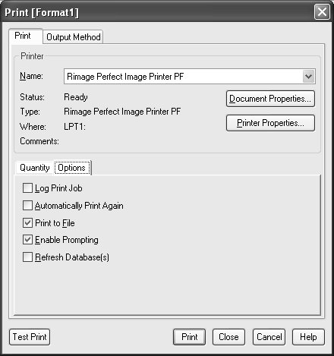
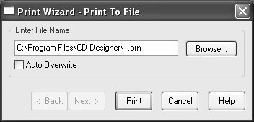
(fig. A)
(fig. B)
(fig. C)

Creating .prn Files (Inkjet Printer)
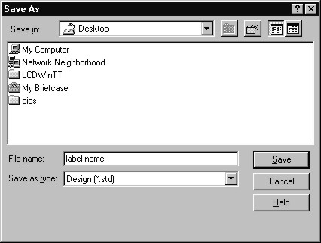
Note:
A .prn file cannot be edited. It contains information to create the image, and the settings of the particular printer. If any of the settings of the printer are changed, a new .prn file must be generated.
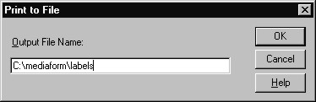
Create a .prn by printing the document to a file instead of routing it directly to a printer. You will be prompted to specify the filename and location. This puts the document in a format that the Scribe SA Standalone can use for printing. Follow the instructions below to create a .prn.

- When a label file is saved in Sure Thing it is given a .std extension. This format is not usable by the Scribe SA Standalone. You will however want to save your label as a .std for future editing (fig. A).
- To create a .prn you must use the Print feature after you have created your label.

- Select the Inkjet printer (fig. B)
- Click Advanced (fig. B)
- lick Print to file (fig. C)
- Cick OK
- Type in the full path to the Labels folder that you will use as your default label folder, and print the file to this folder (fig. D)
- Click OK
- After creating PRN file, you must give your PRN file the name 1.prn and burn this file to a CD. A second idea is to use the Command Module Application (SA Client and transmit your PRN file across your network, see Utilizing the Scribe SA Standalone Client Application.
(fig. A)
(fig. B)
(fig. C)
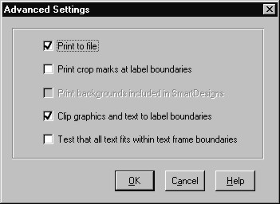
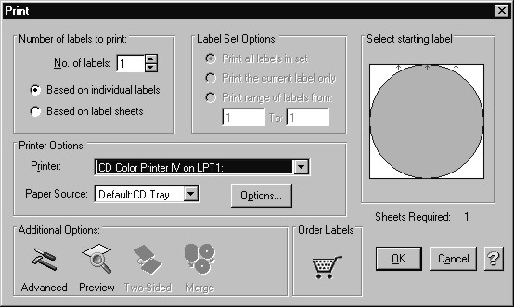
(fig. D)

Utilizing .PDF Files for Printing (Command Module Client Only)
MF Digital Duplication Systems now allows you to create your Disc labels using the popular Adobe Acrobat File, PDF for printing. To make this process simple, MF Digital has created PDF templates for you to design your artwork on. These templates are located on our tech support page. http://www.mfdigital.com/techsupport.html

To use these templates, please follow the instructions below. For this example we will use Adobe Photoshop.

- Open Adobe Photoshop and from the File Menu, choose Open. Browse to find the PDF template that you downloaded and choose that file, click the open button. You will be alerted with an IMPORT PDF dialog window. Fig. A
- Click the OK button.
- The template will open in Adobe Photoshop. If you select the IMAGE menu, then choose Image Size, the image size dialog will appear, verify the Document Size, Height & Width reads the correct size for the template you are working with. For this example, the document size reads, 119.94mm x 119.94mm. Fig. B
- When laying out text in Photoshop, Photoshop automatically creates a new layer, one for each piece of text you add, should you need to insert a graphic. From the Layer Menu, choose LAYER->NEW LAYER. Photoshop will insert a new layer for you. You can then add the graphic onto this layer.(Yellow Square) Fig. C

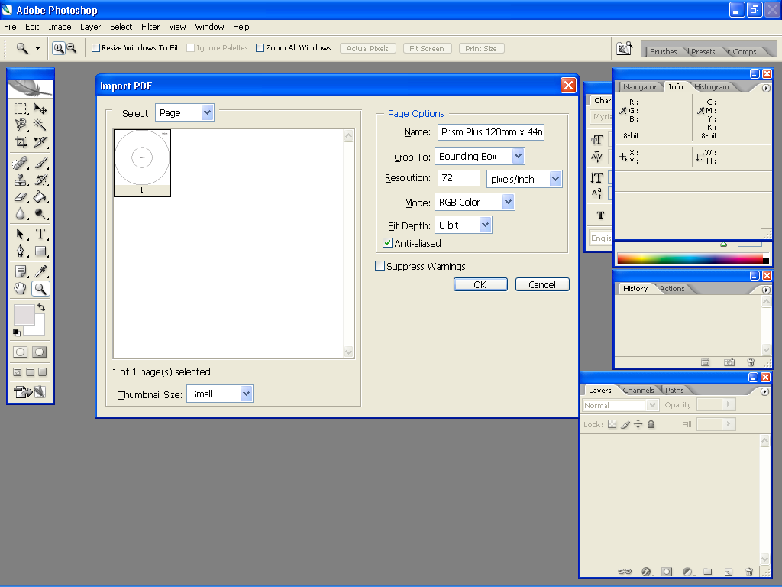
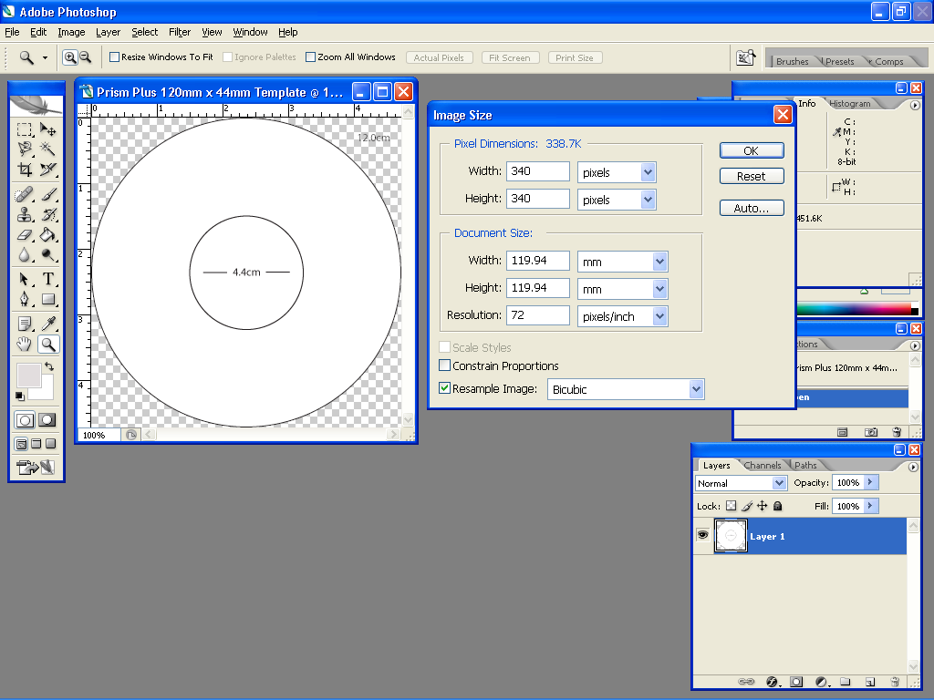
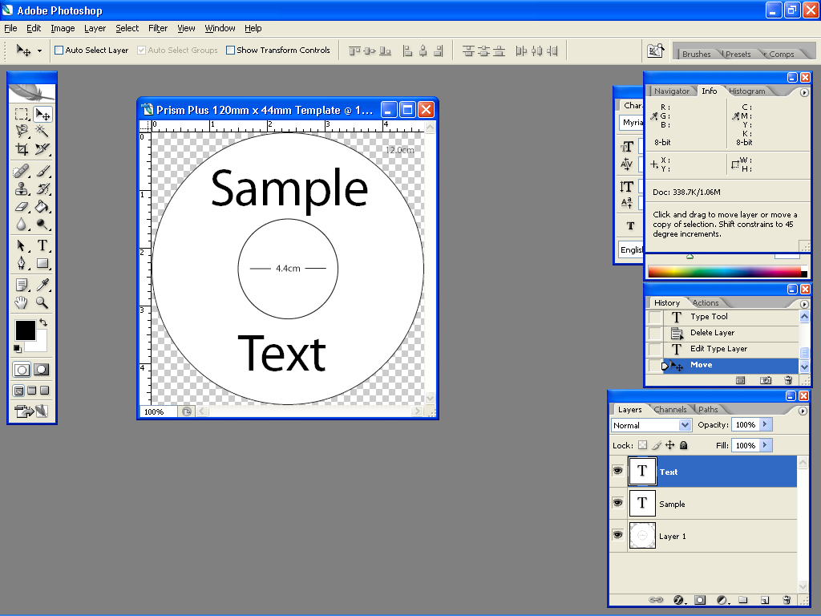
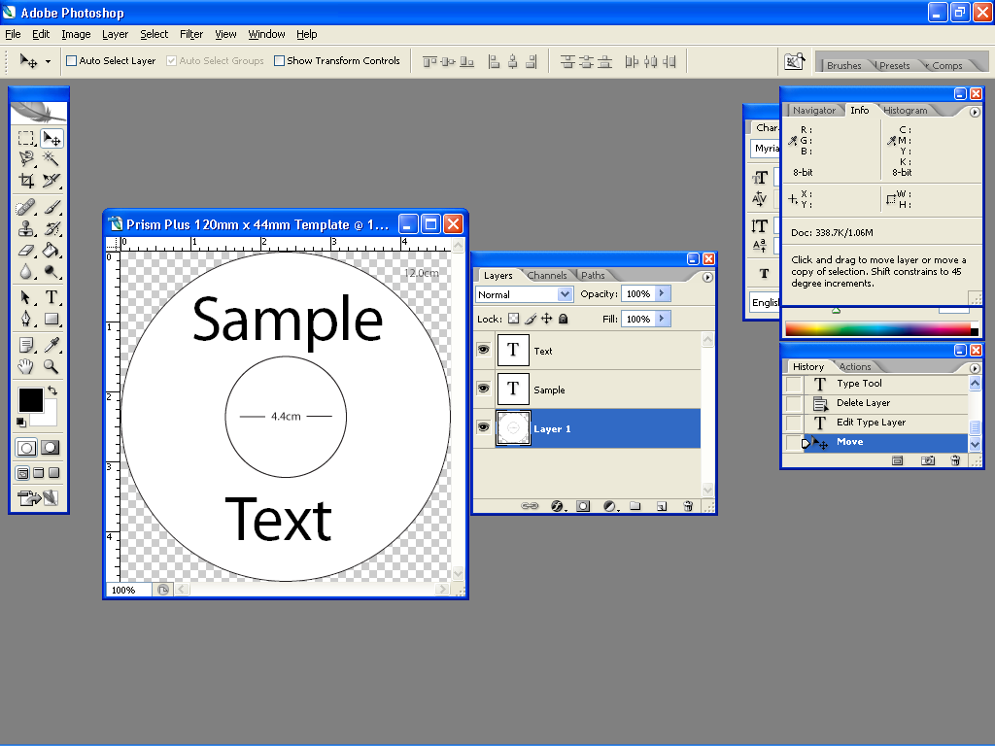
Fig. A.
Fig. B.
Fig. C.
Fig. D.

Utilizing .PDF Files for Printing – Con’t
(Command Module Client Only)
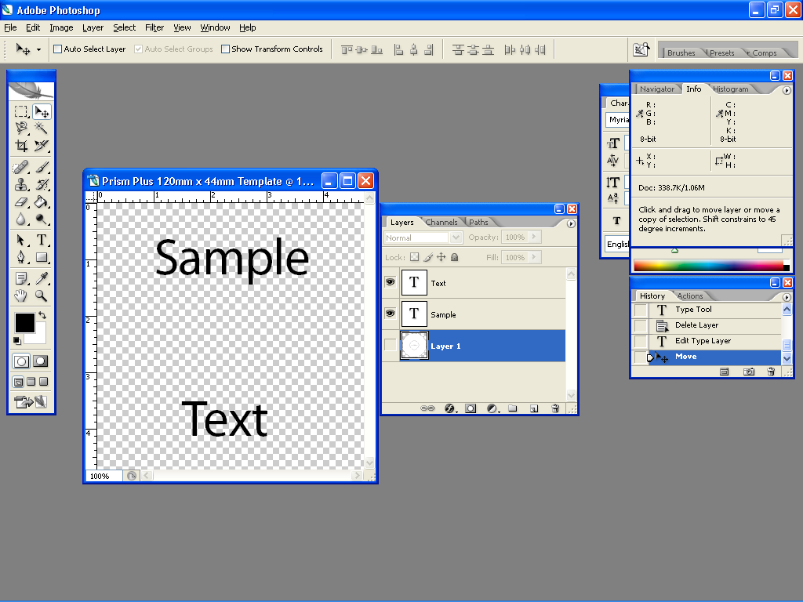
- After you lay out your design, the template layer needs to be “turned off”. This simply done by using the layers palatte (red square, Fig. D) You’ll notice to the left of each layer is an eye. Clicking the eye will turn that layer off. Notice the template now disappears. Fig. E
- You will now need to convert your design into a PDF file, to do this, make sure you have Adobe Acrobat installed. From the File Menu, choose Print. Under the Printer section of the Print Dialog, change the Printer name to the PDF Printer (acrobat versions vary in names). Fig. F Click the OK button.
- You will be prompted to give a name to the PDF file. The default name that should be used for Standalone units, is 1.PDF. If this is a multi set of labels, then label the PDF filename accordingly (example, 1.PDF, 2.PDF, etc.). Fig. G

Fig. E.

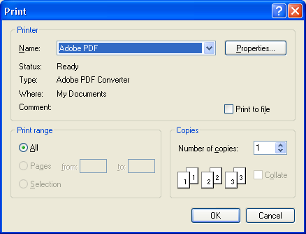

Fig. F.

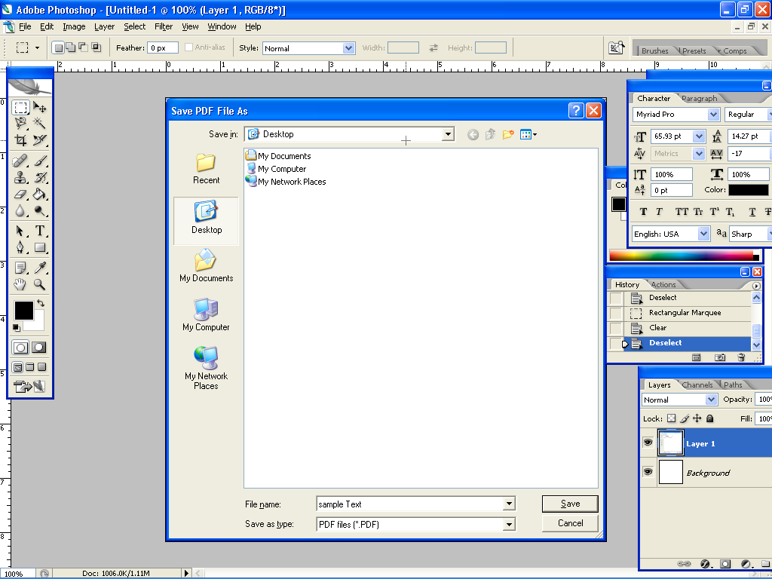

Fig. G.

Utilizing the Printer Option
 | CAUTION  When submitting the PDF file to print, please make sure the target printer is not the default printer. (If printing to PicoJet – PicoJet cannot be the default printer) If needed, add a dummy printer to printers and faxes directory.

Tip: Please make sure you have selected the appropriate printer and have archived an image to the Hard Disk Drive. Please refer to the previous sections outlining those procedures.

Copy and Print
- From the main operating screen depicted below:

- Press the COPY button
- The screen now reads:
- Push the “Start/Yes” button
- The screen now reads:
- Enter the desired quantity.
- The screen now reads:
- Push the “Start/Yes” button
- If a PRN file was previously loaded on the Internal Hard Disk Drive, the screen will prompt, “Use Existing PRN file”. Pushing the “Start/Yes” button will instruct Scribe SA Standalone to use that PRN file.

Scribe SA Standalone will now start duplicating your discs; the Scribe SA Standalone will duplicate first, then remove the burned disc and load it to the printer’s tray for printing. When the printing is completed, Scribe SA Standalone will remove the completed disc, and place it on the output spindle. The Good counter will increment by 1.

- If no PRN file was loaded before hand, push the “Stop/NO” button. Please make sure your PRN file CD is placed in the first Input Bin so the Scribe SA Standalone may load your PRN file to it’s Internal Hard Disk Drive.

Once the PRN file loaded, Scribe SA Standalone will now start the copy and print operation.

TIP: When copying in Relay Mode, with multiple masters, ensure the CD contains the printer image files (1.PRN, 2.PRN, etc.) for use with each master. This CD must be placed in the first input bin on top of the very first master. All of the PRN will be imported.

Print Only
In addition to the Copy and Print feature, the Scribe SA Standalone is capable of processing Print Only jobs. Please follow the instructions below to utilize this capability.

- Place the CD containing the .prn file, which you wish to use, on top of the CD stack in the input bin. You can use the SA Client Feature to send your PRN file to your Scribe SA Standalone via your network. See the section, Utilizing the Scribe Client Feature later in this manual.

- From the main operating screen, press the “COPY” key on the keypad.

- You will be prompted to:

- Press the “Stop/No” key.

- Press the “Stop/No” key.

- Press the “Stop/No” key.

- Press the “Stop/No” key and you will be prompted to enable the Print Only function.

- Press the “Start/Yes” key and you will be prompted to enter a quantity of discs to be printed.

- Enter a quantity and press the “Start/Yes” key.
- If a PRN file was previously loaded the display will read:

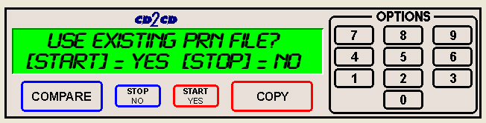
- If you push the “Start/Yes” Key, the screen will now read:
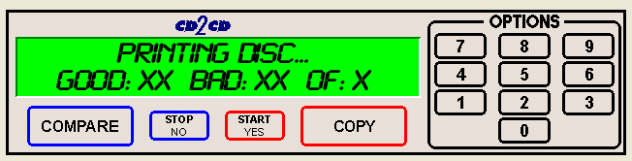
- If you push the “Stop/No” Key, have your PRN disc loaded in the first input hopper as the Scribe SA Standalone will import the PRN file(s), the display will read:
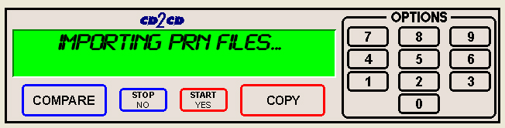

- Once the PRN file(s) have been imported, the display will read:
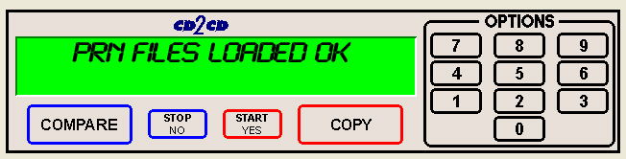
- Scribe SA Standalone will unload the PRN disc and place it in the reject area. The print job will now continue, the display will now read.
- When the Print Job is complete, the display will now read:
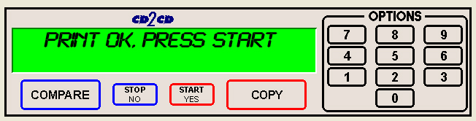
- After pressing start, you will be returned to the main operating screen:

Viewing Device Information
To view the Scribe SA Standalone device information, the steps are as follows:

- From the main operating screen depicted below:

- Press the “6” key. Something similar to the following will be displayed on the screen:
B
A
C

The device information is displayed for each of the DVD or CD recorders installed in the Scribe SA Standalone. The information displayed in this example is for DVD Records. CD Device information will be slightly different.

A= Device Number (position of device in system)
B= Drive Model Number
C= Firmware version installed on drive itself.

Setting The Internal Clock
The Scribe SA Standalone’s internal clock is set at the factory for Eastern Standard Time (observing daylight savings when applicable).

To set the internal clock, the steps are as follows:

- Press the “7” key on the keypad. The screen will now read:

Press the “Stop/No” and you will be prompted to set the “System Time.”

• Press the “Start/Yes” key if you would like to set the system time. The screen will then read:

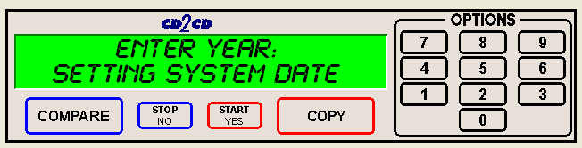
• Press the “Start/Yes” key after each entry.

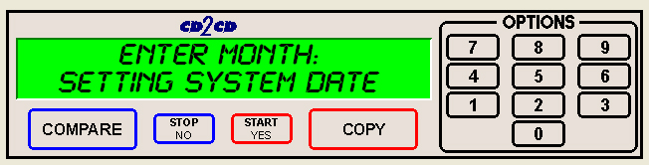
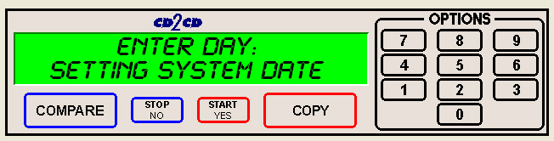
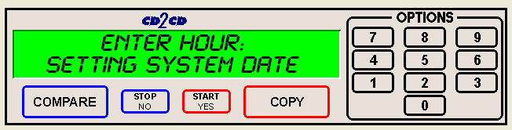
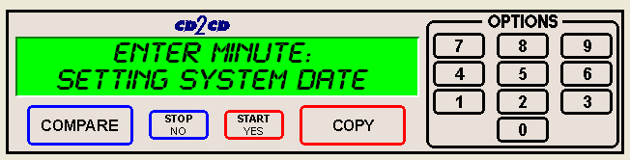
• You will then be returned to the main operating screen:

Firmware Updates

From time to time the Scribe SA Standalone’s internal “firmware” may need updating to add new features or improve existing functions. Firmware is easily updated by loading a “Firmware Update CD” into the system. The latest version of firmware will be available for downloading to your computer from the MF DIGITAL web site: www.MFDIGITAL.com
Once a firmware image file is downloaded, a “Firmware Update CD” can then be written using a computer, a CD-R/RW recorder, and most popular pre-mastering programs (such as: Adaptec Easy CD Creator and Toast, CeQuadrat, WinOnCD, Ahead Nero, NTI CD-Maker, and others). Refer to your pre-mastering software documentation for details on how to record a disc from an image file.
To correctly make a Firmware Update CD, after downloading the file, extract the .ZIP file. A folder labeled, Embedded will be on your Hard Drive. Burn the folder including the contents to the root of the CD. Do not, empty the contents of the folder on the CD.

After having created a “Firmware Update CD”, perform the following steps to update the Scribe SA Standalone firmware:

- With the system turned ON, load the “Firmware Update CD” into the top CD-R/RW recorder.
- Turn off the power to the Scribe SA Standalone.
- Turn on the power to the Scribe SA Standalone.
- The system will startup:

- You will see the “Initializing System” screen:

• You will see the upgrade firmware screen:
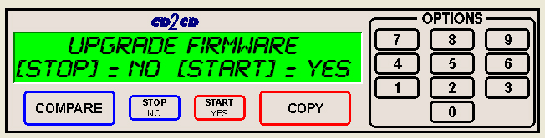
- Select “Yes” to upgrade the firmware.
Note: Do not turn the system off as the upgrade is taking place.
- Upon completion, the system will automatically reboot and the following screen will appear:
• After the Scribe Standalone SA reboots, the screen will prompt you again to Upgrade Firmware. Press the “Stop/No” button. You will then be returned to the main operating screen: The loader may unload the disc automatically.
• To confirm the upgrade has taken place. Press the “1” key on your keypad, the first screen will display the following. The screen does change rapidly. You might have to press the “1” key again once you are returned the main operating screen as indicated in the above illustration.

Quick Setup Guide for the Scribe SA Standalone Series Client Application

Utilizing the Scribe SA Standalone Series Client
The Scribe SA Standalone series has a client feature which enables a remote user.

Configuring the Scribe SA Standalone Series
- Connect the Scribe SA Standalone Series to your network using the RJ-45 connector on the back of the system.
- Turn on the Scribe SA Standalone Series
- Wait for the Scribe SA Standalone Series to boot up, you will see:

- Press the “7” key, you will see:

• Press the “START/YES” key, you will see:

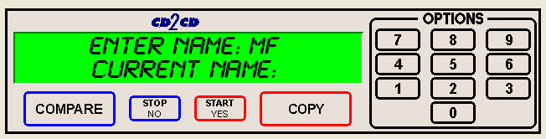
• You must leave “MF” at the front of the name. You should name it “MF001” for example.

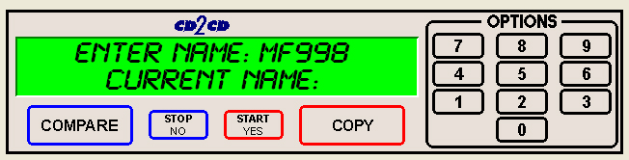
• Press the “START/YES” key, you will see:

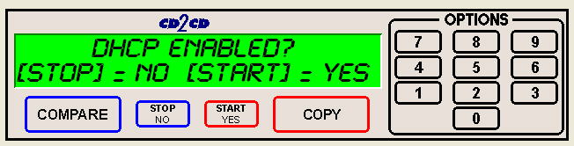
• Press the “Stop No” key if the network does not use DHCP or press the “START/YES” key if the network does use DHCP. If you press the ““START/YES” “ key you will be prompted to Restart the system, if you press the “Stop No” key you will see:

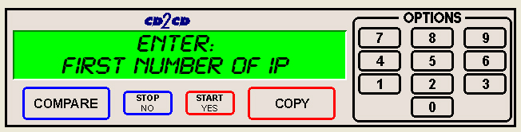
• Enter the 4 sets of numbers of the IP address, one set at a time. After each octet press the “START/YES” key. Do not enter an IP address of a machine that is already on the network. When you have entered in the entire IP address, you will see:

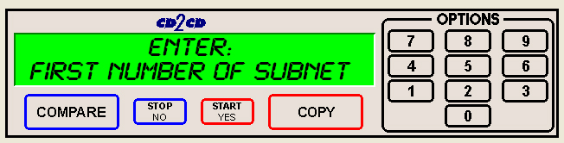
• Enter the 4 sets of numbers of the subnet. Pressing “START/YES” after each set. You will then see:

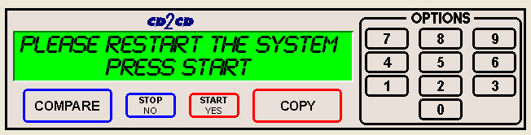
• Press the “START/YES” key and then Restart the system by turning it Off and back On again.

Installing the SA Client Application

- Place the firmware CD into the CD-ROM drive of your PC
- Double click on “Embedded” folder
- Copy the SaClient.EXE to the remote PC
- Once copied, double click on the SaClient.EXE file
- Press “Connect” in the lower right hand corner
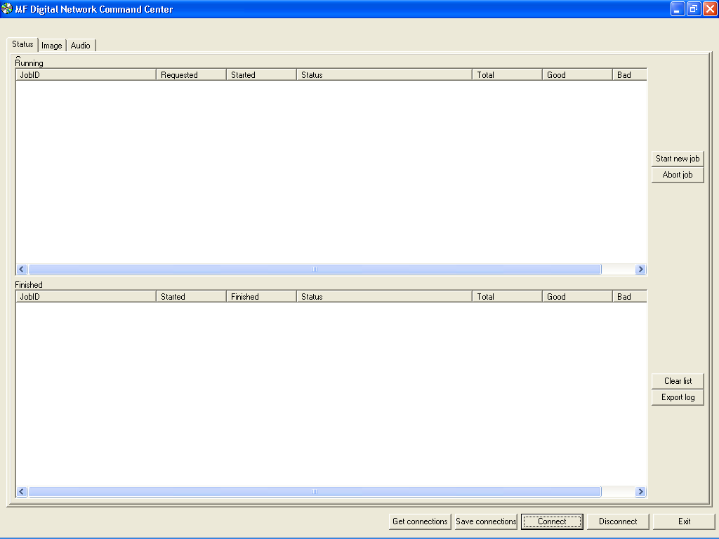

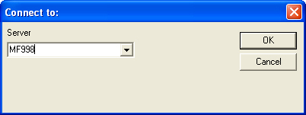

- Click in the Server Name Text Box and enter the name of the Scribe SA Standalone Series on the network.
- Press “OK”
- For this example, a new tab will appear at the top of the screen called “MF998”
- Click the “MF998” tab and you will see:
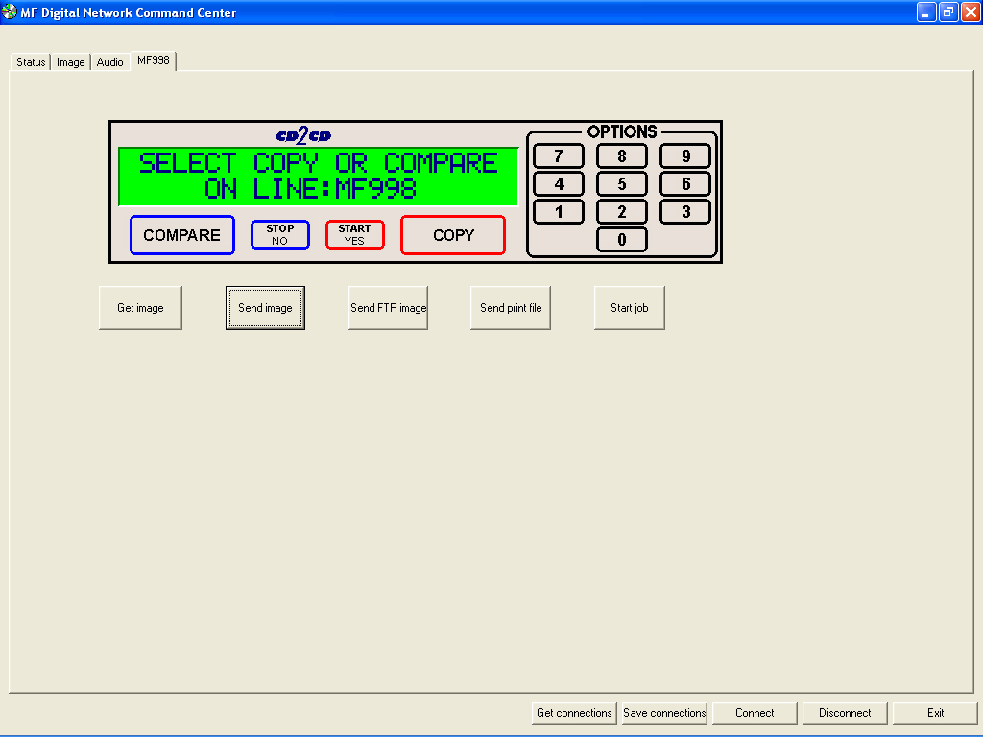

Utilizing the SA Client Application

- Click “Get image” to pull an image from the Scribe SA Standalone. Give the image a name and location. The image will be saved with a .img file extension.
- Click “Send image” to send an image to the Scribe SA Standalone. The image may be an .img, .iso, .udf, or .isc.
- Click “Send FTP Image” to send a image to the Scribe SA Standalone via FTP.
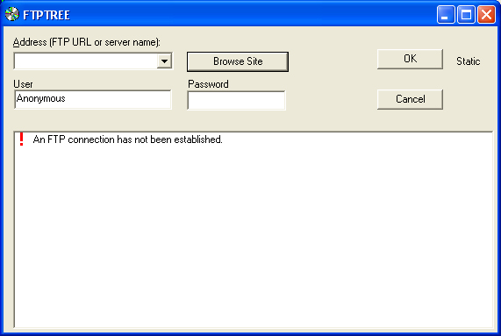

- Click “Send Print File” to send a PRN or PDF file to the Scribe SA Standalone.
- To start a job from the client on the individually connected Scribe SA Standalone, click “Start job”. Click “Browse” to select an image to burn to the Scribe SA Standalone. Select “Copy”, “Verify”, or “Test. Enter a quantity and click “OK”.
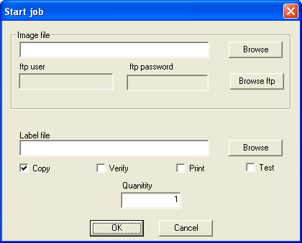

The Start New Job Dialog can be accessed from the Status Tab, and clicking the Start New Job Button on the right. This dialog is used when the remote user wants to submit a job to multiple machines at once. Individuals who are running a production floor will find this option useful. As you can add/remove resources(SA Units) as needed. You can even specify a Job ID if desired. The default Job ID consists of the Month_Date_Hours_Minutes_Seconds

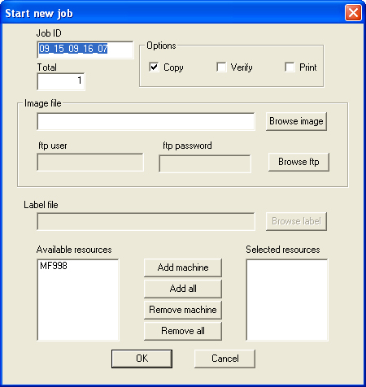

The SA Client application makes it easier to now connect to many units simultaneously. Once you connect to all your units, simply press the SAVE CONNECTIONS button. This will make a registry entry on your Remote PC remembering which units you are connected to.

When you are ready to reconnect to all of your units, simply press the LOAD CONNECTIONS button, and all your units will be automatically and simultaneously connect with just click of a button

.

Tip: Keep in mind the SAVE and LOAD Connections are saved per Remote PC. If you want to save/load connections on multiple PC’s you will need to connect to each Scribe SA Standalone first, then save your connections on that PC.

