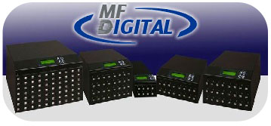

MF Digital 5000 USB Platform Series

Operating Manual

MF Digital
A Division of Formats Unlimited, Inc
155 Sherwood Avenue
Farmingdale, NY 11735

T: +1 631 249 9393
F: +1 631 249 9273

Authors: Robert Warnock & Patrick McGrath
support@mfdigital.com
www.mfdigital.com/techsupport.html

Contents Page

- Introduction Pages 3 - 5
1.1 Feature Overview Page 3
1.2 Hardware Overview Page 4
1.3 Technical Specification Page 5

2.0 Function Pages 6 – 11

2.1 Synchronous Copy Page 6
2.2 Asynchronous Copy Page 7
2.3 Capacity Check Page 8
2.4 USB/SD Information Page 8
2.5 System Information Page 9
2.6 Utilities
2.6.1 Fat 16/32 Formatting Page 9
2.6.2 Measure Speed Page 9
2.6.3 Media Check Page 10
2.7 Erase Functions
2.7.1 Quick Erase Page 10
2.7.2 Full Erase Page 10
2.8 System Update Page 10
2.9 Operational Tips Page 11

3.0 System Settings Functions Pages 11 – 13

3.1 Start Up Menu Page 11
3.2 Copying
3.2.1 Only Data Area Page 11
3.2.2 Whole Media Page 11
3.3 Button Beep Page 11
3.4 Asynchronous Hold Time Page 11
3.5 Ignore Size Page 12
3.6 Asynchronous Copy Mode Page 13
3.7 Language Page 13
3.8 Working Mode Page 13

4.0 Function List Pages 14 – 15

5.0 Help & Support Page 16

  - Introduction

  - Feature Overview
- 33MB per second transfer speed with each USB/SD channel being independent from each other.
- High speed comparison function to guarantee successful copies.
- Powerful quality machine that has a Multi-task processing capability, with the copy, compare, media check and format functions all being independently operated. Each USB/SD slot has an independent control processing unit so during operation one can use the buttons to check each USB/SD’s status and progress.

- Not a PC based system so there is no risk of PC based malware or virus infection. The SD/USB duplicator is an embedded system and therefore only copies whatever is on the source. When the system is turned off no residual memory or file is left in the system.

- Instant system on and off with zero boot time

- Simple one touch copy with real time information displayed on the LCD screen.

- The flash duplicator supports both Synchronous and Asynchronous copy, compare, erase, format, media and speed check functions.

- 32 bit CRC checksum.

- Direct source to target duplication with no chance of copying the wrong files.

  - Hardware Overview

[Name Plate and LCD Screen]
LCD Screen

Forward
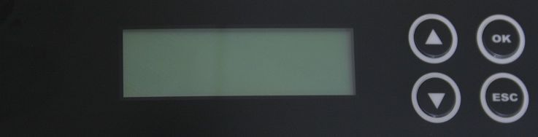
Backward
OK, Confirm
Escape

[ Flash Slot board ]
USB Master Port

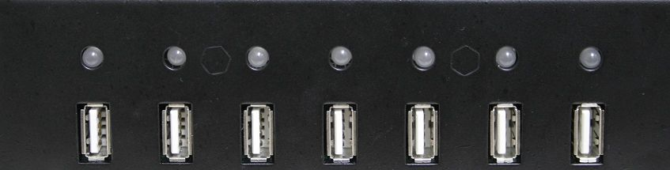
Two-Colour LED (Red and Green)

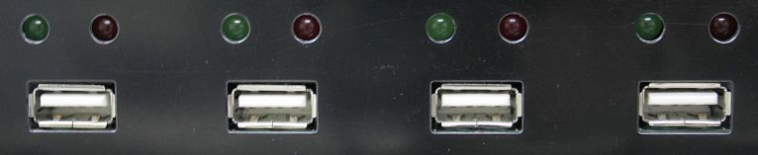
Single Colour LED (Red and Green)

SD Master Port


Single Colour LED (Red and Green)

1.3 Technical Specification

Model | UB/SD/CF8xx
Target | 8/16/24/32~2040 port
Operation | Stand Alone
Supported Media | USB1.1, UBS2.0
Supported Media | SD/ SDHC/ Micro SD/ MMC/ MiniSD
Supported Media | Compact Flash TM,
Features | 1. | Copy, Compare, Copy+Compare Function for Selection
Features | 2. | Real Asynchronous of Copy, Compare, Check (Speed/ Capacity/ media) and Format
Features | 3. | Quick FAT16 /32 Format Function
Features | 4. | Maximum up to 33MB/s bandwidth on each slot channel
Features | 5. | Support most of common formats such FAT16/32/NTFS/Linux (Ext2,Ext3).
Features | 6. | 32 bit CRC checksum
Features | 7. | Firmware update through USB/SD.
Display | Monochrome LCD display
Power Supply | 80W~or up (depends on different type of system requirement); support 110V/220V full range power
Control Button | 4 push buttons (,, OK, Esc)
LED | LED(Green/Red) on each slot
Humidity | Working |  | 20%~80%
Humidity | Storage |  | 5%~95%
Temperature | Working |  | 0⁰C~75ºC
Temperature | Storage |  | -20⁰C~85⁰C
*The product specification is for reference only

2.0 Function Overview

The system offers both Asynchronous and Synchronous Copy. Initially the system will check the content size of the source. If the source content size is less than system’s buffer memory it will automatically start the asynchronous copy process. If the source content size is larger than the system’s buffer memory it will automatically start the synchronous copy process. The purpose of the compare function is to verify the target data and ensure it is the same as the source data.

2.1 Synchronous Copy

Plug in the source flash card and select either the copy, compare or the copy/compare function and then press OK.

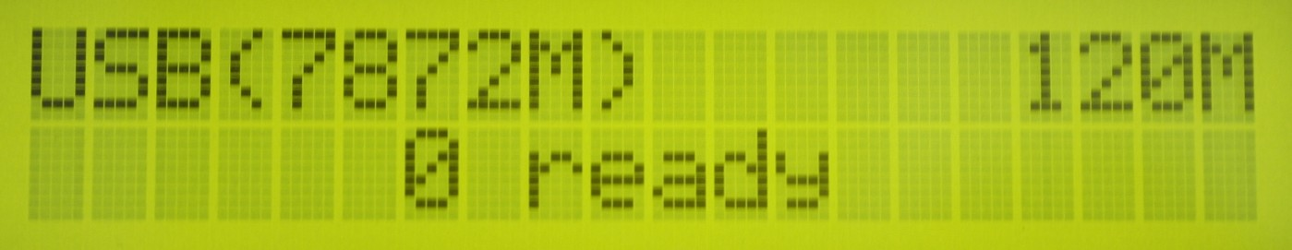

Plug in the target flash cards. The LCD display will show the number of target flash plugged into the unit that are ready for copying.

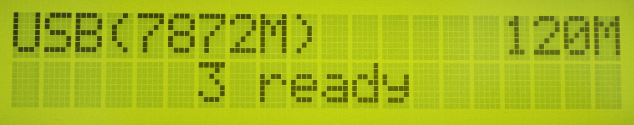

When all the flash cards are plugged in, press OK to start the copying process. Or when all slots are filled the system will automatically start the copying process

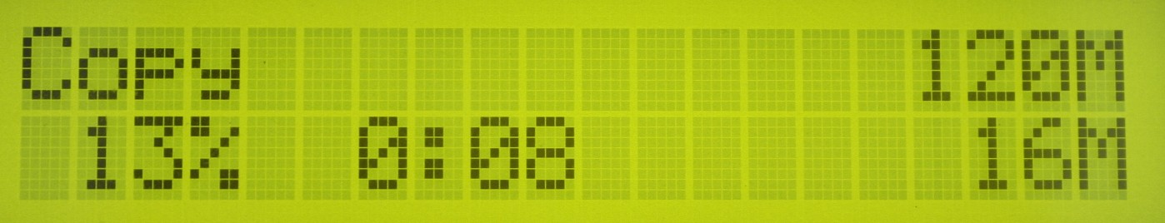
Content size
Content Copied
Time Elapsed & % Completed

When the copying has finished the LCD display shows whether the copying has succeeded or failed. It also shows the quantity that was copied and the time that it took.

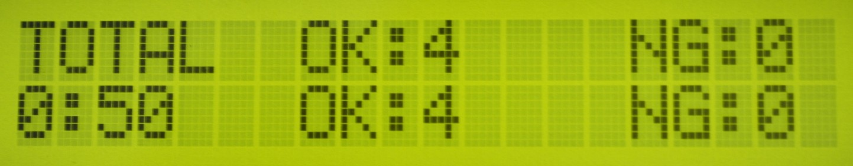

Note:

When the copying process is in operation the green LED lights will flash. When the copying process has finished the green LED lights will stop flashing and remain a solid green. If an error occurs the red LED light will illuminate.

During the copying process each card slot’s green LED will flash, do not remove the card while the unit is copying.

When there is a big difference in the target and source cards capacity (e.g. copying from 1GB to 4GB), an error may occur with the target cards capacity and format. It is strongly recommended that the capacity of the target and source cards, are in close range of each other.

  - Asynchronous Copy

Plug in the source flash and press OK, and then the system will start to read the source content and transfer it into system’s buffer. It will then immediately start to copy, once a target flash card has been plugged in.

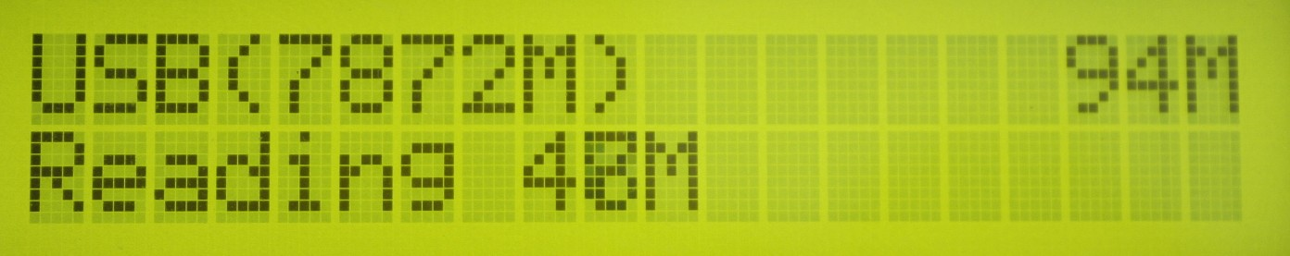

During the copying process each card slots green LED light will flash. When copying has finished, the green LED will stop flashing and remain solidly lit. Then you can take out the card and put in another new flash card. The Red LED will only be lit when a copying error has taken place

You can take out cards which have finished copying and plug in replacement flash cards, and the unit will continue to copy. When the copying has finished the LCD display shows whether the copying has succeeded or failed. It also shows the quantity that was copied and the time that it took.

Quantity Copied

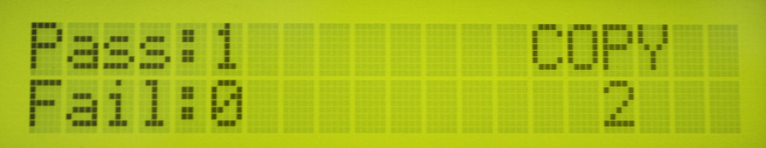
Quantity of flash cards copying

During the asynchronous copy process you can press the buttons to check each Flash Card’s copying status and progress.

When there is an error (i.e. the Red LED is on) you can also press the buttons to check each Flash Card’s status.

For example：
Port no. 5 status

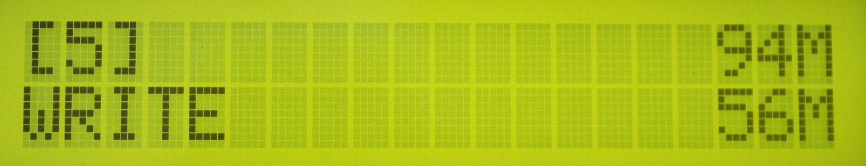 Amount Completed
Total size

  - Capacity check

This function checks the actual capacity of the Flash card.

Plug the SD/USB card into a slot and then select function 4 which is “Capacity Check”, then press OK. Approximately 3 seconds later the system will display the exact capacity of the USB/SD card and whether it can be used or not.

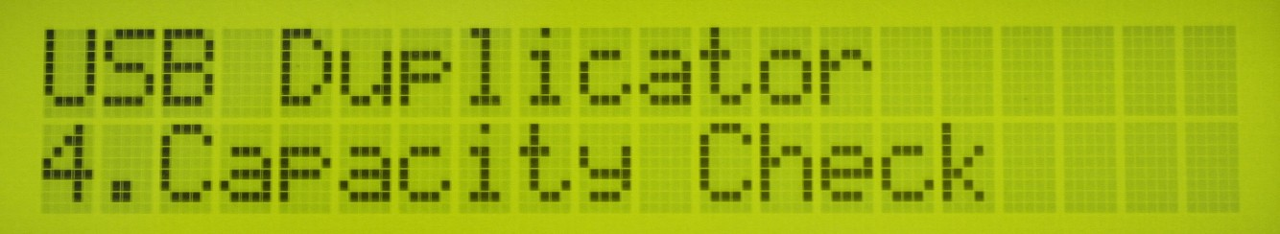

The System will use the Green LED to indicate the card is suitable for use and the Red LED to indicate that the card is not suitable for use. The buttons can be used to check the progress of the “Capacity Check”.

Note: When the Red LED is lit this indicates an error and you can use the buttons to check the error information.

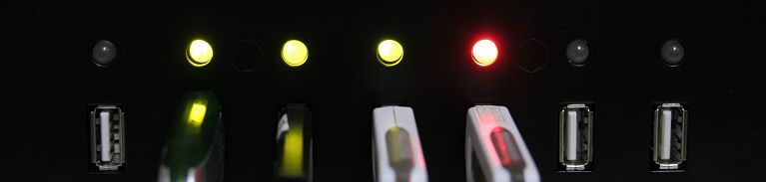

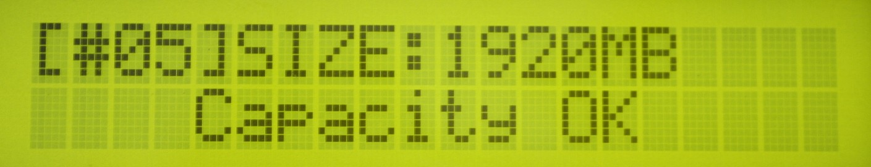 (Red Light indicates incorrect size)
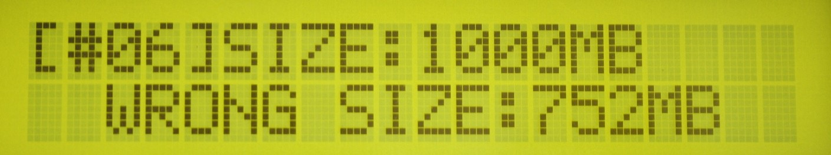
(Green Light indicates correct size))

This function can support the asynchronous operation so the user can continuously plug in and pull out USB/SD cards as required; there is no need to push any further buttons once the process has been started.

  - USB/SD information

This display will show the USB/SD flash’s basic information such as flash type, content size and total capacity.

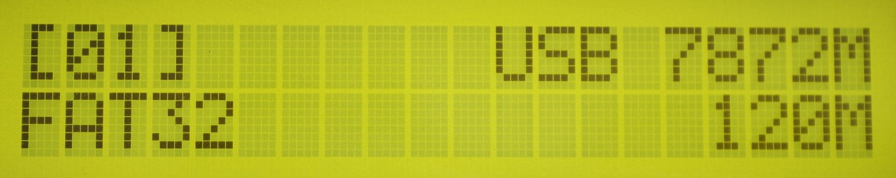
USB total capacity
File content size
File Format

Port Number Being Checked

  - System Information

This feature will show the duplicator system information which includes the controller model number and the software version.

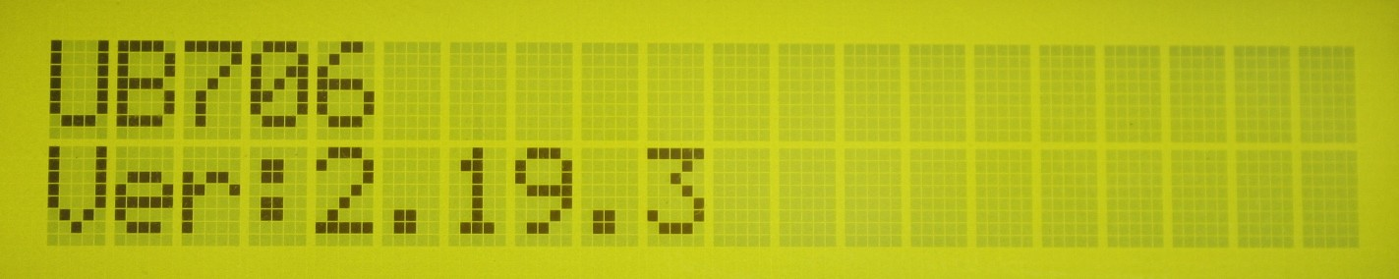
Controller Model Number
System Firmware

  - Utilities

    - FAT16/32 Formatting

The purpose of this function is to perform FAT flash formatting of the USB/SD Cards. Plug the USB/SD into the slot and press OK, the system will start the auto detect capacity function and format according to the card’s capacity.

If USB/ SD format is already FAT16 or FAT32, the format function won’t change original format.

If USB/ SD format is un-FAT format, i.e. NTFS, Linux or FAT multi-partition. The system will format according to capacity. When the capacity is above 2GB the system will format to FAT32 and if the capacity is below 2GB the system will automatically format to FAT16.

During the formatting process the user can press the buttons to check each Flash Card’s formatting status, progress and information.

The source port (port#1) will not execute any formatting.

    - Measure Speed

This function will measure the Flash “read” and “write” speed. The speed check function will not delete any data from the Flash.

Plug the SD/USB into the slot and select the Measure Speed function then press ok to start the process. The user can also use the buttons to see the exact “Read” and “Write” speed from each port



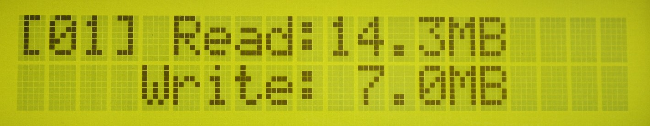

2.6.3 Media Check

This function will analyze the media quality. There are two modes which you can set - Normal and Safe.

The Safe media check will read through the flash and will not damage the content or formatting of the media. By using the Setup Range function with the Safe function you can determine whether you want to check a portion or all of the Media. It uses the buttons to determine how much of the flash is checked, the range can be set from 1 to 100%. If the user selects 100% the process will take a lot longer.

The Normal media check function will check flash quality by measuring the read and write speeds for the whole flash. Therefore, this function will delete the flash’s content and format.

Note: USB/SD data will be erased during normal mode test

Measure Speed and Media check (Safe Mode) won’t damage the data in the USB/SD Flash, but if the SD/USB has bad media it may cause some data damage after the check fails.

2.7 Erase Functions

2.7.1 Quick Erase

This function will erase the USB/SD data content but will not erase the flash FAT16/32 formatting. If the USB/SD format is not FAT16/32, the quick erase will not start execute. You can use the buttons to check each Flash Card’s status, progress and information.

    - Full Erase

This will completely erase the whole flash card, including format and content. This process will take more time. You can stop the process by pressing the ESC button. Though the original format and content can no longer be read once the ESC button is pressed and the USB/SD will need to be reformatted.

  - System Update

The purpose of this function is to update the system’s firmware version. Please save an un-zipped update file to your SD/USB drive; do not put the unzipped files in a folder. Select function 6.5 which is the System Update and then press OK. The system will automatically start updating the system and when it is finished turn off the system for 5 seconds. Then when the unit is powered on again the new firmware version will have been installed.

  - Operational Tips

Do not remove any flash card which is still in the copying process, when a flash card is copying the green LED light will flash. Removing a card that has a flashing light may not only damage the flash card but also the system hardware.

Some users may like to use a USB converter to copy different types of flash cards, such as CF, SD, or Memory stick etc. This is not recommended, since the quality and reliability of each USB converter on the market is very different, a poor quality USB converter may cause the damage to the system hardware and the flash card. When using a converter the resulting copy quality from the Flash card may also be very poor.

- System Settings Functions

3.1 Start up menu

The user can select which function is shown first when the duplicator is turned on.

  - Copying

    - Only Data Area

This is also called the “quick copy” mode. The system will automatically analyze the source flash card’s file format and if the data’s file format is recognizable by the system (FAT16/32, NTFS, Linux, Ext2, Ext3) it will be able to only copy the data and not the whole Flash. Otherwise if the file format is non-recognizable the system will copy the whole flash card including the empty space. For example if a 2GB flash card which has FAT32 file format and has only 50 MB of data inside, the system will only copy the 50MB of data.

    - Whole Media

Setup the duplicator in Whole Media function, the system will copy the whole flash card, including the empty space and format. This function is used when you have a flash source which has an unknown file format and you don’t want the system to be confused by such a format. For example a 2GB flash card which is FAT32 file format and has only 50 MB of data inside, if you setup “Whole Media” the system will copy whole 2GB of Flash. It will take long time to copy the source.

  - Button Beep

Choose whether to hear a beep when a button is pressed.

  - Asynchronous Hold time

This is to set the exit time for asynchronous copying. This is to prevent the user from mistakenly overwriting a source device when they are about to start a new batch and have forgotten to stop the previous asynchronous copying job. The default setting is for 30 seconds, so when the system detects that all the flash cards have been removed and no new cards have been inserted after 30 seconds the LCD will display:

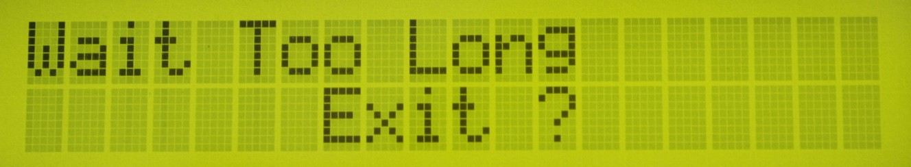

Press OK to exit the current Asynchronous copy or press ESC to keep the unit operating in the current Asynchronous copy.

  - Ignore Size

The purpose of this function is to set the flash card tolerance between the source and target memory capacity.

The default setting is “Don’t Care” and this means there is no limit of tolerance between the source and target. If you require the source and target flash cards to be limited to a certain capacity tolerance then you can set the percentage of the tolerance. For example if your source device has a capacity of 1919MB, that means the acceptable target devices’ capacity will be limited to between 1976MB to 1861MB.

Note: If the capacity difference between the source and target is larger than the tolerance setting then when you start to copy Red LED will be lit to indicate there is an error. You will then see a “Fail” message and you can press the buttons to check the status of each flash card that is currently in the Asynchronous Copying process.

Differences in Source and Target capacity

If Source capacity is smaller than the target, for example 1GB to 2GB:

Example: A. Source B. Target
1GB 2GB
FAT table
Copy OK.
FAT table

Warning: The 2GB target device will become 1GB when it is read on a PC. You can only restore its real capacity by re-formatting the device.

Note: When there is a big difference in the target and source’s capacity such as 1GB to 4GB, there is a possibility to cause error to the target’s capacity and format. It is strongly recommended that the capacity of the target and source are within a close range.

If the Source capacity is Greater than the target, for example 2GB to 1GB:

When the source content is within the target flash card’s capacity

- Source B. Target
2GB 1GB
O -- Copy OK. The copying process will succeed as the capacity of the target device is the same size as the amount of data to be transferred.

(Data)

When the source content exceeds the target flash card’s capacity

A. Source B. Target
2GB 1GB
X -- Copy Fail. The copying process will fail as the capacity of the target device is smaller than the amount of data to be transferred.

FAT16/32 Data
X

  - Asynchronous Copy Mode

The function can be enabled by selecting “ON” or disabled by selecting “OFF". If asynchronous copy is enabled and the source content size is less than the system’s buffer memory it will automatically start the asynchronous copy process. If the asynchronous copy is disabled no matter what the content size or which copy method has been selected the system will only use the synchronous copy mode.

  - Language

This function enables the user to choose the language of the system interface.

  - Working mode

This function enables the user to choose between the “Turbo mode” and “Normal mode”. Turbo mode can support high speed Flash with a high speed copy. If using the “Turbo mode” function please ensure sure the Flash cards support high speed transfer and are of a good quality. If the Flash card is bad quality there will be errors in the transfer of data, when using Turbo mode. The factory default System setting is “Normal Mode”.

4.0 Function List

Function | Description
1. Copy | USB/SD/CF flash copy.
2. Compare | This option makes bit-by-bit comparison between the master source and all other copied flash cards.
3. Copy+Compare | This option will make a copy first and then compare the copied flash with the source, immediately after the copy has finished.
4. Capacity check | Checks the real capacity of the Flash
5. Information | 5.1 SD/USB info - This feature will show the USB/SD flash’s information i.e. file format, content size and capacity.
 | 5.2 System Info -This feature will show system information for the duplicator i.e. controller model number and software version.
6. Utility | 6.1 Format – Use this function to perform FAT 16/32 formatting of flash cards.
 | 6.2 Measure Speed -This function can measure the read and write speed of the Flash card. This function won’t damage the format or content.
6.3 Media check
6.3. Safe mode – Use this function to check the quality of the flash by reading the flash card. The safe check will not delete flash content or format.
6.3.2 Normal mode – Use this function to check the quality (“0”) by reading/writing the flash (“1”). The normal check will delete the content and format.
6.3.3 Setup Range – Use this function to set up the area media check will examine. Range can be set from 1% to 100%
 | 6.4 Quick Erase – Use this function to erase USB/SD flash content. It will keep the FAT format.
 | 6.5 Full Erase SD/USB – Use this function to completely erase USB/SD flash data including format and content.
 | 6.6 System Update - System firmware update via the SD/USB

7.0 Utility | 7.1 Start-up Menu - To select which function is shown first when the system is first turned on.
7.2 Copy Area
7.2.1 Only Data Area – Use the system to automatically detect the format (FAT16/32, NTFS, Linux, Ext2, Ext3) and only copy the data area.
7.2.2 Whole Media – the system will copy the whole content of the flash including the empty space area if the target is not formatted to any of the following; FAT16/32, NTFS, Linux, Ext2, Ext3.
 | 7.3 Button Beep - Choose whether to hear a beep when a button is pressed.
 | 7.4 Asynchronous Hold Time - To set how long the system will wait to continue or exit the function of the Asynchronous copying job.
 | 7.5 Ignore Size - To set the tolerance % of the source and target flash cards. The default setting is “don’t care”.
 | 7.6 Asynchronous - “On” to enable Asynchronous copy mode. “OFF” to disable Asynchronous copy mode.
 | 7.7 Language - Set language of system interface.
 | 7.8 Working Mode – Use this function to setup “Turbo mode” or “Normal mode”.

- Help & Support

Contact details:

MF Digital
A Division of Formats Unlimited, Inc
155 Sherwood Avenue
Farmingdale, NY 11735

T: +1 631 249 9393
F: +1 631 249 9273

support@mfdigital.com
www.mfdigital.com/techsupport.html

